Supplementary Materials
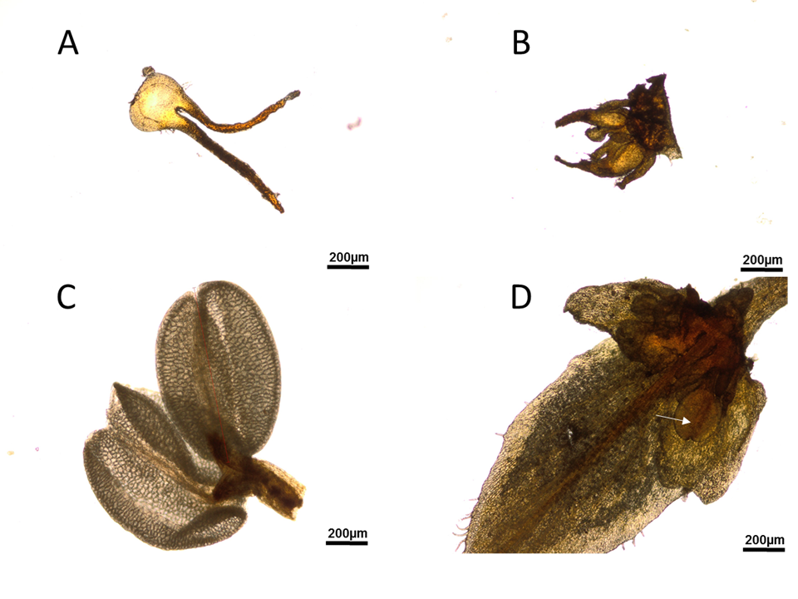
Fig. S1. Generative organs of bisexual inflorescences of silver birch: A) pistil in “female zone”, B) pistils in “transition zone” C) anthers in “male zone”, and D) anthers in “transition zone”.
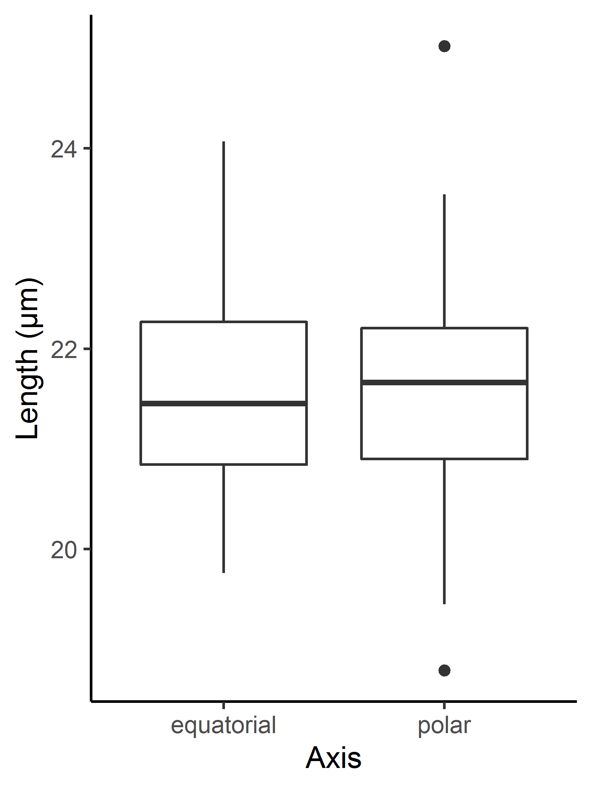
Fig. S2. Mean diameter of pollen grains (n=50) collected from anthers from bisexual catkins.
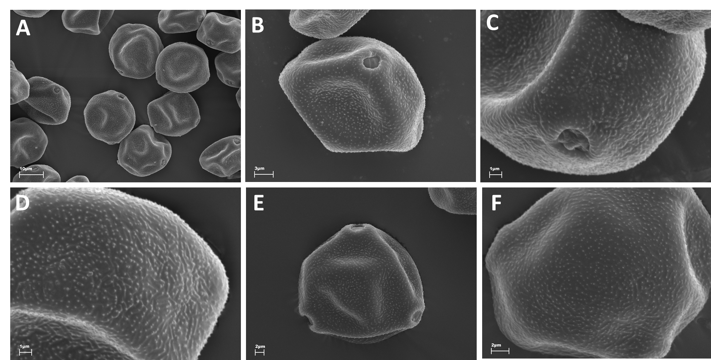
Fig. 3S. Examples of pollen grains collected from bisexual catkins (A, B, C, D) and from normal male catkins (from another tree growing at the same location) (E,F).

