Supplementary material
Figure 1 – spore release measurements across sites
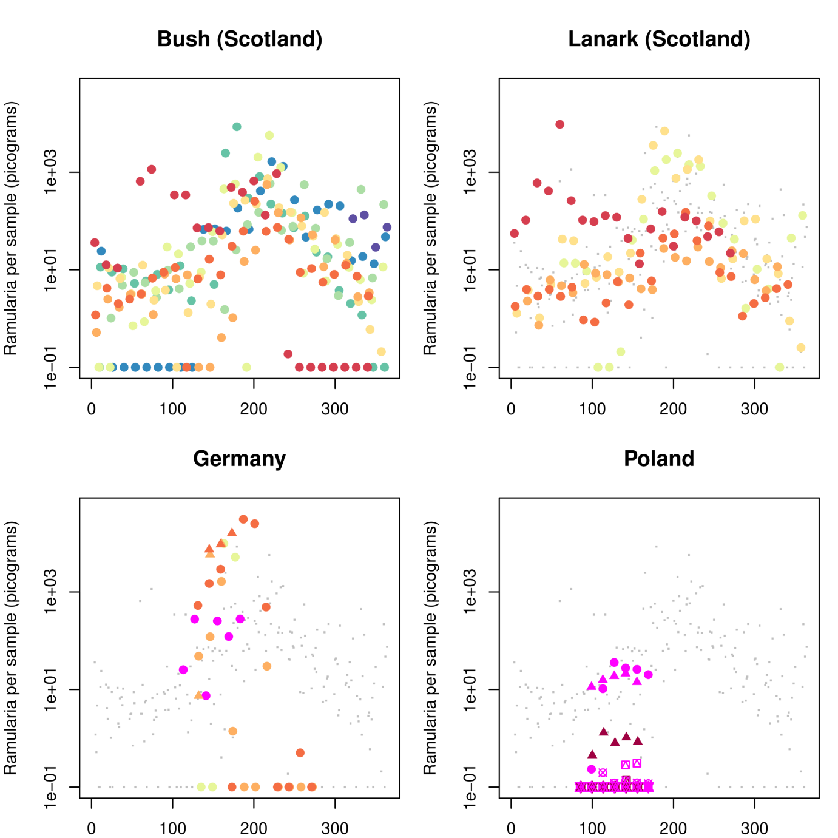
Supplementary Figure 1. Comparison of R. collo-cygni airborne inoculum concentrations across German (2 sites), Polish (7 sites) and UK (2 sites) in all years of study

Supplementary 2: 2012 as an anomalous year

In much of our analysis, we have chosen to remove the year 2012 from the dataset. While we collected data from this data, we have reason to believe it is anomalous. Figure A1 and Figure A2 illustrate the two years.
The key feature of 2012 at both Scottish sites was the very high levels of spore counts early in the season. This is especially clear in the Lanark data, where spore counts reached some of the highest levels recorded, except in March instead of the usual times of July and August. Data in 2012 in Bush are more patchy, but suggest a similar pattern.
The cause of this difference in pattern is unclear. It may be connected to environmental factors – the temperatures in February and March were very high. However Lanark already showed high levels of spores at the end of January, at least relative to what is normal at this time. Surface wetness was high early in the year at Lanark, which may explain this.
The unusual nature of Ramularia in 2012 continued to disease levels. That year, while Bush showed low Winter Barley and high spring barley disease levels, Lanark showed the opposite, showing high winter barley disease and low spring barley disease. Spore levels appeared to linger at higher levels for a longer period at Bush, which may explain the presence in Bush’s spring barley crop.
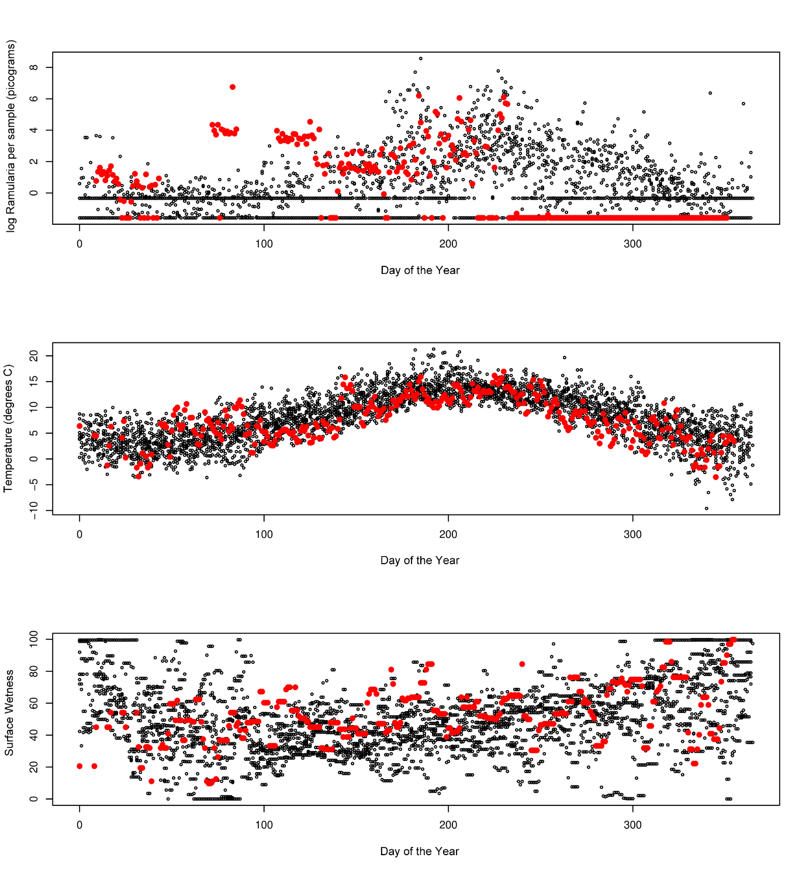
Figure A2: Daily Spore count (A), temperature (B), and surface wetness (C) at Bush, with red for 2012 and black for all other years. Is 0 on the x-axis Jan 1st?
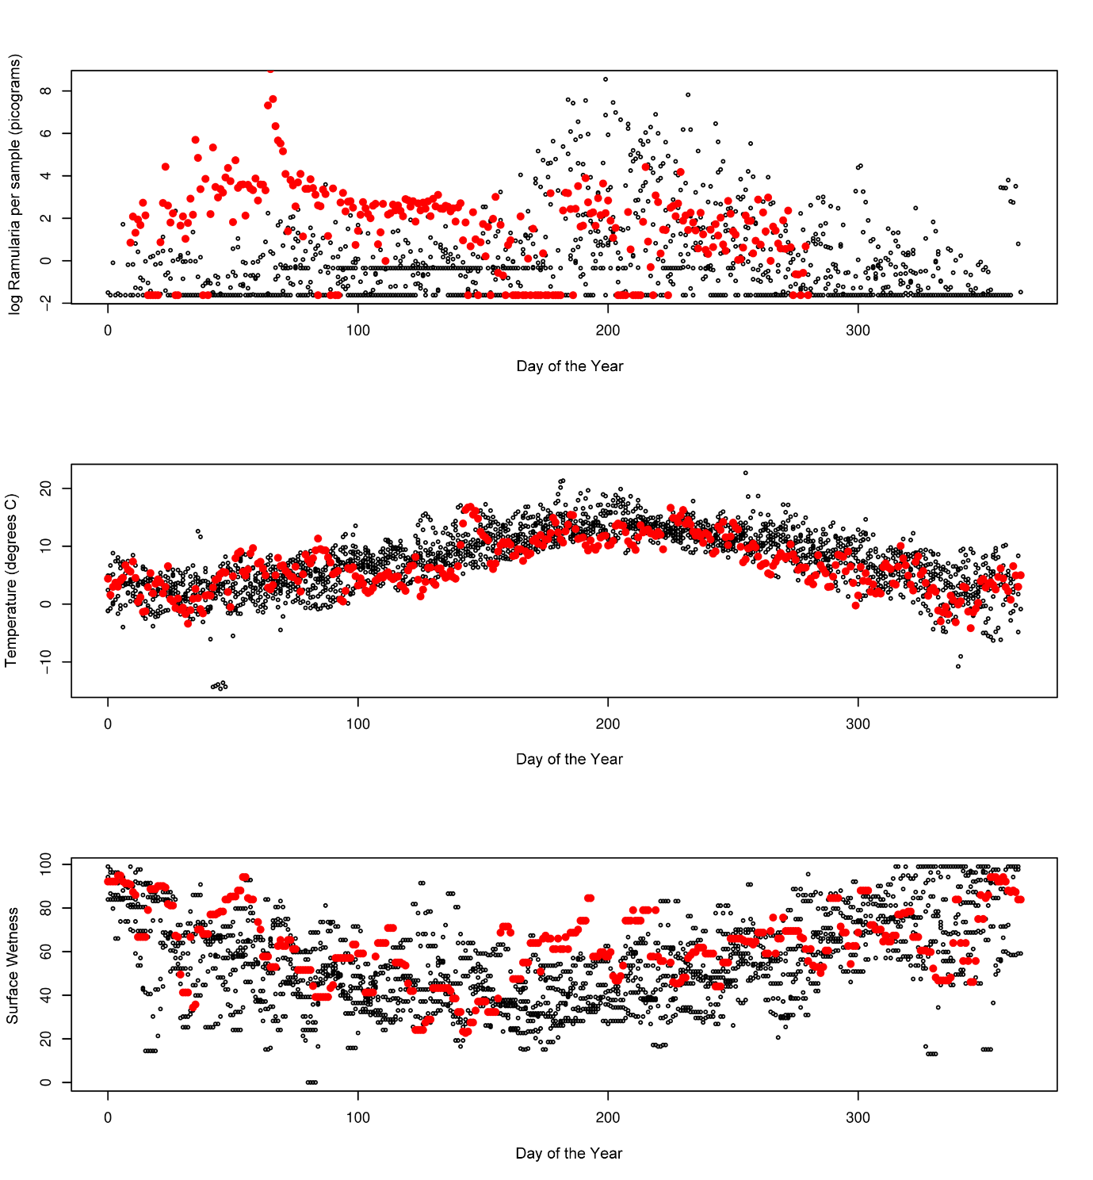
Figure A3: Daily Spore count (A), temperature (B), and surface wetness (C) at Lanark, with red for 2012 and black for all other years.

