Supplementary Data

Linalool inhibits the angiogenic activity of endothelial cells by downregulating intracellular ATP levels and activating TRPM8

Vivien Becker¹, Xin Hui², Lisa Nalbach¹, Emmanuel Ampofo¹, Peter Lipp², Michael D. Menger¹, Matthias W. Laschke¹, Yuan Gu¹*

¹Institute for Clinical & Experimental Surgery, Saarland University, 66421 Homburg/Saar, Germany
²Molecular Cell Biology, Research Center for Molecular Imaging and Screening, Medical Faculty, Saarland University, 66421 Homburg/Saar, Germany

*Corresponding author:
Yuan Gu, Ph.D.
Institute for Clinical & Experimental Surgery
Saarland University
66421 Homburg/Saar
Germany

phone: +49 6841 162 6368
fax: +49 6841 162 6553
e-mail: yuan.gu@uks.eu

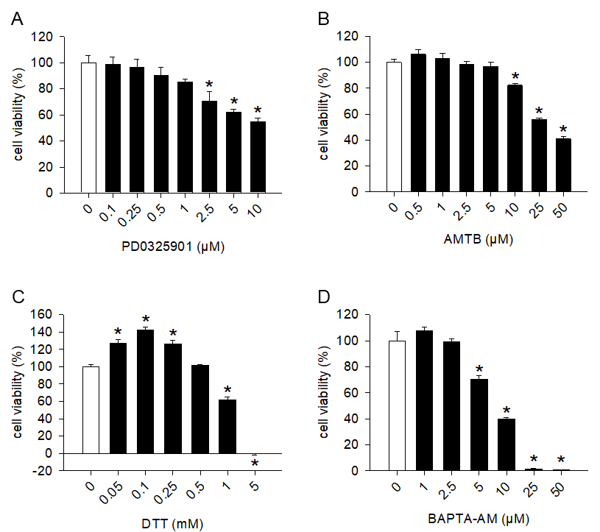

Fig. S1. Effects of PD0325901, AMTB, DTT and BAPTA-AM on HDMEC viability. A-D: Viability (in % of 0 µM or 0 mM) of HDMECs, which were exposed for 24 h to serial dilutions of PD0325901 (A), AMTB (B), DTT (C) or BAPTA-AM (D) as assessed by the WST-1 assay (n = 4). Means ± SEM. *P < 0.05 vs. 0 µM or 0 mM.

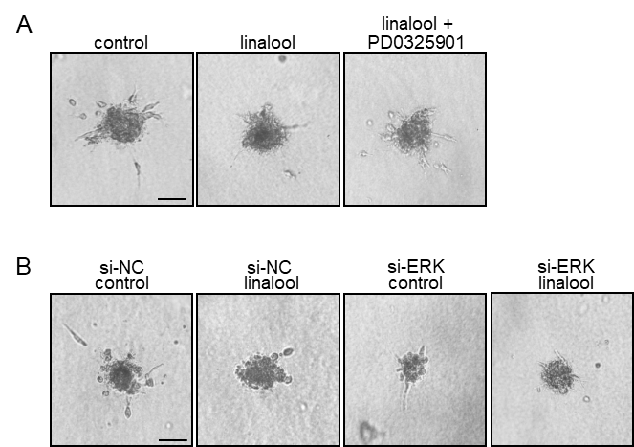

Fig. S2. Representative images of the spheroid sprouting assays in Fig. 5. A: Phase-contrast microscopic images of HDMEC spheroids, which were treated for 24 h with 0 (control) or 2 mM linalool in the presence or absence of 1 µM PD0325901. B: Phase-contrast microscopic images of HDMEC spheroids, which were transfected for 48 h with si-NC or si-ERK and then treated for 24 h with 0 (control) or 2 mM linalool. Scale bars 70 µm.

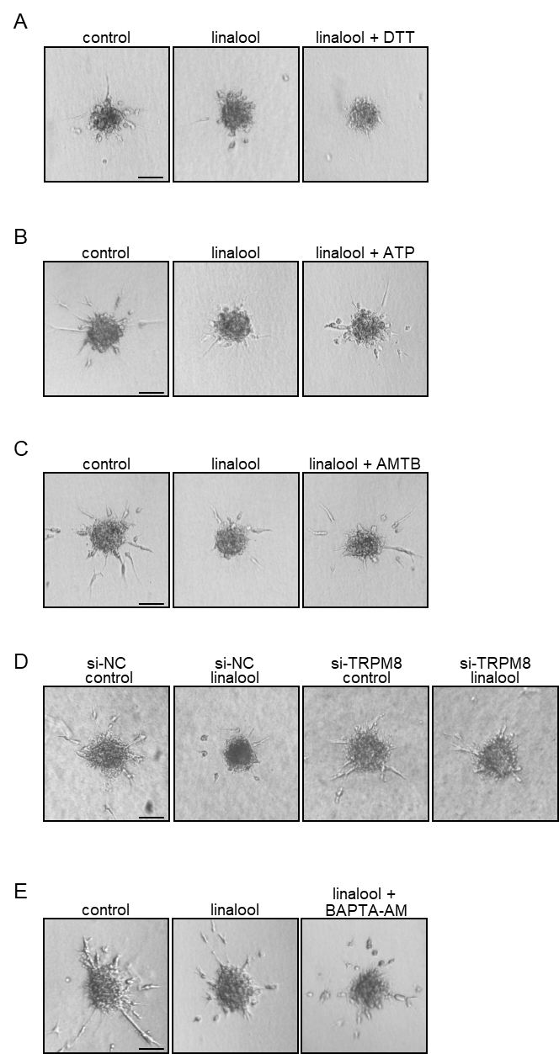

Fig. S3. Representative images of the spheroid sprouting assays in Figs. 6 and 8. A-C: Phase-contrast microscopic images of HDMEC spheroids, which were treated for 24 h with 0 (control) or 2 mM linalool in the presence or absence of 0.5 mM DTT (A), 1 mM ATP (B) or 5 µM AMTB (C). D: Phase-contrast microscopic images of HDMEC spheroids, which were transfected for 48 h with si-NC or si-TRPM8 and then treated for 24 h with 0 (control) or 2 mM linalool. E: Phase-contrast microscopic images of HDMEC spheroids, which were treated for 24 h with 0 (control) or 2 mM linalool in the presence or absence of 2.5 µM BAPTA-AM. Scale bars 70 µm.

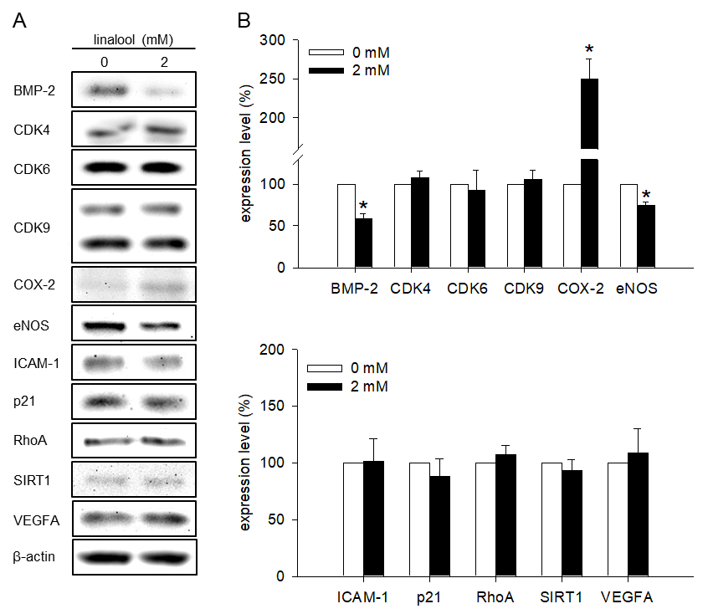
Fig. S4. Effects of linalool on the expression of several angiogenesis-related proteins. A: Western blot of BMP-2, CDK4, CDK6, CDK9, COX-2, eNOS, ICAM-1, p21, RhoA, SIRT1, VEGFA and β-actin expression in HDMECs, which were exposed for 30 min to 0 or 2 mM linalool. B: Expression levels of each protein corrected by β-actin (in % of 0 mM) as assessed by Western blot (n = 3-4 independent experiments). Means ± SEM. *P < 0.05 vs. 0 mM.

