Supplementary Figures and Tables

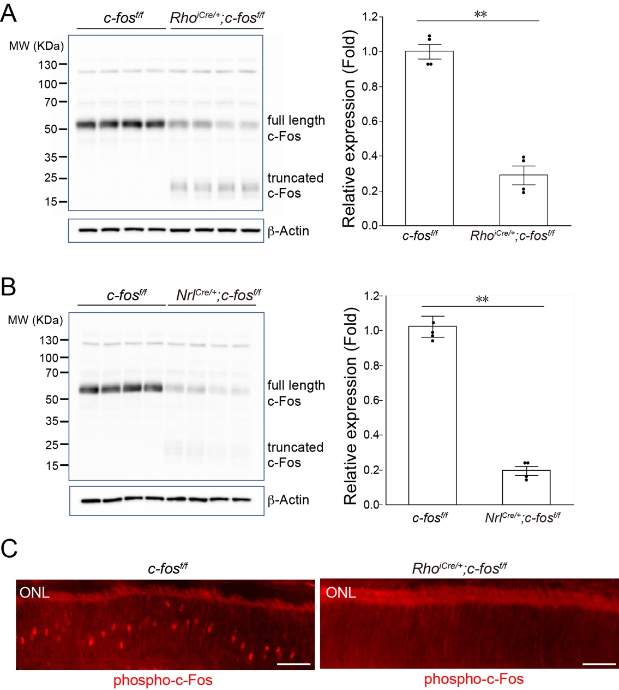
Figure S1. Rod photoreceptor-specific c-Fos knockout mice were validated. (A) Western blots were conducted to examine c-Fos protein expression in retinas from Rho^{iCre/+};c-fos^{f/f} mice and littermate c-fos^{f/f} control mice. The levels of c-Fos were determined by quantifying the density of c-Fos bands and normalized them to β-Actin (n=4). (B) Western blots were conducted to examine c-Fos protein expression in retinas from from Nrl^{Cre/+};c-fos^{f/f} mice and littermate c-fos^{f/f} control mice. The levels of c-Fos were determined by quantifying the density of c-Fos bands and normalized them to β-Actin(n=4). (C) Immunofluorescence staining was employed to visualize c-Fos phosphorylation (phosphor-c-Fos, red) in the ONL of OIR retinas from c-fos^{f/f} and Rho^{iCre/+};c-fos^{f/f} mice. Data are represented as mean ± SEM. Mann-Whitney test was used for two-group comparison. **, p<0.01.
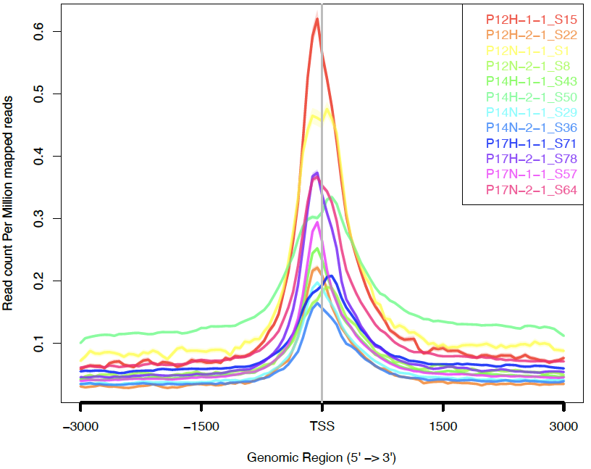

Figure S2. Enrichments at TSS of the CUT&Tag libraries. Read distributions across peaks. The x-axis represents regions near peaks; the y-axis represents the normalized read counts. 0: peak center; -3000: 3 kb upstream of the peak center, 3000: 3 kb downstream of the peak center.

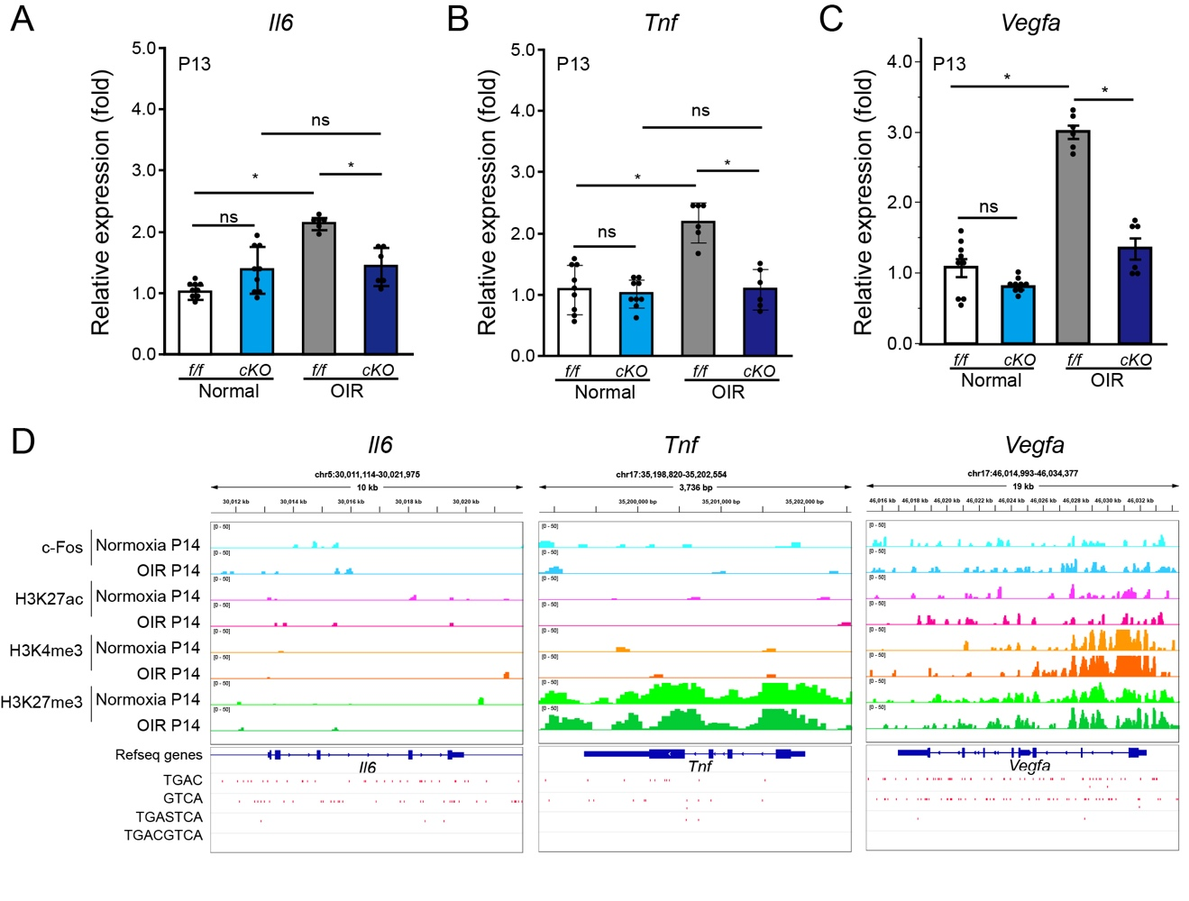
Figure S3. The mRNA expression of inflammatory factors in normal and OIR mice. (A-C) The mRNA levels of inflammatory factor including Il6, Tnf, and Vegfa were assessed in whole retinas from both Rho^{iCre/+};c-fos^{f/f} mice and c-fos^{f/f} mice under normal and OIR conditions at P13 using RT-qPCR (n=6-8). (D) Representative genome browser tracks of c-Fos, H3K27ac, H3K4me3, and H3K27me3 CUT&Tag in the retinas of P14 normal and OIR mice for Il6, Tnf, and Vegfa genes. Data are represented as mean ± SEM. Mann-Whitney test was used for two-group comparison. Kruskal-Wallis Dunn’s test was used for multiple-group comparison. *, p<0.05; ns, no significance.

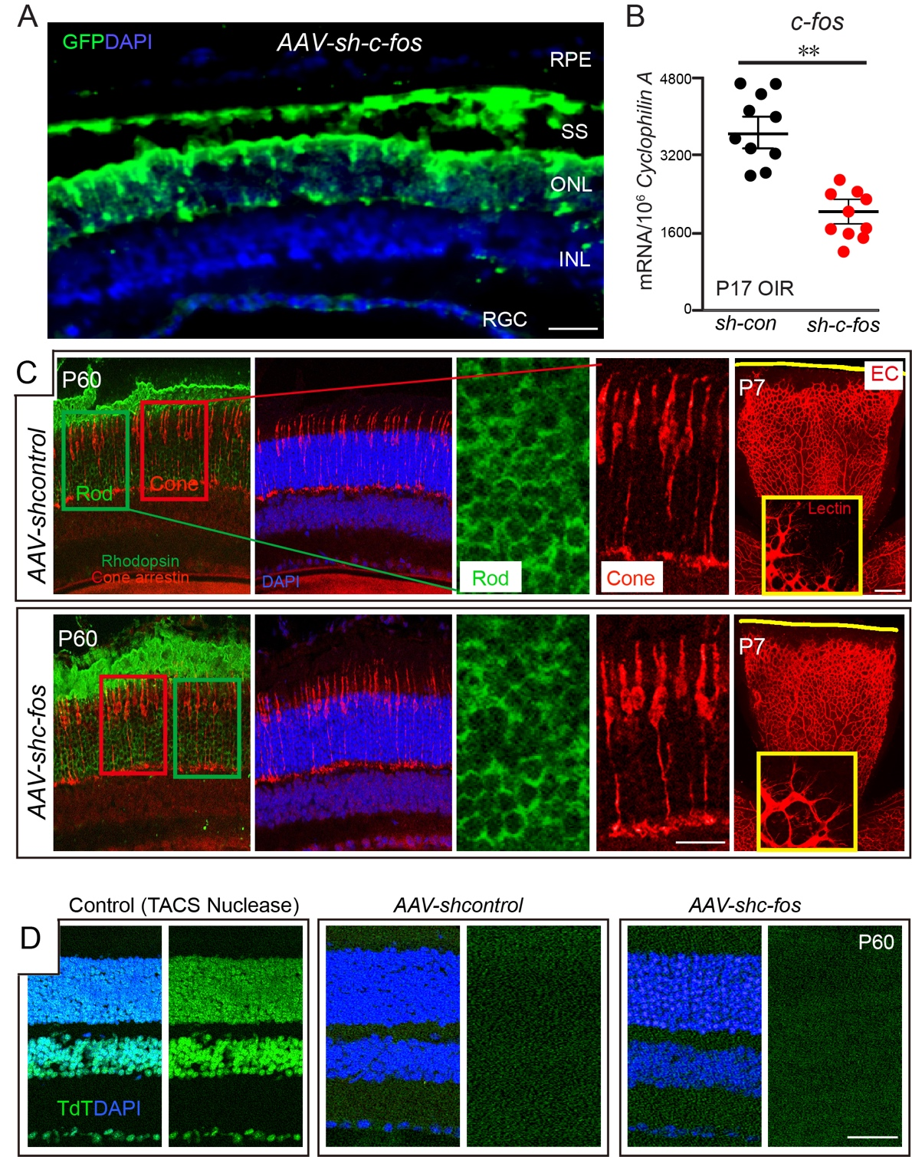

Figure S4. shRNA targeting c-Fos had no discernible impact retinal development. (A) Immunofluorescence staining on retinal cross sections showed the photoreceptor specificity of AAV-hRK-sh-c-fos; (B) The mRNA expression of c-fos showed the knockdown efficacy of AAV-hRK sh-c-Fos in retinas (n=10); (C) Immunofluorescence staining of rod photoreceptor cells, cone photoreceptor cells, and endothelial cells (EC) with anti-Rhodopsin, anti-Cone arrestin, and isolectin B4, respectively, in the retinas of mice infected with AAV-hRK-shc-fos or AAV-hRK-shcontrol. (D) TUNEL assay of retinas infected with AAV-hRK shc-fos or AAV-hRK-shcontrol at P60. TUNEL, green. Data are represented as mean ± SEM. Mann-Whitney test was used for two-group comparison. **, p<0.01; ns, no significance.
Table S1. Antibodies for IHC and CUT&Tag (company, clone number, cat #, RRID#)

Antibodies | Vender | Catalog number | RRID number | Usage
Histone H3K4me3 | Active Motif | 39159 | AB_2615077 | CUT&Tag
Histone H3K27ac | Active Motif | 39133 | AB_2561016 | CUT&Tag
guinea pig anti-rabbit IgG | Antibodies-Online | ABIN101961 | AB_10775589 | CUT&Tag
Tri-Methyl-Histone H3 (Lys27) (C36B11) | Cell Signaling Technology | 9733S | AB_2616029 | CUT&Tag
c-Fos (9F6) | Cell Signaling Technology | 2250S | AB_2247211 | CUT&Tag, WB, IHC
Anti-Adam17 | Abcam | ab13535 | AB_300436 | WB, IHC
β-Actin (D6A8) | Cell Signaling Technology | 8457S | AB_10950489 | WB
Phospho-c-Fos (Ser32) (D82C12) | Cell signaling | 5348S | AB_10557109 | IHC
Rhodopsin, clone 4D2 | Millipore | MABN15 | AB_10807045 | IHC
Isolectin GS-IB4 Alexa Fluor™ 594 Conjugated | Fisher | I21413 |  | IIHC

