Title: A novel approach for reliable differentiation of lymphatic endothelial precursor cells in vitro

Inazio Arriola-Alvarez¹, María Rodríguez-Hidalgo^{2#}, Luca Melotti^{1,3,4,#}, Ainhoa Irastorza-Lorenzo^{1,#}, Héctor Lafuente^{1,†}, Sonia Alonso-Martín^{1,5*}, Ander Izeta^{1,6,7*}

¹ Biogipuzkoa Health Research Institute, Stem Cells & Aging Group, Donostia/San Sebastián, 20014, Spain.
² Biogipuzkoa Health Research Institute, Genomics Platform, Donostia/San Sebastián, 20014, Spain.
³ Department of Comparative Biomedicine and Food Science, University of Padova, Legnaro (Padova), 35020, Italy.
⁴ Department of Human Sciences, Link Campus University, Rome, 00165, Italy.
⁵ CIBERNED, ISCIII (CIBER, Carlos III Institute, Spanish Ministry of Sciences and Innovation), 28031, Madrid, Spain.
⁶ Donostia University Hospital, Advanced Therapies Unit, Donostia/San Sebastian, 20014, Spain.
⁷ Tecnun-University of Navarra, School of Engineering, Donostia/San Sebastian, 20009, Spain.

#Equally contributed.
†Current address: POLYMAT, University of the Basque Country UPV/EHU, Avenida Tolosa 72, Donostia/San Sebastian 20018, Gipuzkoa, Spain.
*Corresponding authors: ANDER.IZETAPERMISAN@osakidetza.eus; SONIA.ALONSOMARTIN@bio-gipuzkoa.eus

Table S1. Antibodies and other reagents used for immunofluorescence staining.
Antigen | Type | Conjugated | Reference | Host | Reactivity | Fluorophore | Dilution | Brand
PDPN | Primary | No | 127402 | Syrian Hamster | Mouse | No | 1/100 | BioLegend
LYVE1 | Primary | No | 103-PA50AG | Rabbit | Mouse | No | 1/100 | Reliatech
VEGFR3 | Primary | No | AF743 | Goat | Mouse | No | 1/100 | RD Systems
TdTomato | Primary | No | orb182397 | Goat | - | No | 1/100 | Byorbit
- | Secondary | Yes | A21451 | Goat | Hamster | Alexa Fluor 647 | 1/500 | Invitrogen
- | Secondary | Yes | A31572 | Donkey | Rabbit | Alexa Fluor 555 | 1/500 | Molecular Probes
- | Secondary | Yes | A11055 | Donkey | Goat | Alexa Fluor 488 | 1/500 | Molecular Probes
- | Secondary | Yes | A21432 | Donkey | Goat | Alexa Fluor 555 | 1/500 | Molecular Probes
F-Actin | Phalloidin Staining | Yes | A12379 | - | - | Alexa Fluor 488 | 1/400 | Invitrogen
Nuclei | DAPI Staining | No | D3571 | - | - | DAPI | 1/1000 | Invitrogen

Table S2. Antibodies used for flow cytometry analysis.
Antigen | Type | Conjugated | Fluorophore | Reference | Host | Reactivity | Clone | Isotype | Dilution | Brand
PDPN | Primary | Yes | APC | 127410 | Syrian Hamster | Mouse | 8.1.1 | IgG | 1/200 | BioLegend
SCA1 | Primary | Yes | PE-Cy7 | 558162 | Rat | Mouse | D7 | IgG2a k | 1/100 | BD
CD90.2 | Primary | No | - | 553009 | Rat | Mouse | 30-H12 | IgG2b | 1/200 | BD
CD105 | Primary | No | - | 14-1051-82 | Rat | Mouse | MJ7/18 | IgG2a k | 1/100 | Thermo Fisher
CD44 | Primary | Yes | PE | 553134 | Rat | Mouse | IM7 | IgG2b | 1/40 | BD
CD31 | Primary | Yes | PE | 553373 | Rat | Mouse | MEC 13.3 | IgG2a k | 1/100 | BD
CD34 | Primary | Yes | PE | 551387 | Rat | Mouse | RAM34 | IgG2a k | 1/100 | BD
CD45 | Primary | No | - | 550539 | Rat | Mouse | 30-F11 | IgG2b k | 1/100 | BD
CD11 | Primary | No | - | M1/70.15.11.5.2 | Rat | Mouse | NS1 | IgG2b | 1/100 | DSHB
- | Secondary | Yes | Alexa Fluor 488 | A11006 | Goat | Rat | - | IgG | 1/500 | Molecular Probes
- | Secondary | Yes | Alexa Fluor 647 | A21247 | Goat | Rat | - | IgG | 1/500 | Molecular Probes
- | Isotype control | Yes | APC | 402012 | Syrian Hamster | Mouse | SHG-1 | IgG | 1/200 | BioLegend
- | Isotype control | Yes | PE | 553930 | Rat | Mouse | R35-95 | IgG2a k | 1/40 | BD

Table S3. Taqman probes use for RT-qPCR analysis.
Gene | Reference | Amplicon Length (bp) | Genomic
Gapdh | Mm99999915_g1 | 107 | Yes
Tbp | Mm00446971_m1 | 93 | No
Pdpn | Mm00494716_m1 | 86 | No
Lyve1 | Mm01280692_m1 | 85 | No
Vegfr3 | Mm01292604_m1 | 72 | No
Prox1 | Mm00435969_m1 | 93 | No
Vegf-c | Mm00437310_m1 | 78 | No
Igf-2 | Mm00439564_m1 | 107 | No

Supplementary 1
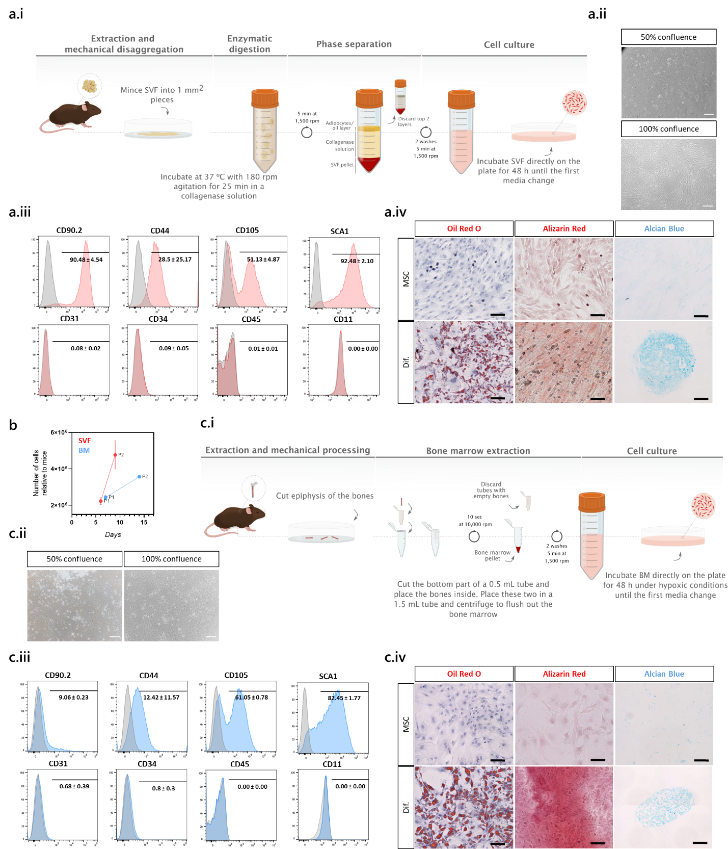
Supplementary 1. MSC isolation protocol and lineage confirmation. (a) Isolation and validation of SVF-MSCs. (a.i) Illustration of the isolation protocol followed for obtaining SVF-MSCs. (a.ii) Morphology of the SVF-MSCs in culture. (a.iii) Expression of the canonical MSC markers by flow cytometry. (a.iv) Adipogenic, osteogenic and chondrogenic differentiation of SVF-MSCs. (b) Accumulated cell proliferation of SVF- and BM-MSCs over passages relative to mice. (c) Isolation and validation of BM-MSCs. (c.i) Illustration of the isolation protocol followed for obtaining BM-MSCs. (c.ii) Morphology of the BM-MSCs in culture. (c.iii) Expression of the canonical MSC markers by flow cytometry. (c.iv) Adipogenic, osteogenic and chondrogenic differentiation of BM-MSCs. Dif., differentiation. Scales bars: 100 µm for a.ii-a.iv-c.ii-c.iv.
Supplementary 2
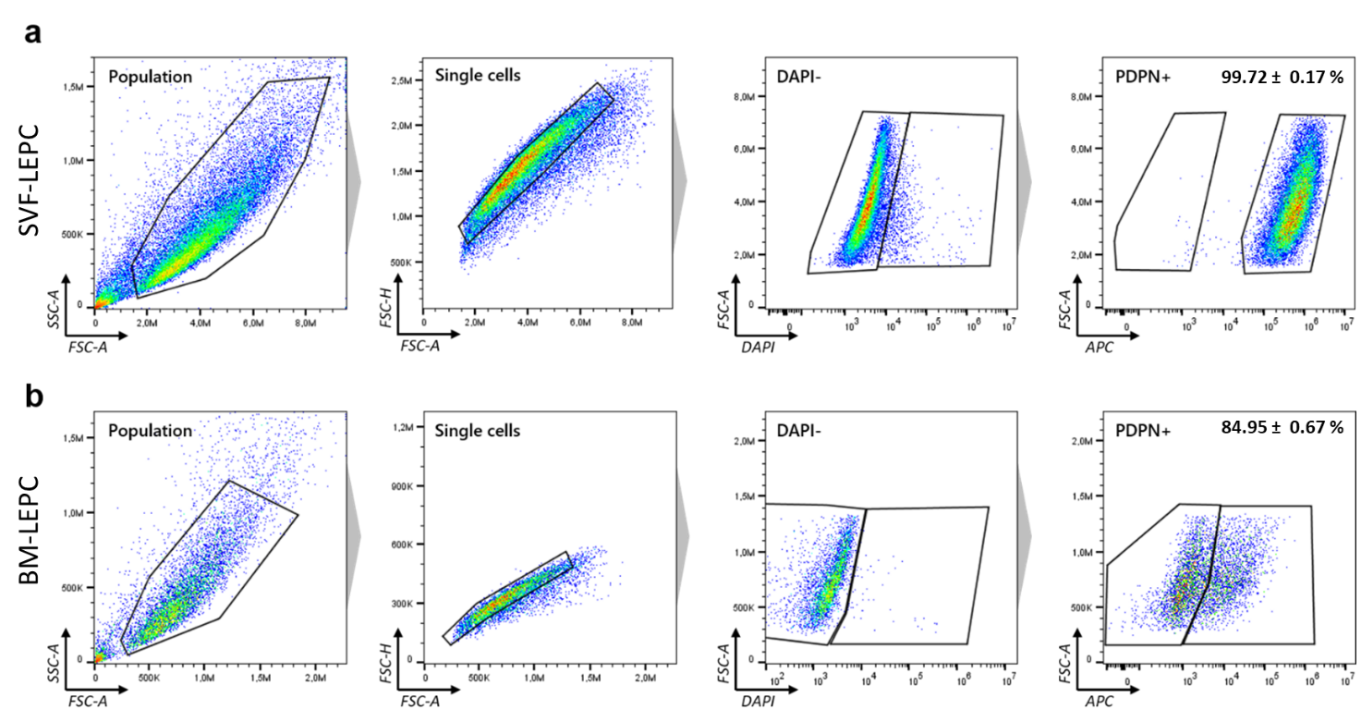
Supplementary 2. Flow cytometry gating strategy for LEPC characterization. (a) Representative gating hierarchy employed for the identification and isolation of SVF-derived LEPCs. (b) Same gating strategy used for BM-derived LEPCs counterparts.

Supplementary 3
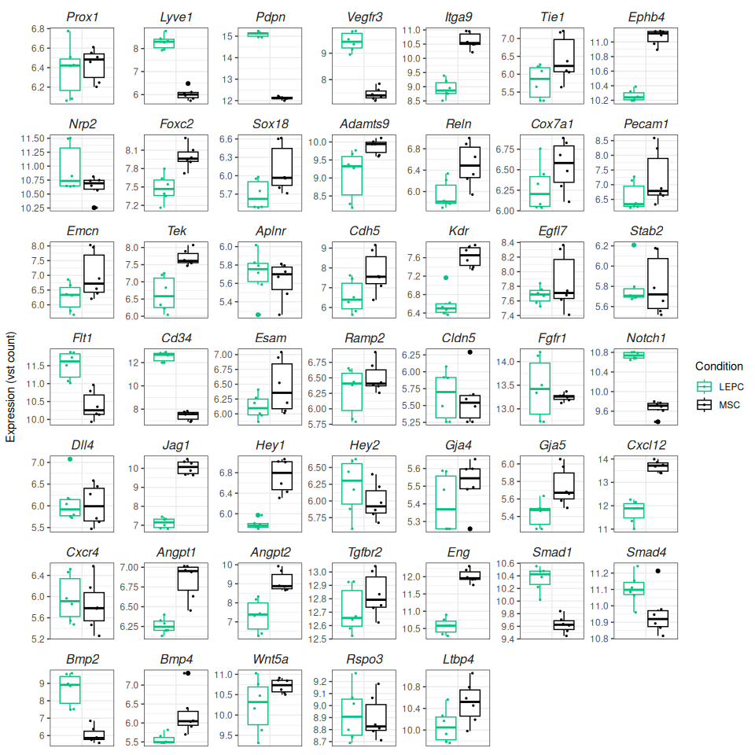
Supplementary 3. Boxplots of the top 47 LEC markers expressed in LEPCs in comparison to their mesenchymal progenitors (MSCs).

