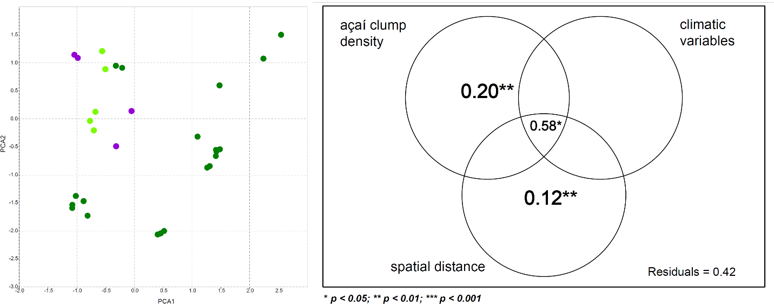
Figure S1. A) Principal component analysis of all 19 temperature and precipitation records available in the Worldclim dataset. Control plots are displayed in dark green, certified plots in purple and non-certified plots in light green. B) Venn diagram and with the individual fraction of the adjusted R squared for each of the explanatory variables (bold values are significant with p < 0.001). Non-significant adjusted r-squares not shown.

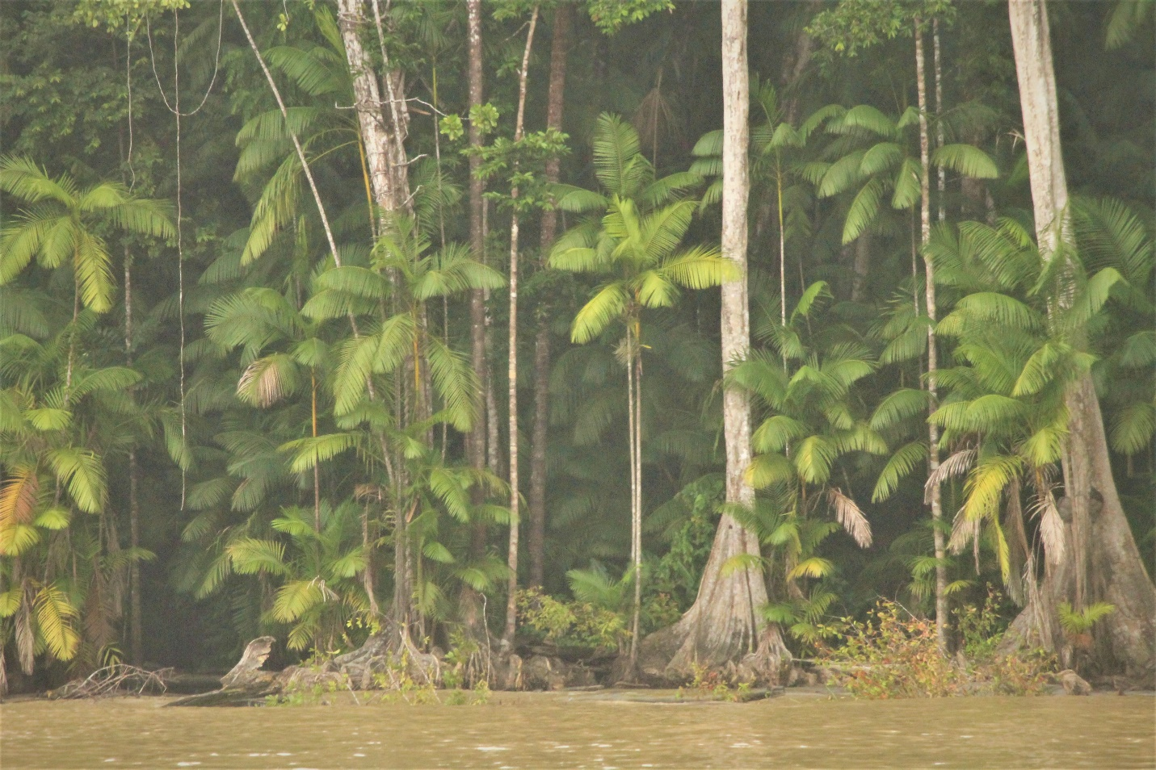
Figure S2. Picture of one of the certified harvesting areas sampled by our study. The image shows the presence of a less intensive thinning of native tree species and a relatively higher basal area and biomass due to the presence of large trees and resulting in a more intact forest structure.

Table S1. Fair for Life certification standards and criteria according to the requirements for ecosystem management, biodiversity, and wildlife. Certified areas in this study were required to met the requirements listed below.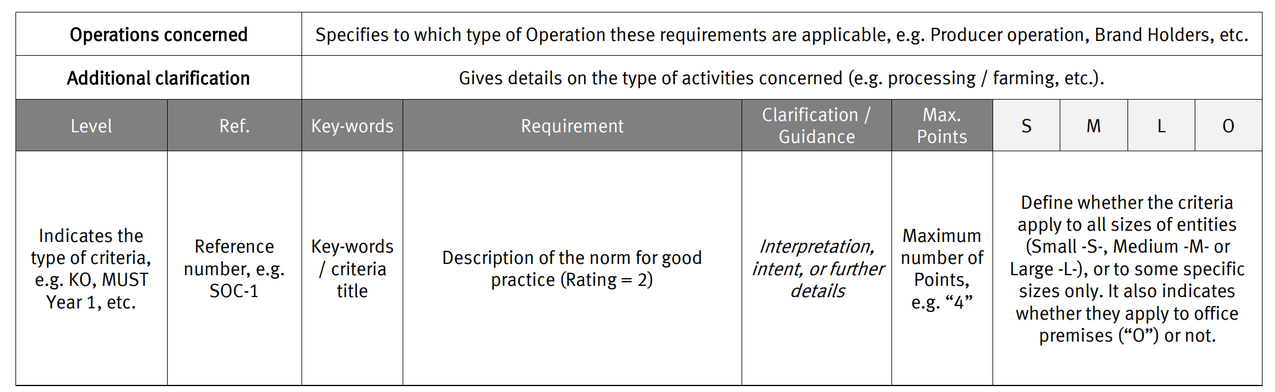
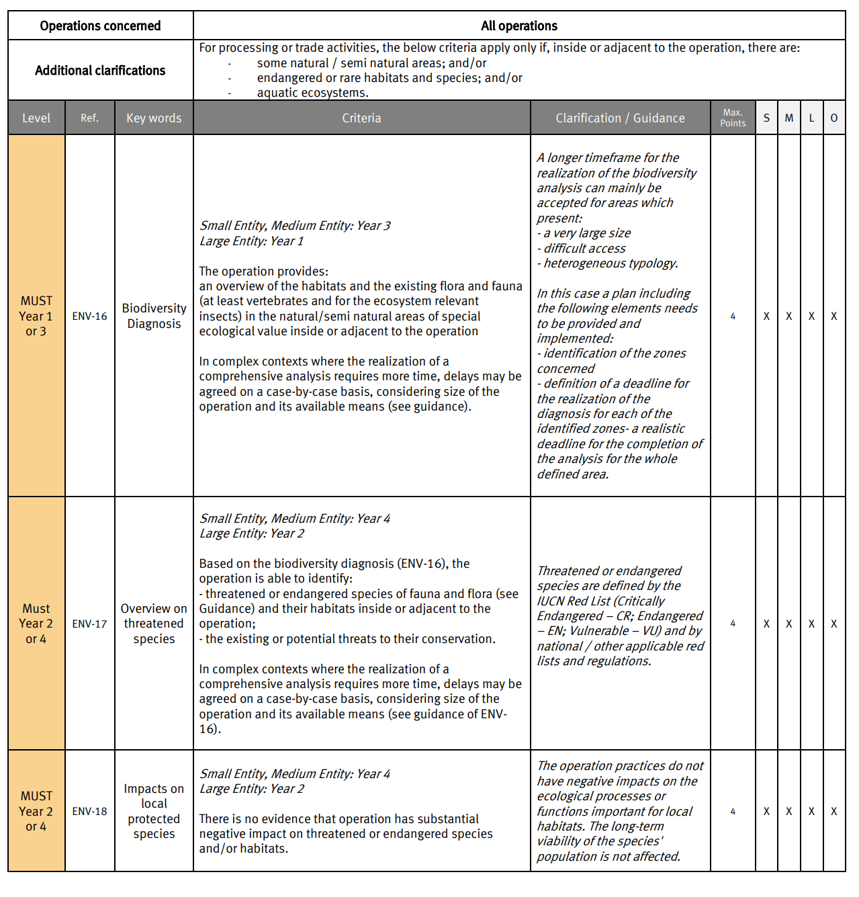
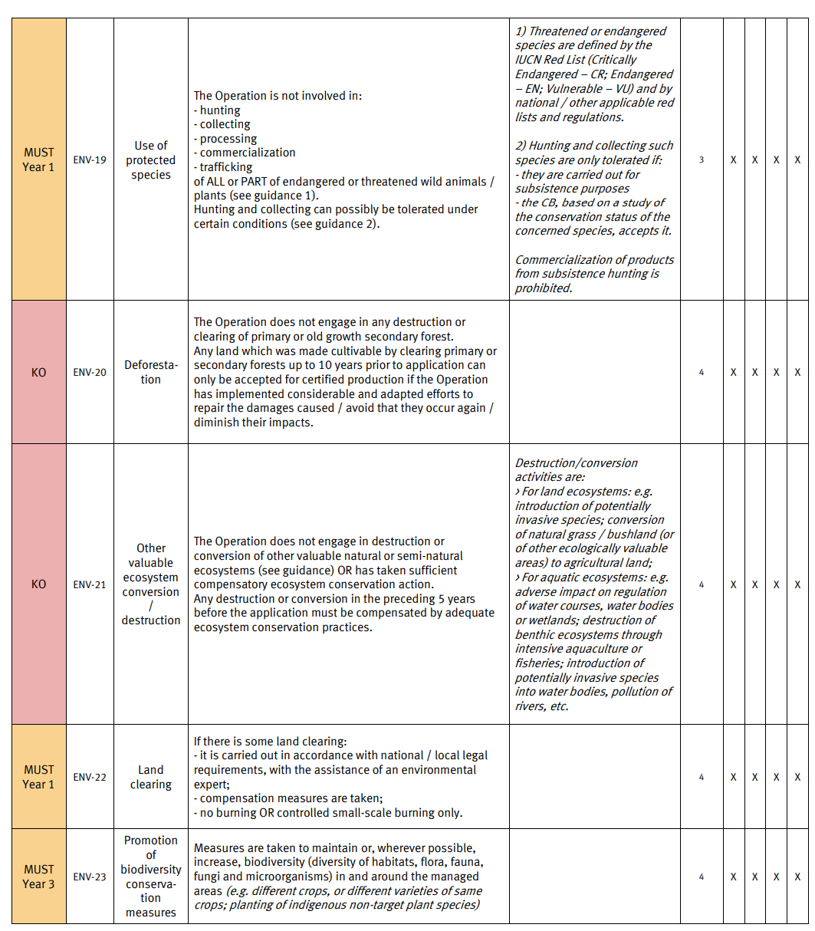

Table S2. Density, relative frequency and basal area values for families and species sampled in this study. Scientific names are checked against the Plants of the World online (POWO, http://www.plantsoftheworldonline.org/).
 | Density  (ind.ha⁻¹) | Relative Frequency | Basal Area  (m².ha⁻¹)
Anacardiaceae | 32 | 0.75 | 8.570
Mangifera indica | 2.5 | 0.1 | 1.049
Spondias mombin | 29.5 | 0.75 | 7.521
Annonaceae | 2.5 | 0.15 | 0.418
Unonopsis floribunda | 1 | 0.1 | 0.148
Apocynaceae | 0.5 | 0.05 | 0.024
Aspidosperma sp. | 0.5 | 0.05 | 0.024
Araliaceae | 0.5 | 0.05 | 0.133
Schefflera sp. | 0.5 | 0.05 | 0.133
Arecaceae | 1670.5 | 1 | 133.229
Astrocaryum murumuru | 58.5 | 0.7 | 7.117
Attalea phalerata | 1.5 | 0.1 | 0.498
Euterpe oleracea | 1571 | 1 | 117.649
Manicaria saccifera | 36.5 | 0.55 | 7.598
Oenocarpus bacaba | 0.5 | 0.05 | 0.098
Socratea exorrhiza | 2.5 | 0.2 | 0.270
Boraginaceae | 0.5 | 0.05 | 0.060
Cordia sp. | 0.5 | 0.05 | 0.060
Burseraceae | 1 | 0.05 | 0.058
Protium aff. krukoffii | 1 | 0.05 | 0.058
Calophyllaceae | 2.5 | 0.2 | 0.337
Calophyllum brasiliense | 0.5 | 0.05 | 0.022
Calophyllum cf. brasiliense | 0.5 | 0.05 | 0.136
Caraipa cf. punctulata | 1.5 | 0.15 | 0.180
Caryocaraceae | 0.5 | 0.05 | 0.064
Caryocar microcarpum | 0.5 | 0.05 | 0.064
Chrysobalanaceae | 11 | 0.4 | 1.713
Hirtella racemosa | 1 | 0.05 | 0.105
Hymenopus macrophyllus | 7 | 0.35 | 1.233
Licania sp. | 1.5 | 0.1 | 0.309
Parinari excelsa | 1 | 0.05 | 0.040
Clusiaceae | 11 | 0.3 | 1.412
Garcinia madruno | 3 | 0.1 | 0.264
Symphonia globulifera | 8 | 0.3 | 1.148
Combretaceae | 7 | 0.25 | 2.050
Terminalia cf. dichotoma | 3 | 0.2 | 0.865
Terminalia cf. lucida | 4 | 0.15 | 1.185
Elaeocarpaceae | 1 | 0.05 | 0.104
Sloanea grandiflora | 1 | 0.05 | 0.104
Euphorbiaceae | 24.5 | 0.7 | 7.239
Hevea brasiliensis | 8.5 | 0.45 | 3.350
Hura crepitans | 3.5 | 0.2 | 1.238
Sapium ciliatum | 11 | 0.4 | 2.513
Sapium sp. | 1.5 | 0.1 | 0.139
Hernandiaceae | 0.5 | 0.05 | 0.022
Hernandia guianensis | 0.5 | 0.05 | 0.022
Hypericaceae | 3 | 0.1 | 0.247
Vismia sp. 1 | 1.5 | 0.05 | 0.118
Vismia sp. 2 | 0.5 | 0.05 | 0.043
Vismia sp. 3 | 1 | 0.05 | 0.087
Lamiaceae | 5 | 0.1 | 0.433
Aegiphila integrifolia | 5 | 0.1 | 0.433
Lauraceae | 12 | 0.5 | 1.824
Aniba sp.1 | 0.5 | 0.05 | 0.040
Aniba sp.2 | 1 | 0.05 | 0.097
Clinostemon mahuba | 9 | 0.4 | 1.279
Lecythidaceae | 6 | 0.25 | 0.885
Allantoma lineata | 3.5 | 0.15 | 0.501
Eschweilera sp. | 1 | 0.1 | 0.286
Gustavia augusta | 1.5 | 0.1 | 0.098
Leguminosae | 151.5 | 1 | 22.526
Crudia cf. glaberrima | 4.5 | 0.15 | 0.695
Diplotropis sp. | 0.5 | 0.05 | 0.075
Inga sp.1 | 4.5 | 0.25 | 0.715
Inga sp.2 | 1.5 | 0.05 | 0.424
Inga sp.3 | 0.5 | 0.05 | 0.081
Inga sp.4 | 0.5 | 0.05 | 0.025
Inga sp.5 | 0.5 | 0.05 | 0.157
Macrolobium bifolium | 1.5 | 0.05 | 0.218
Macrolobium sp. | 0.5 | 0.05 | 0.035
Mora paraensis | 17.5 | 0.4 | 4.525
Ormosia coutinhoi | 2.5 | 0.2 | 0.587
Peltogyne sp. | 0.5 | 0.05 | 0.024
Pentaclethra macroloba | 45.5 | 0.65 | 5.025
Platymiscium sp. | 2.5 | 0.2 | 0.410
Platymiscium trinitatis | 10.5 | 0.35 | 1.997
Pterocarpus santalinoides | 13 | 0.45 | 2.224
Swartzia cf. polyphylla | 0.5 | 0.05 | 0.078
Swartzia racemosa | 9 | 0.25 | 0.896
Swartzia sp. | 0.5 | 0.05 | 0.336
Tachigali cf. paniculata | 5.5 | 0.25 | 0.617
Vatairea sp. | 3.5 | 0.2 | 0.817
Zygia juruana | 6 | 0.35 | 0.499
Zygia latifolia | 17.5 | 0.4 | 1.439
Malvaceae | 39 | 0.75 | 4.982
Apeiba sp. | 1 | 0.1 | 0.219
Ceiba pentandra | 2.5 | 0.15 | 1.788
Herrania mariae | 2 | 0.15 | 0.088
Pachira sp. | 1.5 | 0.1 | 0.225
Pseudobombax munguba | 0.5 | 0.05 | 0.083
Sterculia excelsa | 5 | 0.35 | 0.928
Theobroma cacao | 24 | 0.2 | 1.402
Theobroma subincanum | 2 | 0.15 | 0.226
Melastomataceae | 0.5 | 0.05 | 0.124
Mouriri grandiflora | 0.5 | 0.05 | 0.124
Meliaceae | 16.5 | 0.6 | 3.232
Carapa guianensis | 10.5 | 0.45 | 2.130
Cedrela sp. | 1.5 | 0.05 | 0.445
Guarea sp. | 2 | 0.15 | 0.217
Trichilia sp. | 1 | 0.05 | 0.058
Moraceae | 11 | 0.5 | 3.057
Artocarpus altilis | 0.5 | 0.05 | 0.108
Brosimum sp.1 | 1 | 0.05 | 0.295
Brosimum sp.2 | 0.5 | 0.05 | 0.051
Brosimum sp.3 | 2 | 0.1 | 0.253
Brosimum sp.4 | 0.5 | 0.05 | 0.108
Ficus sp.1 | 1.5 | 0.05 | 0.618
Ficus sp.2 | 0.5 | 0.05 | 0.141
Naucleopsis sp. | 3 | 0.15 | 0.959
Diplotropis sp. | 0.5 | 0.05 | 0.248
Musaceae | 3 | 0.05 | 0.238
Musa paradisiaca | 3 | 0.05 | 0.238
Myristicaceae | 47.5 | 0.8 | 10.228
Iryanthera sp. | 2 | 0.1 | 0.168
Virola surinamensis | 45.5 | 0.8 | 10.060
Myrsinaceae | 0.5 | 0.05 | 0.020
Myrtaceae | 3 | 0.1 | 0.159
Myrcia sp. | 0.5 | 0.05 | 0.031
Olacaceae | 0.5 | 0.05 | 0.026
Minquartia guianensis | 0.5 | 0.05 | 0.026
Rubiaceae | 19.5 | 0.55 | 4.112
Calycophyllum spruceanum | 18 | 0.55 | 4.007
Faramea sp. | 0.5 | 0.05 | 0.024
Ferdinandusa sp. | 0.5 | 0.05 | 0.055
Genipa americana | 0.5 | 0.05 | 0.026
Salicaceae | 7 | 0.05 | 0.603
Casearia sp. | 7 | 0.05 | 0.603
Sapindaceae | 1 | 0.1 | 0.066
Cupania cf. scrobiculata | 0.5 | 0.05 | 0.026
Cupania cinerea | 0.5 | 0.05 | 0.040
Sapotaceae | 5.5 | 0.3 | 0.651
Ecclinusa sp. | 1.5 | 0.1 | 0.185
Pouteria sp.1 | 1 | 0.05 | 0.105
Pouteria sp.2 | 0.5 | 0.05 | 0.045
Pouteria sp.3 | 0.5 | 0.05 | 0.061
Solanaceae | 1 | 0.05 | 0.057
Solanum sp. | 1 | 0.05 | 0.057
Urticaceae | 8 | 0.3 | 1.411
Cecropia sp. | 6.5 | 0.15 | 1.300
Pourouma sp. | 1.5 | 0.15 | 0.111
Non-Identified | 4 | 0.2 | 0.808

Table S3. Geographical coordinates and tree community parameters for all 94 plots analyzed in this study.
Plot code | Plot group | Latitude | Longitude | Number of Families | Tree species richness | Açaí clump density (ind.ha⁻¹) | Fisher Index | Basal area (m².ha⁻¹) | Data Source
CERT_1 | certified | -0.86492 | -51.093 | 12.0 | 22.0 | 370.0 | 7.5 | 64.6 | This study
CERT_2 | certified | -1.18327 | -51.5572 | 9.0 | 8.0 | 710.0 | 2.0 | 60.4 | This study
CERT_3 | certified | -1.18647 | -51.5549 | 12.0 | 23.0 | 310.0 | 7.6 | 77.7 | This study
CERT_4 | certified | -1.18794 | -51.5485 | 13.0 | 22.0 | 750.0 | 5.6 | 50.3 | This study
CERT_5 | certified | -1.18831 | -51.5448 | 11.0 | 21.0 | 470.0 | 5.5 | 84.1 | This study
CERT_6 | certified | 0.774353 | -50.2027 | 10.0 | 15.0 | 1200.0 | 4.4 | 35.4 | This study
CERT_7 | certified | -0.85922 | -51.0797 | 11.0 | 18.0 | 570.0 | 6.6 | 71.8 | This study
CERT_8 | certified | 0.771501 | -50.2048 | 8.0 | 15.0 | 670.0 | 3.9 | 59.7 | This study
CERT_9 | certified | -0.86722 | -51.0875 | 7.0 | 13.0 | 720.0 | 2.9 | 45.2 | This study
CERT_10 | certified | 0.773753 | -50.1998 | 11.0 | 17.0 | 580.0 | 4.6 | 87.8 | This study
CERT_11 | certified | -0.86614 | -51.0883 | 14.0 | 22.0 | 300.0 | 7.4 | 61.9 | This study
CERT_12 | certified | 0.769281 | -50.2086 | 8.0 | 10.0 | 520.0 | 2.3 | 41.8 | This study
CERT_13 | certified | -0.86528 | -51.0854 | 8.0 | 10.0 | 470.0 | 2.3 | 91.7 | This study
CERT_14 | certified | 0.480491 | -50.411 | 10.0 | 15.0 | 470.0 | 4.3 | 45.9 | This study
CERT_15 | certified | -0.86301 | -51.0836 | 13.0 | 19.0 | 610.0 | 4.9 | 58.9 | This study
CERT_16 | certified | 0.476989 | -50.4098 | 8.0 | 9.0 | 590.0 | 2.2 | 26.9 | This study
CERT_17 | certified | -1.18008 | -51.546 | 10.0 | 21.0 | 940.0 | 5.7 | 29.9 | This study
CERT_18 | certified | 0.483822 | -50.405 | 12.0 | 25.0 | 260.0 | 8.2 | 58.7 | This study
CERT_19 | certified | -1.1751 | -51.5477 | 12.0 | 22.0 | 90.0 | 10.4 | 51.0 | This study
CERT_20 | certified | -1.1851 | -51.5565 | 13.0 | 30.0 | 170.0 | 9.9 | 57.4 | This study
AMANA_IA | control | -2.56355 | -64.7015 | 39.0 | 94.0 | 91.0 | 32.2 | 90.4 | PELD-MAUA
AMANA_IB | control | -2.56135 | -64.6962 | 18.0 | 31.0 | 0.0 | 7.3 | 90.9 | PELD-MAUA
AMANA_IM | control | -2.55915 | -64.695 | 25.0 | 49.0 | 0.0 | 13.9 | 82.9 | PELD-MAUA
BRANCO_01 | control | 0.46 | -61.69 | 18.0 | 34.0 | 54.0 | 8.4 | 102.3 | PELD-MAUA
BRANCO_02 | control | 0.46 | -61.69 | 33.0 | 62.0 | 0.0 | 17.8 | 87.7 | PELD-MAUA
BRANCO_03 | control | 0.46 | -61.69 | 27.0 | 49.0 | 0.0 | 13.2 | 97.8 | PELD-MAUA
CURARI | control | -3.34389 | -60.1172 | 29.0 | 64.0 | 0.0 | 21.0 | 96.5 | PELD-MAUA
JUR-BC | control | -3.23656 | -66.0549 | 30.0 | 73.0 | 0.0 | 27.9 | 117.0 | PELD-MAUA
JUR-BJ | control | -3.21228 | -66.0012 | 21.0 | 51.0 | 0.0 | 18.1 | 103.3 | PELD-MAUA
JUR-FL | control | -3.34486 | -66.0465 | 23.0 | 60.0 | 0.0 | 20.6 | 131.9 | PELD-MAUA
JUR-I | control | -3.20828 | -65.9904 | 29.0 | 77.0 | 0.0 | 33.5 | 98.3 | PELD-MAUA
JUR-IB | control | -3.20542 | -66.0199 | 31.0 | 74.0 | 0.0 | 28.8 | 103.1 | PELD-MAUA
JUR-LS | control | -3.35894 | -66.0264 | 25.0 | 47.0 | 0.0 | 13.7 | 136.7 | PELD-MAUA
JUT-CA | control | -3.32811 | -67.4475 | 19.0 | 29.0 | 0.0 | 8.0 | 77.4 | PELD-MAUA
JUT-CP | control | -3.36925 | -67.4942 | 32.0 | 59.0 | 0.0 | 18.8 | 138.8 | PELD-MAUA
JUT-ER | control | -3.39689 | -67.497 | 31.0 | 78.0 | 0.0 | 30.3 | 123.7 | PELD-MAUA
JUT-LP | control | -3.37653 | -67.5045 | 22.0 | 40.0 | 0.0 | 13.2 | 80.1 | PELD-MAUA
JUT-VC | control | -3.37011 | -67.4821 | 33.0 | 84.0 | 6.0 | 34.7 | 115.1 | PELD-MAUA
MARCH | control | -3.25056 | -59.9717 | 20.0 | 38.0 | 0.0 | 9.6 | 113.5 | PELD-MAUA
MSDR_A | control | -2.85861 | -64.9117 | 22.0 | 37.0 | 0.0 | 8.5 | 109.7 | PELD-MAUA
MSDR_D | control | -2.89722 | -64.8856 | 19.0 | 32.0 | 0.0 | 6.6 | 122.4 | PELD-MAUA
MSDR_G | control | -2.905 | -64.8833 | 28.0 | 46.0 | 0.0 | 12.5 | 119.8 | PELD-MAUA
MSDR_M1 | control | -2.85639 | -64.9117 | 34.0 | 90.0 | 0.0 | 33.4 | 96.8 | PELD-MAUA
MSDR_M2 | control | -2.8575 | -64.9211 | 36.0 | 100.0 | 0.0 | 39.3 | 82.9 | PELD-MAUA
RD_BB_01 | control | -2.9345 | -59.9675 | 31.0 | 78.0 | 0.0 | 25.8 | 88.2 | PELD-MAUA
RJAP_01 | control | -2.36083 | -65.4736 | 36.0 | 78.0 | 0.0 | 26.3 | 85.8 | PELD-MAUA
RJAP_02 | control | -2.37361 | -65.4778 | 34.0 | 71.0 | 0.0 | 20.9 | 89.6 | PELD-MAUA
RJAP_03 | control | -1.76833 | -65.765 | 28.0 | 71.0 | 6.0 | 20.7 | 111.6 | PELD-MAUA
RJAP_04 | control | -1.77083 | -65.7628 | 27.0 | 63.0 | 0.0 | 19.4 | 85.3 | PELD-MAUA
RJARI_01 | control | -1.09806 | -52.3444 | 29.0 | 66.0 | 32.0 | 18.0 | 119.5 | PELD-MAUA
RJARI_02 | control | -1.07333 | -52.3572 | 25.0 | 58.0 | 43.0 | 14.4 | 127.6 | PELD-MAUA
RJARI_03 | control | -1.1175 | -52.3375 | 30.0 | 68.0 | 0.0 | 18.7 | 114.9 | PELD-MAUA
TEF-CA | control | -4.13028 | -65.0779 | 26.0 | 75.0 | 19.0 | 37.6 | 74.3 | PELD-MAUA
TEF-CT | control | -3.98881 | -65.0171 | 22.0 | 69.0 | 63.0 | 27.0 | 91.5 | PELD-MAUA
TEF-ES | control | -4.12308 | -65.0873 | 29.0 | 70.0 | 1.0 | 26.4 | 114.4 | PELD-MAUA
TEF-GE | control | -3.98967 | -65.0182 | 23.0 | 59.0 | 1.0 | 21.9 | 102.7 | PELD-MAUA
TEF-PO | control | -4.17339 | -65.1293 | 29.0 | 74.0 | 9.0 | 29.7 | 106.0 | PELD-MAUA
TEF-SA | control | -4.16411 | -65.1039 | 27.0 | 62.0 | 7.0 | 24.6 | 98.3 | PELD-MAUA
RMB_33 | control | -1.49901 | -48.4631 | 14.0 | 31.0 | 20.0 | 18.2 | 37.5 | Freitas et al. (2015)
ABA_35 | control | -1.77867 | -48.9996 | 14.0 | 31.0 | 20.0 | 17.8 | 26.0 | Freitas et al. (2015)
BAR_27 | control | -1.51615 | -48.6681 | 18.0 | 35.0 | 30.0 | 26.4 | 47.0 | Freitas et al. (2015)
BAR_28 | control | -1.51954 | -48.6625 | 15.0 | 30.0 | 30.0 | 15.8 | 49.4 | Freitas et al. (2015)
ABA_34 | control | -1.77952 | -48.9981 | 21.0 | 41.0 | 30.0 | 36.3 | 23.8 | Freitas et al. (2015)
BAR_30 | control | -1.51939 | -48.6642 | 12.0 | 27.0 | 50.0 | 12.9 | 66.4 | Freitas et al. (2015)
ABA_36 | control | -1.78081 | -48.9978 | 14.0 | 31.0 | 50.0 | 20.7 | 22.2 | Freitas et al. (2015)
BAR_32 | control | -1.51724 | -48.6565 | 14.0 | 27.0 | 110.0 | 9.9 | 51.9 | Freitas et al. (2015)
RMB_26 | control | -1.50073 | -48.4635 | 16.0 | 33.0 | 120.0 | 18.1 | 87.7 | Freitas et al. (2015)
BAR_29 | control | -1.51322 | -48.6588 | 16.0 | 32.0 | 120.0 | 14.4 | 38.4 | Freitas et al. (2015)
RMB_25 | control | -1.48132 | -48.305 | 17.0 | 31.0 | 150.0 | 17.4 | 47.6 | Freitas et al. (2015)
RMB_31 | control | -1.48622 | -48.3005 | 12.0 | 14.0 | 210.0 | 5.2 | 31.6 | Freitas et al. (2015)
BAR_14 | non-certified | -1.51599 | -48.672 | 11.0 | 26.0 | 270.0 | 10.8 | 48.4 | Freitas et al. (2015)
RMB_23 | non-certified | -1.49965 | -48.4633 | 13.0 | 18.0 | 270.0 | 9.5 | 15.5 | Freitas et al. (2015)
RMB_8 | non-certified | -1.49896 | -48.4628 | 8.0 | 9.0 | 300.0 | 2.8 | 16.0 | Freitas et al. (2015)
RMB_24 | non-certified | -1.49879 | -48.4641 | 12.0 | 21.0 | 320.0 | 8.9 | 22.9 | Freitas et al. (2015)
ABA_22 | non-certified | -1.75363 | -48.9452 | 10.0 | 15.0 | 350.0 | 5.8 | 23.4 | Freitas et al. (2015)
BAR_5 | non-certified | -1.51668 | -48.6747 | 8.0 | 12.0 | 400.0 | 4.0 | 31.4 | Freitas et al. (2015)
RMB_11 | non-certified | -1.49373 | -48.4697 | 8.0 | 10.0 | 410.0 | 3.0 | 10.9 | Freitas et al. (2015)
RMB_19 | non-certified | -1.49551 | -48.4669 | 12.0 | 17.0 | 440.0 | 6.5 | 38.8 | Freitas et al. (2015)
RMB_20 | non-certified | -1.49368 | -48.4051 | 8.0 | 12.0 | 460.0 | 4.1 | 23.9 | Freitas et al. (2015)
BAR_4 | non-certified | -1.51533 | -48.6771 | 5.0 | 5.0 | 470.0 | 1.3 | 13.5 | Freitas et al. (2015)
BAR_13 | non-certified | -1.51575 | -48.6691 | 11.0 | 21.0 | 470.0 | 8.9 | 17.9 | Freitas et al. (2015)
BAR_16 | non-certified | -1.51255 | -48.6702 | 9.0 | 18.0 | 480.0 | 6.7 | 35.2 | Freitas et al. (2015)
BAR_17 | non-certified | -1.51273 | -48.674 | 7.0 | 14.0 | 480.0 | 4.7 | 39.4 | Freitas et al. (2015)
ABA_3 | non-certified | -1.75598 | -48.9481 | 3.0 | 4.0 | 620.0 | 0.9 | 8.0 | Freitas et al. (2015)
BAR_7 | non-certified | -1.41422 | -48.6303 | 9.0 | 14.0 | 620.0 | 4.9 | 17.6 | Freitas et al. (2015)
RMB_2 | non-certified | -1.49391 | -48.4034 | 6.0 | 12.0 | 630.0 | 3.8 | 38.2 | Freitas et al. (2015)
RMB_10 | non-certified | -1.45181 | -48.4012 | 3.0 | 5.0 | 640.0 | 1.1 | 11.6 | Freitas et al. (2015)
ABA_15 | non-certified | -1.73882 | -48.9621 | 8.0 | 15.0 | 640.0 | 4.9 | 20.4 | Freitas et al. (2015)
ABA_21 | non-certified | -1.7392 | -48.9615 | 10.0 | 10.0 | 670.0 | 2.7 | 17.9 | Freitas et al. (2015)
ABA_9 | non-certified | -1.73994 | -48.96 | 9.0 | 12.0 | 700.0 | 3.8 | 15.4 | Freitas et al. (2015)
BAR_18 | non-certified | -1.4137 | -48.629 | 6.0 | 12.0 | 700.0 | 3.6 | 32.7 | Freitas et al. (2015)
BAR_6 | non-certified | -1.41008 | -48.6296 | 3.0 | 3.0 | 790.0 | 0.6 | 9.5 | Freitas et al. (2015)
RMB_1 | non-certified | -1.48144 | -48.2922 | 8.0 | 11.0 | 1010.0 | 3.0 | 28.7 | Freitas et al. (2015)
BAR_12 | non-certified | -1.41324 | -48.63 | 5.0 | 7.0 | 1040.0 | 1.7 | 12.3 | Freitas et al. (2015)

