Land-use strategies for dry forest ecosystems: a multicriteria approach for enhanced socioeconomic benefits and ecosystem services under uncertainty
Journal name: Agroforestry Systems

Jonathan Torres-Celi^{a,b*} , Thomas Knokeª, Luz María Castro^{b}
ª Department of Life Science Systems, Institute of Forest Management, TUM School of Life Sciences Weihenstephan, Weihenstephan, Technical University of Munich, Hans‑Carl‑von‑Carlowitz‑Platz 2, 85354 Freising, Germany.
^{b} Department of Economics, Universidad Técnica Particular de Loja (UTPL), San Cayetano alto, Paris s/n y Praga, Loja, Ecuador.

* Correspondence author.
E-mail addresses: jonathan.torres@tum.de

Supplementary Information (SI)
Fig. S1 LULC Supervised Classification Process using Support Vector Machine (SVM) classifier in ArcGIS Pro 3.0
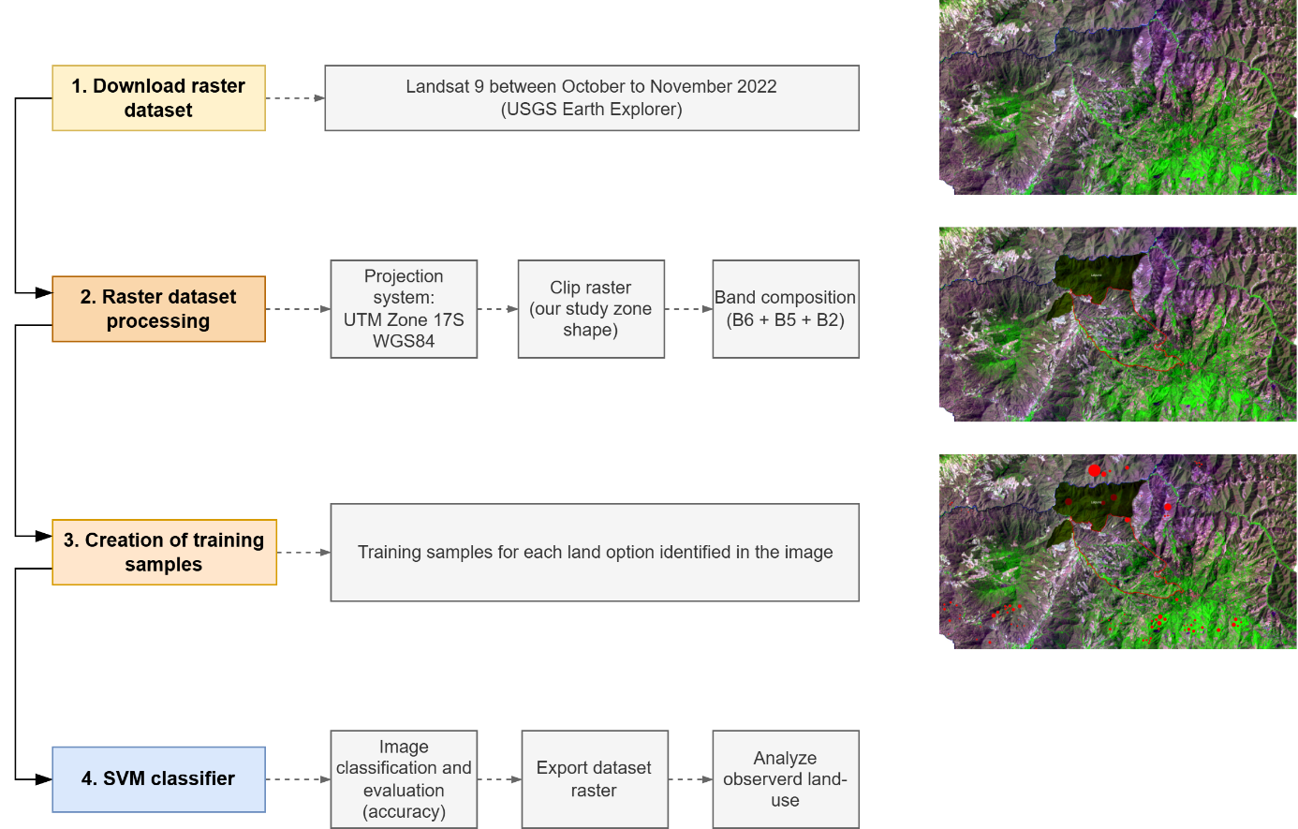
Fig. S2 Observed land-use classification of the influence zone in Laipuna Reserve through GIS method (supervised classification using SVM model)
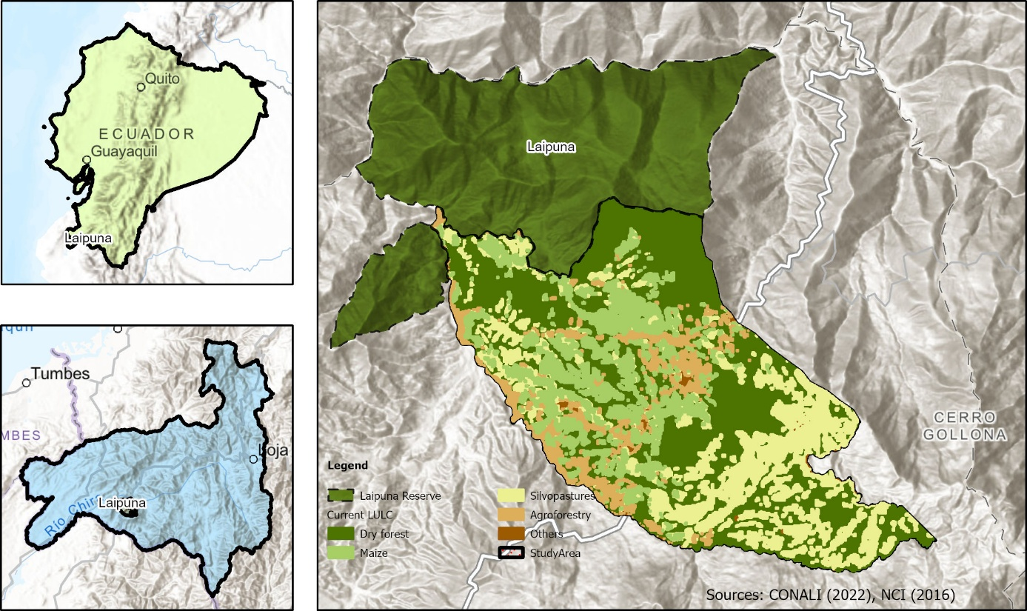

Table S1 Description of the land options identified in the influence zone in Laipuna Reserve
System | Description
Maize | Maize (Zea mays) is an annual monoculture that cycles between 215 and 270 days. It is produced between January and July using traditional methods (non-mechanized systems) in hillside areas in monocultures. Farmers usually produce maize for 5 years, followed by a fallow period of around 2 years. They use hybrid seeds and agrochemicals for fertilizer and weed control (Zambrano et al. 2021).  According to local farmers, maize (grain) production primarily serves household consumption, small animal feed, and local market sales.
Shaded cocoa and Shaded coffee | Agroforestry is a diverse matrix where farmers produce coffee (Coffea arabica) and cacao (Theobroma cacao), in combination with other options like cassava, peanuts, beans, banana, fruit trees (orange, mandarin, guava), and sugar cane (Ochoa et al. 2019). Generally, agroforestry systems are usually located near houses. Farmers apply fertilizer and pesticides (Useche and Blare 2013). Although pruning and renewals of coffee and cocoa plants are uncommon, we did consider annual renewal for both species from year 15 until year 18 in about 25% of the land.  Local farmers indicate that coffee and cocoa production are primarily used for household consumption and sale in the local markets.
Silvopasture | Silvopasture instead is a perennial system consisting of grass (Brachiaria sp.) and sometimes isolated trees. Typically, cows graze on the same paddock at least three times a year, with a stocking rate of 1 animal per hectare (INEC 2021). Farmers use natural and improved seeds and agrochemicals for fertilizer, weed control, and medicines for cow health (León et al., 2018).  As reported by local farmers, milk, meat, and timber derived from these land options serve for both household consumption and sale in the local market.

Table S2 Planting densities for defined agroforestry systems
System | Species | Plant density per ha | Reference
Shaded cocoa | Theobroma cocoa | 833 | INIAP (2010) and interviews with local farmers
Shaded cocoa | Cordia sp. | 92 | INIAP (2010) and interviews with local farmers
Shaded coffee | Coffea arabica | 4,352 | Ospina et al. (2010) and interviews with local farmers
Shaded coffee | Cordia sp. | 92 | Ospina et al. (2010) and interviews with local farmers
Silvopasture | Cordia sp. | 25 | Interviews with local farmers

Table S3 Expected investment costs, yields, and prices for each land-use
Land-use alternatives | Expected item | Values | Unit | Reference
Shaded Cocoa | Initial investment | 2.230.22 | $/ha | Own calculation
Shaded Cocoa | Producer cost | 257.79 | $/ha/year | Own calculation
Shaded Cocoa | Labor cost | 373.99 | $/ha/year | Own calculation
Shaded Cocoa | Yield cocoa | 0.30 | ton/ha/year | MAG (2018a, 2019, 2020)
Shaded Cocoa | Yield timber | 60.03 | m³/ha/year | Own calculation
Shaded Cocoa | Price cocoa | 2.640.00 | $/ton | Local price
Shaded Cocoa | Price timber | 150.00 | $/m³ | Local price
Shaded Coffee | Initial investment | 2.801.92 | $/ha | Own calculation
Shaded Coffee | Producer cost | 264.77 | $/ha/year | Own calculation
Shaded Coffee | Labor cost | 529.92 | $/ha/year | Own calculation
Shaded Coffee | Yield coffee | 0.41 | ton/ha/year | MAG (2016, 2017, 2018b)
Shaded Coffee | Yield timber | 60.03 | m³/ha/year | Own calculation
Shaded Coffee | Price coffee | 2.200.00 | $/ton | Local price
Shaded Coffee | Price timber | 150.00 | $/m³ | Local price
Maize | Initial investment | 867.50 | $/ha | Own calculation
Maize | Producer cost | 542.71 | $/ha/year | Own calculation
Maize | Labor cost | 615.65 | $/ha/year | Own calculation
Maize | Yield | 5.23 | ton/ha/year | Local yield and MAG (2021)
Maize | Price | 396.00 | $/ton | Local price
Silvopasture | Initial investment | 2.952.00 | $/ha | Own calculation
Silvopasture | Producer cost | 825.23 | $/ha/year | Own calculation
Silvopasture | Labor cost | 438.87 | $/ha/year | Own calculation
Silvopasture | Yield milk* | 1.73 | ton/ha/year | Local yield
Silvopasture | Yield beef* | 0.23 | ton/an/year | Local yield
Silvopasture | Yield timber | 19.12 | m³/ha/year | Own calculation
Silvopasture | Price milk | 588.00 | $/ton | Local price
Silvopasture | Price beef | 3.921.57 | $/ton | Local price
Silvopasture | Price timber | 150.00 | $/m³ | Local price
*Milk was converted from liters to tons using the formula by CSO (1999). Beef is the average weight of an adult cow sold per year
Table S4 Methods applied to modeling plant growth and biomass production of each land-use
Species | Variables | Method to quantify biomass production
Laurel trees | Diameter at breast height (DBH - 1,30 m) and height of the tree | - The annual DBH-age and heigh-DBH for laurel trees were modeled using Ortiz et al. (2008) and Ospina et al. (2010) equations, respectively. Annual wood volume was obtained using Ospina et al. (2010) equations and multiplying by a 0.70 form factor (Castro et al. 2015).  - Above and below-ground (roots) biomass was computed using the allometric models of (Andrade et al. 2022; IPCC 2003). Then, it was multiplied by the number of trees according to each land option's density, considering a random mortality rate between 0.02 and 0.05. We obtained average values of 35.71 ton/ha/year for cocoa and coffee and 9.66 ton/ha/year for pasture.
Cocoa and Coffee | Diameter (cm) at 30 cm above ground | - We used a diameter database of 486 coffee and 963 cocoa plants (Ordóñez et al. 2011) to estimate the diameter-age for both species based on Gompertz and Logistic functions (Zeide 1993) (R2 of 0.84 and 0.85, correspondingly).  - Allometric models from (Andrade et al. 2022; IPCC 2003; Segura et al. 2006) were used to estimate the biomass of coffee and cocoa above and below ground (roots). With a random mortality rate between 0.02 and 0.05, the biomass was multiplied by the number of coffee and cocoa plants. Adding laurel trees, we obtained an average of 55.48 and 48.80 ton/ha/year for cocoa and coffee, respectively.
Corn | Height of plant (stem), leaves, and corncob growth | - Using the equations generated by Vásconez et al. (2021), we estimated an annual average during a vegetative period of 210 days, considering (i) the accumulation and reduction of stem and leave biomass; and (ii) the accumulation of cob biomass. An average of 3.26 ton/ha/year was calculated.
Pasture | Height of plant (cm) | - Height–age of grass (Brachiaria sp.) was modeled with a logistic equation (R2 of 0.68) and technical notes from the Climate Smart Livestock project implemented in Ecuador (FAO 2019; Villegas et al. 2019a). We used a non-linear model from (Conrado et al. 2021) to compute the mean biomass production of grass based on local practices. Including laurel trees, we obtained an average of 13.85 ton/ha/year.

Table S5 Inputs used to run the InVest model. We follow the steps and methods suggested by Leh et al. (2013) and Natural Capital Project (2024)
Input | Unit | File required | Description, method of calculation, and sources
Precipitation | mm/year | Raster | Map of average annual precipitation between 1970 – 2000 from WorldClim - spatial resolution of ~1 km2 (Fick and Hijmans 2017). It was processed using RStudio and ArcGisPro.
Evapotranspiration | mm | Raster | A map of evapotranspiration was generated using the modified Hargreaves method (Droogers and Allen 2002) in Rstudio. The mean daily maximum and minimum temperature and precipitation data were attained from WorldClim - spatial resolution of ~1 km2 (Fick and Hijmans 2017).
Root restricting layer depth | mm | Raster | The depth to bedrock (R horizon) up to 200 cm provides World Soil Information was used to know the depth of the root-restricting layer at 250 m spatial resolution (Hengl et al. 2017).
Plant-available water content | Fraction (%) | Raster | Following Hengl et al. (2017), using ArcGisPro, we combined the available soil water capacity layers by World Soil Information between 0 - 200 cm depth to generate a map of the average over these intervals.
LULC | Land type | Raster | Map of the LULC classification (refer to section 3.2.1. in the article).
Biophysical table | Value | CSV | This table contains the biophysical parameters of each land alternative. It has the following columns: (i) LULC codes; (ii) code (1 or 0) indicating which land options have vegetation; (iii) maximum root depth for crops (average of root restricting layer depth); and (iv) the crop evapotranspiration coefficient (Kc). Kc values from FAO for the initial, median, and end growth stages were used (Allen et al. 2006; Doorenbos et al. 1992).
Z parameter | Value | ----- | Z is an empirical value representing the specific precipitation pattern and hydrogeological traits of the locality, typically within the range of 1 to 30 (Natural Capital Project 2024). We used 2.93 as an average from (Xu et al. 2013).

Table S6 Comparing observed vs optimized (multiobjective, socioeconomic, and ecological) indicators performance in the worst-case scenario
Portfolio | Indicators | Unit | Uncertainty level (u)
Portfolio | Indicators | Unit | 0.0 | 0.5 | 1.0 | 1.5 | 2.0 | 2.5 | 3.0
Observed | ANPV | $/ha/year | 343.24 | 285.63 | 228.03 | 170.43 | 112.82 | 55.22 | -2.38
Observed | PP | Years | 5.93 | 5.93 | 5.93 | 5.93 | 5.93 | 5.93 | 5.93
Observed | CBR | ----- | 3.14 | 2.38 | 1.62 | 0.85 | 0.09 | -0.67 | -1.44
Observed | LD | $/ha/year | 505.45 | 505.45 | 505.45 | 505.45 | 505.45 | 505.45 | 505.45
Observed | FP | Mcal/ton/year | 5.47 | 5.27 | 5.07 | 4.87 | 4.67 | 4.46 | 4.26
Observed | BP | ton/ha/year | 14.63 | 14.49 | 14.36 | 14.22 | 14.08 | 13.94 | 13.80
Observed | C | ton/ha/year | 5.93 | 5.93 | 5.93 | 5.93 | 5.93 | 5.93 | 5.93
Observed | WRC | mm/ha/year | 0.37 | 0.31 | 0.26 | 0.20 | 0.14 | 0.08 | 0.03
Multiobjective | ANPV | $/ha/year | 257.90 | 213.81 | 147.20 | 72.45 | 24.87 | -43.58 | -115.09
Multiobjective | PP | Years | 7.36 | 7.54 | 8.20 | 8.55 | 8.12 | 12.96 | 8.47
Multiobjective | CBR | ----- | 3.12 | 2.15 | 1.34 | 0.58 | -0.13 | 0.94 | -1.65
Multiobjective | LD | $/ha/year | 499.56 | 511.40 | 504.73 | 505.53 | 506.57 | 507.93 | 507.19
Multiobjective | FP | Mcal/ton/year | 7.06 | 5.78 | 4.68 | 4.41 | 4.34 | 4.71 | 3.90
Multiobjective | BP | ton/ha/year | 28.43 | 24.46 | 26.07 | 27.49 | 25.15 | 26.13 | 26.44
Multiobjective | C | ton/ha/year | 67.97 | 63.36 | 60.21 | 56.69 | 51.73 | 58.12 | 44.35
Multiobjective | WRC | mm/ha/year | 0.37 | 0.32 | 0.28 | 0.22 | 0.16 | 0.25 | 0.05
Socioeconomic | ANPV | $/ha/year | 262.89 | 243.32 | 214.89 | 152.20 | 94.78 | 39.48 | -12.16
Socioeconomic | PP | Years | 7.11 | 6.18 | 5.50 | 5.57 | 5.54 | 9.61 | 5.28
Socioeconomic | CBR | ----- | 3.18 | 2.33 | 1.50 | 0.55 | -0.37 | 1.03 | -2.20
Socioeconomic | LD | $/ha/year | 505.16 | 510.90 | 515.03 | 514.66 | 514.94 | 517.10 | 517.53
Socioeconomic | FP | Mcal/ton/year | 7.29 | 6.74 | 6.29 | 6.05 | 5.78 | 6.23 | 5.26
Ecological | BP | ton/ha/year | 53.94 | 51.62 | 47.04 | 39.62 | 36.60 | 28.73 | 28.67
Ecological | C | ton/ha/year | 77.42 | 73.32 | 68.78 | 62.83 | 57.98 | 59.43 | 45.73
Ecological | WRC | mm/ha/year | 0.47 | 0.41 | 0.34 | 0.27 | 0.21 | 0.26 | 0.05

Fig. S3 (a) Historical crop yields, milk, and beef (FAO 2022). Coefficient of variation (CV): cocoa 38%, coffee 54%, maize 41%, milk 10%, and beef 4%. (b) Historical crop prices, milk, beef (FAO 2022), and sawn wood (ITTO 2022). CV: cocoa 29%, coffee 54%, maize 15%, milk 25%, beef 22%, and wood 26%
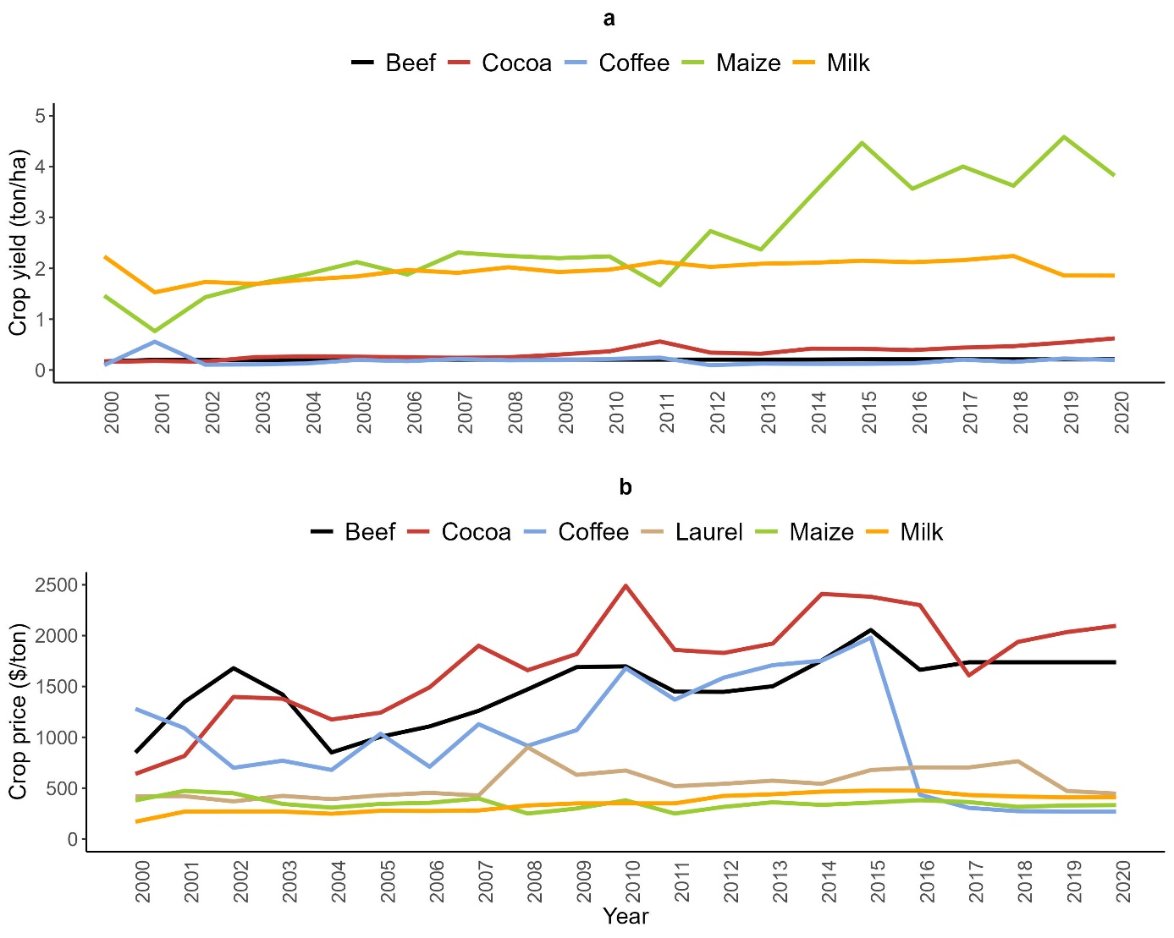

Fig. S4 Guaranteed performance of observed land composition (red lines and black triangles) compared with optimal land composition (blue lines and colored circles) under uncertainty levels. In all graphs, 100% represents the most desirable performance. Each triangle and circle represent the achievement level of each indicator (1 = ANPV, 2 = AW, 3 = BP, 4 = C, 5 = CBR, 6 = FP, 7 = PP, and 8 = WRC) for the unique combination of optimistic – pessimistic uncertainty scenarios
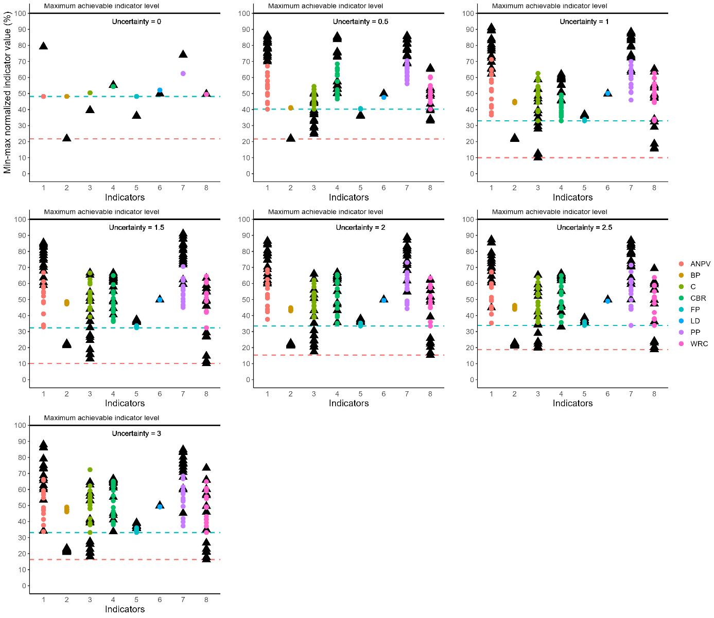

References
Allen R, Pereira L, Raes D, Smith M (2006) Evapotranspiración del cultivo. Guías para la determinación de los requerimientos de agua de los cultivos. https://openknowledge.fao.org/server/api/core/bitstreams/f3660258-d07f-487e-b3c1-01661c83cb16/content
Andrade H, Segura M, Somarriba E (2022) Above-ground biomass models for dominant trees species in cacao agroforestry systems in Talamanca, Costa Rica. Agroforestry Systems 96(4):787-797. https://doi.org/10.1007/S10457-022-00741-Y
Castro LM, Calvas B, Knoke T (2015) Ecuadorian Banana Farms Should Consider Organic Banana with Low Price Risks in Their Land-Use Portfolios. PLoS One 10(3):e0120384. https://doi.org/10.1371/journal.pone.0120384
CONALI (Comité Nacional de Límites Internos) (2022) Límites de la Organización Territorial del Estado, Provincial, Cantonal y Parroquial.
Conrado JA de A, Lopes MN, Cândido MJ, Macedo VH, Silva VJ da, Damasceno VG (2021) Prediction of Brachiaria decumbens forage biomass using structural characteristics. Chil J Agric Res 81(3):467-478. https://doi.org/10.4067/S0718-58392021000300467
CSO (Central Statistics Office) (1999) Milk Statistics. https://www.cso.ie/en/media/csoie/releasespublications/documents/agriculture/1999/milk_sept1999.pdf
Doorenbos J, Pruitt WO, Aboukhaled A et al (1992) Crop Water Requirements. FAO. https://openknowledge.fao.org/server/api/core/bitstreams/a60d6c27-3fe1-4eab-8b0f-679312c70a57/content
Droogers P, Allen RG (2002) Estimating reference evapotranspiration under inaccurate data conditions. Irrigation and Drainage Systems 16(1):33-45. https://doi.org/10.1023/A:1015508322413
FAO (2022) FAOSTAT: Production (Crops and livestock products) and Trade (Crops and livestock products) [dataset]. https://www.fao.org/faostat/en/#data. Accessed 15 December 2022
FAO (2019) Evaluación de la productividad de mezclas forrajeras para pastoreo en el cantón Gonzanamá - Proyecto Ganadería Climáticamente Inteligente. Loja.
Fick SE, Hijmans RJ (2017) WorldClim 2: new 1-km spatial resolution climate surfaces for global land areas. International Journal of Climatology 37(12):4302-4315. https://doi.org/10.1002/joc.5086
Hengl T, Mendes de Jesus J, Heuvelink GB et al (2017) SoilGrids250m: Global gridded soil information based on machine learning. PLoS One 12(2):e0169748. https://doi.org/10.1371/journal.pone.0169748
INEC (2021) Encuesta de Superficie y Producción Agropecuaria Continua (ESPAC), período 2002 - 2021[dataset]. Quito.
INIAP (2010) Manejo Técnico Del Cultivo de Cacao en Manabí.
IPCC (2003) Good Practice Guidance for Land Use, Land-Use Change and Forestry. Penman J, Gytarsky M, Hiraishi T, (eds). Japan. https://www.ipcc-nggip.iges.or.jp/public/gpglulucf/gpglulucf_files/GPG_LULUCF_FULL.pdf
ITTO (2022) ITTO’s online statistical database - Biennial review statistics [dataset]. https://www.itto.int/biennal_review/. Accessed 20 December 2022
Leh MD, Matlock MD, Cummings EC, Nalley LL (2013) Quantifying and mapping multiple ecosystem services change in West Africa. Agric Ecosyst Environ 165:6-18. https://doi.org/10.1016/j.agee.2012.12.001
León R, Bonifaz N, Gutiérrez F (2018) Pastos y forrajes del Ecuador: siembra y producción de pasturas. In Repositorio Institucional de la Universidad Politécnica Salesiana (Primera Ed, Issue Editorial ABYA-YALA). Editorial Universitaria Abya-Yala. http://dspace.ups.edu.ec/handle/123456789/19019
MAG (2017) Rendimientos Objetivos de Café Grano Oro en el Ecuador 2017. Quito. https://sipa.agricultura.gob.ec/descargas/estudios/rendimientos/cafe/rendimiento_cafe_grano_seco_2017.pdf
MAG (2018a) Rendimientos de Cacao Almendra Seca (Theobroma cacao) 2017. Quito. https://sipa.agricultura.gob.ec/biblioteca/rendimientos/rendimiento_cacao_2017.pdf
MAG (2018b) Rendimientos Objetivos de Café Grano Oro en el Ecuador 2018. Quito. https://sipa.agricultura.gob.ec/descargas/estudios/rendimientos/cafe/rendimiento_cafe_grano_oro_2018.pdf
MAG (2019) Informe de Rendimientos Objetivos de Cacao Almendra Seca en el Ecuador 2018. Quito. https://sipa.agricultura.gob.ec/descargas/estudios/rendimientos/cacao/rendimiento_cacao_2018.pdf
MAG (2020) Informe de Rendimientos Objetivos de Cacao (Almendra Seca) 2019. Quito. https://sipa.agricultura.gob.ec/descargas/estudios/rendimientos/cacao/rendimiento_cacao_2019.pdf
MAG (2021) Superficie, Producción y Rendimiento de Maíz Duro del cantón Macará Periodo 2014 – 2021[dataset]. Quito.
MAG (2016) Rendimientos Objetivos de Café Grano Oro en el Ecuador 2016. Quito. https://sipa.agricultura.gob.ec/descargas/estudios/rendimientos/cafe/rendimiento_cafe_grano_seco_2016.pdf
Natural Capital Project (2024) InVEST 3.14.1 User Guide. https://naturalcapitalproject.stanford.edu/software/invest. Accessed 24 January 2024
NCI (2014) Límite territorial Reserva Natural Laipuna.
Ochoa S, Härtl FH, Paul C, Knoke T (2019) Cropping systems are homogenized by off-farm income – Empirical evidence from small-scale farming systems in dry forests of southern Ecuador. Land use policy 82:204-219. https://doi.org/10.1016/j.landusepol.2018.11.025
Ordóñez L, Gavilánez C, Salazar A (2011) Secuestro de carbono en biomasa aérea en sistemas agroforestales de cacao y café ubicados en la Reserva de Biosfera Sumaco. Estudio Técnico. Quito. https://cadenacacaoca.info/CDOC-Deployment/documentos/proyectocarbono.pdf
Ortiz Á, Riascos L, Somarriba E (2008) Almacenamiento y tasas de fijación de biomasa y carbono en sistemas agroforestales de cacao (Theobroma cacao) y laurel (Cordia alliodora). Agroforestería en las Américas. 46:26-29. https://repositorio.catie.ac.cr/handle/11554/5764. Accessed 25 January 2023
Ospina PC, Hernández RJ, Sánchez FA et al (2010) Guías Silviculturales Para El Manejo de Especies Forestales Con Miras a La Producción de Madera En La Zona Andina Colombia. https://www.cenicafe.org/es/index.php/nuestras_publicaciones/cartillas/publicaciones_guias_silviculturales_para_el_manejo_de_especies_foresta3. Accessed 18 January 2023
Segura M, Kanninen M, Suárez D (2006) Allometric models for estimating aboveground biomass of shade trees and coffee bushes grown together. Agroforestry Systems 68(2):143-150. https://doi.org/10.1007/S10457-006-9005-X
Useche P, Blare T (2013) Traditional vs. modern production systems: Price and nonmarket considerations of cacao producers in Northern Ecuador. Ecological Economics, 93, 1–10. https://doi.org/10.1016/J.ECOLECON.2013.03.010
Vásconez G, Caicedo L, Véliz D, Sánchez F (2021) Producción de biomasa en cultivos de maíz: zona central de la Costa de Ecuador. Rev Cienc Soc 27(3):417-428. https://www.redalyc.org/journal/280/28068276032/28068276032.pdf
Villegas D, Valbuena N, Milla M (2019) Applied models evaluation to dry matter production of Brachiaria brizantha in rainy season. Revista de Ciencias Agrícolas 36(1):33-45. https://doi.org/10.22267/rcia.193601.96
Xu X, Liu W, Scanlon BR, Zhang L, Pan M (2013) Local and global factors controlling water-energy balances within the Budyko framework. Geophys Res Lett 40(23):6123-6129. https://doi.org/10.1002/2013GL058324
Zambrano J, Velásquez J, Peñaherrera D et al (2021) Guía para la producción sustentable de maíz en la Sierra Ecuatoriana. INIAP-EESC. Quito. https://repositorio.iniap.gob.ec/handle/41000/5796. Accessed 17 January 2023
Zeide B (1993) Analysis of Growth Equations. Forest Science 39(3):594-616. https://doi.org/10.1093/forestscience/39.3.594

