Appendices with supplementary materials for research article titled “The impact of decomposer size classes and litter quality on litter decomposition in food forests”
Isabelle van der Zanden^{1,a*}, Gelieke G.T. Steeghs^{1*}, Lieke Moereels^{2,3} & G.F. (Ciska) Veen¹
¹ Department of Terrestrial Ecology, Netherlands Institute of Ecology (NIOO-KNAW), Droevendaalsesteeg 10, 6708 PB Wageningen, Netherlands
² Forest & Nature Lab, Department of Environment, Ghent University; Geraardsbergsesteenweg 267, 9090 Melle, Gontrode, Belgium
³Flanders Research Institute for Agriculture, Fisheries and Food (ILVO), Plant Sciences, Caritasstraat 39, 9820 Merelbeke, Belgium
ª Corresponding author.
E-mail address: i.vanderzanden@nioo.knaw.nl (I. van der Zanden).
* Shared first authorship.
- Methods abiotic and biotic soil properties
  - Abiotic properties
  - Soil microbial biomass
  - Soil faunal abundance
- Litter bags not used for analysis
- Results abiotic and biotic soil properties
- Analysis and results litter quality verification

- Methods abiotic and biotic soil properties
  - Abiotic properties
All food forest and grassland sites were divided in six even sized strata, where in each stratum a random coordinate was generated for six 5x5 meter plots. In each plot we collected one composite soil sample, consisting of 25 mixed soil cores of the topsoil (0-25 cm), between April and July 2021. However, for location 3, the grassland used for the litter bag experiment was not available, and we used an alternative nearby grassland with similar land use and soil type. Samples were cooled during transport and stored at 4 °C before further analysis. All analyses were carried out at the Netherlands Institute of Ecology (NIOO-KNAW) if not stated otherwise.
Soil moisture content (%) was measured on a subsample of around 10 grams by oven-drying for 24 hours at 105 °C. Then, the dried sample was used to determine soil organic matter content (%) by loss on ignition (550 °C for 3 hours). pH-KCl was measured with an electrode (WTW inoLab® pH 7310 benchtop meter) after adding 50 mL of 1 M KCl solution to a 10-gram oven-dried (40 °C) subsample. To measure bulk density, Kopecky rings were used (⌀53 mm, volume 100 cm³) to take undisturbed soil samples at around 10 cm soil depth. Rings were weighed and corrected for soil moisture content (soils dried at 105 °C for 24 hours) to obtain bulk density content in grams of soil per cm³.
To measure soil C, N and P content, samples were oven dried (40 °C), ground and sieved (2mm). For total carbon (C) and nitrogen (N) the samples were combusted at 1150 °C and measured in a CNS elemental analyzer (vario Macro Cube, Elementar, Germany). Total phosphorous (P) was measured after complete destruction of the soil samples with HClO₄ (65%), HNO₃ (70%) and H2SO₄ (98%) in teflon bombs (4 hours at 150 °C). Bioavailable P was extracted in NaHCO₃ (P-Olsen; according to ISO 11263:1994(E)). Colorimetric measurements of both total and available P-concentrations were done according to the malachite green procedure (Lajtha et al. 1999). All soil nutrient analyses were carried out at the Forest and Nature Lab of Ghent University.
  - Soil microbial biomass
As representatives of the microbial size class, we quantified fungal and bacterial biomass by phospholipid and neutral lipid fatty-acid analysis (Frostegård et al. 1991). Prior to analysis, soil samples were freeze-dried for 5 days and homogenized. Phospholipids were extracted from 2 grams of freeze-dried soil with a Bligh & Dyer solution (Chloroform:MeOH:citrate buffer 1:2:0.8 v/v/v) twice, first with 10 and then with 5 ml. Subsequently, the obtained supernatant was dissolved in 4 ml chloroform and 4 ml citrate buffer to split phases (Bligh and Dyer 1959). The lipid phase was then fractionated by adding chloroform to extract non-polar lipids and methanol to extract polar lipids on SPE Bond Elut 1cc LRC-SI columns from Agilent (USA). Both fractions were dried using a RapidVap Vacuum Evaporator System (Labconco, USA) and derivatized into fatty acid methyl esters: neutral-lipid fatty acids (NLFAs) from the chloroform fraction and polar-lipid fatty acids (PLFAs) from the methanol fraction. An internal standard was added (FAME standard mix C12:0 sigma 61689 and C19:0 sigma N5377) to be able to calculate concentrations into µg per gram of freeze-dried soil. PLFAs and NLFAs were measured separately on a gras-chromatograph with flame ionization detection (Agilent Technologies GC Sampler 80, USA). NLFA 16:1ω5 has shown to indicate arbuscular mycorrhizal (AM) fungal biomass, whereas different PLFAs have shown to indicate bacterial and fungal (e.g., ECM and saprotrophic) biomass (Olsson 1999; Olsson and Lekberg 2022; Zelles 1999) (Table A1.1).

Table A1.1 Fatty acids used as biomarkers. AM stands for arbuscular mycorrhizal

Organism | Group | Phospholipid fatty acids
Bacteria | Firmicutes (gram-positive) | i14:0, i15:0, a15:0, i16:0, i17:0, a17:0
 | Actinobacteria (gram-positive) | 10Me16:0, 10Me17:0, 10Me18:0
 | Gram negative | 16:1ω7c, 18:1ω7c, cy17:0
Fungi | AM fungi | 16:1ω5c (from NLFA)
 | Non-AM fungi | 18:2ω6

  - Soil faunal abundance
As representatives of the larger (meso- and macrofaunal) decomposer community we quantified springtails (Collembola) and mites (Sarcoptiformes, Mesostigmata and Trombidiformes) and earthworms (Lumbricidae). Springtails and mites were retrieved from 6 cm x 9 cm cylindrical cores taken from three of the six 5x5 m plots using a Tullgren-Berlese funnel at the Free University of Amsterdam (Straalen and Rijninks 1982). The top of the sample was heated up to 30 °C while the bottom of the sample was cooled to 5 °C in closed-off climate chambers. The soil fauna passing through the funnel was collected in a 70% ethanol solution. Extraction in the Tullgren-Berlese funnel lasted three weeks and afterwards samples were stored at 4 °C. Complete samples were counted using a stereomicroscope and grouped under springtails, oribatid mites and other (mesostigmatic and prostigmatic) mites. Total counts were divided by the mass of the dried sample and expressed as number of micro-arthropods per gram of dry soil.
Earthworms were collected in the field in October and November of 2022 in three of the six plots. Within 0.1 m², the soil was excavated to a depth of 20 cm and hand-sorted for earthworms. Simultaneously, a mustard powder solution (6 gr/L H₂O) was poured into the pit for 50 minutes to attract deeper burrowing earthworms. All earthworms were fixed on 5% formaldehyde and later washed with and stored in 70% ethanol at the Forest and Nature Lab of Ghent University. Here, earthworms were counted and weighted per plot and expressed as numbers or grams per m².

- Litter bags not used for analysis

Table A2.1 Litter bags that were excluded for further analysis. 30 litter bags were excluded for analysis due to various reasons: not found in the field or lab, found broken or negative litter mass loss

Location | Code | Litter type | Mesh size | Reason for exclusion
L2 | FF073 | Alder | Fine | Not found in the field
L4 | FF109 | Alder | Fine | Not found in the field
L4 | FF128 | Hazel | Fine | Not found in the field
L4 | FF129 | Chestnut | Fine | Not found in the field
L4 | FF130 | Alder | Medium | Not found in the field
L4 | FF131 | Hazel | Medium | Not found in the field
L4 | FF132 | Chestnut | Medium | Not found in the field
L4 | FF134 | Hazel | Coarse | Not found in the field
L4 | FF135 | Chestnut | Coarse | Not found in the field
L4 | FF136 | Alder | Fine | Found broken
L4 | FF137 | Hazel | Fine | Not found in the field
L4 | FF139 | Alder | Medium | Negative litter mass loss
L4 | FF142 | Alder | Coarse | Not found in the field
L4 | FF143 | Hazel | Coarse | Not found in the field
L4 | FF159 | Chestnut | Medium | Negative litter mass loss
L4 | FF160 | Alder | Coarse | Negative litter mass loss
L4 | FF162 | Chestnut | Coarse | Negative litter mass loss
L1 | FF181 | Alder | Fine | Not found in the field
L1 | FF182 | Hazel | Fine | Not found in the field
L1 | FF183 | Chestnut | Fine | Not found in the field
L1 | FF184 | Alder | Medium | Not found in the field
L1 | FF185 | Hazel | Medium | Not found in the field
L1 | FF186 | Chestnut | Medium | Not found in the field
L1 | FF187 | Alder | Coarse | Not found in the field
L1 | FF188 | Hazel | Coarse | Not found in the field
L1 | FF189 | Chestnut | Coarse | Not found in the field
L1 | FF198 | Chestnut | Coarse | Negative litter mass loss
L1 | FF209 | Hazel | Fine | Found broken
L3 | FF303 | Chestnut | Medium | Negative litter mass loss
L3 | FF305 | Hazel | Coarse | Not found in the lab

- Results abiotic and biotic soil properties
Table A3.1 ANOVA table based on the linear mixed model of the response of soil abiotic and biotic properties to land use with location as random factor. AM stands for Arbuscular Mycorrhizal. Values represent mean (standard deviation) per land use type, and F- and P-values. † these measurements were log-transformed for statistical analyses, but untransformed data is shown. ‡ these measurements were square-root-transformed, but untransformed data is shown. Significant differences are shown in bold fonts
Category | Measurement | Food forests | Grasslands | F-value | P-value
Abiotic | Bulk density (g/cm³) | 1.03 (0.25) | 1.17 (0.25) | 29.38 | <0.001
 | Soil moisture (%) | 36.87 (18.89) | 30.10 (11.94) | 16.82 | <0.001
 | pH (KCl) | 5.89 (1.34) | 5.83 (1.16) | 0.19 | 0.662
 | Soil organic matter (%) | 2.76 (1.45) | 2.33 (0.81) | 7.45 | <0.01
 | Electrical conductivity (mS/m) † | 81.50 (29.82) | 99.79 (43.02) | 17.96 | <0.001
 | Total P (mg/kg) † | 802.67 (427.07) | 844.54 (369.13) | 1.54 | 0.221
 | Olsen P (mg/kg) † | 53.60 (23.37) | 69.20 (47.15) | 0.19 | 0.662
 | Total C (%) † | 4.52 (2.47) | 3.62 (0.86) | 3.61 | 0.064
 | Total N (%) † | 0.32 (0.18) | 0.26 (0.09) | 2.71 | 0.107
Biotic | Bacterial biomass (µg/g) | 25.23 (16.01) | 26.23 (13.65) | 0.65 | 0.036
 | AM fungal biomass (µg/g) † | 2.43 (2.61) | 4.71 (3.96) | 24.75 | <0.001
 | Non-AM fungal biomass (µg/g) | 1.64 (0.85) | 1.72 (1.04) | 0.25 | 0.620
 | Springtails abundance (#/kg) | 518.52 (282.43) | 679.41 (524.49) | 1.00 | 0.329
 | Oribatid mite abundance (#/kg) ‡ | 738.73 (780.58) | 217.55 (222.56) | 10.15 | <0.01
 | Meso- and prostigmatic mite abundance (#/kg) ‡ | 591.82 (560.18) | 386.77 (242.37) | 1.16 | 0.295
 | Earthworm abundance (#/m²) | 191.67 (218.13) | 456.67 (188.55) | 19.80 | <0.001
 | Earthworm biomass (g/m²) | 28.94 (30.63) | 168.73 (92.37) | 33.97 | <0.001

Fig. A2 PCA on three samples per land use per location of abiotic and biotic soil properties: bulk density (g/cm³) , soil moisture (%), pH (KCl), soil organic matter (S.O.M., %), electrical conductivity (mS/m), total P (mg/kg), Olsen P (mg/kg), total C (%), total N (%), bacterial biomass (µg/g), arbuscular mycorrhizal (AM)-fungal biomass (µg/g), non-AM fungal biomass (µg/g), springtail abundance (#/kg), oribatid mite abundance (#/kg), other (meso-and prostigmatic) mite abundance (#/kg), earthworm abundance (#/m²), earthworm biomass (g/m²). Results from the PERMANOVA on the effects of location and land use on soil abiotic and biotic soil properties are shown (n=24)
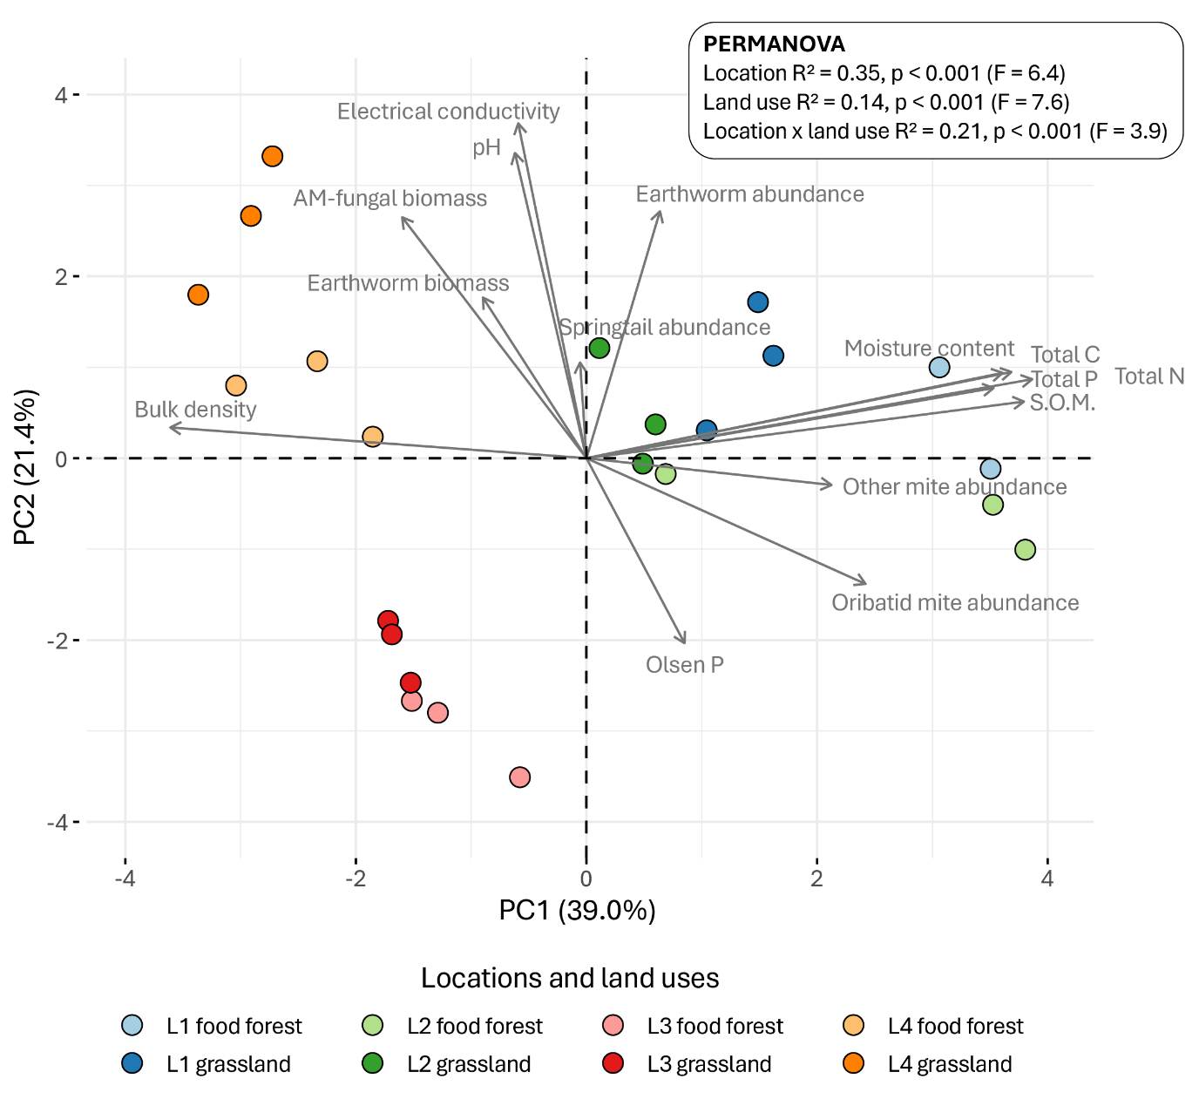

- Analysis and results litter quality verification
To verify litter quality, we tested how chemical traits (C, N and lignin content) differed between litter types using a one-way ANOVA (type I SS) from the stats package with litter type as a fixed factor. Carbon content was lowest for common hazel, intermediate for black alder and highest for sweet chestnut litter (Table A4.1). Nitrogen content did not differ between litter species. C:N ratio was lower for sweet chestnut leaves than for black alder and common hazel (Table A4.1). Furthermore, sweet chestnut leaves contained the most lignin, black alder had intermediate concentrations, and common hazelnut leaves had the lowest lignin concentrations (Table A4.1).
Table A4.1 Chemical litter traits per litter species. Values are represented as mean (standard deviation). F- and P-values from one-way ANOVA (type I SS). n = 10 for the analysis of C and N (in % of litter weight) of all litter species. n = 3 for lignin analysis of A. glutinosa and C. avellana, while n = 2 for C. sativa due to insufficient sample material. Degrees of freedom is 2 in all cases. Significant results are shown in bold fonts. Groups not sharing any letter are significantly different by the Tukey-test with 5% level of significance
Measurements | Alnus glutinosa (L.) Gaertn. (black alder) | Corylus avellana (L.) (common hazel) | Castanea sativa Mill. (sweet chestnut) | F-value | P-value
C (%) | 48.72 (2.11) b | 46.31 (1.21) a | 50.44 (0.67) c | 20.35 | <0.001
N (%) | 1.92 (0.18) a | 1.77 (0.15) a | 1.73 (0.24) a | 2.71 | 0.085
C:N ratio | 25.48 (2.07) a | 26.26 (2.19) a | 29.59 (3.80) b | 6.08 | 0.007
Lignin (mg/g) | 153.27 (16.08) ab | 121.54 (46.34) a | 285.19 (92.28) b | 6.43 | 0.041

References

Bligh EG, Dyer WJ (1959) A rapid method of total lipid extraction and purification. Can J Biochem Physiol 37:911–917. https://doi.org/10.1139/o59-099
Frostegård Å, Tunlid A, Bååth E (1991) Microbial biomass measured as total lipid phosphate in soils of different organic content. Journal of Microbiological Methods 14:151–163. https://doi.org/10.1016/0167-7012(91)90018-L
Lajtha K, Driscoll C, Jarrell W, Elliott E (1999) Soil phosporous - characterization and total element analysis. In: Standard soil methods for long-term ecological research. Oxford University Press, New York
Olsson PA (1999) Signature fatty acids provide tools for determination of the distribution and interactions of mycorrhizal fungi in soil. FEMS Microbiology Ecology 29:303–310. https://doi.org/10.1111/j.1574-6941.1999.tb00621.x
Olsson PA, Lekberg Y (2022) A critical review of the use of lipid signature molecules for the quantification of arbuscular mycorrhiza fungi. Soil Biology and Biochemistry 166:108574. https://doi.org/10.1016/j.soilbio.2022.108574
Straalen N van, Rijninks P (1982) The efficiency of Tullgren apparatus with respect to interpreting seasonal changes in age structure of soil arthropod populations.
Zelles L (1999) Fatty acid patterns of phospholipids and lipopolysaccharides in the characterisation of microbial communities in soil: a review. Biol Fertil Soils 29:111–129. https://doi.org/10.1007/s003740050533

