Appendix
Table 4 Overview over the upscaled area covered by the woody landscape feature (WLF) types per state for the manual delineation and classification. The values outside brackets are absolute values in km², while the values inside brackets are relative values in percent and refer to the proportion of the area of the respective WLF type relative to the total WLF area per state.
State | Agricultural area in km² | WLF type in km² (%)
State | Agricultural area in km² | Hedgerow | Hedgerow with gaps | Tree row | Grove | Shrub | Tree | Orchard | Total
NI | 27,593 | 238  (26.8) | 15  (1.7) | 122  (13.7) | 401  (45.2) | 25  (2.9) | 73  (8.2) | 13  (1.5) | 887
NW | 15,951 | 110  (32.3) | 5  (1.4) | 70  (20.6) | 88  (25.9) | 16  (4.7) | 31  (9.1) | 21  (6.1) | 340
BB | 14,233 | 145  (50.9) | 17  (5.8) | 21  (7.3) | 35  (12.4) | 42  (14.6) | 25  (8.9) | 0  (0) | 285
HE | 8,717 | 179  (45.1) | 6  (1.6) | 15  (3.8) | 131  (33.1) | 30  (7.6) | 16  (4.1) | 18  (4.7) | 396
ST | 12,287 | 97  (35.1) | 21  (7.5) | 26  (9.3) | 41  (14.9) | 11  (4.1) | 33  (11.8) | 47  (17.2) | 276
SN | 9,920 | 67  (36.7) | 4  (2.3) | 18  (10.0) | 24  (13.0) | 43  (23.5) | 26  (14.4) | 0  (0) | 182
TH | 8,416 | 106  (38.9) | 17  (6.2) | 21  (7.6) | 35  (12.9) | 17  (6.4) | 19  (6.8) | 58  (21.1) | 273
Total | 97,118 | 942 | 84 | 293 | 756 | 185 | 223 | 157 | 2,640

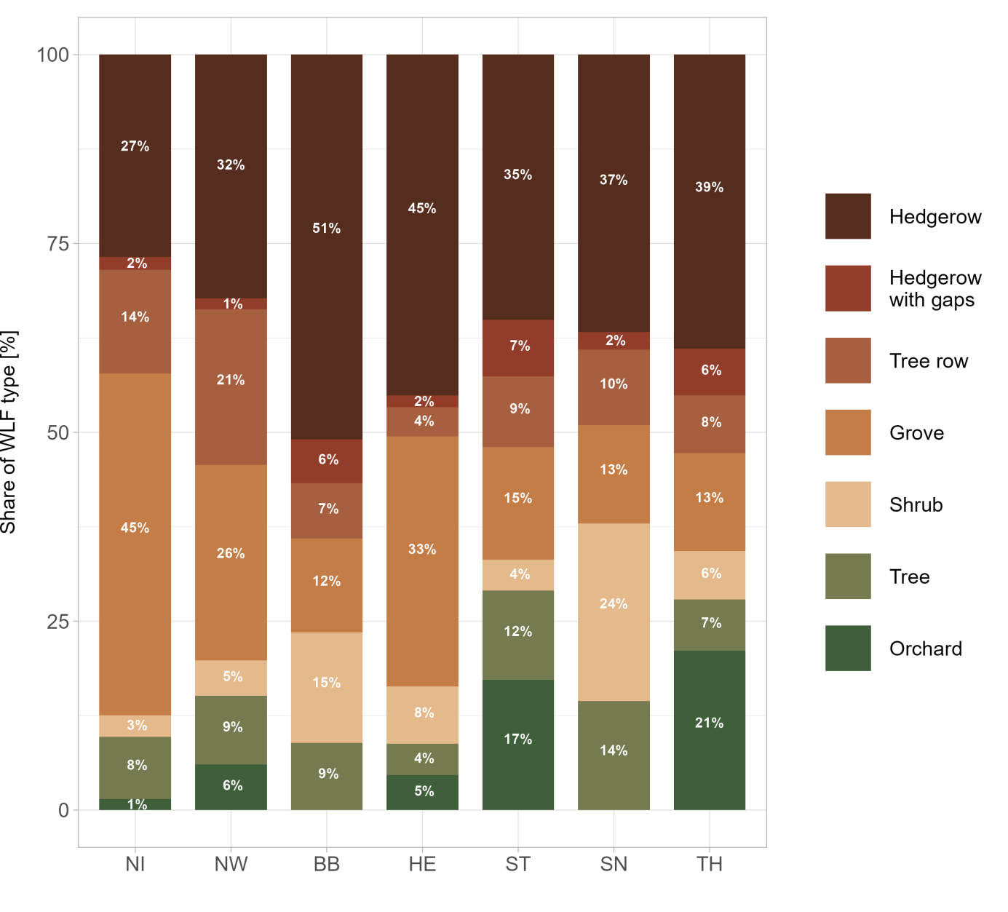
Fig. 8 Overview over the upscaled area covered by the woody landscape feature (WLF) types per federal state from the manual delineation and classification. The stacked bars and the numbers within the bars show the share of the different WLF types of the total upscaled WLF area per federal state.

