Supplementary materials
a
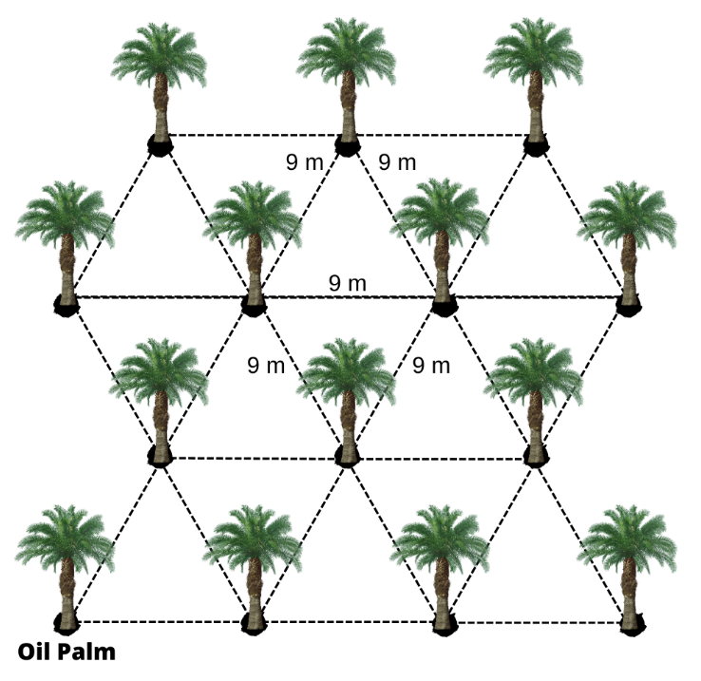

b
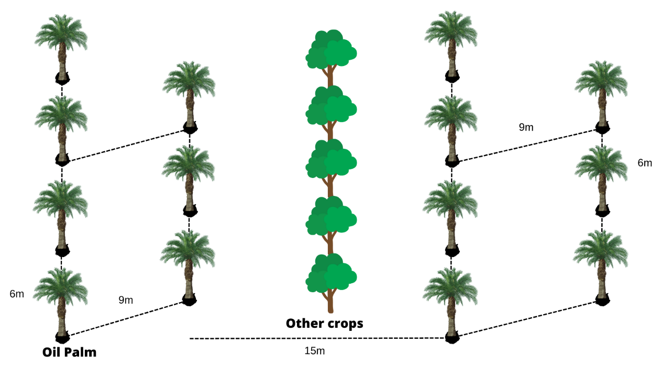

c
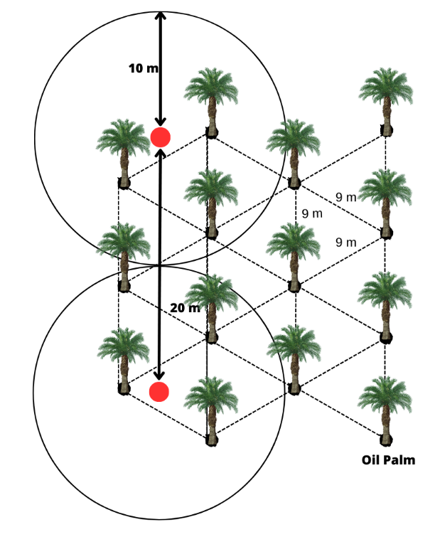

d
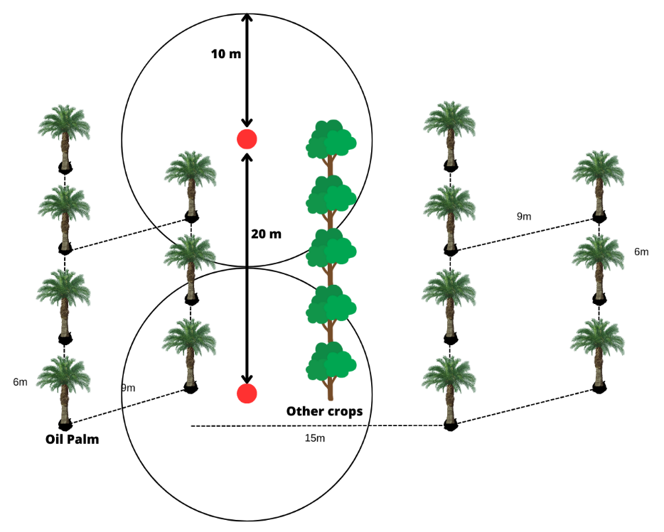
Figure S1. Images showing the layout of oil palms in (a) conventional monoculture and (b) alley-cropping systems, as well as the butterfly sampling plot configuration in (c) monoculture and (d) alley-cropping systems. The distance between points is 20 meters, with a 10-meter radius established at each point for butterfly observations and measurement of environmental factors.
a
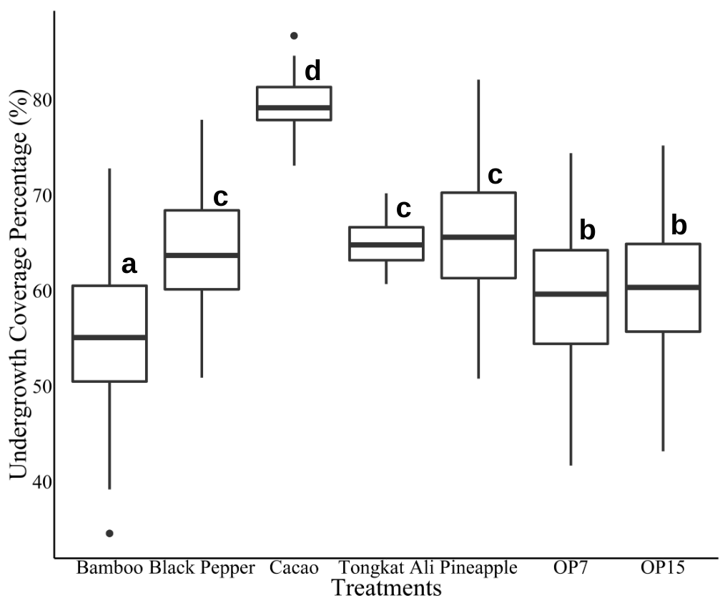

b
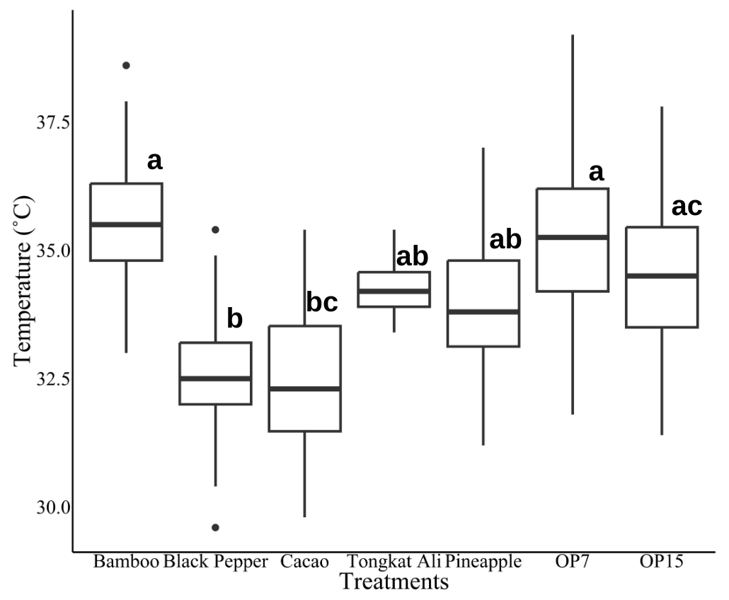
c
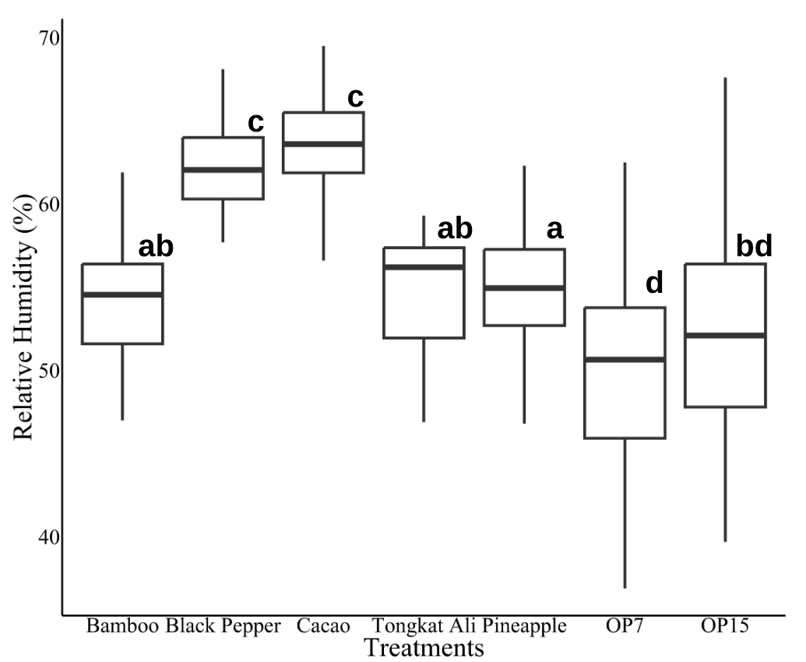

d
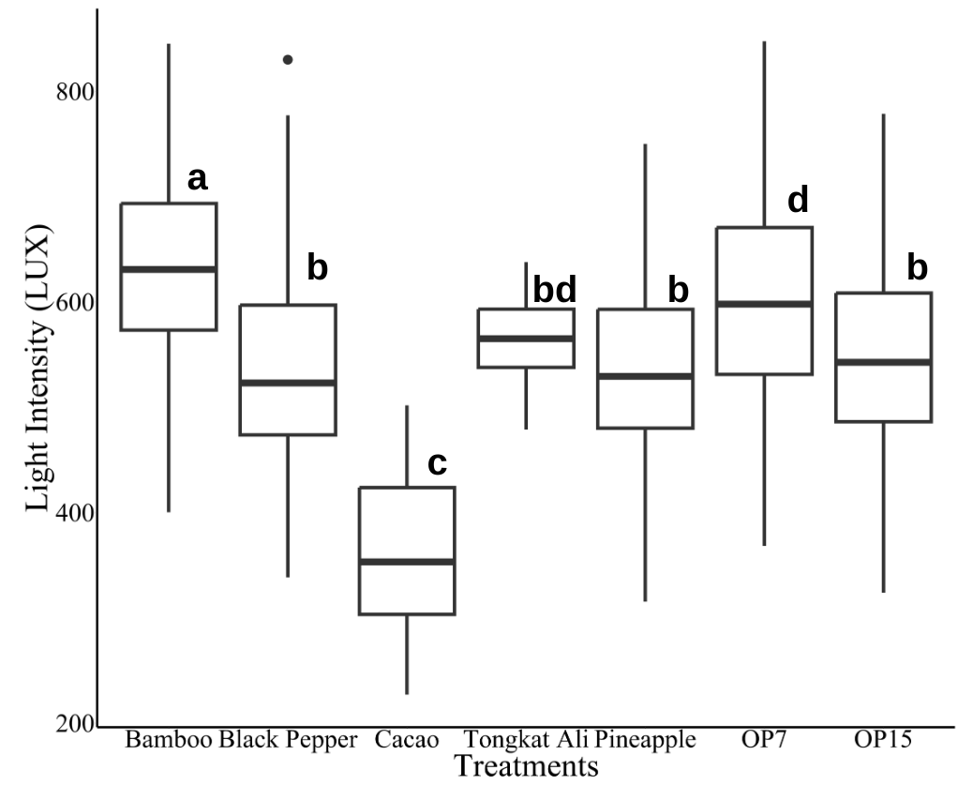
Figure S2. Images showing the (a) Undergrowth coverage percentage, (b) Temperature, (c) Relative humidity and (d) Light intensity in the alley-cropping (oil palm plantations with bamboo, black pepper, cacao, Tongkat Ali and pineapple) and monoculture (OP7 (oil palm ages 7 years) and OP15 (oil palm ages 15 years)). Different lowercase letters indicate significant differences in means among treatments (p < 0.05, multiple comparisons for GLMM.

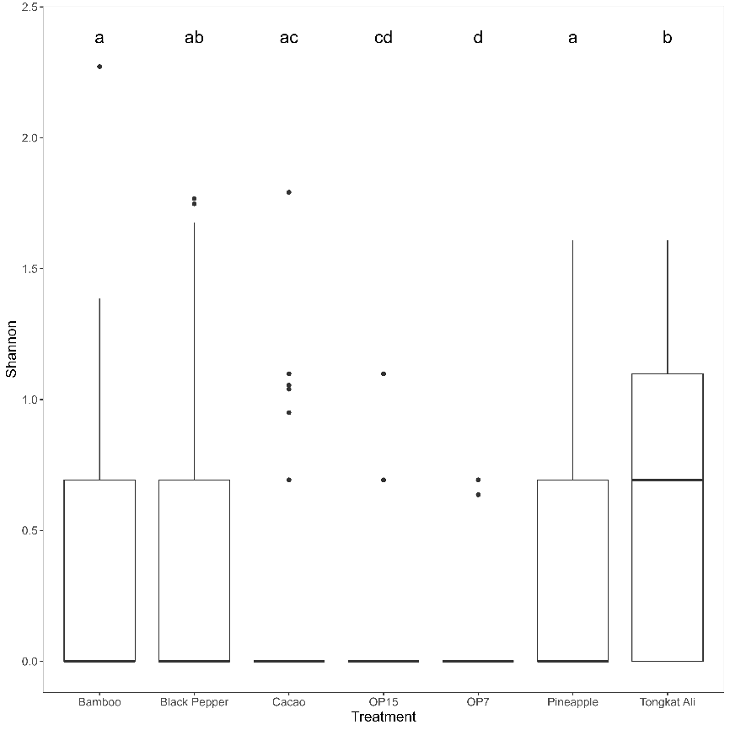

Figure S3. Boxplots showing the Shannon Diversity Index of butterfly communities across different treatments. Different lowercase letters above the bars indicate statistically significant differences between treatments (Tukey HSD, p < 0.05). Treatments sharing the same letter are not significantly different.

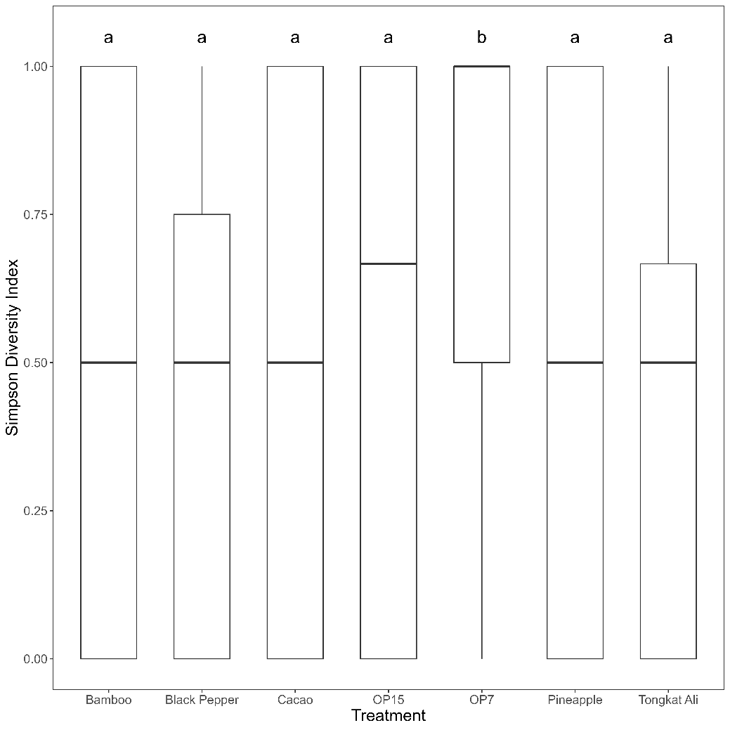

Figure S4. Simpson Diversity Index of butterfly communities across different land-use treatments. Different lowercase letters indicate statistically significant differences (Tukey HSD, p < 0.05). The Control 7yr site ('b') was significantly distinct from all other land-use types ('a')

Table S1. List of butterfly's species recorded at each treatment with their hostplants. The hostplant information was obtained from Robinson et al. (2001).
ID | Family | Scientific name | Common name | Host | Bamboo | Black Pepper | Cacao | Tongkat Ali | Pineapple | OP7 | OP15 | Total
S1 | Hesperiidae | Astictopterus jama | Forest hopper | Miscanthus sinensis (Gramineae), Phrynium spicatum (Marantaceae) | 0 | 1 | 0 | 0 | 0 | 0 | 0 | 1
S2 |  | Caltoris malaya | Malayan swift | Bambusa spp. (Graminae) | 0 | 5 | 2 | 0 | 0 | 2 | 0 | 9
S3 |  | Cephrenes trichopepla | Yellow palm dart | Arecaceae | 2 | 2 | 2 | 0 | 0 | 0 | 2 | 8
S4 |  | Erionota thrax | Banana skipper | Musa acuminata (Musaceae), Cocos nucifera (Arecaceae), Ravenala madagascariensis (Strelitziaceae), Gramineae | 0 | 0 | 0 | 0 | 0 | 1 | 0 | 1
S5 |  | Gangara thyrsis | Giant redeye | Cocos nucifera (Arecaceae), Arecaceae , Saccharum officinarum (Graminae), Musaceae, Psidium guajava (Myrtaceae) | 0 | 2 | 0 | 1 | 1 | 0 | 0 | 4
S6 |  | Lambrix salsala | Chestnut bob | No information available | 0 | 0 | 0 | 0 | 10 | 0 | 0 | 10
S7 |  | Oriens gola pseudolus | Common dartlet | Imperata cylindrica (Gramineae), Paspalum conjugatum (Gramineae) | 7 | 4 | 3 | 2 | 0 | 3 | 2 | 21
S8 |  | Pelopidas conjunctus | Conjoined swift | Bambusa spp. (Gramineae), Oryza sativa (Gramineae), Zea mays (Gramineae), Gramineae | 2 | 0 | 0 | 0 | 0 | 0 | 1 | 3
S9 |  | Pelopidas mathias | Small branded swift | Saccharum officinarum (Gramineae), Andropogon sorghum (Gramineae), Gramineae, Caryota urens (Arecaceae), Livistona chinensis (Arecaceae) | 2 | 0 | 0 | 0 | 0 | 0 | 0 | 2
S10 |  | Pithauria stramineipennis | Light straw ace | No information available | 2 | 0 | 0 | 0 | 0 | 0 | 0 | 2
S11 |  | Taractrocera archias quinta | Yellow grass dart | Gramineae | 0 | 2 | 0 | 0 | 0 | 0 | 0 | 2
S12 |  | Taractrocera ardonia lamia | Spotted grass dart | Gramineae | 0 | 1 | 0 | 1 | 0 | 1 | 0 | 3
S13 |  | Telicota augias augias | Pale palm dart | Andropogon spp. (Gramineae), Bambusa spp. (Gramineae), Imperata cylindrica (Gramineae), Oryza sativa (Gramineae), Saccharum officinarum (Gramineae) | 0 | 1 | 5 | 1 | 4 | 7 | 1 | 19
S14 |  | Telicota colon stinga | Common palm dart | Miscanthus sinensis (Gramineae), Setaria palmifolia (Gramineae), Zizania latifolia (Gramineae) | 3 | 5 | 0 | 3 | 0 | 0 | 2 | 13
S15 |  | Telicota linna | Linna palm dart | Bambusa spp. (Graminae) | 4 | 0 | 0 | 1 | 4 | 0 | 0 | 9
S16 | Lycaenidae | Lampides boeticus | Pea blue | Macaranga tanarius (Euphorbiaceae), Butea monosperma (Leguminosae), Leguminosae | 0 | 0 | 0 | 0 | 1 | 0 | 0 | 1
S17 |  | Zizeeria maha serica | Pale grass blue | No information available | 0 | 0 | 0 | 1 | 0 | 0 | 0 | 1
S18 |  | Zizina otis | Lesser grass blue | Mimosa pudica (Leguminosae), Leguminosae, Tribulus terrestris (Zygophyllaceae) | 5 | 0 | 0 | 0 | 0 | 0 | 0 | 5
S19 |  | Zizula hylax pygmaea | Pygmy grass blue | Mimosa pudica (Leguminosae) | 4 | 0 | 0 | 2 | 0 | 0 | 0 | 6
S20 | Nymphalidae | Amathusia phidippus phidippus | Palm king | Cocos nucifera (Arecaceae), Elaeis guineensis (Arecaceae), Nypa fruticans (Arecaceae) | 0 | 7 | 1 | 5 | 7 | 2 | 11 | 33
S21 |  | Ariadne merione | Common castor | Pterococcus corniculatus (Euphorbiaceae), Ricinus communis (Euphorbiaceae), Tragia hispida (Euphorbiaceae), Tragia plukenetii (Euphorbiaceae) | 0 | 0 | 0 | 1 | 0 | 0 | 1 | 2
S22 |  | Cirrochroa tyche rotundata | Common yeoman | Hydnocarpus spp. (Achariaceae) | 0 | 2 | 0 | 1 | 0 | 0 | 0 | 3
S23 |  | Cupha erymanthis lotis | Rustic | Flacourtia spp. (Salicaceae), Lepisanthes rubigonosa (Sapindaceae) | 0 | 4 | 0 | 0 | 0 | 2 | 2 | 8
S24 |  | Elymnias hypermnestra | Common palmfly | Arecaceae, Butea monosperma (Leguminosae), Lantara camara (Verbenaceae) | 14 | 2 | 0 | 3 | 2 | 0 | 24 | 45
S25 |  | Elymnias panthera panthera | Tawny palmfly | Arenga obtusifolia (Arecaceae), Metroxylon sagu (Arecaceae), Pinanga kuhlii (Arecaceae) | 0 | 0 | 0 | 6 | 0 | 0 | 0 | 6
S26 |  | Euploea camaralzeman malayica | Malayan crow | Strophanthus dichotomus (Apocynaceae) | 0 | 0 | 1 | 0 | 0 | 0 | 0 | 1
S27 |  | Euploea midamus | Blue spotted crow | Strophantus spp. (Apocynaceae), Nerium oleander (Apocynaceae), Ficus ampelas (Moraceae) | 0 | 0 | 0 | 0 | 2 | 0 | 0 | 2
S28 |  | Euploea mulciber mulciber | Striped blue crow | Nerium indicum (Apocynaceae), Aristolochia spp. (Aristolochiaceae), Ficus spp. (Moraceae) | 13 | 3 | 3 | 5 | 1 | 0 | 0 | 25
S29 |  | Hypolimnas bolina bolina | Common eggfly | Acanthaceae, Amaranthaceae, Asclepiadaceae, Commelinaceae, Compositae, Convolvulaceae, Labiatae, Leguminosae, Malvaceae, Moraceae, Polygonaceae, Portulacaceae, Rubiaceae, Urticaceae | 11 | 1 | 2 | 2 | 1 | 1 | 1 | 19
S30 |  | Ideopsis juventa | Grey glassy tiger | Gymnema spp. (Apocynaceae), Telosma cordata (Apocynaceae), Piper longum (Piperaceae) | 0 | 0 | 1 | 1 | 0 | 0 | 0 | 2
S31 |  | Ideopsis vulgaris | Blue glassy tiger | Gymnema spp. (Apocynaceae) | 0 | 0 | 3 | 0 | 0 | 0 | 2 | 5
S32 |  | Junonia atlites | Grey pansy | Acantaceae, Amaranthaceae, Oryza sativa (Gramineae), Lindernia procumbens (Scrophulariaceae) | 0 | 5 | 0 | 0 | 0 | 0 | 0 | 5
S33 |  | Junonia orithya | Blue pansy | Asystasia gangetica (Acanthaceae), Ipomoea batatas (Convolvulaceae), Plectranthus scandens (Labiatae), Scrophulariaceae, Phyla nodiflora (Verbenaceae), Viola odorata (Violaceae) | 30 | 38 | 4 | 22 | 16 | 3 | 6 | 119
S34 |  | Parantica agleoides | Dark glassy tiger | Gymnema spp. (Apocynaceae), Lasianthus firmus (Rubiaceae) | 0 | 4 | 2 | 0 | 0 | 0 | 0 | 6
S35 |  | Parthenos sylvia | Clipper | Trichosanthes spp. (Cucurbitaceae), Tinospora cordifolia (Menispermaceae), Adenia spp. (Passifloraceae), Smilax aspera (Smilacaceae) | 3 | 0 | 0 | 3 | 0 | 0 | 0 | 6
S36 |  | Ypthima baldus | Common five ring | Cynodon dactylon (Gramineae), Microstegium ciliatum (Gramineae), Miscanthus sinensis (Gramineae), Paspalum conjugatum (Graminae), Pogonatherum crinitum (Gramineae) | 0 | 64 | 16 | 2 | 7 | 2 | 13 | 104
S37 |  | Ypthima horsfieldi humei | Malayan five ring | Gramineae | 5 | 8 | 1 | 5 | 16 | 0 | 0 | 35
S38 |  | Ypthima huebneri | Common four ring | Gramineae | 0 | 3 | 1 | 7 | 0 | 0 | 0 | 11
S39 |  | Ypthima pandocus | Common three ring | Bambusa spp. (Gramineae), Imperata cylindrica (Gramineae), Miscanthus sinensis (Gramineae), Paspalum conjugatum (Gramineae) | 0 | 0 | 0 | 0 | 2 | 0 | 0 | 2
S40 |  | Zeuxidia amethystus amethystus | Saturn | Arecaceae | 0 | 0 | 1 | 0 | 0 | 0 | 2 | 3
S41 | Papilionidae | Graphium agamemnon | Tailed jay | Annonaceae, Durio spp. (Bombacaceae), Dioscorea hispida (Dioscoreaceae), Cinnamomum spp. (Lauraceae), Leguminosae, Magnoliaceae, Cistrus maxima (Rutaceae) | 0 | 0 | 0 | 2 | 3 | 0 | 3 | 8
S42 |  | Graphium doson | Common jay | Annonaceae, Hunteria zeylanica (Apocynaceae), Mesua ferrea ( Calophyllaceae), Lauraceae, Magnoliaceae | 0 | 0 | 2 | 0 | 0 | 0 | 0 | 2
S43 |  | Pachliopta aristolochiae | Common rose | Rutaceae, Aristolochiaceae | 6 | 0 | 1 | 0 | 2 | 0 | 0 | 9
S44 |  | Papilio demoleus malayanus | Lime butterfly | Rutaceae | 7 | 3 | 0 | 3 | 3 | 3 | 0 | 19
S45 |  | Papilio demolion | Banded swallowtail | Rutaceae | 0 | 0 | 3 | 0 | 3 | 1 | 0 | 7
S46 |  | Papilio iswara | Great helen | Rutaceae | 0 | 0 | 0 | 0 | 2 | 0 | 0 | 2
S47 |  | Papilio nephelus | Black and white helen | Rutaceae | 0 | 5 | 1 | 0 | 0 | 1 | 2 | 9
S48 |  | Papilio polytes | Common mormon | Rutaceae | 0 | 6 | 2 | 2 | 1 | 3 | 0 | 14
S49 |  | Papilio prexaspes | Blue helen | Rutaceae | 2 | 0 | 0 | 2 | 7 | 0 | 0 | 11
S50 |  | Troides helena | Common birdwing | Aristolochiaceae | 0 | 0 | 0 | 1 | 0 | 0 | 0 | 1
S51 | Pieridae | Appias libythea | Striped albatross | Capparaceae, Brassica juncea (Brassicaceae), Passiflora foetida (Passifloraceae) | 9 | 14 | 3 | 8 | 14 | 6 | 3 | 57
S52 |  | Appias nero figulina | Orange albatross | Capparaceae, Euphorbiaceae | 1 | 0 | 0 | 1 | 0 | 0 | 0 | 2
S53 |  | Catopsilia pomona | Lemon immigrant | Cassia spp. (leguminosae), Butea spp. (Leguminosae) | 17 | 15 | 2 | 2 | 5 | 5 | 4 | 50
S54 |  | Eurema blanda | Three spotted yellow grass | Alstonia scholaris (Apocynaceae), Caesalpinia spp. (Leguminosae), Cassia spp. (Leguminosae), Albizia spp. (Leguminosae), Camella sinensis (Theaceae), | 31 | 18 | 5 | 10 | 14 | 1 | 6 | 85
S55 |  | Eurema hecabe | Common grass yellow | Apocynaceae, Composita, Connaraceae, Cucurbitaceae, Euphorbiaceae, Clusiaceae, Leguminosae, Osmunda japonica (Osmundaceae), Cocos nucifera (Palmae), Rhamnaceae, Coffea spp. (Rubiaceae), Santalum album (Santalaceae), Camellia sinensis (Theaceae), Verbenaceae | 0 | 0 | 0 | 0 | 2 | 0 | 0 | 2
S56 |  | Eurema nicevillei | Malayan grass yellow | Leguminosae | 0 | 0 | 0 | 0 | 6 | 0 | 0 | 6
S57 |  | Leptosia nina malayana | Psyche | Cleome rutodosperma (Capparaceae), Capparis heydeana (Capparaceae), Crateva religiosa (Capparaceae) | 11 | 22 | 23 | 22 | 25 | 7 | 24 | 134
S58 |  | Pieris canidia | Cabbage white | Alstonia scholaris (Apocynaceae), Capparaceae, Cruciferae, Tropaeolum spp. (Tropaeolaceae) | 0 | 0 | 0 | 0 | 4 | 0 | 0 | 4

Table S2. List of predicted butterfly species number using Chao 2 and ACE estimators with average distance to nearest forest patches.
Treatments | Observed Species | Chao 2 Mean | ACE mean | Sampling completeness (%) | Range (Min-Max) to nearest forest patches (m) | Average distance to nearest forest patches (m)
Bamboo | 23 | 23.2 | 23.35 | 97.9% | 484.4-567.7 | 530.0
Black pepper | 28 | 29.32 | 29.68 | 94.3% | 389.7-485.2 | 435.8
Cacao | 25 | 28.07 | 29.54 | 84.6% | 657.9-790.5 | 710.6
Tongkat Ali | 31 | 35.93 | 40.61 | 76.3% | 714.8-869.6 | 793.3
Pineapple | 28 | 29.42 | 31.07 | 90.1% | 614.3-686.4 | 651.9
OP7 | 18 | 20.98 | 22.63 | 85.8% | 684.7-878.2 | 784.4
OP15 | 20 | 20.75 | 22.3 | 89.7% | 182.8-355.3 | 246.7

Table S3. Bray–Curtis similarity matrix for butterfly communities among treatments.
Values range from 0 (no similarity) to 1 (identical composition). Diagonal values represent within-treatment similarity.
Treatment | Bamboo | Black Pepper | Cacao | Control 15yr | Control 7yr | Tongkat Ali | Pineapple
Bamboo | 1.000 | 0.484 | 0.263 | 0.343 | 0.240 | 0.533 | 0.421
Black Pepper | 0.484 | 1.000 | 0.427 | 0.418 | 0.289 | 0.528 | 0.500
Cacao | 0.263 | 0.427 | 1.000 | 0.604 | 0.482 | 0.477 | 0.447
Control 15yr | 0.343 | 0.418 | 0.604 | 1.000 | 0.356 | 0.483 | 0.462
Control 7yr | 0.240 | 0.289 | 0.482 | 0.356 | 1.000 | 0.369 | 0.333
Tongkat Ali | 0.533 | 0.528 | 0.477 | 0.483 | 0.369 | 1.000 | 0.580
Pineapple | 0.421 | 0.500 | 0.447 | 0.462 | 0.333 | 0.580 | 1.000

