Supplementary Material: Farmers’ actions towards sustainability: An evidence-based methodology for native forest ecosystems supporting low-carbon livestock in grazed dairy systems
Efraín Duarte ^{1, 2, 3,} *, Viviana Bustos ^{3, 8} *, Elisavet Zoupanidou ⁴, Patricio Barria ⁵, Claudia Garrido-Ruiz ^{3,} ⁶, Alexander Hernandez ¹, Jose I. Orellana ⁷, and Benjamín Glasner ^{3, 8}
¹ Agricultural Research Service (ARS) Forage and Range Research Laboratory (FRR), United States Department of Agriculture (USDA), Logan, UT 84322, USA.
² SCINet Program and ARS AI Center of Excellence, Office of National Programs, USDA Agricultural Research Service, Beltsville, MD 20705, USA.
³ Departamento de Acuicultura y Recursos Agroalimentarios, Universidad de Los Lagos, Avda. Fuchslocher 1305, Osorno 5290000, Los Lagos, Chile.
⁴ GEDT Institute/Hub, Université de Genève. 66 boulevard Carl-Vogt, 1205 Geneva, Switzerland.
⁵ Consultora Sociedad Forestal Bosques de Paimún Ltda, Chacabuco 308, Of. 223, Valdivia, Chile.
⁶ Department of Plants, Soils and Climate, Utah State University, Logan, UT 84322, USA.
⁷ Instituto de Biología, Facultad de Ciencias, Pontificia Universidad Católica de Valparaíso, Valparaíso, Chile.
⁸ Programa de Investigación Cero Huella, Vicerrectoría de Investigación y Post Grado, Universidad de Los Lagos, Avda. Fuchslocher 1305, Osorno 5290000, Los Lagos, Chile .
* Corresponding author: Viviana Bustos, Laboratorio de Carbono y Cambio Climático, Departamento de Acuicultura y Recursos Agroalimentarios, Universidad de Los Lagos, Av. Fuchslocher 1305, Casilla 933, Osorno, Chile. Tel.: +56 93393 4828, E-mail: viviana.bustos@ulagos.cl, ORCID: 0000-0002-4347-1107
* Corresponding author: Efrain Duarte, Agricultural Research Service (ARS) Forage and Range Research Laboratory (FRR), United States Department of Agriculture (USDA), Logan, UT 84322, USA. Tel.: +1 435 554-6839, E-mail: efrain.duarte@usda.gov, ORCID: 0000-0003-3977-1024.

Table S1. Overview of the six dairy farm study sites, including general characteristics, soil and physical features, chemical properties, climatic conditions, and dominant forest types.
Description | Study sites
Description | Site 1 | Site 2 | Site 3 | Site 4 | Site 5 | Site 6
General features
Region | Los Ríos | Los Ríos | Los Ríos | Los Lagos | Los Lagos | Los Lagos
Farm Name  Province | Pitriuco  Ranco | CDM  Valdivia | CDL  La Unión | Las Vertientes  Osorno | La Querencia  Osorno | Amancayes  Llanquihue
Type of Dairy Farming | Year Round | Year Round | Year Round | Seasonal | Year Round | Year Round
System | Pasture- based | Mixed | Stalls** | Pasture- based | Pasture- based | Pasture- based
Commune | Lago Ranco | Máfil | La Unión | Puyehue | Puyehue | Fresia
Latitude and Longitude (GCS-WGS84) | -72.62, -40.25 | -72.84, -39.71 | -72.83, -40.18 | -72.81, -40.67 | -72.59, -40.72 | -73.43, -41.25
Soil features
Soil Type | Trumao – Red Clay | Trumao | Trumao – Red Clay | Trumao | Trumao | Red Clay
Slope (%) | 3% | 0% | 0% | 2% | 2% | 2%
Soil Texture | Clayey | Clayey | Clayey | Clayey | Clayey | XX
Soil Order | Andisol | Andisol | Andisol | Andisol | Andisol | Ultisol
Physical Features
Organic matter | Medium | High | High | High | High | Medium
Drainage | Imperfect | Imperfect | Imperfect | Free | Free | Imperfect
Erosion risk | Medium | Low | Medium | High | High | Medium
Chemical Features
Acidity | Moderate | Moderate | Moderate | High | High | Moderate
Phosphorus | Low | Low | Low | Low | Low | Very Low
Sulphur | Low | Low | Low | Low | Low | Very Low
Potassium | Moderate | Moderate | Moderate | Low | Low | Low
Climate features
Winter mean Tº (ºC) | 6.9 | 7.1 | 7.7 | 5.7 | 5.7 | 7.5
Summer mean Tº (ºC) | 11.7 | 15.5 | 15.9 | 14.9 | 14.9 | 12.9
Mean precipitation (mm) | 1,544 | 1,571 | 1,040 | 1,420 | 1,420 | 2,307
Forest type* | RO-RA-CO and Evergreen | RO-RA-CO and Evergreen | Evergreen | Evergreen | RO-RA-CO | RO-RA-CO
*RORACO: Roble, Raulí Coigüe (Donoso et al., 1993; Santibáñez et al., 2016)

Table S2: Tree volume functions and basic wood density values used for the calculation of biomass per species (Data compiled by Drake et al., 2003).
Common Name (Abbreviation) | Volume Functions | Basic Density  (kg/m³)
Arrayan (LA) | $$V=0.0381+0.4731×(\frac{D}{100})2×(-5.081÷0.7704×H)$$ | 799.1
Avellano (GA) | $$V=0.000079+0.000033318×D^{2}H$$ | 506.7
Canelo (DW) | $$V=0.17079+3.1379×D^{2}×\frac{H}{100000}$$ | 431.2
Coigüe (ND) | $$V=e^{(-10.312929+0.991795×LN\left(D^{2}H\right))}$$ | 504.2
Espino Negro (RE) | $$V=0.000028× D^{2}H+7.0473×{10}^{-10}× D^{2} H^{2}-2.583×{10}^{-14 }× D^{2 }H^{2}$$ | 830*
Laurel (LP) | False form factor | 447.2
Lingue (PL | $$V=-0.041488+0.000448×D^{2}+0.003063×H$$ | 464.3
Luma (AL) | $$V=0.000028 ×D^{2}H + 7.0473 × {10}^{-10}× D^{2}H^{2} - 2.583 × {10}^{-14}× D^{2}H^{2}$$ | 764.5
Maiten (MB) | False form factor | 474.4
Maqui (AC) | $$V=e^{(-6.85116+1.6647×LN(D))}$$ | 331.0
Meli (AM) | $$V=0.000025×D^{2}H+1.4085×{10}^{-10} ×{(D}^{2 }{H)}^{2}-1,28933×{10}^{-15} ×{(D}^{2}{H)}^{3}$$ | 799.1
EC (Notro) | False form factor | 474.4
Olivillo (AP) | $$V=e^{(- 9.970339 + 2.4774308× LN (D) + 0,313590783 ×LN (H))}$$ | 487.9
Palmilla (LF) | False form factor | **
Patagua (CP) | False form factor | **
Picha (MP) | False form factor | 799.1
Radal (LH) | $$V=0.007019 + 0.00002229 ×D^{3}$$ | 474.4
Roble (NO) | $$V=- 0,03695309 + 0,00075407 × D^{2}$$ | 461.4
Tepu o Temo (BC) | False form factor | 799.1
Tiaca (CP) | False form factor | 555.0
Ulmo (EC) | $$V=e^{(-8.666544 +2.149093× LN (D)+ 0.2508636 ×LN (H))}$$ | 546.9

Table S3. Mean annual periodic increment (m³ ha⁻¹ year⁻¹) for the main native forest types of southern Chile, based on National Forest Inventory data
Forest type | Mean annual periodic increment (m³ ha⁻¹ year⁻¹)*
Alerce (Fitzroya cupressoides) | 0.5
Ciprés de Las Guaitecas (Pilgerodendron uviferum) | 3.9
Ciprés de La Cordillera (Austrocedrus chilensis) | 5.0
Lenga (Nothofagus pumilio) | 5.8
Roble Hualo (Nothofagus obliqua and/or Nothofagus glauca) | 5.1
Roble (Nothofagus obliqua) – Raulí (Nothofagus alpina) Coihue (Nothofagus dombeyi) | 6.6
Coihue – Raulí – Tepa (Laureliopsis philippiana) | 5.8
Esclerófilo | 1.5
Siempreverde (Evergreen) | 6.0
*Source: (INFOR, 2015).

Table S4: Summary of Sentinel 2 spectral bands and indices covariates used to model aboveground biomass (AGB) in this study.
Dataset (Covariates) | Abbr | Formula | Bands | Reference
Normalized Difference Vegetation Index | NDVI | $$NDVI=\frac{\left(NIR-Red\right)}{\left(NIR+Red\right)}$$ | B8, B4 | (Illarionova et al., 2024)
Enhanced Vegetation Index | EVI | $$EVI=2.5 * \frac{\left(NIR+Red\right)}{\left(NIR+6*Red-7.5*Blue+L\right)}$$ | B8A, B4, B2 | (A. Huete et al., 2002)
Soil Adjusted Vegetation Index | SAVI | $$SAVI=\frac{\left(NIR-Red\right)}{\left(NIR+Red+L\right)}*\left(1+L\right)$$ | B8, B4 | (A. R. Huete, 1988)
Index-Based built-up Index | IBI | $$IBI=\frac{NDBI -\frac{\left(SAVI + MNDWI\right)}{2}}{NDBI +\frac{\left(SAVI + MNDWI\right)}{2}}$$ | B11, B3, B8, B4 | (Xu, 2008)
Bare Soil Index | BSI | $$BSI=\frac{\left(SWIR1+Red\right)-\left(NIR+Blue\right) }{\left(SWIR1+Red\right)+\left(NIR+Blue\right)}$$ | B11, B4, B8, B2, | (Hill, 2013)
Green Normalized Difference Vegetation Index | GNDVI | $$GNDVI=\frac{\left(NIR-Green\right)}{\left(NIR+Green\right)}$$ | B8A, B3 | (Gitelson et al., 1996)
Band 2 Blue | B_{BLUE} | Wavelength (nm) 490 - Bandwidth (nm) 65 | B2 | (Drusch et al., 2012)
Band 3 Green | B_{GREEN} | Wavelength (nm) 560 - Bandwidth (nm) 35 | B3 | (Drusch et al., 2012)
Band 4 Red | B_{RED} | Wavelength (nm) 665 - Bandwidth (nm) 30 | B4 | (Drusch et al., 2012)
Band 5 | Red Edge1 | Wavelength (nm) 705 - Bandwidth (nm) 15 | B5 | (Drusch et al., 2012)
Band 6 | Red Edge2 | Wavelength (nm) 740 - Bandwidth (nm) 15 | B6 | (Drusch et al., 2012)
Band 7 | Red Edge3 | Wavelength (nm) 783 - Bandwidth (nm) 20 | B7 | (Drusch et al., 2012)
Band 8 | NIR_{wide} | Wavelength (nm) 842 - Bandwidth (nm) 115 | B8 | (Drusch et al., 2012)
Band 8A | NIR_{narrow} | Wavelength (nm) 865 - Bandwidth (nm) 20 | B8A | (Drusch et al., 2012)
Band 11 Shortwave infrared- | SWIR | Wavelength (nm) 1,610 - Bandwidth (nm) 90 | B11 | (Drusch et al., 2012)
Band 12 Shortwave infrared- | SWIR | Wavelength (nm) 2,190 - Bandwidth (nm) 180 | B12 | (Drusch et al., 2012)

Table S5: Main native species found in the carbon inventories of the six dairy farms of Los Ríos and Los Lagos Regions.
Common Name | Scientific name | Abb | IUCN Red List Categories*
Arrayán | Luma apiculata | LA | LC
Avellano | Gevuina avellana | GA | LC
Canelo | Drimys winteri | DW | LC
Coigüe | Nothofagus dombeyi | ND | LC
Espino Negro | Rhaphithamnus espinosus | RE | LC
Laurel | Laurelia sempervirens | LS | NT
Lingue | Persea lingue | PL | LC
Luma | Amomyrtus luma | AL | NE
Maitén | Maytenus boaria | MB | LC
Maqui | Aristotelia chilensis | AC | NE
Meli | Amomyrtus meli | AM | LC
Notro | Embothrium coccineum | EC | LC
Olivillo | Aextoxicon punctatum | AP | LC
Palmilla | Lomatia ferruginea | LF | NE
Patagua | Crinodendron patagua | CP | NE
Picha o Pitra | Myrceugenia planipes | MP | NE
Radal | Lomatia hirsuta | LH | LC
Roble | Nothofagus obliqua | NO | LC
Temu o Temo | Blepharocalyx cruckshanksii | BC | NT
Tiaca | Caldcluvia paniculata | CP | NE
Ulmo | Eucryphia cordifolia | EC | NT
* IUCN red list categories: Not Evaluated (NE), Data Deficient (DD), Least Concern (LC), Near Threatened (NT), Vulnerable (V), Endangered (E), Critically Endangered (CE), Extinct in the Wild (EW) and Extinct.

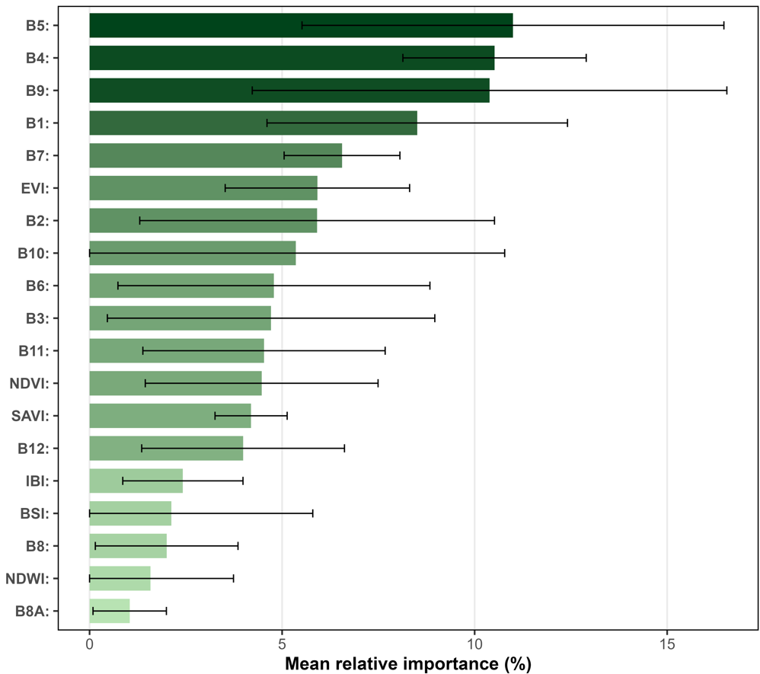
Fig. S1. Mean relative importance of Sentinel-2 spectral predictors used in the Random Forest models. Values represent normalized importance averaged across Sites. Error bars indicate standard deviation among sites

Supplementary Script S1: Example Google Earth Engine workflow used for carbon modeling. Due to data confidentiality agreements, original input datasets cannot be publicly shared. Access may be granted upon reasonable request. This example script using sample data is provided to illustrate the workflow: https://github.com/EDuarteCode/Aboveground-Carbon-Stock

