Appendix

Table A1. Codebook

First-level code | Second-level codes | Third-level codes
1. Meaning of agricultural diversification | Diversified production systems | Grazed livestock, horticultural food crops, agroforestry, extended rotations/small grains, perennials, cover crops, organics, crop and livestock variety
1. Meaning of agricultural diversification | Memories/nostalgia for pre-1960s farming systems; market diversification, sustainability/interconnectedness; enterprise diversity; creativity; landscape diversification; labor diversification; risk management; seasonality; intensification | n/a
2. Economics and markets | Income, prices, and productivity; risk; market access; buyer requirements; landowners; alternative marketing arrangements; consumers; scale; food and beverage companies; labeling/certification | Benefit of nondiversified system  Challenge of current agricultural system  Opportunity for diversification
3. Internal factors and decision-making | Farmer well-being; status quo bias; Farmer goals, values, identity, beliefs
4. Social networks and norms | Access to farmer networks; influence of neighbors; aesthetic preferences; family collaboration and succession planning
5. Infrastructure | On and off farm infrastructure
6. Capacity | Technical support; access to information; marketing and other skills; agricultural education
7. Inputs and technology | Research and development; input use; time required to adopt; technology/equipment; land; labor; credit and capital
8. Policy and financial incentives | Crop insurance; commodity payments; biofuel policies; cost share programs; carbon trading
9. Social impacts of agriculture | Nutrition and local food; worker safety; political economy; rural community; underrepresented farmers
10. Farm management and environmental conditions | Soil health; water quality and runoff; pests and diseases; climatic conditions; farm management; ecosystem services

Figure A1: Jaccard coefficient diagram
The Jaccard coefficient measures coding similarity for a given set of codes, ranging from zero (no similarity) to one (complete similarity). The cluster diagramming of Jaccard coefficients shown in Figure A1 illustrates the importance of income, prices, and productivity and challenges with access to markets in terms of relationships to other codes. Lines and colors indicate relationships between codes – for example, the codes for market access, income, and scale are strongly related to the ‘benefits of corn and soybean agriculture’ category; while risk, access to information and technical support, time and effort required to diversify, land, and technology and equipment are typically framed as challenges to the current agricultural system. The diagram also illustrates the strong relationship between benefits and challenges of the current agricultural system, indicating trade-offs in corn and soybean agriculture.

Figure A1: Cluster diagramming of Jaccard coefficients for codes relating to benefits and challenges of the agricultural system, using a threshold of .7.
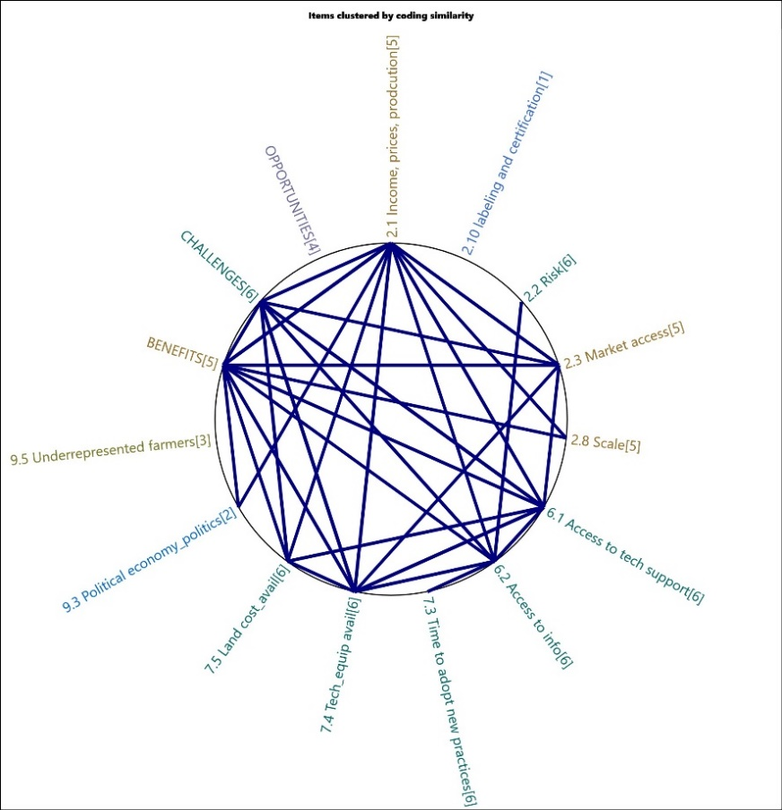

Table A2. Crops and livestock produced by study participants. Note-categories based on participant entered data; thus, some categories overlap.

Table 3. Crops and livestock produced by study participants.
Crops | Iowa (n) | Iowa (%) | Illinois (n) | Illinois (%) | Indiana (n) | Indiana (%) | All states (n) | All states (%) | % participants
corn | 20 | 17.7 | 19 | 18.1 | 44 | 21.9 | 83 | 19.8 | 83
soybeans | 20 | 17.7 | 17 | 16.2 | 45 | 22.4 | 82 | 19.6 | 82
wheat | 1 | 0.9 | 8 | 7.6 | 26 | 12.9 | 35 | 8.4 | 35
hay | 3 | 2.7 | 4 | 3.8 | 14 | 7.0 | 21 | 5.0 | 21
cattle | 4 | 3.5 | 3 | 2.9 | 13 | 6.5 | 20 | 4.8 | 20
rye | 6 | 5.3 | 4 | 3.8 | 4 | 2.0 | 14 | 3.3 | 14
pumpkins | 3 | 2.7 | 3 | 2.9 | 2 | 1.0 | 8 | 1.9 | 8
apples | 4 | 3.5 | 3 | 2.9 | 0 | 0.0 | 7 | 1.7 | 7
hogs | 1 | 0.9 | 2 | 1.9 | 4 | 2.0 | 7 | 1.7 | 7
alfalfa | 2 | 1.8 | 0 | 0.0 | 4 | 2.0 | 6 | 1.4 | 6
cover crops | 0 | 0.0 | 0 | 0.0 | 6 | 3.0 | 6 | 1.4 | 6
oats | 1 | 0.9 | 3 | 2.9 | 2 | 1.0 | 6 | 1.4 | 6
vegetables | 2 | 1.8 | 2 | 1.9 | 2 | 1.0 | 6 | 1.4 | 6
goats | 2 | 1.8 | 1 | 1.0 | 2 | 1.0 | 5 | 1.2 | 5
pasture | 0 | 0.0 | 0 | 0.0 | 5 | 2.5 | 5 | 1.2 | 5
sheep | 2 | 1.8 | 1 | 1.0 | 2 | 1.0 | 5 | 1.2 | 5
sunflowers | 0 | 0.0 | 3 | 2.9 | 2 | 1.0 | 5 | 1.2 | 5
eggs | 1 | 0.9 | 3 | 2.9 | 0 | 0.0 | 4 | 1.0 | 4
pears | 2 | 1.8 | 2 | 1.9 | 0 | 0.0 | 4 | 1.0 | 4
chickens | 0 | 0.0 | 2 | 1.9 | 1 | 0.5 | 3 | 0.7 | 3
pawpaw | 2 | 1.8 | 1 | 1.0 | 0 | 0.0 | 3 | 0.7 | 3
asian pears | 1 | 0.9 | 1 | 1.0 | 0 | 0.0 | 2 | 0.5 | 2
blackberries | 1 | 0.9 | 1 | 1.0 | 0 | 0.0 | 2 | 0.5 | 2
blueberries | 2 | 1.8 | 0 | 0.0 | 0 | 0.0 | 2 | 0.5 | 2
canola | 0 | 0.0 | 1 | 1.0 | 1 | 0.5 | 2 | 0.5 | 2
cherries | 2 | 1.8 | 0 | 0.0 | 0 | 0.0 | 2 | 0.5 | 2
chestnuts | 2 | 1.8 | 0 | 0.0 | 0 | 0.0 | 2 | 0.5 | 2
flowers | 0 | 0.0 | 0 | 0.0 | 2 | 1.0 | 2 | 0.5 | 2
forage | 0 | 0.0 | 0 | 0.0 | 2 | 1.0 | 2 | 0.5 | 2
gooseberries | 2 | 1.8 | 0 | 0.0 | 0 | 0.0 | 2 | 0.5 | 2
green beans | 0 | 0.0 | 1 | 1.0 | 1 | 0.5 | 2 | 0.5 | 2
honeyberries | 2 | 1.8 | 0 | 0.0 | 0 | 0.0 | 2 | 0.5 | 2
lumber | 0 | 0.0 | 0 | 0.0 | 2 | 1.0 | 2 | 0.5 | 2
peaches | 0 | 0.0 | 2 | 1.9 | 0 | 0.0 | 2 | 0.5 | 2
persimmon | 2 | 1.8 | 0 | 0.0 | 0 | 0.0 | 2 | 0.5 | 2
potatoes | 0 | 0.0 | 1 | 1.0 | 1 | 0.5 | 2 | 0.5 | 2
raspberries | 2 | 1.8 | 0 | 0.0 | 0 | 0.0 | 2 | 0.5 | 2
strawberries | 1 | 0.9 | 1 | 1.0 | 0 | 0.0 | 2 | 0.5 | 2
aronia | 1 | 0.9 | 0 | 0.0 | 0 | 0.0 | 1 | 0.2 | 1
berries | 1 | 0.9 | 0 | 0.0 | 0 | 0.0 | 1 | 0.2 | 1
black currant | 1 | 0.9 | 0 | 0.0 | 0 | 0.0 | 1 | 0.2 | 1
butterflies | 0 | 0.0 | 0 | 0.0 | 1 | 0.5 | 1 | 0.2 | 1
clovers | 0 | 0.0 | 0 | 0.0 | 1 | 0.5 | 1 | 0.2 | 1
elderberries | 1 | 0.9 | 0 | 0.0 | 0 | 0.0 | 1 | 0.2 | 1
fruits | 0 | 0.0 | 0 | 0.0 | 1 | 0.5 | 1 | 0.2 | 1
grape onions | 1 | 0.9 | 0 | 0.0 | 0 | 0.0 | 1 | 0.2 | 1
hazel | 1 | 0.9 | 0 | 0.0 | 0 | 0.0 | 1 | 0.2 | 1
heartnuts | 1 | 0.9 | 0 | 0.0 | 0 | 0.0 | 1 | 0.2 | 1
heartouts | 1 | 0.9 | 0 | 0.0 | 0 | 0.0 | 1 | 0.2 | 1
herbs | 0 | 0.0 | 0 | 0.0 | 1 | 0.5 | 1 | 0.2 | 1
hican | 1 | 0.9 | 0 | 0.0 | 0 | 0.0 | 1 | 0.2 | 1
hickory | 1 | 0.9 | 0 | 0.0 | 0 | 0.0 | 1 | 0.2 | 1
kousa | 1 | 0.9 | 0 | 0.0 | 0 | 0.0 | 1 | 0.2 | 1
lamb | 0 | 0.0 | 1 | 1.0 | 0 | 0.0 | 1 | 0.2 | 1
lavender | 0 | 0.0 | 0 | 0.0 | 1 | 0.5 | 1 | 0.2 | 1
live plants | 0 | 0.0 | 0 | 0.0 | 1 | 0.5 | 1 | 0.2 | 1
nuts | 0 | 0.0 | 0 | 0.0 | 1 | 0.5 | 1 | 0.2 | 1
peas | 0 | 0.0 | 0 | 0.0 | 1 | 0.5 | 1 | 0.2 | 1
pecans | 1 | 0.9 | 0 | 0.0 | 0 | 0.0 | 1 | 0.2 | 1
pepper | 1 | 0.9 | 0 | 0.0 | 0 | 0.0 | 1 | 0.2 | 1
plums | 1 | 0.9 | 0 | 0.0 | 0 | 0.0 | 1 | 0.2 | 1
popcorn | 0 | 0.0 | 0 | 0.0 | 1 | 0.5 | 1 | 0.2 | 1
red currant | 1 | 0.9 | 0 | 0.0 | 0 | 0.0 | 1 | 0.2 | 1
rhubarb | 1 | 0.9 | 0 | 0.0 | 0 | 0.0 | 1 | 0.2 | 1
small grains | 0 | 0.0 | 0 | 0.0 | 1 | 0.5 | 1 | 0.2 | 1
spelt | 0 | 0.0 | 0 | 0.0 | 1 | 0.5 | 1 | 0.2 | 1
tomato | 1 | 0.9 | 0 | 0.0 | 0 | 0.0 | 1 | 0.2 | 1
trees | 1 | 0.9 | 0 | 0.0 | 0 | 0.0 | 1 | 0.2 | 1
triticale | 0 | 0.0 | 0 | 0.0 | 1 | 0.5 | 1 | 0.2 | 1
vetch | 0 | 0.0 | 0 | 0.0 | 1 | 0.5 | 1 | 0.2 | 1
watermelons | 1 | 0.9 | 0 | 0.0 | 0 | 0.0 | 1 | 0.2 | 1
winter squash | 1 | 0.9 | 0 | 0.0 | 0 | 0.0 | 1 | 0.2 | 1
buckwheat | 0 | 0.0 | 1 | 1.0 | 0 | 0.0 | 1 | 0.2 | 1
tree fruits | 0 | 0.0 | 1 | 1.0 | 0 | 0.0 | 1 | 0.2 | 1
mums | 0 | 0.0 | 1 | 1.0 | 0 | 0.0 | 1 | 0.2 | 1
saskatoon | 0 | 0.0 | 1 | 1.0 | 0 | 0.0 | 1 | 0.2 | 1
brassica's | 0 | 0.0 | 1 | 1.0 | 0 | 0.0 | 1 | 0.2 | 1
lettuces | 0 | 0.0 | 1 | 1.0 | 0 | 0.0 | 1 | 0.2 | 1
leafy greens | 0 | 0.0 | 1 | 1.0 | 0 | 0.0 | 1 | 0.2 | 1
sunchokes | 0 | 0.0 | 1 | 1.0 | 0 | 0.0 | 1 | 0.2 | 1
sweetcorn | 0 | 0.0 | 1 | 1.0 | 0 | 0.0 | 1 | 0.2 | 1
flint corn | 0 | 0.0 | 1 | 1.0 | 0 | 0.0 | 1 | 0.2 | 1
nightshades | 0 | 0.0 | 1 | 1.0 | 0 | 0.0 | 1 | 0.2 | 1
artichokes | 0 | 0.0 | 1 | 1.0 | 0 | 0.0 | 1 | 0.2 | 1
aliums | 0 | 0.0 | 1 | 1.0 | 0 | 0.0 | 1 | 0.2 | 1
sweet potatoes | 0 | 0.0 | 1 | 1.0 | 0 | 0.0 | 1 | 0.2 | 1
melons | 0 | 0.0 | 1 | 1.0 | 0 | 0.0 | 1 | 0.2 | 1
milo | 0 | 0.0 | 0 | 0.0 | 1 | 0.5 | 1 | 0.2 | 1
Sum of all: | 113 | 100 | 105 | 100 | 201 | 100 | 419 | 100

Table A3. Benefits of corn and soybean agriculture mentioned in 30% or more of the focus groups, sorted by frequency.
 | Focus group total (20)
Code | Mention (n) | %
2.1 income, prices, and productivity | 16 | 80%
2.3 access to markets | 13 | 65%
8.1 crop insurance | 13 | 65%
6.1 Access to technical support | 11 | 55%
7.4 availability of technology or equipment | 11 | 55%
9.3 political economy/politics | 9 | 45%
3.2 ease of status quo/path dependence/status quo bias | 7 | 35%
6.2 access to information | 7 | 35%
7.2 input use, availability or cost | 7 | 35%
7.6 labor availability/intensity | 7 | 35%
10.1 soil health | 6 | 30%
2.2 Risk | 6 | 30%
2.8 Scale | 6 | 30%
3.1 Farmer quality of life/well-being | 6 | 30%

Table A4: Challenges for the agricultural system mentioned in 70% or more of the discussions, sorted by frequency.

 | Focus Group Total (20)
Code | Mention (n) | %
2.1 Income, prices, and productivity | 19 | 95%
2.3 Access to Markets | 19 | 95%
7.6 labor availability/intensity | 19 | 95%
7.5 land cost or availability | 18 | 90%
9.3 political economy/politics | 18 | 90%
2.8 Scale | 17 | 85%
7.3 time required for adoption of new practices | 17 | 85%
7.2 input use, availability or cost | 16 | 80%
8.1 crop insurance | 16 | 80%
10.4 Climatic conditions | 15 | 75%
2.2 Risk | 15 | 75%
4.2 perceptions/influence of neighbors | 15 | 75%
7.4 availability of technology or equipment | 15 | 75%
9.1 nutrition, local food, and food access | 15 | 75%
10.5 Farm management | 14 | 70%
2.7 consumer preferences/awareness | 14 | 70%
3.3 Farmer goals, values, identity, beliefs | 14 | 70%
5.1 on farm infrastructure | 14 | 70%
5.2 off farm infrastructure | 14 | 70%
6.1 Access to technical support | 14 | 70%
6.2 access to information | 14 | 70%

Table A5: Opportunities for diversified agriculture mentioned in more than 50% of the focus groups, sorted by frequency.
 | Focus Group Total (20)
Code | Mention (n) | %
2.1 income, prices, and productivity | 18 | 90%
2.6 alternative marketing arrangements | 16 | 80%
6.2 access to information | 16 | 80%
10.1 soil health | 15 | 75%
2.3 access to markets | 14 | 70%
4.1 Access to farmer networks | 14 | 70%
6.1 Access to technical support | 13 | 65%
7.4 availability of technology or equipment | 13 | 65%
9.1 nutrition, local food, and food access | 13 | 65%
10.5 Farm management | 12 | 60%
2.2 Risk | 12 | 60%
2.7 consumer preferences/awareness | 12 | 60%
7.2 input use, availability or cost | 12 | 60%
4.4 family collaboration and succession plans/next-generation farmer | 11 | 55%

