Supplementary material to “Assessing the impact of EU agricultural policies on the sustainability of the livestock sector: a review of the recent literature”

Table S1: Combinations of search terms and Boolean operators
No. | Level 1 | Level 2 | Level 3 | Level 4
1 | (“Europe” OR “EU”) AND | “Polic*” AND | “livestock” AND | (“sustainability” OR “impact*” OR “efficacy”)
2 | (“Europe” OR “EU”) AND | “Polic*” AND | (“beef” OR “dairy”) AND | (“sustainability” OR “impact*” OR “efficacy”)
3 | (“Europe” OR “EU”) AND | “Polic*” AND | (“goat” OR “sheep”) AND | (“sustainability” OR “impact*” OR “efficacy”)
4 | (“Europe” OR “EU”) AND | “Polic*” AND | (“pig” OR “poultry”) AND | (“sustainability” OR “impact*” OR “efficacy”)
5 |  | (“CAP” OR  ”Common Agri-cultural Policy”) AND | “livestock” AND | (“sustainability” OR “impact*” OR “efficacy”)
6 |  | (“CAP” OR ”Common Agri-cultural Policy”) AND | (“beef” OR “dairy”)  AND | (“sustainability “ OR “impact*” OR “efficacy”)
7 |  | (“CAP” OR ”Common Agri-cultural Policy”) AND | (“goats” OR “sheep”) AND | (“sustainability “ OR “impact*” OR “efficacy”)
8 |  | (“CAP” OR ”Common Agri-cultural Policy”) AND | (“pig” OR “poultry”) AND | (“sustainability “ OR “impact*” OR “efficacy”)

Table S2: Literature search results overview
Search combi-nation No. | No. of results screened | Excluded because of … |  |  |  |  |  | Could not be obtained | Included in review
Search combi-nation No. | No. of results screened | Geo-graphy | No livestock focus | No EU policy focus | Not related to research topic | Langu-age | Other | Could not be obtained | Included in review
1 | 438 | 37 | 29 | 121 | 183 | 9 | 27 | 6 | 26
2 | 146 | 16 | 7 | 43 | 44 | 3 | 19 | 0 | 14
3 | 25 | 1 | 0 | 8 | 14 | 0 | 1 | 0 | 1
4 | 151 | 17 | 6 | 33 | 72 | 3 | 10 | 0 | 10
5 | 152 | 25 | 5 | 33 | 53 | 3 | 22 | 3 | 8
6 | 65 | 6 | 1 | 15 | 35 | 0 | 7 | 0 | 1
7 | 10 | 0 | 0 | 1 | 9 | 0 | 0 | 0 | 0
8 | 97 | 8 | 0 | 87 | 2 | 0 | 0 | 0 | 0
Totals | 1084 | 110 | 48 | 341 | 412 | 18 | 86 | 9 | 60

Table S3: List of review categories
Aggregated Category | Review question categories
Sustainability Definition | Does the paper define sustainability?
Sustainability Definition | How does the paper define sustainability?
Policy impacts | What impacts have past policies had in enhancing or decreasing the sustainability of the European livestock sector? (incl. Quantitative indicators)
Policy impacts | How have past European policies influenced the sustainability of the livestock sector? (mechanisms, processes)
Policy impacts | What are the reasons for successes and failures of the EU policies with regards to the sustainability of the livestock sector?
Leverage Points | Re-Connect  Does the paper discuss a reconnection of people with nature as an impact of policies and what does it look like?
Leverage Points | Re-Structure  Does the paper discuss whether the impacts are linked to institutional changes (e.g. laws, regulations, contracts, customs) such as failures, crises, new institutions replacing old ones? What are these changes and what impacts do they have?
Leverage Points | Re-Think  Does the paper discuss how knowledge is created and shared as an impact of policies and what does it look like? Does the paper itself question existing perceptions?
SAFA categories | Economy  Does the paper cover economic impacts of policies and what are they?
SAFA categories | Environment (incl. animal welfare)  Does the paper cover environmental impacts of policies and what are they?
SAFA categories | Social  Does the paper cover social impacts of policies and what are they?
SAFA categories | Governance  Does the paper cover governance impacts of policies and what are they?
One Welfare categories | Animal Welfare  Does the paper cover animal welfare impacts of policies and what are they?
One Welfare categories | Human Wellbeing  Does the paper cover human wellbeing impacts of policies and what are they?
One Welfare categories | Environmental Conservation  Does the paper cover environmental conservation impacts of policies and what are they?"

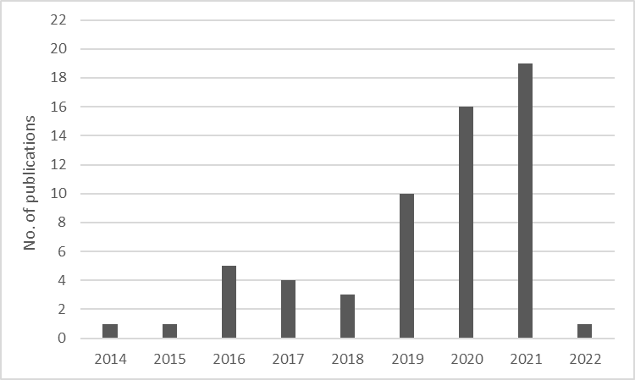
Figure S1: Number of publications per year included in this review
The EU level was represented the most by studies included (n=14) (Figure S2). This was followed by a group of countries with 6-8 studies: UK (n=6), Ireland (n=7), Spain (n=7) and Germany (n=7); and a group of the same counts (n=5) for Romania and France. However, there were also ten countries with only one or two studies covering this area. No references were identified for the Member States Czech Republic, Hungary, Luxembourg, Cyprus, Estonia, Lithuania, Malta and Poland, or Switzerland. For livestock types, livestock on a general level was considered by 22% of the included studies, followed by dairy cattle (n=15), pigs (n=14) and beef cattle (n=14) (Figure S3). The lowest number of included studies was on poultry (n=5). Dairy and beef cattle combined covered a third of all studies (34%).
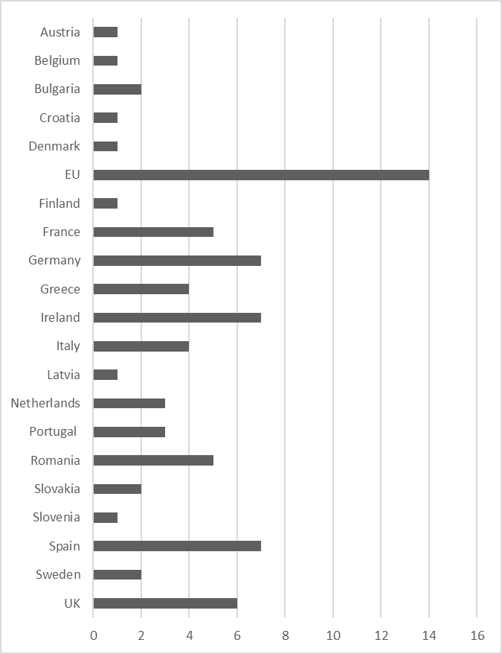
Figure S2 Number of studies included in review by geographic scope

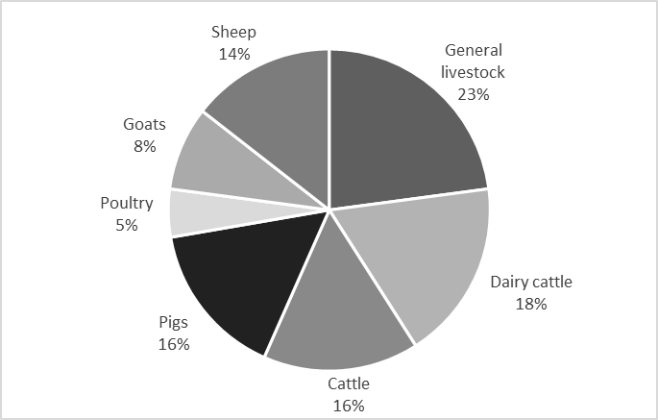
Figure S3 Share of livestock species included in review

