Supplemental
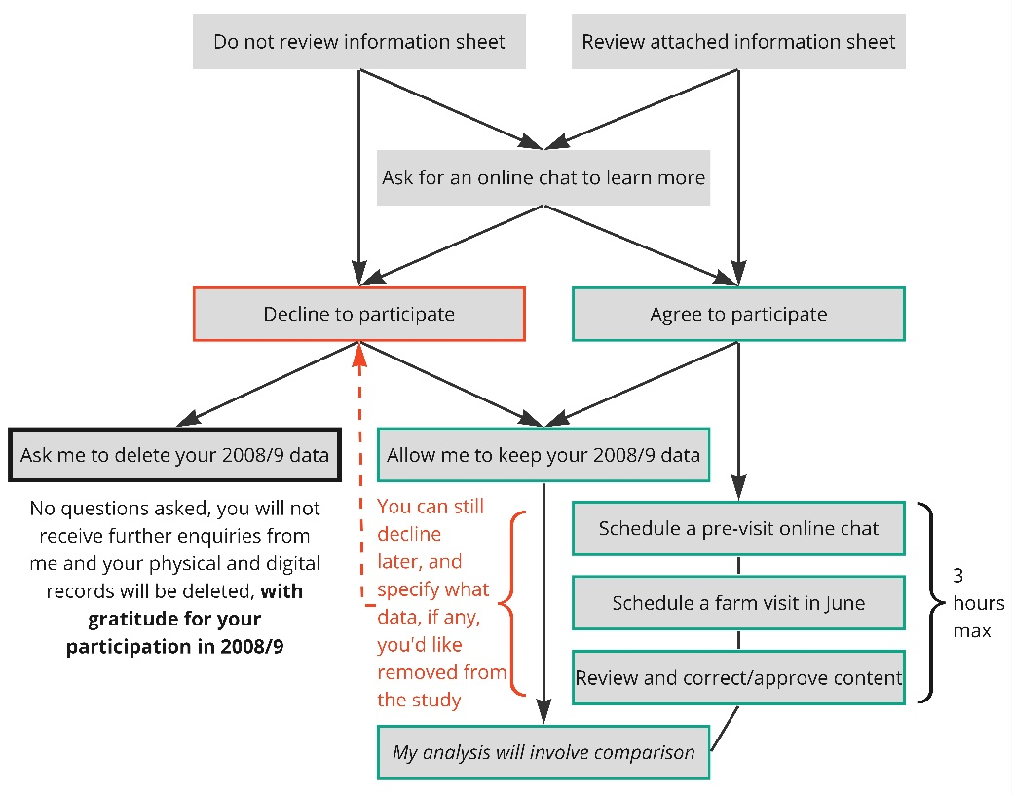
Supplemental Fig. 1 Decision and information flowchart provided to farmers in 2024 to determine their concluded or continued participation in this study
Pseudonyms
Ken (after Kenneth Slessor)
Will and Dora (after Will Ogilvie and Dora Wilcox)
Les (after Les Murray)
Dorothea (after Dorothea MacKellar)
Adam and Judy (after A.L. Gordon and Judith Wright)
John and Lucy (after John O’Brien and Lucy Homfray)
Henry and Gwen (after Henry Lawson and Gwen Harwood)
Bruce (after Bruce Dawe)
Andrew and Elsie (after Banjo Patterson and Elsie Cole)

Supplemental Table 1 Pseudonyms of grazier participants, after Australian bush poets (names redacted)

