Supplement Graphs
Figure S1. Predicted probabilities for at least 75% ART adherence in Month 8 (with 95% confidence intervals) based on MDS scale (Black/Race) for Africultural coping (cognitive/emotional debriefing).
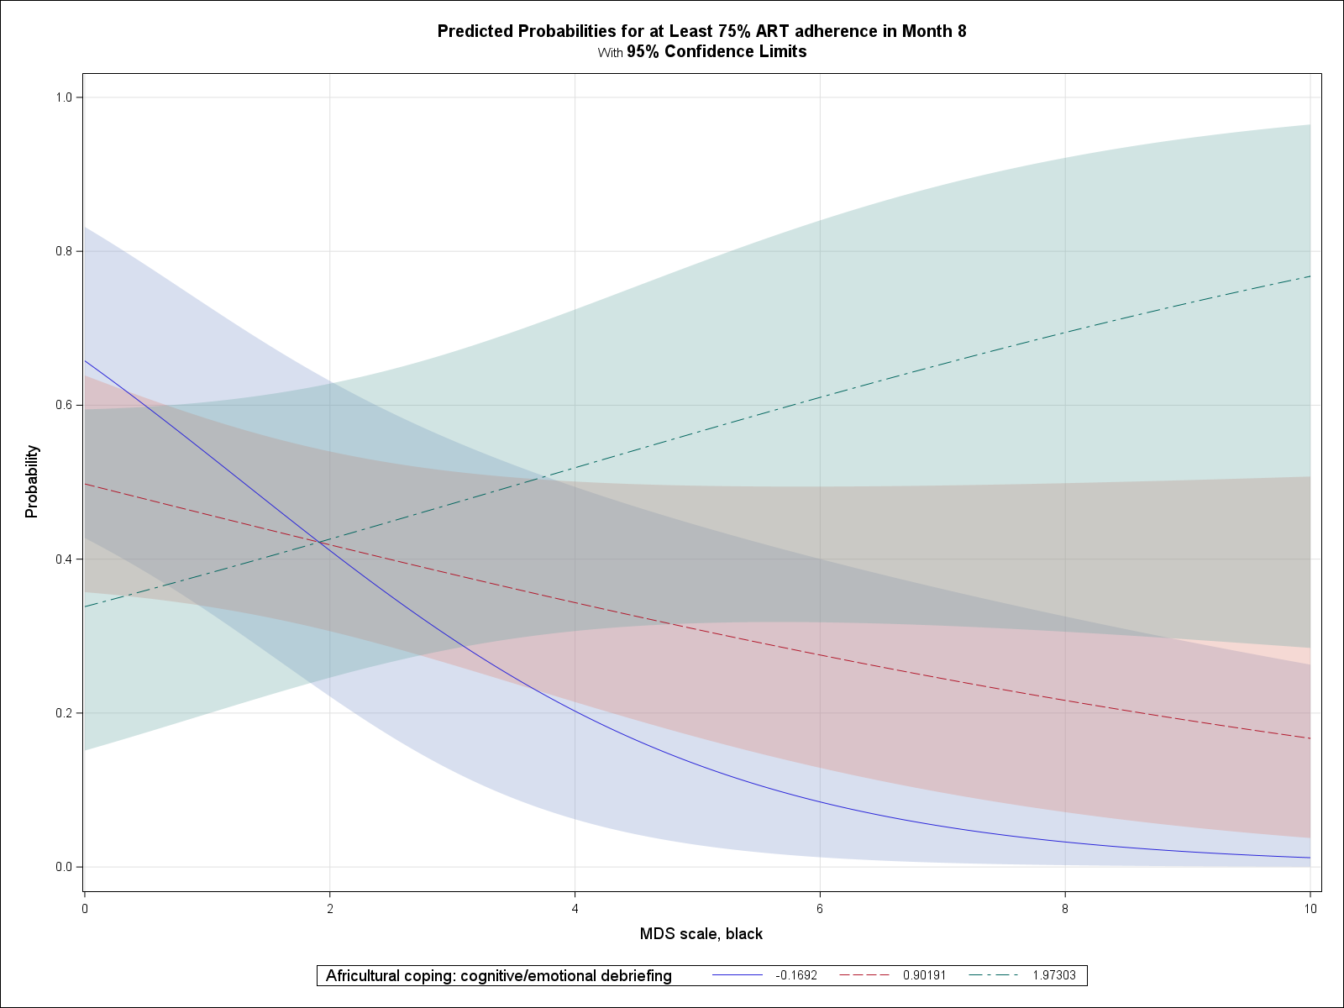

Figure S1. Predicted probabilities for at least 75% ART adherence in Month 8 (with 95% confidence intervals) based on MDS scale (Black/Race) for Africultural coping (collective).
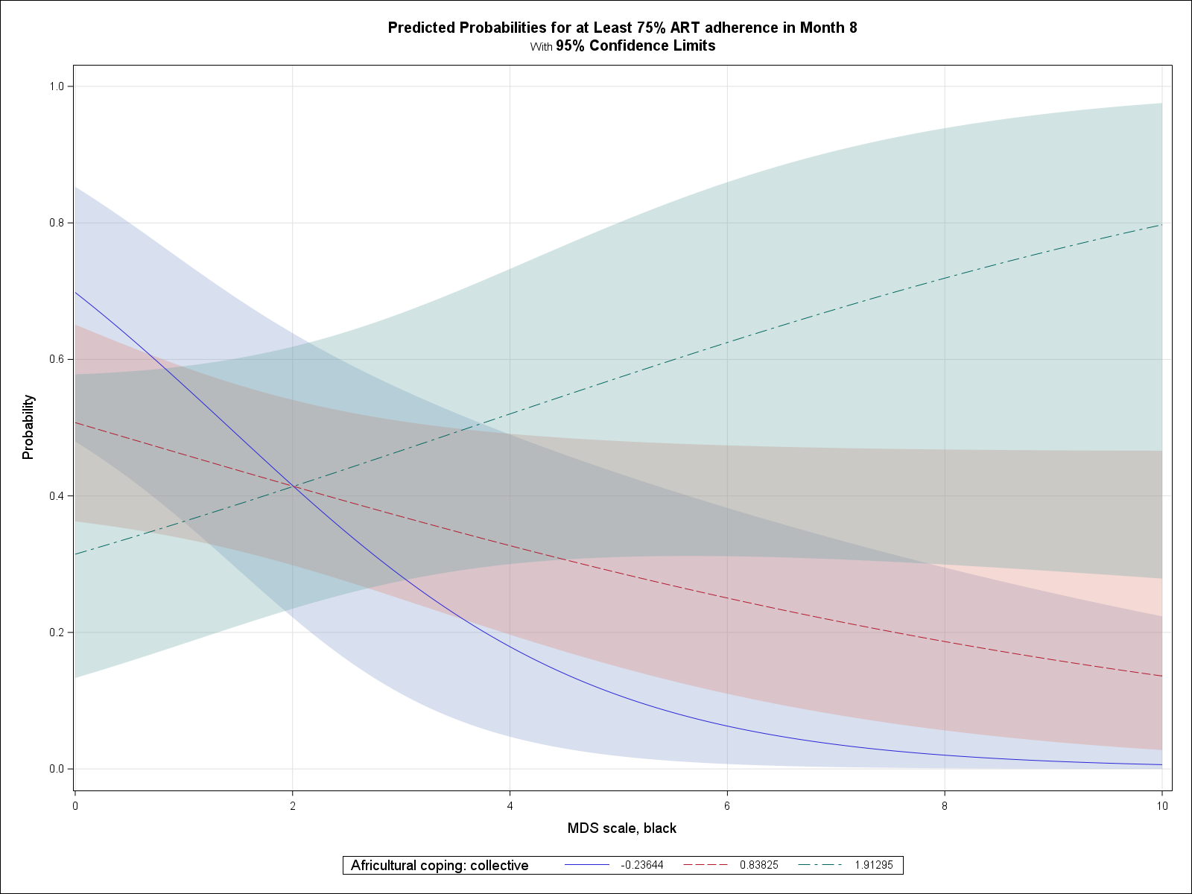

Figure S3. Predicted probabilities for at least 75% ART adherence in Month 8 (with 95% confidence intervals) based on MDS scale (Black/Race) for Africultural coping (spiritual-centered).
