Supplementary Figures Appendix
Figure S1. Quartile Setting
Figure S1(a). ANN configuration

Figure S1(b). DEA-ANN configuration
Figure S2. Tercile Setting
Figure S2(a). First ANN configuration: CNF1

Figure S2(b). Second ANN configuration: CNF2

Figure S2(c). DEA-ANN configuration

Figure S3. Median Setting
Figure S3(a). ANN configuration

Figure S3(b). DEA-ANN configuration

Figure S4. Patient performance across input variables for the different index categories generated using DEA when death and days spent in intensive care are taken as outputs
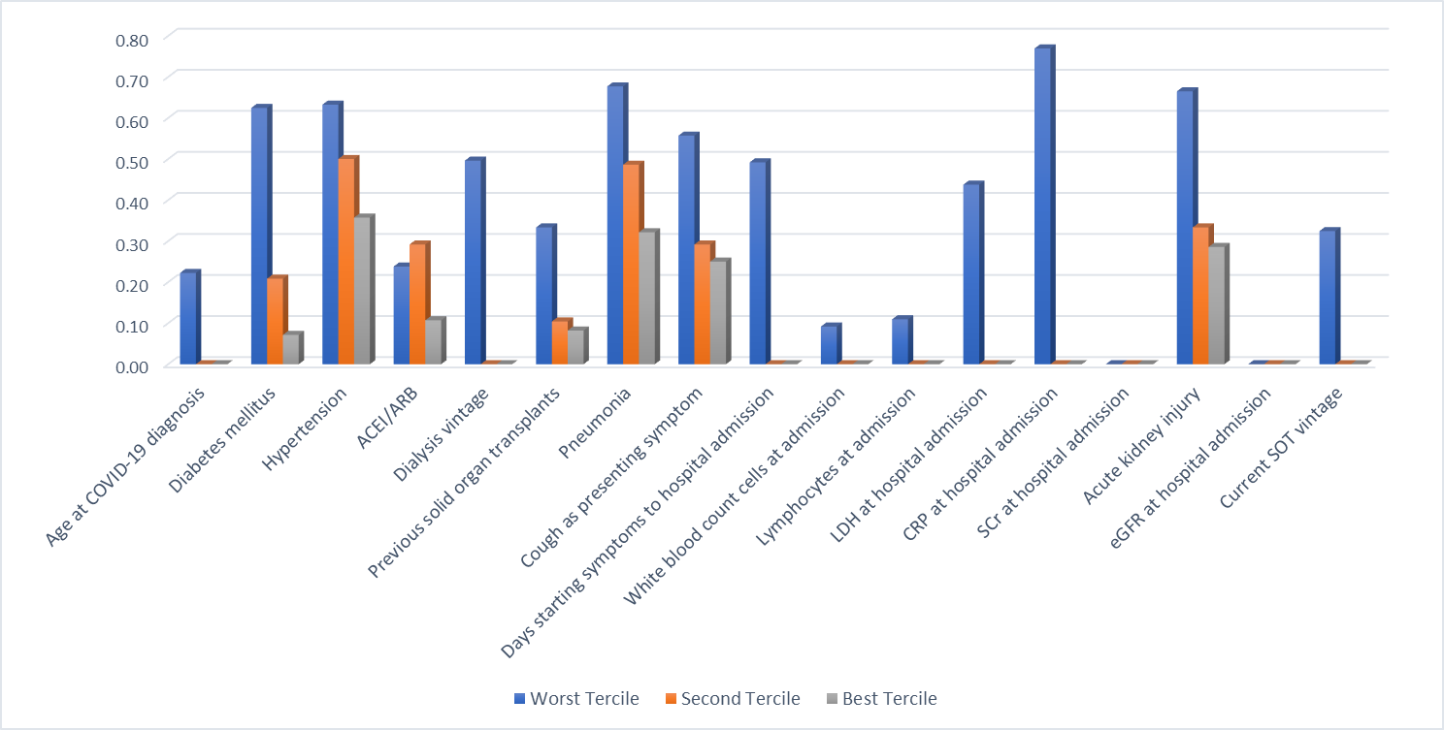
Legend: The index has been normalized within the interval [0, 1]. Higher values represent relatively worse performances.

Supplementary Tables Appendix
Extended Data Table S1. Kidney and transplant characteristics
Etiology of Chronic Kidney Disease, n (%)
Glomerulonephritis | 9 (23.7)
Polycystic disease | 8 (21.1)
Diabetic nephropathy | 6 (15.8)
Hypertensive nephroangiosclerosis | 5 (13.2)
Unknown | 5 (13.2)
Others | 5 (13.2)
Type of transplant, n (%)
Kidney transplant | 35 (92.1)
Multiple organ transplant | 3 (7.9)
Source of donor, n (%)
Decease donor | 30 (78.9)
Living donor | 8 (21.1)
Other comorbidities, n (%)
Dyslipidemia | 14 (36.8)
Coronary Artery Disease | 4 (10.5)
Immunosuppressive drug at COVID-19 diagnosis, n (%)
Calcineurin inhibitor | 33 (86.8)
Antimetabolite drug | 24 (57.9)
mTOR inhibitor | 16 (42.1)
Prednisone | 32 (84.2)

Extended Data Table S2. Hospital admission laboratory results
Mean serum creatinine at hospital admission (mg/dl) (s.d.) (range) | 1.59 (0.65) (0.7-3.4)
Mean eGFR at hospital admission (ml/min/1.73 m2) (s.d.) (range) | 49.47 (19.17) (18-95)
Mean white cell count at hospital admission (s.d.) (range) | 6734 (3154) (2800-13400)
Mean lymphocytes at hospital admission (s.d.) (range) | 877 (1419) (0-8700)
Mean haemoglobin at hospital admission (g/dL) (s.d.) (range) | 12.49 (2.07) (8.8-17.5)
Mean platelets at hospital admission (s.d.) (range) | 192969 (77687) (71000-404000)
Mean AST at hospital admission (IU/L) (s.d.) (range) | 42.37 (32.01) (14-142)
Mean ALT at hospital admission (IU/L) (s.d.) (range) | 34.63 (26.74) (8-127)
Mean GGT at hospital admission (IU/L) (s.d.) (range) | 77.77 (67.24) (13-378)
Mean LDH at hospital admission (IU/L) (s.d.) (range) | 310.26 (107.92) (142-529)
Mean CRP at hospital admission (mg/dL) (s.d.) (range) | 13.58 (7.78) (0.4-32)
Mean procalcitonin at hospital admission (ng/mL) (s.d.) (range) | 0.42 (0.57) (0-1.9)
Mean ferritin at hospital admission (ng/mL) (s.d.) (range) | 513.50 (422.78) (70-1566)
Mean D-dimer at hospital admission (ng/mL) (s.d.) (range) | 1316.13 (1339.03) (200-5600)
Mean high sensitivity Troponin I at hospital admission (ng/mL) (s.d.) (range) | 58.85 (168.91) (3.8-803)

Acronyms: eGFR: estimated Glomerular Filtrate Rate; AST: Aspartate transaminase; ALT: Alanine transaminase; GGT: gamma glutamyl transferase; LDH: Lactate dehydrogenase; CRP: C-reactive protein.

Extended Data Table S3. ICU comparative analysis
Variable | Intensive Care Unit (N=9) | Non-intensive Care Unit (N=29) | P value
Cough as presenting symptom, n (%) | 8 (88.9) | 15 (51.7) | 0.030
Pneumonia, n (%)
No | 0 (0.0) | 7 (24.1) | 0.032
Unilateral | 0 (0.0) | 7 (24.1)
Bilateral | 9 (100.0) | 15 (51.8)
Mean lactate dehydrogenase (IU/L) (s.d.) | 397.86 (130.41) | 281.47 (84.54) | 0.009
Mean CRP (mg/dl) (s.d.) | 11.99 (4.73) | 8.76 (7.94) | 0.011
Mean D-dimer (ng/mL) (s.d.) | 5000 (4687.93) | 2113.45 (1776.83) | 0.021
Steroid pulse, n (%) | 7 (77,8) | 10 (34.5) | 0.034
Mean days at hospital(s.d.) | 16.33 (7.19) | 10.48 (6.11) | 0.026
Graft loss, n (%) | 2 (22.2) | 4 (13.8) | 0.457
Death, n (%) | 2 (22.2) | 3 (10.3) | 0.352

Results include all recipients who were hospitalized with COVID-19 from March 3 to April 24, and followed-up till April 27,2020.
χ2 test (or Fisher’s exact test whenever appropriate), Student’s t test, and analysis of variance (Mann-Whitney test).
Table S4. Input profiles of patients and output treatment variables

Input Variables | Output Variables
Age at COVID-19 diagnosis | ICU admission
Diabetes mellitus | Treatments with tocilizumab
Hypertension | Pulses of methylprednisolone
Angiotensin-converting-enzyme inhibitors (ACEI) / angiotensin-receptor blockers (ARB) treatment
Dialysis vintage (months)
Previous SOT
Pneumonia
Cough as presenting symptom
Time from starting symptoms to hospital admission (days)
White blood count cells at admission
Lymphocytes at admission
LDH at hospital admission
CRP at hospital admission
SCr at hospital admission
Acute kidney injury
eGFR at hospital admission
Current SOT vintage

Table S5. Categorization of the index values and each alternative configuration
 | Index Values and Categories
 | [1, 0.75] | [0.75, 0.5] | [0.5, 0.25] | [0.25, 0]
DEA | Worst Quartile | - | Third Quartile | Best Quartile
 | Number of Output Treatments per Quartile
CNF1 | 3 | - | 2 and 1 | 0
CNF2 | 3 and 2 | - | 1 | 0
CNF3 | 3 | 2 | 1 | 0

Table S6. Binary variables assigned to the hybrid model and each alternative configuration
 | Index Values and Logistic Categories
 | [1, 0.75] | [0.75, 0.5] | [0.5, 0.25] | [0.25, 0]
DEA | 1 | - | 0 | 0
DEA2 | 1 | - | 1 | 0
 | Number of Output Treatments per Logistic Category
CNF1  Logistic | 3  1 | - | 2 and 1  0 | 0  0
CNF2  Logistic | 3 and 2  1 | - | 1  0 | 0  0
CNF3  Logistic | 3  1 | 2  1 | 1  1 | 0  0

Table S7. Categorization of the index values and the alternative configurations when death and days spent in intensive care are taken as outputs

Table S7(a). Quartile setting
 | Index Values and Categories
 | [1, 0.75] | [0.75, 0.5] | [0.5, 0.25] | [0.25, 0]
DEA | Worst Quartile | Second Quartile | Third Quartile | Best Quartile
 | Outputs per Category
CNF | Death | ICU > 2 weeks | ICU < 2 weeks | None
Class | 1 | 2 | 3 | 4

Table S7(b). Tercile setting
 | Index Values and Categories
 | [1, 0.67] | [0.67, 0.33] | [0.33, 0]
DEA | Worst Tercile | Second Tercile | Best Tercile
 | Outputs per Category
CNF1 | Death | ICU | None
CNF2 | Death and ICU > 2 weeks | ICU < 2 weeks | None
Class | 1 | 2 | 3

Table S7(c). Median setting
 | Index Values and Categories
 | [1, 0.5] | [0.5, 0]
DEA | Worst Median | Best Median
 | Outputs per Category
CNF | Death and ICU | None
Class | 1 | 2

