Supplementary Appendix E: Other Materials
As a methodological note on the journal materials presented below, the complementary performance indicators reported in Table E1, comprising publication volume, journal impact, and citation metrics obtained from Web of Science, Clarivate, and Google Scholar, were compiled for the same set of journals to characterize their output over the period from 2020 to 2025. What’s more, this account describes how the subject-category analysis was conducted and how the associated network diagram in Figure 3B was generated. The journals in which the included studies appeared were first matched to their corresponding records in the Web of Science Core Collection, and the Journal Citation Reports subject categories assigned to each journal were retrieved from Clarivate. Because a single journal is frequently indexed under several categories, every constituent category was recorded and then aggregated into one of eight higher-order research-field groups according to the Web of Science classification, and the few journals that are not indexed in the Journal Citation Reports were assigned to groups manually on the basis of their stated aims and scope. The count reported for each group and category in Table E2 and Table E3 denotes the number of included articles indexed under that heading, so that journals spanning multiple fields contribute to more than one group and thereby expose the interdisciplinary structure of the literature. The network diagram renders this structure as a force-directed graph produced with bibliometric visualization software, in which each bubble represents a research-field group or one of its constituent categories, the area of a bubble is proportional to its article count, the color of a bubble encodes the cluster to which the field belongs, and an edge joins two nodes that share one or more journals, so that strongly co-classified fields are positioned close together.

Table E1 defines the bibliometric metrics and data sources used to evaluate journal performance and publication trends

Table E1. Definition of each item in Figure 3C
Item Name | Definition | Data Source
Count | Number of articles included in this systematic review | -
Volume | Total volume of articles published in 2020-2025 year | Web of Science
JIF | Journal Impact Factor in 2024 | Clarivate
JIC | Journal Citation Indicator in 2024 | Clarivate
h5-index | The number of articles a journal has published in the last five years that have each received at least that many citations. | Google Scholar
h5-median | The median number of citations received by the articles that contribute to the publication's h5-index. | Google Scholar
Volume Change | Change in the volume of articles published in 2020-2025 | Web of Science
2024 Citations | Total citations of papers up to 2024 | Clarivate
Citations Change | Histogram of total citations to papers in 2019-2024 | Clarivate

Table E2 outlines the distribution of research across eight category groups. Clinical Medicine leads the ranking with 48 entries, followed by Computer Science and Multidisciplinary groups with 42 and 40 entries respectively. Engineering ranks fourth with 35 entries, while Social Sciences contributes 23. Biology and Psychology each record 12 entries, and Environment and Ecology represents the smallest group with 5. Medical Informatics and Gerontology frequently appear across multiple groups, which indicates significant interdisciplinary overlap in literature. Table E3 provides more detailed mapping information.

Table E2. Definition of each item in Figure 3
Rank | Main Count | Categories’ Group | Journal Category (Some Example) | Count
1 | 48 | Clinical Medicine | Medical Informatics | 18
 |  | Clinical Medicine | Geriatrics and Gerontology | 14
 |  | Clinical Medicine | Health Care Sciences and Services | 10
 |  | Clinical Medicine | Neurosciences | 6
2 | 42 | Computer Science | Medical Informatics | 18
 |  | Computer Science | Computer Science, Information Systems | 17
 |  | Computer Science | Computer Science, Interdisciplinary Applications | 7
 |  | Computer Science | Mathematical and Computational Biology | 7
 |  | Computer Science | Computer Science, Artificial Intelligence | 6
3 | 40 | Multidisciplinary | Computer Science, Information Systems | 17
 |  | Multidisciplinary | Multidisciplinary Sciences | 8
 |  | Multidisciplinary | Computer Science, Interdisciplinary Applications | 7
 |  | Multidisciplinary | Physics, Applied | 7
4 | 35 | Engineering | Engineering, Electrical and Electronic | 19
 |  | Engineering | Instruments and Instrumentation | 15
 |  | Engineering | Telecommunications | 6
5 | 23 | Social Sciences, General | Health Care Sciences and Services | 10
 |  | Social Sciences, General | Gerontology | 10
6 | 12 | Biology & Biochemistry | Mathematical and Computational Biology | 7
7 | 12 | Psychiatry/Psychology | Gerontology | 10
8 | 5 | Environment/Ecology | Public, Environmental and Occupational Health | 4

Table E3. Definition of each item in Figure 3
Journal Name | Count | Journal Category (JCR) | Categories by Group (JCR)
sensors | 8 | Chemistry, Analytical  Instruments & Instrumentation  Engineering, Electrical & Electronic | Engineering
ieee sensors journal | 5 | Instruments & Instrumentation  Engineering, Electrical & Electronic,  Physics, Applied | Engineering, Multidisciplinary
ieee journal of biomedical and health informatics | 4 | Computer Science, Interdisciplinary Applications  Mathematical & Computational Biology  Medical Informatics  Computer Science, Information Systems | Computer Science, Multidisciplinary, Clinical Medicine, Biology & Biochemistry
international journal of medical informatics | 4 | Health Care Sciences & Services  Medical Informatics  Computer Science, Information Systems | Clinical Medicine, Social Sciences, General, Computer Science, Multidisciplinary
scientific reports | 4 | Multidisciplinary Sciences | Multidisciplinary
bmc geriatrics | 3 | Gerontology  Geriatrics & Gerontology | Psychiatry/Psychology, Social Sciences, General, Clinical Medicine
jmir aging | 3 | Gerontology  Medical Informatics  Geriatrics & Gerontology | Psychiatry/Psychology, Social Sciences, General, Clinical Medicine, Computer Science
buildings | 2 | Engineering, Civil,  Construction & Building Technology | Engineering
plos one | 2 | Multidisciplinary Sciences | Multidisciplinary
computational intelligence and neuroscience | 2 | Neurosciences  Mathematical & Computational Biology | Clinical Medicine, Computer Science, Biology & Biochemistry
jmir medical informatics | 2 | Medical Informatics | Clinical Medicine, Computer Science
ieee access | 2 | Telecommunications  Computer Science, Information Systems  Engineering, Electrical & Electronic | Engineering, Computer Science, Multidisciplinary
journal of medical internet research | 2 | Health Care Sciences & Services  Medical Informatics | Clinical Medicine, Social Sciences, General, Computer Science
APPLIED SCIENCES-BASEL | 2 | Engineering, Multidisciplinary  Chemistry, Multidisciplinary  Physics, Applied  Materials Science, Multidisciplinary | Engineering, Multidisciplinary
cognitive systems research | 1 | Psychology, Experimental  Neurosciences  Computer Science, Artificial Intelligence | Psychiatry/Psychology, Clinical Medicine, Computer Science, Biology & Biochemistry
Fractals-Complex Geometry, Patterns, and Scaling in Nature and Society | 1 | Multidisciplinary Sciences, Mathematics, Interdisciplinary Applications | Multidisciplinary
universal access in the information society | 1 | Computer Science, Cybernetics  Ergonomics | Computer Science, Multidisciplinary
biomed research international | 1 | Biotechnology & Applied Microbiology  Medicine, Research & Experimental | Clinical Medicine, Biology & Biochemistry
frontiers in public health | 1 | Public, Environmental & Occupational Health | Clinical Medicine, Environment/Ecology
international journal of telemedicine and applications | 1 | Health Care Sciences & Services | Clinical Medicine, Social Sciences, General
ieee transactions on mobile computing | 1 | Telecommunications  Computer Science, Information Systems | Engineering, Computer Science, Multidisciplinary
artificial intelligence in medicine | 1 | Medical Informatics  Computer Science, Artificial Intelligence  Engineering, Biomedical | Clinical Medicine, Computer Science, Engineering
multimedia tools and applications | 1 | Computer Science, Theory & Methods  Computer Science, Software Engineering  Computer Science, Information Systems  Engineering, Electrical & Electronic | Computer Science, Multidisciplinary, Engineering
nature communications | 1 | Multidisciplinary Sciences | Multidisciplinary
the journal of nutrition, health and aging | 1 | Nutrition & Dietetics  Geriatrics & Gerontology | Clinical Medicine
international journal of older people nursing | 1 | Gerontology  Nursing  Geriatrics & Gerontology | Psychiatry/Psychology, Social Sciences, General, Clinical Medicine
jama network open | 1 | Medicine, General & Internal | Clinical Medicine
industrial management & data systems | 1 | Engineering, Industrial  Computer Science, Interdisciplinary Applications | Engineering, Computer Science, Multidisciplinary
health & social care in the community | 1 | Engineering, Industrial  Computer Science, Interdisciplinary Applications | Engineering, Computer Science, Multidisciplinary
frontiers in genetics | 1 | Genetics & Heredity | Clinical Medicine, Biology & Biochemistry
journal of alzheimer's disease | 1 | Neurosciences | Clinical Medicine
frontiers in artificial intelligence | 1 | Computer Science, Artificial Intelligence  Computer Science, Information Systems | Computer Science, Multidisciplinary
maturitas | 1 | Obstetrics & Gynecology  Geriatrics & Gerontology | Clinical Medicine
ieee transactions on instrumentation and measurement | 1 | Instruments & Instrumentation  Engineering, Electrical & Electronic | Engineering
wseas transactions on information science and applications | 1 | NA | Computer Science*
journal of the american geriatrics society (jags) | 1 | Gerontology  Geriatrics & Gerontology | Psychiatry/Psychology, Social Sciences, General, Clinical Medicine
assistive technology: the official journal of resna | 1 | Rehabilitation | Clinical Medicine
journal of universal computer science | 1 | Computer Science, Theory & Methods  Computer Science, Software Engineering | Computer Science
computers in biology and medicine | 1 | Computer Science, Interdisciplinary Applications  Biology  Mathematical & Computational Biology  Engineering, Biomedical | Computer Science, Multidisciplinary, Clinical Medicine, Engineering, Biology & Biochemistry
ieee transactions on games | 1 | Computer Science, Software Engineering  Computer Science, Artificial Intelligence | Computer Science
internet of things | 1 | Telecommunications  Computer Science, Information Systems  Engineering, Electrical & Electronic | Engineering, Computer Science, Multidisciplinary
international journal of human-computer interaction | 1 | Computer Science, Cybernetics  Ergonomics | Computer Science, Multidisciplinary
innovation in aging | 1 | Gerontology  Geriatrics & Gerontology | Psychiatry/Psychology, Social Sciences, General, Clinical Medicine
journal of advanced nursing | 1 | Nursing | Clinical Medicine, Social Sciences, General
sustainability | 1 | Environmental Sciences  Environmental Studies  Green & Sustainable Science & Technology | Multidisciplinary, Social Sciences, General, Environment/Ecology, Biology & Biochemistry
geriatric nursing | 1 | Gerontology  Nursing  Geriatrics & Gerontology | Psychiatry/Psychology, Social Sciences, General, Clinical Medicine
measurement: sensors | 1 | NA | Engineering*
journal of public health | 1 | Public, Environmental & Occupational Health | Clinical Medicine, Environment/Ecology
age and ageing | 1 | Geriatrics & Gerontology | Clinical Medicine
measurement | 1 | Engineering, Multidisciplinary  Instruments & Instrumentation | Engineering, Multidisciplinary
experimental gerontology | 1 | Geriatrics & Gerontology | Clinical Medicine
neurocomputing | 1 | Computer Science, Artificial Intelligence | Computer Science
journal of general internal medicine | 1 | Health Care Sciences & Services  Medicine, General & Internal | Clinical Medicine, Social Sciences, General
bmc public health | 1 | Public, Environmental & Occupational Health | Clinical Medicine, Environment/Ecology
bmc medicine | 1 | Medicine, General & Internal | Clinical Medicine
Alzheimer's & Dementia: Diagnosis, Assessment & Disease Monitoring | 1 | Clinical Neurology  Neurosciences | Clinical Medicine
international journal on interactive design and manufacturing (ijidem) | 1 | Engineering, Manufacturing | Engineering
digital health | 1 | Public, Environmental & Occupational Health  Health Policy & Services  Health Care Sciences & Services  Medical Informatics | Clinical Medicine, Environment/Ecology, Social Sciences, General, Computer Science
journal of signal processing systems | 1 | NA | Computer Science, Engineering*
computational and structural biotechnology journal | 1 | Biochemistry & Molecular Biology | Biology & Biochemistry
convergence: the international journal of research into new media technologies | 1 | Communication | Social Sciences, General
alexandria engineering journal | 1 | Engineering, Multidisciplinary | Engineering, Multidisciplinary
ieee internet of things journal | 1 | Telecommunications, Computer Science, Information Systems, Engineering, Electrical & Electronic | Engineering, Computer Science, Multidisciplinary
Cluster Computing-The Journal of Networks Software Tools and Applications | 1 | Computer Science, Theory & Methods, Computer Science, Information Systems | Computer Science, Multidisciplinary
jmir mhealth uhealth | 1 | Health Care Sciences & Services, Medical Informatics | Clinical Medicine, Social Sciences, General, Computer Science
international journal of hybrid intelligent systems | 1 | Computer Science, Artificial Intelligence | Computer Science
ieee robotics and automation letters | 1 | Robotics | Computer Science, Engineering
healthcare | 1 | NA | Clinical Medicine*
frontiers in human neuroscience | 1 | Psychology, Neurosciences | Psychiatry/Psychology, Clinical Medicine
Journal of Sensor and Actuator Networks | 1 | Telecommunications, Computer Science, Information Systems | Engineering, Computer Science, Multidisciplinary
Note: An asterisk (*) in the Categories by Group (JCR) column indicates that the journal is not indexed in the JCR. This study assigned these categories based on the specific aims and scopes of the journal.

Figure E1 presents the results of topic modeling, visualized on two dimensions (D1 and D2). Each bubble represents a topic, with its size indicating relative prevalence. The accompanying bar charts list the most representative keywords for each topic. For example, Topic 0 focuses on study, adults, care, falls, and security; Topic 1 is associated with terms such as elderly, health, methods, and system; Topic 2 emphasizes background, objective, living, adults, and daily; Topic 3 relates to care, dementia, support, and memory ; while Topic 4 highlights models, sensors, cough, conversational, and emotion. This visualization illustrates the thematic structure of the corpus and the semantic distinctions between topics, as the theoretical foundation for thematic analysis.
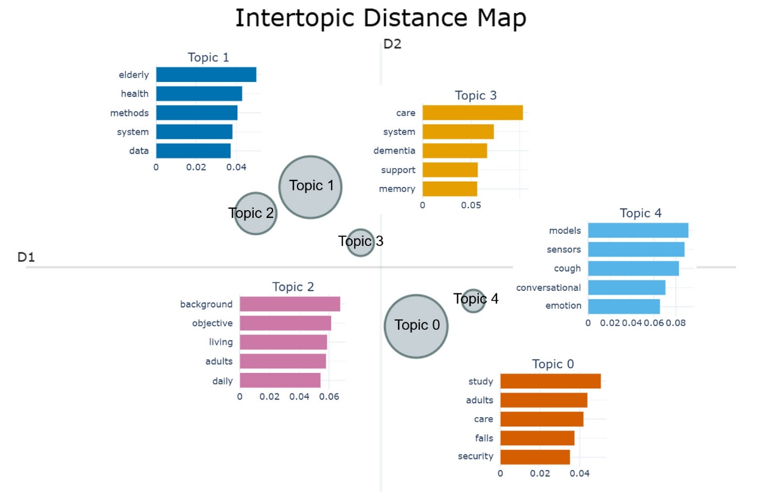
Figure E1. Intertopic Distance Map and Topic Bar Chart

Based on the hierarchical clustering depicted in Figure E2 A, Topic 0 and Topic 1 exhibit the highest degree of semantic proximity. Consequently, these two themes merge at a relatively short distance of approximately 0.38, which suggests a significant conceptual overlap between them. While Topic 2 and Topic 3 eventually integrate into this primary cluster at distances of 0.58 and 0.68, Topic 4 remains the most distinct thematic category. This isolation, characterized by a merger distance of 0.82, indicates that Topic 4 addresses a specialized domain that is conceptually separate from the other identified research areas.
The class based term frequency inverse document frequency (c-TF-IDF) weight distribution in Figure E2 B, reveals further details regarding the internal cohesion of each topic. Specifically, Topic 3 demonstrates the highest level of concentration, as its primary keyword weight exceeds 0.10. This indicates a very specific and well-defined core concept. Topic 4 also shows strong thematic cohesion because it maintains consistently high weights across its top five keywords. On the other hand, the lower overall weights observed for Topic 0 and Topic 1 suggest that these themes represent more generalized or shared concepts that appear across a broader range of the analyzed articles.
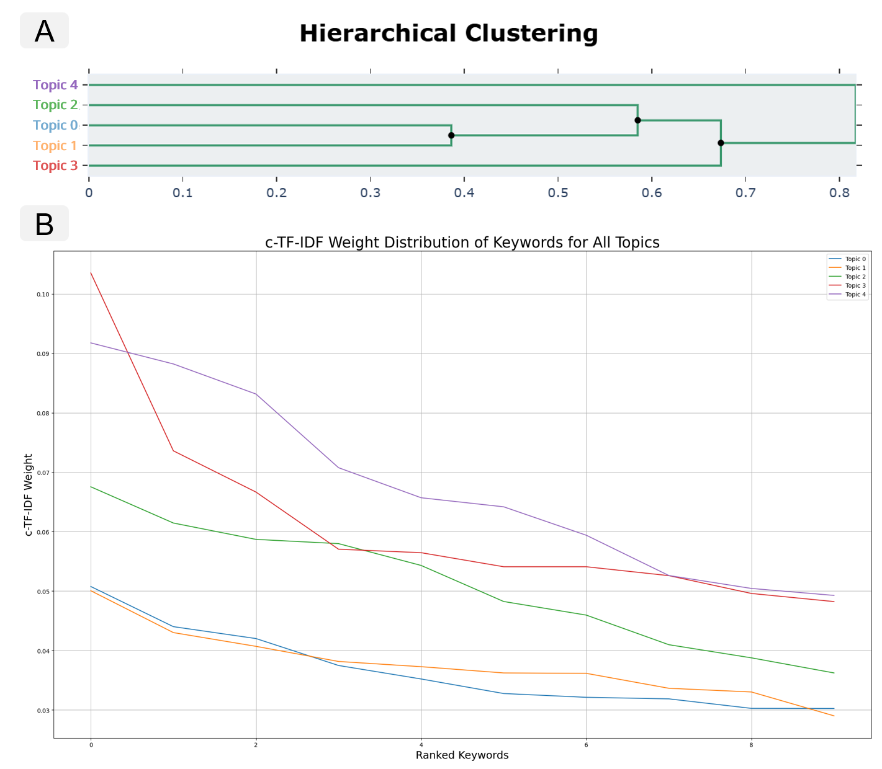
Figure E2. Hierarchical Clustering Outcome and Weight Distribution of Keywords
As a supplementary account of the topic-modeling procedure summarized above, this note documents the complete configuration of the BERTopic pipeline used to derive the five topics reported in Figures E1 and E2. BERTopic is a modular model in which document embedding, dimensionality reduction, density-based clustering, and class-based term weighting are performed by independently configurable components; each stage was therefore set explicitly rather than left to an unstated default. The settings governing text pre-processing, the embedding model, the UMAP reduction, the HDBSCAN clustering, the minimum cluster size, the topic-reduction step, the software environment, and the random seed are summarized in Table E4. Values that were recovered exactly from the stored model artifacts are identified as such; the remaining values are the established BERTopic defaults used to obtain the reported topic structure.
Table E4. Summary of the BERTopic pipeline configuration.
Setting | Reported value | Basis
Pre-processing | Two parallel streams. Embedding input: original abstracts, lower-cased with whitespace collapsed, with punctuation and sentence structure retained. Representation input: lower-cased, alphabetic tokens only, with English stop-words and generic scholarly terms (e.g., background, objective, methods, results) removed; unigrams. | Verified against the stored intermediate text streams.
Embedding model | all-mpnet-base-v2 (Sentence Transformers); 768-dimensional sentence embeddings. | Determined exactly from the stored embedding matrix (101 rows × 768 dimensions).
Dimensionality reduction (UMAP) | n_neighbors = 15; n_components = 5; min_dist = 0.0; metric = cosine; random_state = 42. | BERTopic default.
Clustering (HDBSCAN) | min_cluster_size = 9; min_samples = none (set equal to min_cluster_size); metric = euclidean (computed in the UMAP space); cluster-selection method = excess of mass (eom). | BERTopic default.
Minimum cluster size | 9 (the BERTopic parameter min_topic_size, which sets the HDBSCAN min_cluster_size). | BERTopic default; consistent with the smallest reported topic (n = 9) after outlier reassignment.
Topic reduction | Reduced to five topics (nr_topics = 5); residual outliers reassigned by the class-based TF-IDF strategy (reduce_outliers, strategy = c-tf-idf), so that all 101 documents are assigned and no outlier class (encoded as −1) remains. | Inferred from the reported result (five topics; 101 of 101 documents assigned).
Software version | Python 3.10–3.12 with BERTopic 0.17.4, Sentence-Transformers 3.3.1, UMAP-learn 0.5.7, HDBSCAN 0.8.40, scikit-learn 1.5.2, NumPy 1.26.4, pandas 2.2.3, and SciPy 1.14.1. | As executed; a lower bound of BERTopic 0.16 is fixed independently by the output schema.
Random seed | 42, propagated to Python, NumPy, and UMAP (random_state = 42). | Set to ensure deterministic output, because UMAP is stochastic.

