Supplemental Table 1. Primers used in this study
Primer
1 | AGTATTCCACTCAGCTCTGGACTAACCTCTTTAATGGGATACTACCAGCCAGTAGTACC
2 | TGATGTGTGTGACGTGATGTGTATATCCTACACTTAGTAAGACGCACGTTCCCC
3 | TGATGATGGATATATGGAAGCTGGAGGATGCCCGTTTCCTATTAAGCAGTGCAGTG
4 | TAGCAGGTGAGAACTCACTTGTACTCGACTCCTGCAGATACAGTATTGGACGGTGGCTGG
5 | AAGCCGCTGCTGGAATTGGGCTCTGAGGTGCAGTGGAT
6 | CGATGGATAATTGTGCCGTGTTGGGTGTTACGGAGCATTCA
7 | GGCGTCGGTTTCCACTATC
8 | AAAGTTCGACAGCGTCTCC
9 | TCTCTAGATTTCGGCACGGCTAC
10 | TGACACAGTACACGAGGACTTC
11 | TGATTACGAATTCCCTCGGGGAGTCATATGAAAGG
12 | GACGCGTGGATCCCCGCGGGTAATATTGAGCCAAC
13 | TTCTGGCATGCGGAGAGAC
14 | GTGGTACCATGGGTTGAGTGG
15 | TACGACGATAAGCCATCCGC
16 | ACAACTGTCGAAGGGGCATT
17 | GACTGAGAGTGTACGCCTGG
18 | GCCTGTATAGACGCCATGCT
19 | TAGCGATTGTTGGCATGGGT
20 | GTCCACGTTGAACCGACTCT
21 | ATGATGGCTGCCTCTGACTTC
22 | TTCTTGCTCTGGATGTTGCG
23 | GCTCGGCACCTTACGAGAAATC
24 | TTCAGCCTTGCGACCATACTCC

Supplemental Table 2. Differentially expressed genes in Δfum21 compared to the wild-type strain in MM-X (Δ21XX and wtXX) or MM-G (Δ21GX and wtGX). Expression levels in FPKM are the average of duplicates. Rows of genes implied in secondary metabolism are grey-shaded.
ProteinId | Δ21XX | Δ21GX | wtXX | wtGX | Functional annotation | PFAM annotation | GO annotation | KEGG annotation | Predicted secretion signal sequence | Secondary metabolism
DOWN REGULATED IN Δfum21
1166045 | 0 | 0 | 5.49 | 13.21 | AAA+-type ATPase |  | GO:0005524| ATP binding
1182124 | 0 | 0 | 2.90 | 4.89 | Major Facilitator Superfamily transporter | PF07690,11|MFS_1;PF07690,11|MFS_1;PF01306,14|LacY_symp | GO:0016020|membrane;GO:0006810|transport;GO:0016021|integral component of membrane;GO:0055085|transmembrane transport |  |  | Part of secondary metabolism cluster 15;Secondary metabolism, Type: Decorating
225717 | 0.02 | 0 | 25.19 | 29.92 | Transcription factor An01g06900 | PF04082,13|Fungal_trans;PF00172,13|Zn_clus | GO:0000981|sequence-specific DNA binding RNA polymerase II transcription factor activity;GO:0006355|regulation of transcription, DNA-templated;GO:0003677|DNA binding;GO:0005634|nucleus;GO:0008270|zinc ion binding;GO:0006351|transcription, DNA-templated |  |  | Part of secondary metabolism cluster 15;Secondary metabolism, Type: Decorating
1117227 | 0.06 | 0.30 | 285.71 | 519.60 | Peroxisomal acyl-CoA synthetase; fum10 orthologue | PF00501,23|AMP-binding;PF13193,1|AMP-binding_C | GO:0003824|catalytic activity;GO:0008152|metabolic process |  |  | Part of secondary metabolism cluster 15
1117230 | 0.12 | 0.25 | 224.46 | 368.97 | α-oxoamine synthase; serine palmitoyltransferase; fum8 orthologue | PF00155,16|Aminotran_1_2 | GO:0009058|biosynthetic process;GO:0030170|pyridoxal phosphate binding | Metabolism|Lipid metabolism|Sphingolipid metabolism|K00654|E2,3,1,50, serine palmitoyltransferase [EC:2,3,1,50]:EC:2,3,1,50 |  | Part of secondary metabolism cluster 15;Secondary metabolism, Type: Decorating
1182116 | 0.12 | 0.39 | 347.32 | 573.20 | Fe-containing alcohol dehydrogenase type IV; fum7 orthologue | PF00465,14|Fe-ADH | GO:0016491|oxidoreductase activity;GO:0046872|metal ion binding;GO:0055114|oxidation-reduction process | Metabolism|Carbohydrate metabolism|Glycolysis / Gluconeogenesis|K04022|eutG, alcohol dehydrogenase: |  | Part of secondary metabolism cluster 15
1142053 | 1.179 | 1.0923 | 2068.63 | 1433.24 | No annotation
1162446 | 0.14 | 0.25 | 81.29 | 167.04 | Polyketide synthase; fum1 orthologue | PF00698,16|Acyl_transf_1;PF08659,5|KR;PF14765,1|PS-DH;PF00109,21|ketoacyl-synt;PF00106,20|adh_short;PF02801,17|Ketoacyl-synt_C;PF08242,7|Methyltransf_12;PF00107,21|ADH_zinc_N;PF13489,1|Methyltransf_23;PF13602,1|ADH_zinc_N_2;PF13847,1|Methyltransf_31;PF12847,2|Methyltransf_18;PF08240,7|ADH_N;PF00550,20|PP-binding;PF08241,7|Methyltransf_11 | GO:0016491|oxidoreductase activity;GO:0008270|zinc ion binding;GO:0055114|oxidation-reduction process;GO:0008168|methyltransferase activity;GO:0008152|metabolic process | Metabolism|Overview|Fatty acid metabolism|K00665|FASN, fatty acid synthase, animal type [EC:2,3,1,85]:EC:2,3,1,85;Metabolism|Lipid metabolism|Fatty acid biosynthesis|K00665|FASN, fatty acid synthase, animal type [EC:2,3,1,85]:EC:2,3,1,85;Environmental Information Processing|Signal transduction|AMPK signaling pathway|K00665|FASN, fatty acid synthase, animal type [EC:2,3,1,85]:EC:2,3,1,85;Organismal Systems|Endocrine system|Insulin signaling pathway|K00665|FASN, fatty acid synthase, animal type [EC:2,3,1,85]:EC:2,3,1,85 |  | Part of secondary metabolism cluster 15;Secondary metabolism, Type: PKS
1162442 | 1.66 | 2.19 | 807.36 | 913.32 | NAD-dependent epimerase/dehydratase; fum13 orthologue | PF01370,16|Epimerase;PF13460,1|NAD_binding_10;PF01073,14|3Beta_HSD;PF02719,10|Polysacc_synt_2;PF00106,20|adh_short;PF08659,5|KR;PF07993,7|NAD_binding_4;PF05368,8|NmrA | GO:0003854|3-beta-hydroxy-delta5-steroid dehydrogenase activity;GO:0016491|oxidoreductase activity;GO:0055114|oxidation-reduction process;GO:0044237|cellular metabolic process;GO:0008152|metabolic process;GO:0050662|coenzyme binding;GO:0006694|steroid biosynthetic process;GO:0009058|biosynthetic process;GO:0003824|catalytic activity;GO:0016616|oxidoreductase activity, acting on the CH-OH group of donors, NAD or NADP as acceptor |  |  | Part of secondary metabolism cluster 15;Secondary metabolism, Type: Decorating
1101614 | 0.45 | 0.98 | 145.98 | 236.55 | Cytochrome p450; fum6 orthologue | PF00067,17|p450;PF00667,15|FAD_binding_1;PF00258,20|Flavodoxin_1;PF00175,16|NAD_binding_1 | GO:0016705|oxidoreductase activity, acting on paired donors, with incorporation or reduction of molecular oxygen;GO:0020037|heme binding;GO:0016491|oxidoreductase activity;GO:0055114|oxidation-reduction process;GO:0010181|FMN binding;GO:0005506|iron ion binding | Metabolism|Lipid metabolism|Fatty acid degradation|K14338|cypD_E, CYP102A2_3, cytochrome P450 / NADPH-cytochrome P450 reductase [EC:1,14,14,1 1,6,2,4]:EC:1,14,14,1 1,6,2,4;Metabolism|Amino acid metabolism|Tryptophan metabolism|K14338|cypD_E, CYP102A2_3, cytochrome P450 / NADPH-cytochrome P450 reductase [EC:1,14,14,1 1,6,2,4]:EC:1,14,14,1 1,6,2,4;Metabolism|Xenobiotics biodegradation and metabolism|Aminobenzoate degradation|K14338|cypD_E, CYP102A2_3, cytochrome P450 / NADPH-cytochrome P450 reductase [EC:1,14,14,1 1,6,2,4]:EC:1,14,14,1 1,6,2,4 |  | Part of secondary metabolism cluster 15;Secondary metabolism, Type: Decorating
1142051 | 4.63 | 8.34 | 1192.75 | 1607.79 | No annotation
1166044 | 2.66 | 2.75 | 284.01 | 347.93 | No annotation
1172265 | 1.70 | 1.62 | 3.51 | 191.62 | Oxidoreductase | PF03171,15|2OG-FeII_Oxy;PF14226,1|DIOX_N | GO:0016706|oxidoreductase activity, acting on paired donors, with incorporation or reduction of molecular oxygen, 2-oxoglutarate as one donor, and incorporation of one atom each of oxygen into both donors;GO:0055114|oxidation-reduction process;GO:0016491|oxidoreductase activity
1162443 | 3.61 | 6.66 | 384.23 | 564.86 | CoA-dependent acyltransferase; fum14 orthologue | PF00668,15|Condensation;PF00550,20|PP-binding |  |  |  | Part of secondary metabolism cluster 15
1186369 | 8.13 | 0.57 | 11.86 | 19.06 | Ca2+-modulated nonselective cation channel polycystin; Homo sapiens mucin 5AC orthologue
51907 | 1.45 | 3.73 | 75.16 | 110.86 | Predicted 3-ketosphinganine reductase | PF00106,20|adh_short | GO:0016491|oxidoreductase activity;GO:0008152|metabolic process |  |  | Part of secondary metabolism cluster 15;Secondary metabolism, Type: Decorating
1181633 | 11.77 | 0.49 | 73.92 | 12.69 | Putative SWI-SNF chromatin-remodeling complex protein |  |  |  |  | Part of secondary metabolism cluster 12
1082505 | 1.56 | 1.48 | 18.44 | 32.99 | Major Facilitator Superfamily permease | PF07690,11|MFS_1;PF00083,19|Sugar_tr | GO:0016021|integral component of membrane;GO:0055085|transmembrane transport; GO:0022857| transmembrane transporter activity
1142861 | 2.77 | 1.59 | 34.50 | 33.92 | Chloroperoxidase | PF01328,12|Peroxidase_2 | GO:0004601|peroxidase activity
1159889 | 0.88 | 0.93 | 20.02 | 17.88 | O-methyltransferase | PF00891,13|Methyltransf_2 | GO:0008171|O-methyltransferase activity | Metabolism|iosynthesis of other secondary metabolites|Phenylpropanoid biosynthesis|K13066|E2,1,1,68, COMT, caffeic acid 3-O-methyltransferase [EC:2,1,1,68]:EC:2,1,1,68 |  | Part of secondary metabolism cluster 62;Secondary metabolism, Type: Decorating
1087288 | 1.98 | 2.37 | 82.10 | 39.12 | Taurine catabolism dioxygenase TauD | PF02668,11|TauD | GO:0016491|oxidoreductase activity; GO:0055114|oxidation-reduction process
45784 | 12.44 | 1.70 | 21.20 | 25.17 | Ca²⁺-modulated nonselective cation channel polycystin |  |  |  | yes
1169210 | 2.53 | 5.86 | 12.61 | 72.09 | Glutathione S-transferase-like protein | PF14497,1|GST_C_3;PF13410,1|GST_C_2
1116476 | 1.65 | 2.31 | 3.80 | 28.18 | CDR ABC transporter | PF01061,19|ABC2_membrane;PF01061,19|ABC2_membrane;PF00005,22|ABC_tran;PF00005,22|ABC_tran;PF06422,7|PDR_CDR;PF12698,2|ABC2_membrane_3 | GO:0016887|ATPase activity; GO:0016021|integral component of membrane;GO:0016020|membrane;GO:0005524|ATP binding; GO:0042626| ATPase activity, coupled to transmembrane movement of substances;GO:0006810|transport | Environmental Information Processing|Membrane transport|ABC transporters|K08712|ABCG2,SNQ2, ATP-binding cassette, subfamily G (WHITE), member 2, SNQ2: |  | Part of secondary metabolism cluster 12;Secondary metabolism, Type: Decorating
1089440 | 12.82 | 2.52 | 48.93 | 29.01 | Major Facillitator Superfamily transporter | PF07690,11|MFS_1 | GO:0016021|integral component of membrane;GO:0055085| transmembrane transport
1112167 | 0.46 | 0.60 | 1.10 | 6.38 | Polyketide synthase AdaA | PF00109,21|ketoacyl-synt;PF00698,16|Acyl_transf_1;PF02801,17|Ketoacyl-synt_C;PF00550,20|PP-binding;PF00108,18|Thiolase_N | GO:0008152|metabolic process; GO:0016747|transferase activity, transferring acyl groups other than amino-acyl groups |  |  | Part of secondary metabolism cluster 70;Secondary metabolism, Type: PKS
1181632 | 7.20 | 2.79 | 88.83 | 26.80 | No annotation |  |  |  |  | Part of secondary metabolism cluster 12
1115620 | 2.08 | 1.27 | 2.78 | 12.02 | C-type lectin |  |  |  | yes
189113 | 21.33 | 8.60 | 4.66 | 80.47 | NmrA-like family protein | PF13460,1|NAD_binding_10;PF05368,8|NmrA |  |  |  | Part of secondary metabolism cluster 1
1005100 | 31.19 | 2.33 | 202.62 | 21.65 | No annotation |  |  |  |  | Part of secondary metabolism cluster 12
1186279 | 23.46 | 20.64 | 77.62 | 191.85 | No annotation | PF09351,5|DUF1993
1103854 | 8.96 | 1.34 | 16.66 | 11.77 | Glycosyl transferase | PF00534,15|Glycos_transf_1;PF11997,3|DUF3492 | GO:0009058|biosynthetic process
1139199 | 3.10 | 4.02 | 7.23 | 34.97 | Mono-oxygenase, FAD-binding/aromatic ring hydroxylase | PF01494,14|FAD_binding_3 |  |  |  | Part of secondary metabolism cluster 70;Secondary metabolism, Type: Decorating
1186352 | 11.54 | 2.74 | 3.97 | 23.65 | Molecular chaperone | PF00011,16|HSP20 |  | Genetic Information Processing|Folding, sorting and degradation|Protein processing in endoplasmic reticulum|K13993|HSP20, HSP20 family protein:
1109756 | 1.87 | 1.59 | 8.34 | 13.54 | No annotation | PF11001,3|DUF2841
1187549 | 2.13 | 1.99 | 41.60 | 16.75 | Integral membrane protein
1125454 | 210.50 | 0.71 | 6.22 | 5.80 | Dihydroxy-acid dehydratase | PF00920,16|ILVD_EDD | GO:0003824|catalytic activity;GO:0008152|metabolic process | Metabolism|Overview|2-Oxocarboxylic acid metabolism|K01687|ilvD, dihydroxy-acid dehydratase [EC:4,2,1,9]:EC:4,2,1,9;Metabolism|Overview|Biosynthesis of amino acids|K01687|ilvD, dihydroxy-acid dehydratase [EC:4,2,1,9]:EC:4,2,1,9;Metabolism|Amino acid metabolism|Valine, leucine and isoleucine biosynthesis|K01687|ilvD, dihydroxy-acid dehydratase [EC:4,2,1,9]:EC:4,2,1,9;Metabolism|Metabolism of cofactors and vitamins|Pantothenate and CoA biosynthesis|K01687|ilvD, dihydroxy-acid dehydratase [EC:4,2,1,9]:EC:4,2,1,9
1184525 | 2.96 | 3.92 | 16.19 | 31.30 | Non-ribosomal peptide synthetase | PF00501,23|AMP-binding;PF07993,7|NAD_binding_4;PF01370,16|Epimerase;PF00550,20|PP-binding | GO:0003824|catalytic activity;GO:0050662|coenzyme binding;GO:0044237|cellular metabolic process;GO:0008152|metabolic process | Metabolism|Overview|Biosynthesis of amino acids|K00143|LYS2, L-aminoadipate-semialdehyde dehydrogenase [EC:1,2,1,31]:EC:1,2,1,31;Metabolism|Amino acid metabolism|Lysine biosynthesis|K00143|LYS2, L-aminoadipate-semialdehyde dehydrogenase [EC:1,2,1,31]:EC:1,2,1,31;Metabolism|Amino acid metabolism|Lysine degradation|K00143|LYS2, L-aminoadipate-semialdehyde dehydrogenase [EC:1,2,1,31]:EC:1,2,1,31 |  | Part of secondary metabolism cluster 35;Secondary metabolism, Type: NRPS-like
1124090 | 4.10 | 2.40 | 14.39 | 18.02 | Tryptophan synthase | PF00290,15|Trp_syntA;PF00291,20|PALP | GO:0004834|tryptophan synthase activity;GO:0006568|tryptophan metabolic process | Metabolism|Overview|Biosynthesis of amino acids|K01694|TRP, tryptophan synthase [EC:4,2,1,20]:EC:4,2,1,20;Metabolism|Amino acid metabolism|Glycine, serine and threonine metabolism|K01694|TRP, tryptophan synthase [EC:4,2,1,20]:EC:4,2,1,20;Metabolism|Amino acid metabolism|Phenylalanine, tyrosine and tryptophan biosynthesis|K01694|TRP, tryptophan synthase [EC:4,2,1,20]:EC:4,2,1,20
1015414 | 2.08 | 1.95 | 8.27 | 14.50 | Short chain dehygrogenase | PF00106,20|adh_short;PF13561,1|adh_short_C2;PF08659,5|KR | GO:0016491|oxidoreductase activity;GO:0008152|metabolic process | Metabolism|Overview|Fatty acid metabolism|K00059|fabG, 3-oxoacyl-[acyl-carrier protein] reductase [EC:1,1,1,100]:acyl-carrier protein;Metabolism|Lipid metabolism|Fatty acid biosynthesis|K00059|fabG, 3-oxoacyl-[acyl-carrier protein] reductase [EC:1,1,1,100]:acyl-carrier protein;Metabolism|Lipid metabolism|Biosynthesis of unsaturated fatty acids|K00059|fabG, 3-oxoacyl-[acyl-carrier protein] reductase [EC:1,1,1,100]:acyl-carrier protein;Metabolism|Metabolism of cofactors and vitamins|Biotin metabolism|K00059|fabG, 3-oxoacyl-[acyl-carrier protein] reductase [EC:1,1,1,100]:acyl-carrier protein
1139200 | 21.10 | 33.67 | 39.78 | 239.67 | AdaD | PF13847,1|Methyltransf_31;PF13489,1|Methyltransf_23;PF08241,7|Methyltransf_11 | GO:0008152|metabolic process; GO:0008168| methyltransferase activity |  |  | Part of secondary metabolism cluster 70
1187587 | 1.67 | 2.19 | 6.99 | 15.55 | AAA+-type ATPase | PF00004,24|AAA | GO:0005524|ATP binding
1152279 | 0.36 | 4.10 | 0.23 | 28.71 | Major Facilitator Superfamily transporter | PF07690,11|MFS_1;PF00083,19|Sugar_tr | GO:0016021|integral component of membrane;GO:0055085|transmembrane transport; GO:0022857| transmembrane transporter activity
1162650 | 11.45 | 21.21 | 5.68 | 146.94 | Aegerolysin | PF06355,8|Aegerolysin | GO:0019836|hemolysis by symbiont of host erythrocytes
1200239 | 3.73 | 5.01 | 4.02 | 34.01 | NmrA-like family protein | PF05368,8|NmrA;PF13460,1|NAD_binding_10 |  |  |  | Part of secondary metabolism cluster 1
1223842 | 2.06 | 1.36 | 9.52 | 9.10 | hypothetical FAD/FMN-containing dehydrogenase | PF01565,18|FAD_binding_4;PF08031,7|BBE | GO:0055114|oxidation-reduction process;GO:0016491|oxidoreductase activity;GO:0050660|flavin adenine dinucleotide binding;GO:0008762|UDP-N-acetylmuramate dehydrogenase activity |  | yes | Part of secondary metabolism cluster 64;Secondary metabolism, Type: Decorating
1186845 | 1.03 | 0.79 | 1.10 | 5.13 | No annotation
1187028 | 162.80 | 192.14 | 393.75 | 1228.87 | No annotation | PF08592,6|DUF1772
1181350 | 2.29 | 3.78 | 5.74 | 21.89 | Aspergillus kawachii D-alanine-D-alanine ligase orthologue | PF13535,1|ATP-grasp_4;PF07478,8|Dala_Dala_lig_C | GO:0008716|D-alanine-D-alanine ligase activity
1157348 | 41.45 | 5.07 | 52.27 | 28.54 | UDP-glucose 4-epimerase | PF01370,16|Epimerase;PF13950,1|Epimerase_Csub;PF07993,7|NAD_binding_4;PF01073,14|3Beta_HSD;PF00106,20|adh_short | GO:0003854|3-beta-hydroxy-delta5-steroid dehydrogenase activity;GO:0016491|oxidoreductase activity;GO:0055114|oxidation-reduction process;GO:0044237|cellular metabolic process;GO:0008152|metabolic process;GO:0050662|coenzyme binding;GO:0006694|steroid biosynthetic process;GO:0003824|catalytic activity;GO:0016616|oxidoreductase activity, acting on the CH-OH group of donors, NAD or NADP as acceptor | Metabolism|Carbohydrate metabolism|Galactose metabolism|K01784|galE, GALE, UDP-glucose 4-epimerase [EC:5,1,3,2]:EC:5,1,3,2;Metabolism|Carbohydrate metabolism|Amino sugar and nucleotide sugar metabolism|K01784|galE, GALE, UDP-glucose 4-epimerase [EC:5,1,3,2]:EC:5,1,3,2
1186355 | 2.29 | 2.26 | 3.36 | 12.65 | FAD-linked oxidase | PF01565,18|FAD_binding_4;PF08031,7|BBE | GO:0055114|oxidation-reduction process;GO:0016491|oxidoreductase activity;GO:0050660|flavin adenine dinucleotide binding;GO:0008762|UDP-N-acetylmuramate dehydrogenase activity |  | yes
1155959 | 15.68 | 6.55 | 23.19 | 34.31 | MNNG and nitrosoguanidine resistance protein | PF12051,3|DUF3533
1141103 | 432.60 | 32.82 | 371.26 | 162.69 | trkA-N domain dehydrogenase | PF13460,1|NAD_binding_10;PF01370,16|Epimerase;PF05368,8|NmrA | GO:0003824|catalytic activity;GO:0050662|coenzyme binding;GO:0044237|cellular metabolic process |  |  | Part of secondary metabolism cluster 1
1107461 | 2.15 | 1.26 | 9.55 | 6.04 | Chitinase | PF12708,2|Pectate_lyase_3;PF12708,2|Pectate_lyase_3;PF01476,15|LysM;PF01476,15|LysM
1187643 | 16.44 | 9.17 | 47.07 | 43.25 | No annotation | PF13894,1|zf-C2H2_4
1099871 | 7.50 | 4.00 | 18.39 | 18.48 | Flavin-containing monooxygenase | PF13738,1|Pyr_redox_3;PF00743,14|FMO-like;PF13450,1|NAD_binding_8;PF13434,1|K_oxygenase | GO:0004499|N,N-dimethylaniline monooxygenase activity;GO:0055114|oxidation-reduction process;GO:0050661|NADP binding;GO:0050660|flavin adenine dinucleotide binding | Metabolism|Amino acid metabolism|Histidine metabolism|K00492|E1,14,13,-,:;Metabolism|Metabolism of terpenoids and polyketides|Limonene and pinene degradation|K00492|E1,14,13,-,:;Metabolism|Xenobiotics biodegradation and metabolism|Aminobenzoate degradation|K00492|E1,14,13,-,:;Metabolism|Xenobiotics biodegradation and metabolism|Chlorocyclohexane and chlorobenzene degradation|K00492|E1,14,13,-,:;Metabolism|Xenobiotics biodegradation and metabolism|Toluene degradation|K00492|E1,14,13,-,:;Metabolism|Xenobiotics biodegradation and metabolism|Bisphenol degradation|K00492|E1,14,13,-,:;Metabolism|Xenobiotics biodegradation and metabolism|Naphthalene degradation|K00492|E1,14,13,-,:;Metabolism|Xenobiotics biodegradation and metabolism|Polycyclic aromatic hydrocarbon degradation|K00492|E1,14,13,-,:
1124492 | 3.56 | 3.68 | 16.86 | 16.34 | Phosphoglycerate mutase | PF00300,17|His_Phos_1 |  | Metabolism|Overview|Carbon metabolism|K15634|gpmB, probable phosphoglycerate mutase [EC:5,4,2,12]:EC:5,4,2,12;Metabolism|Overview|Biosynthesis of amino acids|K15634|gpmB, probable phosphoglycerate mutase [EC:5,4,2,12]:EC:5,4,2,12;Metabolism|Carbohydrate metabolism|Glycolysis / Gluconeogenesis|K15634|gpmB, probable phosphoglycerate mutase [EC:5,4,2,12]:EC:5,4,2,12;Metabolism|Energy metabolism|Methane metabolism|K15634|gpmB, probable phosphoglycerate mutase [EC:5,4,2,12]:EC:5,4,2,12;Metabolism|Amino acid metabolism|Glycine, serine and threonine metabolism|K15634|gpmB, probable phosphoglycerate mutase [EC:5,4,2,12]:EC:5,4,2,12
1135815 | 44.48 | 9.66 | 78.96 | 41.71 | Serine/threonine kinase | PF00069,20|Pkinase;PF07714,12|Pkinase_Tyr | GO:0005524|ATP binding;GO:0004672|protein kinase activity;GO:0006468|protein phosphorylation
52063 | 17.45 | 18.67 | 99.88 | 80.01 | No annotation
1150465 | 8.758 | 11.56 | 39.42 | 48.79 | No annotation | PF14420,1|Clr5
1161325 | 36.78 | 56.49 | 164.01 | 217.67 | Integral membrane protein
1141963 | 55.66 | 25.56 | 65.19 | 92.48 | Glutathione S-transferase | PF13417,1|GST_N_3;PF00043,20|GST_C;PF02798,15|GST_N | GO:0005515|protein binding | Metabolism|Metabolism of other amino acids|Glutathione metabolism|K00799|GST, gst, glutathione S-transferase [EC:2,5,1,18]:EC:2,5,1,18;Metabolism|Xenobiotics biodegradation and metabolism|Metabolism of xenobiotics by cytochrome P450|K00799|GST, gst, glutathione S-transferase [EC:2,5,1,18]:EC:2,5,1,18;Metabolism|Xenobiotics biodegradation and metabolism|Drug metabolism - cytochrome P450|K00799|GST, gst, glutathione S-transferase [EC:2,5,1,18]:EC:2,5,1,18;Human Diseases|Cancers|Chemical carcinogenesis|K00799|GST, gst, glutathione S-transferase [EC:2,5,1,18]:EC:2,5,1,18
1145979 | 23.89 | 10.39 | 47.82 | 35.46 | GMC oxidoreductase | PF00732,14|GMC_oxred_N;PF05199,8|GMC_oxred_C;PF01266,19|DAO | GO:0016491|oxidoreductase activity;GO:0016614|oxidoreductase activity, acting on CH-OH group of donors;GO:0055114|oxidation-reduction process;GO:0050660|flavin adenine dinucleotide binding | Metabolism|Amino acid metabolism|Glycine, serine and threonine metabolism|K00108|E1,1,99,1, betA, CHDH, choline dehydrogenase [EC:1,1,99,1]:EC:1,1,99,1 |  | Part of secondary metabolism cluster 46
UPREGULATED IN Δfum21
1184413 | 32.46 | 92.14 | 16.80 | 22.85 | Serine/threonine kinase
1184369 | 12.91 | 139.39 | 15.53 | 31.11 | Lipase | PF00657,17|Lipase_GDSL | GO:0006629|lipid metabolic process;GO:0016788|hydrolase activity, acting on ester bonds |  | yes
1156756 | 73.37 | 32.65 | 18.31 | 6.04 | No annotation
1185088 | 41.49 | 26.99 | 10.13 | 4.98 | No annotation |  |  |  | yes
1180662 | 209.40 | 357.01 | 52.59 | 65.37 | Lipase | PF01764,20|Lipase_3;PF03893,11|Lipase3_N | GO:0006629|lipid metabolic process;GO:0004806|triglyceride lipase activity;GO:0016042|lipid catabolic process | Metabolism|iosynthesis of other secondary metabolites|Tropane, piperidine and pyridine alkaloid biosynthesis|K01066|E3,1,1,-, esterase / lipase [EC:3,1,1,-]:EC:3,1,1,-;Metabolism|Xenobiotics biodegradation and metabolism|Bisphenol degradation|K01066|E3,1,1,-, esterase / lipase [EC:3,1,1,-]:EC:3,1,1,- | yes
1181154 | 176.00 | 89.30 | 43.13 | 13.98 | No annotation
1183897 | 11.41 | 535.00 | 17.59 | 81.16 | Antifungal protein | PF11402,3|Antifungal_prot |  |  | yes
1117716 | 4.09 | 35.43 | 2.23 | 5.03 | Glycoside Hydrolase Family 7 protein CbhB | PF00840,15|Glyco_hydro_7;PF00734,13|CBM_1 | GO:0030248|cellulose binding;GO:0005576|extracellular region;GO:0005975|carbohydrate metabolic process;GO:0004553|hydrolase activity, hydrolyzing O-glycosyl compounds |  | yes
1187764 | 25.43 | 19.37 | 8.72 | 2.55 | No annotation
1146836 | 3.82 | 6.24 | 2.71 | 0.69 | hypothetical FAD/FMN-containing dehydrogenase | PF01565,18|FAD_binding_4;PF08031,7|BBE | GO:0055114|oxidation-reduction process;GO:0016491|oxidoreductase activity;GO:0050660|flavin adenine dinucleotide binding;GO:0008762|UDP-N-acetylmuramate dehydrogenase activity |  | yes
1164071 | 96.22 | 108.91 | 30.43 | 11.66 | Peptidase G1, eqolisin | PF01828,12|Peptidase_A4 | GO:0006508|proteolysis;GO:0004190|aspartic-type endopeptidase activity |  | yes

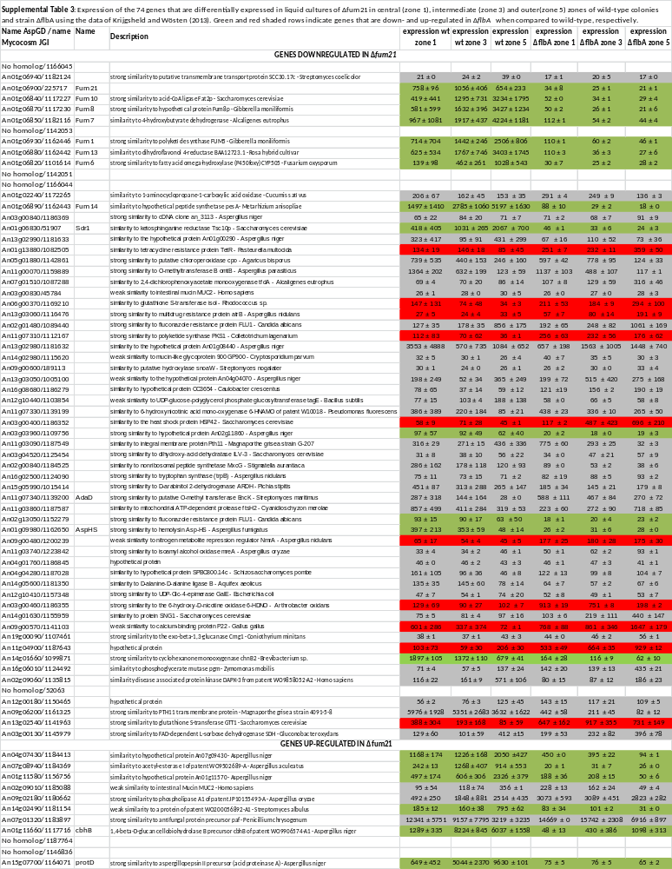
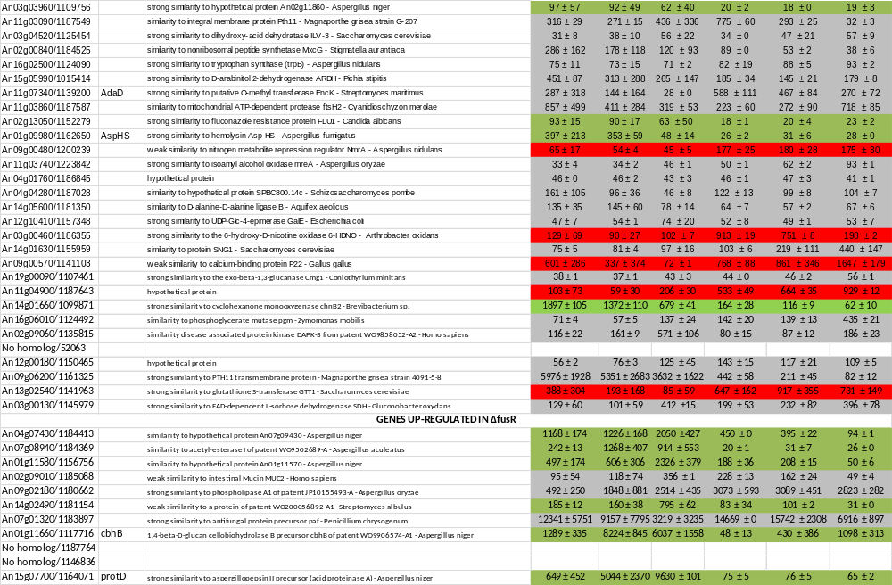
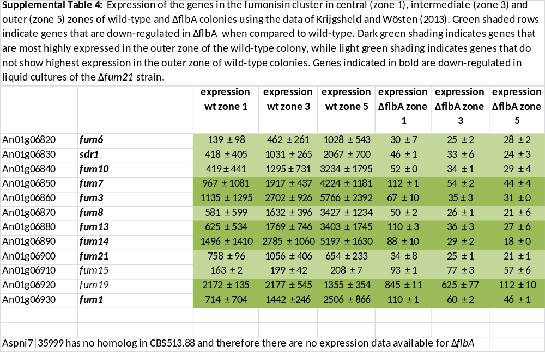

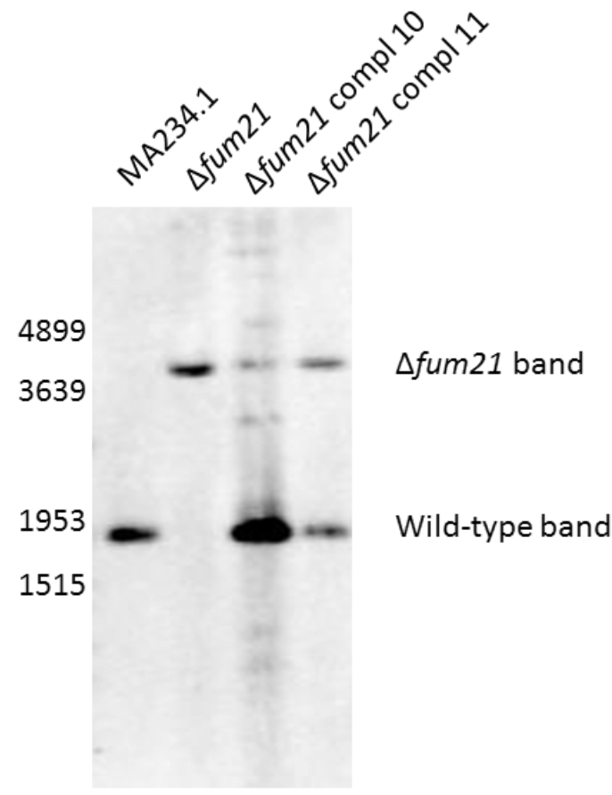
Supplemental Figure 1. Southern blot analysis of wild type strain MA234.1, deletion strain Δfum21 and complemented Δfum21 strains 10 and 11. Deletion of fum21 eliminated a HindIII site, thereby giving a fragment of 4075 and 1876 base pairs in Δfum21 and wild type, respectively. Complemented strain 10 has multiple copies of fum21, while complemented strain 11 has a single integrated copy in its genome.

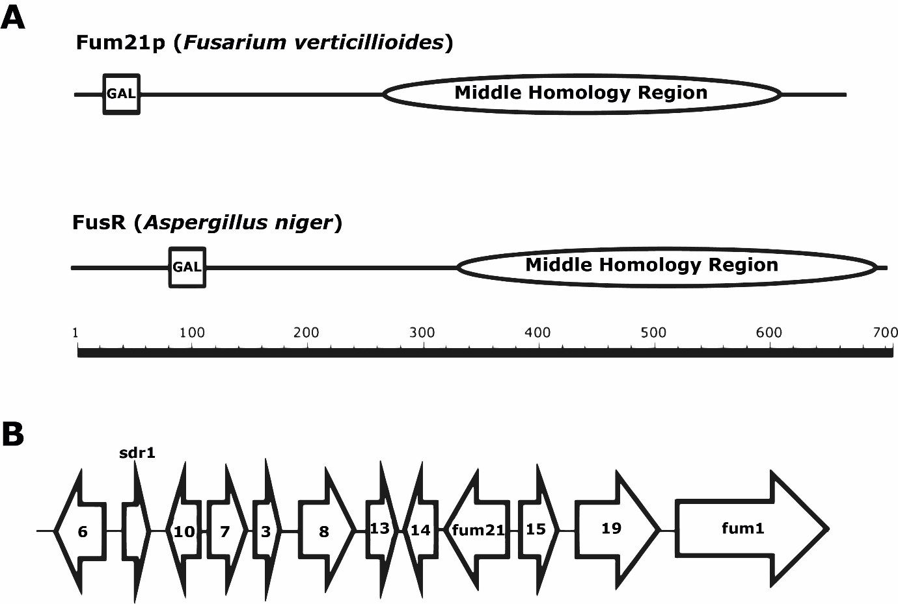
Fum21 (Aspergillus niger)
Supplemental Figure 2. Schematic overview of Fum21 of Fusarium vertillioides and A. niger (A) and the fumonisin gene cluster of A. niger according to Susca et al (2014) (B). GAL = GAL4-like DNA binding domain.

