Supplementary material: Socio-Demographic Predictors of Hospitalization Duration Among Patients with Borderline Personality Disorder

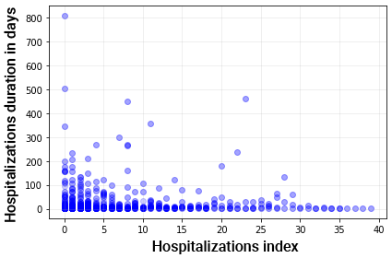
Figure 1: Histogram of the number of hospitalizations per patient in our sample. The histogram consists of 10 bins, each of size 4, thus covering the entire range of 1 to 40 hospitalizations per patient in our sample.
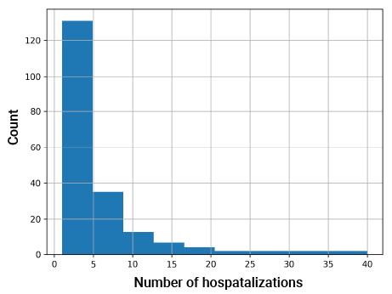
Figure 2: Visit index and the visit's duration. Color intensity denotes the number of samples (the more the darker).

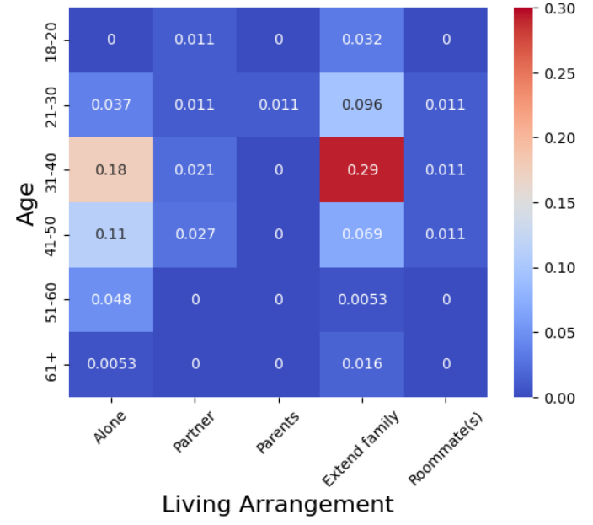
Figure 3: Heatmap of the correlation between age and living arrangement.

