Journal of Experimental and Applied Acarology
Title: The response of the predatory mite Amblyseius swirskii to tomato exudates
Angeliki Paspati^{1*}, Alberto Urbaneja, Joel González-Cabrera²
¹ Instituto Valenciano de Investigaciones Agrarias (IVIA). Centro de Protección Vegetal y Biotecnología. Unidad Mixta Gestión Biotecnológica de Plagas UV-IVIA. Carretera Moncada-Náquera km 4,5. 46113 Moncada, Valencia, Spain
² Universitat de València, Department of Genetics, Estructura de Recerca Interdisciplinar en Biotecnología i Biomedicina (ERI-BIOTECMED). Unidad Mixta Gestión Biotecnológica de Plagas UV-IVIA. Dr Moliner 50, 46100. Burjassot, Valencia, Spain.
*Current addresss: HAO-DEMETER, Institute of Olive, Subtropical crops and Viticulture, IOSV, Heraklion, Greece
Corresponding author: joel.gonzalez@uv.es

Figures
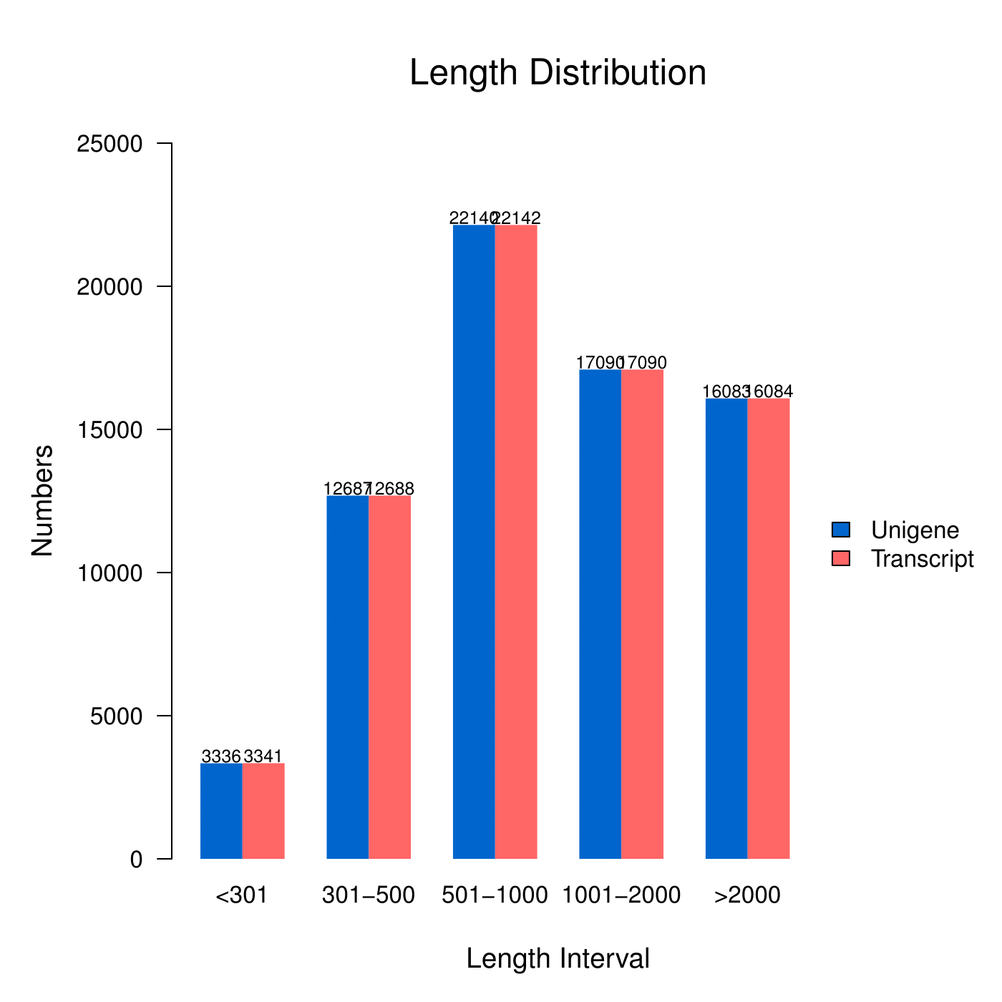
Figure S1. Length distribution of the assembled transcripts and unigenes obtained from the combined reads of eight transcriptome libraries of A. swirskii.

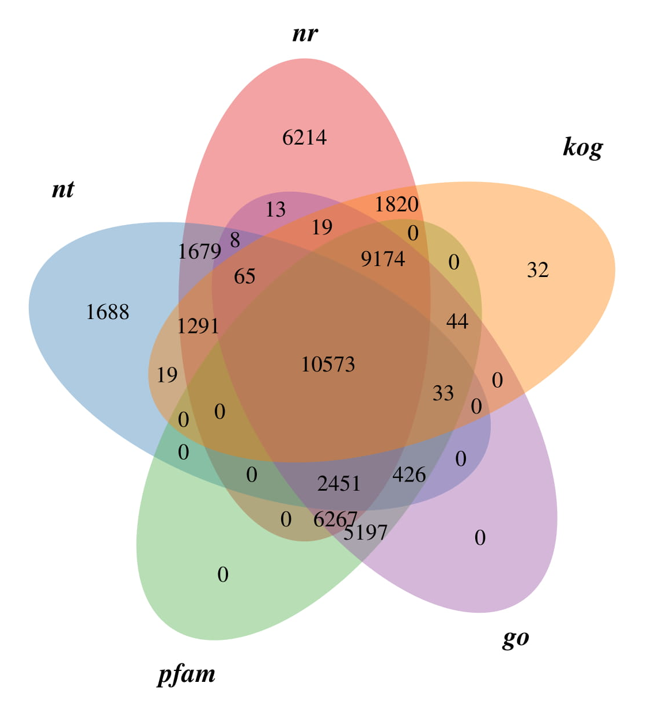
Figure S2. Venn diagram of unigenes of A. swirskii annotated using various databases. The Venn diagram shows the overlapping unigenes annotated in the Nr, Nt, pfam, GO and KOG databases.

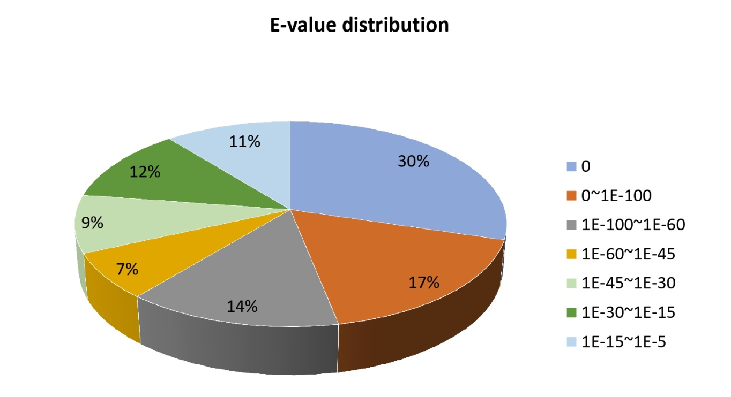
Figure S3. E-value distribution of the blast hits for each unigene with E-value ≤10⁻⁵ of A. swirskii transcriptome data.

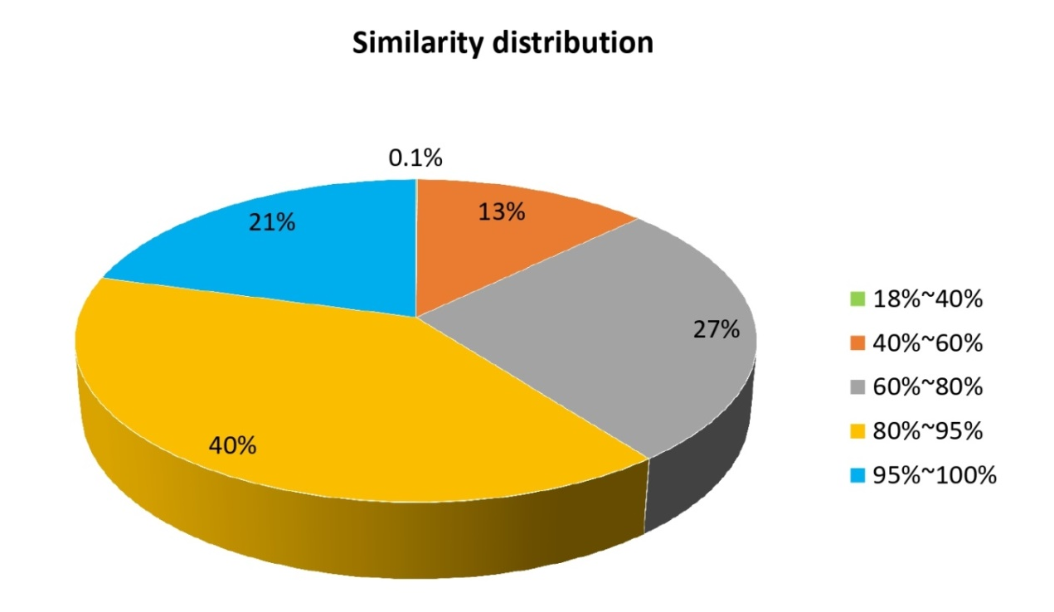
Figure S4. Similarity distribution of the top blast hits for each unigene sequence of A. swirskii transcriptome.

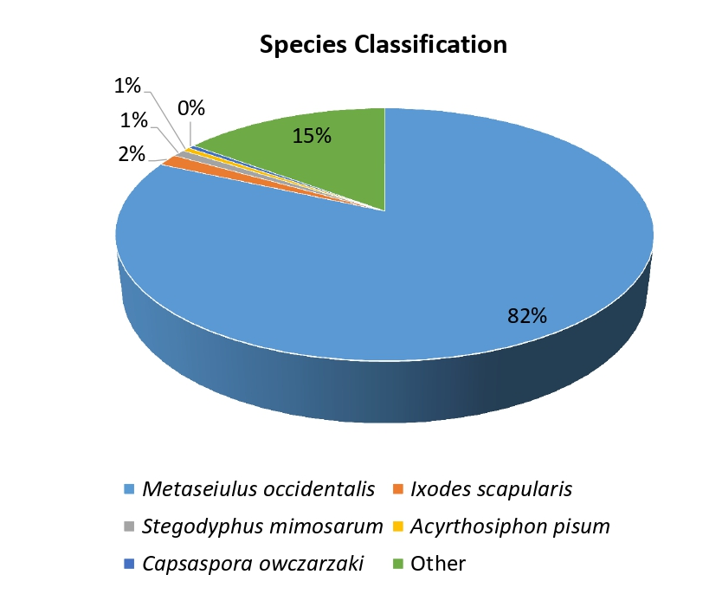
Figure S5. Species distribution of the total homologous sequences with E value ≤10⁻⁵. The first hit of each sequence was used for statistical analysis.

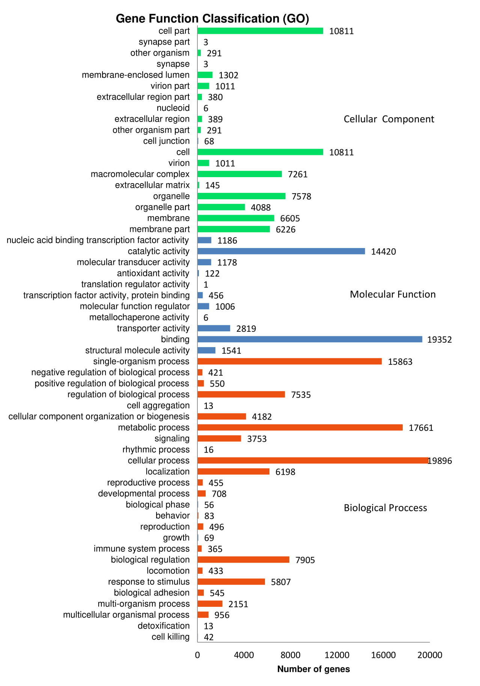
Figure S6. GO annotation of the overall unigene dataset. The total transcriptome dataset of A. swirskii was classified into biological process, cellular component, and molecular function subcategories. X-axis is the names of the 56 subcategories; Y-axis is the number of unigenes annotated under this subcategory.
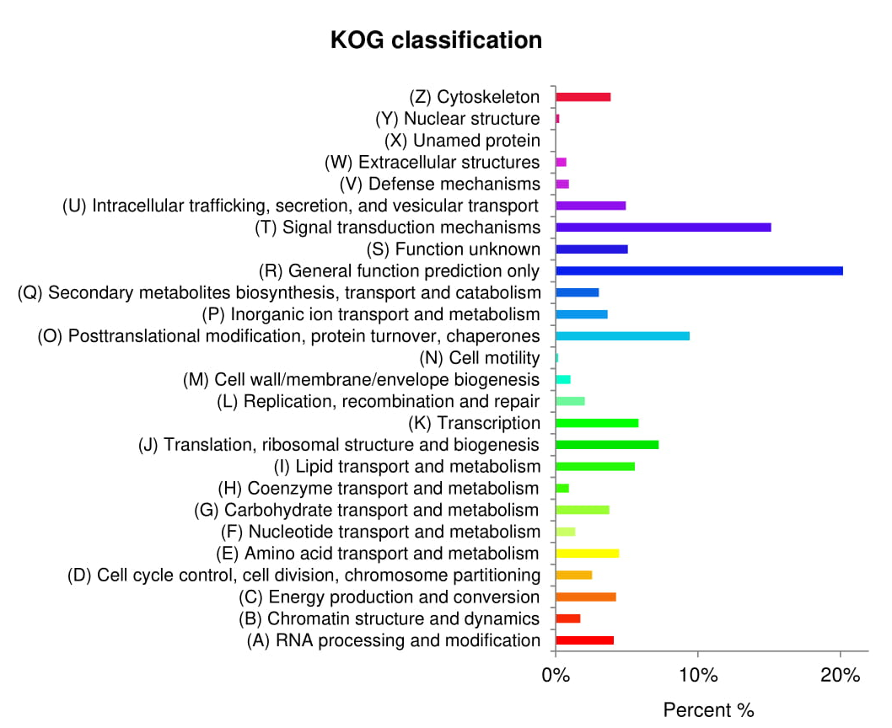
Figure S7. Classification of the euKaryotic Orthologous Groups (KOG) analysis of the A. swirskii transcriptome. X-axis is the names of the 26 KOG group; Y-axis is the percentage of genes annotated under this group in the total annotated genes.

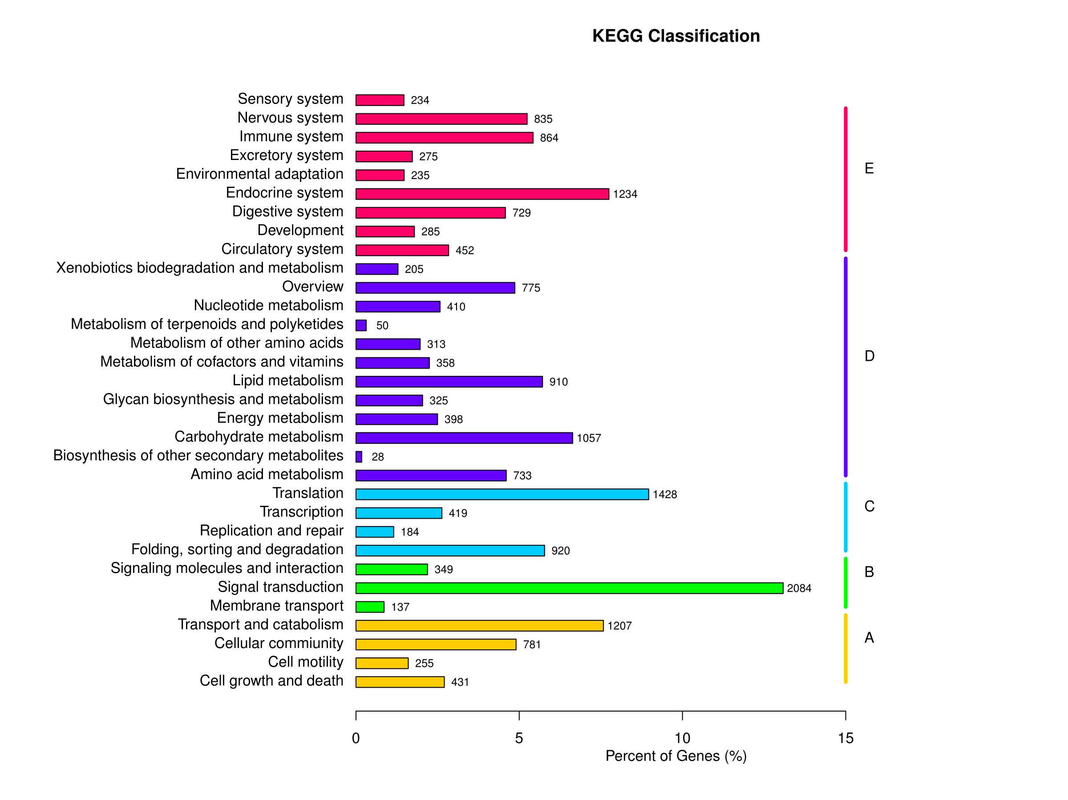
Figure S8. Kyoto Encyclopedia of Genes and Genomes (KEGG) annotation of the A. swirskii transcriptome. The top 15 pathways are shown. Y-axis is the names of KEGG pathways; X-axis is the number of the genes annotated in the pathway and the ratio between the number in this pathway and the total number of annotated genes. The KEGG metabolic pathways gene involved in are divided into 5 branches: A: Cellular Processes, B: Environmental Information Processing, C: Genetic Information Processing, D: Metabolism, E: Organismal Systems.

Tables
Table S1. Summary of the sequence reads obtained from eight transcriptome libraries of A. swirskii. Four transcriptome libraries are from female adults reared on tomato leaves (Treat_T1-Treat_T4) and four from females reared on pepper leaves (Treat_P1-Treat_P4).
Sample | Raw Reads | Clean Reads | Clean Bases | Error(%) | Q20(%) | Q30(%) | GC (%)
Treat_T1 | 104344962 | 98272578 | 14.74G | 0.02 | 96.61 | 91.64 | 47.66
Treat_T2 | 113731580 | 106805200 | 16.02G | 0.02 | 96.66 | 91.74 | 47.96
Treat_T3 | 125843276 | 119195208 | 17.88G | 0.02 | 96.68 | 91.84 | 48.53
Treat_T4 | 117805522 | 111478562 | 16.72G | 0.02 | 97.22 | 92.88 | 50.2
Treat_P1 | 124524702 | 118665004 | 17.8G | 0.02 | 96.73 | 91.95 | 48.23
Treat_P2 | 117971816 | 112701946 | 16.91G | 0.02 | 96.78 | 92.03 | 48.3
Treat_P3 | 128821170 | 123369064 | 18.51G | 0.02 | 96.56 | 91.71 | 46.86
Treat_P4 | 107798420 | 102843378 | 15.43G | 0.02 | 96.72 | 92.04 | 48.27
Total | 940841448 | 893330940 | 134.01 | 0.02 | 96.75 | 91.98 | 48.25

Table S2. Summary of the assembled transcripts and unigenes obtained from the combined reads of eight transcriptome libraries of A. swirskii.
 | Transcripts | Unigenes
Total number | 71345 | 71336
Min length | 201 | 201
Mean length | 1441 | 1441
Median length | 914 | 914
Max length | 21101 | 21101
Total length | 102802715 | 102797693
N50 | 2239 | 2239
N90 | 620 | 620

Table S3. Summary of integrated annotations of unigenes
 | Number of Unigenes | Percentage (%)
Annotated in NR | 39574 | 55.47
Annotated in NT | 18233 | 25.55
Annotated in KO | 15927 | 22.32
Annotated in SwissProt | 29384 | 41.19
Annotated in PFAM | 34165 | 47.89
Annotated in GO | 34270 | 48.04
Annotated in KOG | 23070 | 32.33
Annotated in all Databases | 7218 | 10.11
Annotated in at least one Database | 47159 | 66.1
Annotated in at least five Databases | 71336 | 100

Table S4. Classification of the CYP proteins of A. swirskii. used in the phylogenetic analysis. Columns are: Protein – assigned protein name; Accession No – the Accession number in SRA; Class – classification based on the results of the phylogenetic analysis shown in Figure X; NR Description, Hit Name, Organism, % Identity; and E-value – the results from the blastp against the NR database.

Protein | Accession No Cluster | Class | NR Description | Hit Name | Organism | % Identity | E Value
AS_CYP_01 | 12473 | 4 | cytochrome P450 4c3 | XP_003744153 | Galendromus occidentalis | 72.4 | 0
AS_CYP_02 | 14096.329 | 4 | cytochrome P450 4c3 | XP_003744153 | Galendromus occidentalis | 72.4 | 0
AS_CYP_03 | 14096.47136 | 4 | cytochrome P450 4c3 | XP_003744153 | Galendromus occidentalis | 74.2 | 0
AS_CYP_04 | 14096.47566 | 4 | cytochrome P450 4c3 | XP_003744153 | Galendromus occidentalis | 73.9 | 0
AS_CYP_05 | 14096.14832 | 4 | cytochrome P450 4c3 | XP_003744153 | Galendromus occidentalis | 76.9 | 0
AS_CYP_06 | 14096.38673 | 4 | uncharacterized protein | XP_018497071 | Galendromus occidentalis | 85.9 | 0
AS_CYP_07 | 14096.39632 | 4 | uncharacterized protein | XP_018497071 | Galendromus occidentalis | 83.9 | 1.50E-95
AS_CYP_08 | 14096.42635 | 4 | cytochrome P450 4c3 | XP_003741915 | Galendromus occidentalis | 79.0 | 9.30E-142
AS_CYP_09 | 14096.46827 | 4 | cytochrome P450 4c3 | XP_003741915 | Galendromus occidentalis | 77.8 | 0
AS_CYP_10 | 14096.29671 | 4 | cytochrome P450 4C1 | XP_003740735 | Galendromus occidentalis | 94.1 | 0
AS_CYP_11 | 14096.32881 | 4 | cytochrome P450 4C1 | XP_003740735 | Galendromus occidentalis | 92.2 | 2.39E-68
AS_CYP_12 | 14096.23635 | 4 | cytochrome P450 4V2-like | XP_003746392 | Galendromus occidentalis | 79.0 | 0
AS_CYP_13 | 14096.32675 | 4 | cytochrome P450 4V2-like | XP_022657330 | Varroa destructor | 56.6 | 8.54E-131
AS_CYP_14 | 14096.24998 | 4 | cytochrome P450 4V2-like | OQR78459 | Tropilaelaps mercedesae | 45.7 | 1.37E-164
AS_CYP_15 | 14096.16794 | 4 | cytochrome P450 4V2-like | OQR73969 | Tropilaelaps mercedesae | 70.1 | 0
AS_CYP_16 | 14096.17167 | 4 | cytochrome P450 4V2-like | XP_003744207 | Galendromus occidentalis | 67.2 | 0
AS_CYP_17 | 14096.14981 | 4 | cytochrome P450 4V2 | XP_018493906 | Galendromus occidentalis | 88.2 | 0
AS_CYP_18 | 14096.23655 | 4 | cytochrome P450 4V2 | XP_018493906 | Galendromus occidentalis | 67.3 | 0
AS_CYP_19 | 14096.35067 | 4 | cytochrome P450 4V2-like | XP_018495014 | Galendromus occidentalis | 74.9 | 0
AS_CYP_20 | 14096.39974 | 4 | uncharacterized protein | XP_003747976 | Galendromus occidentalis | 72.3 | 0
AS_CYP_21 | 14096.28681 | 3 | cytochrome P450 3A28 | XP_003740908 | Galendromus occidentalis | 74.8 | 8.76E-137
AS_CYP_22 | 14096.14914 | 3 | cytochrome P450 3A31 | XP_003744549 | Galendromus occidentalis | 80.9 | 0
AS_CYP_23 | 14096.11337 | 3 | cytochrome P450 3A31 | XP_003744549 | Galendromus occidentalis | 62.2 | 7.04E-154
AS_CYP_24 | 14096.22859 | 3 | cytochrome P450 3A6 | XP_018497017 | Galendromus occidentalis | 68.6 | 0
AS_CYP_25 | 14096.12758 | 3 | cytochrome P450 3A6-like | XP_003745699 | Galendromus occidentalis | 65.1 | 0
AS_CYP_26 | 14096.7201 | 3 | cytochrome P450 3A6-like | XP_003745699 | Galendromus occidentalis | 55.1 | 6.81E-130
AS_CYP_27 | 14096.45017 | 3 | cytochrome P450 3A56 | XP_003744550 | Galendromus occidentalis | 54.8 | 0
AS_CYP_28 | 14096.38234 | 3 | cytochrome P450 3A4 | XP_003743686 | Galendromus occidentalis | 78.0 | 0
AS_CYP_29 | 14096.183 | 3 | cytochrome P450 3A24 | XP_003741765 | Galendromus occidentalis | 82.3 | 0
AS_CYP_30 | 14096.23029 | 3 | cytochrome P450 3A24 | XP_003741765 | Galendromus occidentalis | 85.7 | 4.13E-137
AS_CYP_31 | 14096.14727 | 3 | cytochrome P450 3A24 | XP_003741765 | Galendromus occidentalis | 83.8 | 3.41E-138
AS_CYP_32 | 14096.37721 | 3 | cytochrome P450 3A31-like | XP_003744236 | Galendromus occidentalis | 72.5 | 0
AS_CYP_33 | 14096.1855 | 3 | cytochrome P450 3A21 | XP_003741251 | Galendromus occidentalis | 81.9 | 2.52E-127
AS_CYP_34 | 14096.2221 | 3 | cytochrome P450 3A21 | XP_003741251 | Galendromus occidentalis | 83.5 | 1.85E-112
AS_CYP_35 | 14096.1389 | 3 | cytochrome P450 3A16-like | OQR73197 | Tropilaelaps mercedesae | 46.7 | 5.16E-71
AS_CYP_36 | 14096.38954 | 3 | cytochrome P450 3A16-like | OQR73197 | Tropilaelaps mercedesae | 50.2 | 0
AS_CYP_37 | 14096.18325 | 3 | cytochrome P450 3A16 | XP_003744817 | Galendromus occidentalis | 51.3 | 1.42E-30
AS_CYP_38 | 14096.37108 | 3 | cytochrome P450 3A16 | XP_003744817 | Galendromus occidentalis | 51.2 | 2.13E-93
AS_CYP_39 | 14096.8059 | 3 | cytochrome P450 3A16 | XP_003744817 | Galendromus occidentalis | 62.7 | 0
AS_CYP_40 | 14096.17663 | 3 | cytochrome P450 3A9 | XP_003739531 | Galendromus occidentalis | 67.9 | 0
AS_CYP_41 | 14096.39315 | 3 | cytochrome P450 3A24-like | XP_003746429 | Galendromus occidentalis | 70.6 | 0
AS_CYP_42 | 14096.34995 | 3 | cytochrome P450 3A24-like | XP_003746429 | Galendromus occidentalis | 65.3 | 0
AS_CYP_43 | 14096.16575 | 3 | cytochrome P450 3A24-like | XP_003746429 | Galendromus occidentalis | 63.2 | 3.89E-165
AS_CYP_44 | 14096.40867 | 3 | probable cytochrome P450 6d5 | XP_003743386 | Galendromus occidentalis | 78.9 | 0
AS_CYP_45 | 14096.18025 | 3 | cytochrome P450 3A29-like | XP_003737485 | Galendromus occidentalis | 72.5 | 0
AS_CYP_46 | 14096.23742 | 3 | cytochrome P450 3A29-like | XP_003737485 | Galendromus occidentalis | 74.4 | 0
AS_CYP_47 | 14096.22491 | 3 | cytochrome P450 3A29-like | XP_003737485 | Galendromus occidentalis | 64.8 | 0
AS_CYP_48 | 14096.41971 | 3 | cytochrome P450 3A29-like | XP_003737485 | Galendromus occidentalis | 69.0 | 0
AS_CYP_49 | 14096.19522 | 3 | cytochrome P450 3A9-like | XP_003738548 | Galendromus occidentalis | 59.4 | 0
AS_CYP_50 | 14096.23153 | 3 | cytochrome P450 3A9-like | XP_003738548 | Galendromus occidentalis | 58.4 | 3.46E-167
AS_CYP_51 | 14096.16757 | 3 | probable cytochrome P450 6a13 | XP_014094156 | Bactrocera oleae | 36.7 | 6.86E-17
AS_CYP_52 | 14096.111 | M | cytochrome P450 302a1, mitochondrial-like | XP_003745070 | Galendromus occidentalis | 75.5 | 0
AS_CYP_53 | 14096.16995 | M | probable cytochrome P450 49a1 | XP_003741296 | Galendromus occidentalis | 92.1 | 0
AS_CYP_54 | 14096.41654 | 2 | cytochrome P450 2J6-like | XP_018494714 | Galendromus occidentalis | 66.9 | 0
AS_CYP_55 | 14096.36233 | 2 | cytochrome P450 2J6-like | XP_018494714 | Galendromus occidentalis | 66.1 | 0
AS_CYP_56 | 14096.22426 | 2 | cytochrome P450 2J6-like | XP_018494714 | Galendromus occidentalis | 64.6 | 0
AS_CYP_57 | 14096.29831 | 2 | cytochrome P450 2C23 | XP_003747006 | Galendromus occidentalis | 76.3 | 0
AS_CYP_58 | 14096.2349 | 2 | cytochrome P450 2J6 | XP_018495238 | Galendromus occidentalis | 91.4 | 0
AS_CYP_59 | 14096.15944 | 2 | uncharacterized protein | XP_018494895 | Galendromus occidentalis | 57.7 | 0
AS_CYP_60 | 14096.34069 | 2 | uncharacterized protein | XP_018494895 | Galendromus occidentalis | 59.7 | 0
AS_CYP_61 | 14096.20597 | 2 | uncharacterized protein | XP_018494895 | Galendromus occidentalis | 69.7 | 2.20E-53
AS_CYP_62 | 14096.33973 | 2 | uncharacterized protein | XP_018494895 | Galendromus occidentalis | 73.7 | 1.47E-179
AS_CYP_63 | 14096.12347 | 2 | uncharacterized protein | XP_018494895 | Galendromus occidentalis | 63.2 | 1.34E-158
AS_CYP_64 | 14096.19055 | 2 | cytochrome P450 1A1 | XP_003745229 | Galendromus occidentalis | 80.9 | 4.05E-165
AS_CYP_65 | 14096.19304 | 2 | cytochrome P450 1A1 | XP_003745229 | Galendromus occidentalis | 81.7 | 0
AS_CYP_66 | 14096.31074 | 2 | cytochrome P450 1A2 | XP_003741017 | Galendromus occidentalis | 64.8 | 5.33E-116
AS_CYP_67 | 14096.24315 | 2 | cytochrome P450 2F3-like, partial | XP_003738046 | Galendromus occidentalis | 53.2 | 4.79E-162
AS_CYP_68 | 14096.42315 | 2 | cytochrome P450 2J6-like | XP_003748194 | Galendromus occidentalis | 54.1 | 0
AS_CYP_69 | 14096.16396 | 2 | cytochrome P450 2F3-like, partial | XP_003738046 | Galendromus occidentalis | 56.5 | 0
AS_CYP_70 | 14096.44766 | 2 | cytochrome P450 2F3-like, partial | XP_003738046 | Galendromus occidentalis | 57.8 | 0
AS_CYP_71 | 14096.16315 | 2 | cytochrome P450 2F3-like, partial | XP_003738046 | Galendromus occidentalis | 52.5 | 1.38E-180
AS_CYP_72 | 14096.23357 | 2 | cytochrome P450 71B22-like | XP_003748195 | Galendromus occidentalis | 70.0 | 0
AS_CYP_73 | 14096.20063 | 2 | cytochrome P450 2F3-like | XP_018493962 | Galendromus occidentalis | 54.9 | 0
AS_CYP_74 | 14096.25695 | 2 | cytochrome P450 2F3-like | XP_018493962 | Galendromus occidentalis | 59.1 | 0
AS_CYP_75 | 14096.16263 | 2 | cytochrome P450 307a1-like | XP_003747195 | Galendromus occidentalis | 83.0 | 0
AS_CYP_76 | 14096.20839 | 2 | cytochrome P450 307a1-like | XP_003747195 | Galendromus occidentalis | 72.7 | 0

Table S5. Classification of the GST proteins of A. swirskii. used in the phylogenetic analysis. Columns are: Protein – assigned protein name; Accession No – the Accession number in SRA; Class – classification based on the results of the phylogenetic analysis shown in Figure X; NR Description, Hit Name, Organism, % Identity; and E-value – the results from the blastp against the NR database.
Protein | Accession No Cluster | Class | NR Description | Hit Name | Organism | % Identity | E Value
AS_GST01 | 14096.28962 | omega | pyrimidodiazepine synthase | XP_018496135 | Galendromus occidentalis | 82.3 | 6.95E-140
AS_GST02 | 14096.4445 | omega | glutathione S-transferase omega-1 | XP_003738156 | Galendromus occidentalis | 79.3 | 1.08E-90
AS_GST03 | 14096.27508 | kappa | glutathione S-transferase kappa 1 | XP_003738807 | Galendromus occidentalis | 83.6 | 1.50E-139
AS_GST04 | 14096.16668 | mu | glutathione S-transferase Mu 1-like | OQR71874 | Tropilaelaps mercedesae | 62.7 | 2.64E-50
AS_GST05 | 14096.2226 | delta | glutathione S-transferase C-terminal domain-containing | XP_003737347 | Galendromus occidentalis | 69.7 | 0
AS_GST06 | 14096.35417 | kappa | glutathione S-transferase kappa 1 | XP_003738778 | Galendromus occidentalis | 88.8 | 2.16E-151
AS_GST07 | 14096.51772 | uncharacterized | glutathione S-transferase 4-like | XP_022669924 | Varroa destructor | 90.5 | 3.29E-125
AS_GST08 | 14096.2419 | uncharacterized | glutathione S-transferase 4-like | XP_022669924 | Varroa destructor | 81.8 | 7.80E-121
AS_GST09 | 14096.27038 | mu | glutathione S-transferase class-mu 26 kDa isozyme 47 | XP_003737612 | Galendromus occidentalis | 79.1 | 5.60E-60
AS_GSTd01 | 14096.4354 | delta | glutathione S-transferase | EFX81633 | Daphnia pulex | 58.6 | 9.09E-69
AS_GSTd02 | 14096.51347 | delta | glutathione S-transferase 1-1 | XP_003740940 | Galendromus occidentalis | 89.5 | 1.12E-137
AS_GSTd03 | 14096.1759 | delta | glutathione S-transferase 1 | XP_003743487 | Galendromus occidentalis | 64.6 | 2.29E-55
AS_GSTd04 | 14096.18035 | delta | glutathione S-transferase 1 | XP_003743487 | Galendromus occidentalis | 68.3 | 2.27E-103
AS_GSTd05 | 14096.36333 | delta | glutathione S-transferase 1 | XP_003743487 | Galendromus occidentalis | 84.1 | 2.15E-102
AS_GSTd06 | 14096.17204 | delta | glutathione S-transferase 1 | XP_003743487 | Galendromus occidentalis | 87.0 | 5.59E-136
AS_GSTd07 | 14096.25844 | delta | glutathione S-transferase 1 | XP_003746787 | Galendromus occidentalis | 62.9 | 3.76E-78
AS_GSTd08 | 14096.45023 | delta | glutathione S-transferase 1 | XP_003746787 | Galendromus occidentalis | 65.7 | 2.21E-105
AS_GSTd09 | 14096.25851 | delta | glutathione S-transferase 1 | XP_003746787 | Galendromus occidentalis | 84.2 | 5.11E-138
AS_GSTd10 | 14096.32345 | delta | glutathione S-transferase 1-like isoform X1 | XP_022705046 | Varroa jacobsoni | 68.4 | 9.71E-108
AS_GSTd11 | 14096.33358 | delta | glutathione S-transferase 1 | XP_003746787 | Galendromus occidentalis | 78.7 | 4.24E-107
AS_GSTm01 | 14096.8488 | mu | hypothetical protein PENSTE | OQE20378 | Penicillium steckii | 90.5 | 9.64E-133
AS_GSTm02 | 14096.19298 | mu | glutathione S-transferase Mu 1 | XP_003742682 | Galendromus occidentalis | 68.8 | 1.08E-111
AS_GSTm03 | 14096.27548 | mu | glutathione S-transferase Mu 1 | XP_003742682 | Galendromus occidentalis | 89.2 | 3.63E-146
AS_GSTm04 | 14096.25965 | mu | glutathione S-transferase Mu 1 | XP_018495947 | Galendromus occidentalis | 89.1 | 4.05E-159
AS_GSTm05 | 14096.24826 | mu | glutathione S-transferases-1 | AKO22175 | Dermanyssus gallinae | 57.4 | 1.07E-96
AS_GSTo01 | 14096.47912 | omega | glutathione S-transferase omega-1 | XP_003738156 | Galendromus occidentalis | 82.5 | 2.77E-146
AS_GSTo02 | 14096.46561 | omega | glutathione S-transferase omega-1 | XP_003738156 | Galendromus occidentalis | 80.8 | 9.58E-56
AS_GSTo03 | 14096.2114 | omega | glutathione S-transferase omega-1 | XP_003746278 | Galendromus occidentalis | 77.7 | 1.64E-128

Table S6. Classification of the CCE proteins of A. swirskii. used in the phylogenetic analysis. Columns are: Protein – assigned protein name; Accession No – the Accession number in SRA; Class – classification based on the results of the phylogenetic analysis shown in Figure X; NR Description, Hit Name, Organism, % Identity; and E-value – the results from the blastp against the NR database.
Protein | Accession No Cluster | class | NR Description | Hit Name | Organism | % Identity | E Value
AS_CCE_01 | 14096.17155 | J´´ | cholinesterase 1-like | XP_003744419 | Galendromus occidentalis | 72.9 | 0
AS_CCE_02 | 14096.11228 | J´´ | cholinesterase 1-like | XP_003744359 | Galendromus occidentalis | 71.5 | 2.98E-154
AS_CCE_03 | 14096.18193 | J´´ | liver carboxylesterase 1-like | OQR66681 | Tropilaelaps mercedesae | 53.1 | 4.09E-168
AS_CCE_04 | 14096.38789 | J´´ | acetylcholinesterase-like | XP_003747077 | Galendromus occidentalis | 68.3 | 0
AS_CCE_05 | 14096.7546 | J´´ | cholinesterase-like | XP_003740670 | Galendromus occidentalis | 42.0 | 8.67E-45
AS_CCE_06 | 14096.854 | J´´ | acetylcholinesterase-like | XP_003745536 | Galendromus occidentalis | 52.3 | 1.31E-102
AS_CCE_07 | 14096.26752 | J´´ | acetylcholinesterase-like | XP_003745536 | Galendromus occidentalis | 59.4 | 4.18E-141
AS_CCE_08 | 14096.22721 | J´´ | cholinesterase 1-like | XP_003740671 | Galendromus occidentalis | 69.8 | 0
AS_CCE_09 | 14096.48773 | J´´ | cholinesterase 1-like | XP_003740671 | Galendromus occidentalis | 56.7 | 5.96E-113
AS_CCE_10 | 14096.6682 | J´´ | cholinesterase 1-like | XP_003740671 | Galendromus occidentalis | 62.1 | 0
AS_CCE_11 | 14096.23959 | J´´ | cholinesterase 1-like | XP_003740671 | Galendromus occidentalis | 57.2 | 1.95E-130
AS_CCE_12 | 14096.15138 | J´´ | cholinesterase 1-like | XP_003740671 | Galendromus occidentalis | 62.9 | 1.58E-99
AS_CCE_13 | 14096.23398 | J´´ | cholinesterase 1-like | XP_003740671 | Galendromus occidentalis | 56.6 | 0
AS_CCE_14 | 14096.32914 | J´´ | acetylcholinesterase-like | XP_003742289 | Galendromus occidentalis | 52.3 | 4.85E-102
AS_CCE_15 | 14096.14165 | J´´ | carboxylesterase 5A-like | XP_003744189 | Galendromus occidentalis | 73.5 | 0
AS_CCE_16 | 14096.6576 | J´´ | cholinesterase 2-like | XP_003744142 | Galendromus occidentalis | 74.1 | 0
AS_CCE_17 | 14096.49601 | J´ | cholinesterase 1 | XP_003738701 | Galendromus occidentalis | 93.4 | 0
AS_CCE_18 | 14096.44875 | J´ | acetylcholinesterase-1 | XP_003741414 | Galendromus occidentalis | 93.2 | 0
AS_CCE_19 | 14096.42729 | J´ | acetylcholinesterase-1-like | XP_003743019 | Galendromus occidentalis | 89.7 | 0
AS_CCE_20 | 14096.23198 | J´ | acetylcholinesterase-1-like | XP_003743019 | Galendromus occidentalis | 89.6 | 0
AS_CCE_22 | 14096.17565 | J´ | acetylcholinesterase-like | XP_018497642 | Galendromus occidentalis | 91.3 | 0
AS_CCE_23 | 14096.44036 | J´ | cholinesterase 1 | XP_003739903 | Galendromus occidentalis | 82.3 | 0
AS_CCE_24 | 14096.6939 | J´ | cholinesterase 1 | XP_003739903 | Galendromus occidentalis | 84.8 | 0
AS_CCE_25 | 14096.30297 | J´ | acetylcholinesterase-like | XP_018494386 | Galendromus occidentalis | 80.4 | 2.91E-78
AS_CCE_26 | 14096.19664 | J´ | acetylcholinesterase-like | XP_018494387 | Galendromus occidentalis | 64.9 | 8.92E-112
AS_CCE_27 | 14096.35506 | J´ | acetylcholinesterase-1-like | XP_018494388 | Galendromus occidentalis | 55.1 | 0
AS_CCE_29 | 14096.11036 | J´ | acetylcholinesterase | XP_018496861 | Galendromus occidentalis | 87.5 | 0
AS_CCE_30 | 14096.13369 | J´ | carboxylesterase 1C-like | XP_018494965 | Galendromus occidentalis | 92.0 | 0
AS_CCE_31 | 14096.31091 | uncharacterized | cholinesterase-like | XP_003748221 | Galendromus occidentalis | 73.0 | 0
AS_CCE_32 | 14096.22084 | uncharacterized | bile salt-activated lipase-like | XP_003748220 | Galendromus occidentalis | 54.8 | 1.92E-176
AS_CCE_33 | 14096.17240 |  | neuroligin-4, Y-linked-like | XP_003747068 | Galendromus occidentalis | 97.1 | 6.48E-65
AS_CCE_34 | 14096.919 |  | neuroligin-4, Y-linked-like | XP_003747068 | Galendromus occidentalis | 91.2 | 0
AS_CCE_35 | 14096.48842 |  | neuroligin-4, Y-linked-like | XP_003747068 | Galendromus occidentalis | 91.4 | 0
AS_CCE_36 | 14096.50683 |  | neuroligin-1-like | XP_003747809 | Galendromus occidentalis | 88.7 | 0
AS_CCE_37 | 14096.34411 |  | neuroligin-1-like | XP_003746248 | Galendromus occidentalis | 96.6 | 6.62E-133
AS_CCE_38 | 14096.10054 |  | neuroligin-2-like | XP_003740818 | Galendromus occidentalis | 50.7 | 7.05E-125
AS_CCE_39 | 14096.612 |  | neuroligin-2-like | XP_003740818 | Galendromus occidentalis | 50.4 | 0
AS_CCE_40 | 14096.617 |  | conserved hypothetical protein | XP_002433649 | Ixodes scapularis | 63.2 | 1.50E-117
AS_CCE_41 | 14096.29182 |  | neuroligin-4, X-linked-like | XP_003740840 | Galendromus occidentalis | 86.5 | 0
AS_CCE_42 | 14096.44003 |  | neuroligin-2-like | XP_003740818 | Galendromus occidentalis | 95.9 | 0
AS_CCE_43 | 14096.43875 |  | neuroligin-4, X-linked-like | XP_003741692 | Galendromus occidentalis | 94.1 | 0
AS_CCE_44 | 14096.7323 |  | neuroligin-2-like | XP_003742198 | Galendromus occidentalis | 83.4 | 0
AS_CCE_45 | 14096.14167 |  | neuroligin-2-like | XP_003742198 | Galendromus occidentalis | 85.6 | 0
AS_CCE_46 | 14096.46124 |  | neuroligin-2-like | XP_003742198 | Galendromus occidentalis | 89.9 | 0

Table S7. G. occidentalis CYP, GST and CCE gene accession numbers in GenBank, of the sequences used in the phylogenetic analyses.
Gene | Name in tree | Accession N. |  |  | Name in tree | Accession N.
CYP |  | GenBank |  |  |  | GenBank
1 | MO_CYP1A1 | XP 003745229.1 |  | 31 | MO_CYP3A29-like | XP 003737485.1
2 | MO_CYP1A2 | XP 003741017.1 |  | 32 | MO_CYP3A30-like_partial | XP 018497550.1
3 | MO_CYP2B4-like | XP 018496574.1 |  | 33 | MO_CYP3A31 | XP 003744549.2
4 | MO_CYP2C23 | XP 003747006.1 |  | 34 | MO_CYP3A31-like | XP 003744236.1
5 | MO_CYP2C29 | XP 003747005.1 |  | 35 | MO_CYP3A40-like | XP 003743371.2
6 | MO_CYP2F2-like | XP 003738704.1 |  | 36 | MO_CYP3A56_ | XP 003744550.1
7 | MO_CYP2F3-like_ | XP 018493962.1 |  | 37 | MO_CYP4C1 | XP 003740735.2
8 | MO_CYP2J6 | XP 018495238.1 |  | 38 | MO_CYP4C1-like_1 | XP 018495350.1
9 | MO_CYP2J6-like_1 | XP 018494714.1 |  | 39 | MO_CYP4C1-like_2 | XP 003737352.2
10 | MO_CYP2J6-like_2 | XP 003748194.2 |  | 40 | MO_CYP4c3_1 | XP 003744153.1
11 | MO_CYP2J6-like_3 | XP 003748197.1 |  | 41 | MO_CYP4c3_2 | XP 003741915.1
12 | MO_CYP2U1-like | XP 003747196.2 |  | 42 | MO_CYP4c3-like_1 | XP 018497197.1
13 | MO_CYP3A4 | XP 003743686.1 |  | 43 | MO_CYP4c3-like_2 | XP 003739201.2
14 | MO_CYP3A6_1 | XP 018497017.1 |  | 44 | MO_CYP4V2_1 | XP 018493906.1
15 | MO_CYP3A6_2 | XP 003743392.2 |  | 45 | MO_CYP4V2_2 | XP 018496722.1
16 | MO_CYP3A6-like | XP 003745699.1 |  | 46 | MO_CYP4V2-like_1 | XP 003746392.1
17 | MO_CYP3A7-like | XP 018497741.1 |  | 47 | MO_CYP4V2-like_2 | XP 003744207.1
18 | MO_CYP3A9 | XP 003739531.2 |  | 48 | MO_CYP4V2-like_3 | XP 018495014.1
19 | MO_CYP3A9-like_ | XP 003738548.2 |  | 49 | MO_CYP4V2-like_4 | XP 003747974.1
20 | MO_CYP3A12-like | XP 003744583.1 |  | 50 | MO_CYP4V2-like_5 | XP 018494969.1
21 | MO_CYP3A14 | XP 003745878.1 |  | 51 | MO_CYP71B22-like | XP 003748195.1
22 | MO_CYP3A14-like | XP 003743440.1 |  | 52 | MO_CYP98A3-like_ | XP 018495925.1
23 | MO_CYP3A16 | XP 003744817.1 |  | 53 | MO_CYP302a1_mitochondrial-like | XP 003745070.1
24 | MO_CYP3A19-like_1 | XP 003742033.2 |  | 54 | MO_CYP307a1-like | XP 003747195.1
25 | MO_CYP3A19-like_2 | XP 018496532.1 |  | 55 | MO_CYP315a1_mitochondrial | XP 003743235.1
26 | MO_CYP3A21 | XP 003741251.1 |  | 56 | MO_CYP_6d5_ | XP 003743386.2
27 | MO_CYP3A24 | XP 003741765.1 |  | 57 | MO_CYP_49a1_ | XP 003741296.1
28 | MO_CYP3A24-like_1 | XP 003746429.1 |  | 58 | MO_ecdysone_20-monooxygenase-like | XP 003748577.1
29 | MO_CYP3A24-like_2 | XP 003738840.2 |  | 59 | MO_lithocholate_6-beta-hydroxylase-like | XP 003745726.1
30 | MO_CYP3A28 | XP 003740908.1
GST
1 | MO_GST05 | XP_003738807.1 |  | 10 | MO_GST04 | XP 003744624.1
2 | MO_GST06 | XP_003738778.1 |  | 11 | MO_GST03 | XP 003741590.1
3 | MO_GSTp01 | XP 003737007.1 |  | 12 | MO_GST01 | XP 003738383.1
4 | MO_GSTo01 | XP 003746278.1 |  | 13 | MO_GSTp02 | XP 003744621.1
5 | MO_GSTo02 | XP 003738156.1 |  | 14 | MO_GSTm01 | XP 003737612.1
6 | MO_GSTd01 | XP 003740940.1 |  | 15 | MO_GSTm02 | XP 003742682.2
7 | MO_GSTd02 | XP 003743487.1 |  | 16 | MO_GSTm03 | XP 018495947.1
8 | MO_GSTd03 | XP 003746787.1 |  | 17 | MO_GSTm04 | XP 003747409.1
9 | MO_GST02 | XP 003745766.1 |  | 18 | MO_GST07 | XP 003744890.1
CCE
1 | MO CCE3 | XP 003744359.1 |  | 24 | MO CCE37 | XP 003748221.1
2 | MO CCE4 | XP 003744419.1 |  | 25 | MO CCE38 | XP 003748220.1
3 | MO CCE5 | XP 003740650.1 |  | 26 | MO CCE39 | XP 018497642.1
4 | MO CCE6 | XP 003740671.2 |  | 27 | MO CCE40 | XP 018496563.1
5 | MO CCE7 | XP 003740670.1 |  | 28 | MO CCE41 | XP 003737110.1
6 | MO CCE8 | XP 003745536.1 |  | 29 | MO CCE42 | XP 003738697.1
7 | MO CCE9 | XP 003747077.1 |  | 30 | MO CCE43 | XP 028966555.1
8 | MO CCE10 | XP 003744142.2 |  | 31 | MO CCE44 | XP 018494965.1
9 | MO CCE12 | XP 003744189.1 |  | 32 | MO CCE45 | XP 018496352.1
10 | MO CCE13 | XP 003742834.1 |  | 33 | MO CCE46 | XP 018494388.1
11 | MO CCE14 | XP 003738421.1 |  | 34 | MO CCE47 | XP 003739903.2
12 | MO CCE18 | XP 003745369.1 |  | 35 | MO CCE48 | XP 028968333.1
13 | MO CCE20 | XP 003744479.1 |  | 36 | MO CCE49 | XP 018496861.1
14 | MO CCE22 | XP 003746194.2 |  | 37 | MO CCE50 | XP 018496632.1
15 | MO CCE26 | XP 003743019.1 |  | 38 | MO CCE51 | XP 018494964.1
16 | MO CCE27 | XP 003738701.1 |  | 39 | MO CCE52 | XP 018494461.1
17 | MO CCE28 | XP 003741414.1 |  | 40 | MO CCE53 | XP 028966956.1
18 | MO CCE30 | XP 003747841.1 |  | 41 | MO CCE54 | XP 028966822.1
19 | MO CCE31 | XP 003739668.2 |  | 42 | MO CCE55 | XP 028966555.1
20 | MO CCE32 | XP 003742457.2 |  | 43 | MO CCE56 | XP 028966562.1
21 | MO CCE33 | XP 003745863.1 |  | 44 | MO CCE57 | XP 028968576.1
22 | MO CCE34 | XP 003743644.1 |  | 45 | MO CCE58 | XP 028968124.1
23 | MO CCE35 | XP 003746193.1 |  | 46 | MO CCE59 | XP 028968529.1

Table S8. T. urticae CYP, GST and CCE gene accession numbers in OrcAE, of the sequences used in the phylogenetic analyses.
Gene | Name in tree | Accession N. |  |  | Name in tree | Accession N.
CYP |  | OrcAE |  |  |  | OrcAE
1 | TU_CYP4CF2 | tetur09g03800 |  | 44 | TU_CYP392A6 | tetur11g00530
2 | TU_CYP4CL1 | tetur01g00650 |  | 45 | TU_CYP392A7 | tetur16g03500
3 | TU_CYP302A1_1 | tetur05g02550 |  | 46 | TU_CYP392A8 | tetur02g14020
4 | TU_CYP302A1_2 | tetur05g02670 |  | 47 | TU_CYP392A9 | tetur47g00090
5 | TU_CYP307A1 | tetur10g03900 |  | 48 | TU_CYP392A9v2 | tetur02g14330
6 | TU_CYP314A1 | tetur03g03020 |  | 49 | TU_CYP392A10 | tetur16g03790
7 | TU_CYP315A1 | tetur06g05620 |  | 50 | TU_CYP392A10v2 | tetur02g14400
8 | TU_CYP381A1 | tetur13g02850 |  | 51 | TU_CYP392A11 | tetur03g00970
9 | TU_CYP381A2 | tetur13g02840 |  | 52 | TU_CYP392A12 | tetur03g00830
10 | TU_CYP382A1 | tetur03g01560 |  | 53 | TU_CYP392A13v1 | tetur08g08050
11 | TU_CYP384A1 | tetur38g00650 |  | 54 | TU_CYP392A13v2 | tetur03g00020
12 | TU_CYP385A1 | tetur07g05500 |  | 55 | TU_CYP392A14 | tetur08g07950
13 | TU_CYP385B1 | tetur05g04000 |  | 56 | TU_CYP392A16 | tetur06g04520
14 | TU_CYP385C1 | tetur26g01470 |  | 57 | TU_CYP392B1 | tetur20g03200
15 | TU_CYP385C2 | tetur11g05000 |  | 58 | TU_CYP392B2 | tetur02g06650
16 | TU_CYP385C3 | tetur11g05540 |  | 59 | TU_CYP392B3 | tetur20g00290
17 | TU_CYP385C3v2 | tetur46g00170 |  | 60 | TU_CYP392C1 | tetur03g03950
18 | TU_CYP385C4 | tetur11g05520 |  | 61 | TU_CYP392D1 | tetur23g00260
19 | TU_CYP385C4v2 | tetur46g00150 |  | 62 | TU_CYP392D2 | tetur03g04990
20 | TU_CYP386A1 | tetur11g06070 |  | 63 | TU_CYP392D3 | tetur03g05000
21 | TU_CYP387A1 | tetur08g06170 |  | 64 | TU_CYP392D4 | tetur03g05010
22 | TU_CYP387A2 | tetur01g06120 |  | 65 | TU_CYP392D6 | tetur03g05030
23 | TU_CYP388A1 | tetur03g05190 |  | 66 | TU_CYP392D8 | tetur03g05070
24 | TU_CYP389A1 | tetur25g02050 |  | 67 | TU_CYP392E1 | tetur03g05540
25 | TU_CYP389B1 | tetur25g02060 |  | 68 | TU_CYP392E2 | tetur06g02400
26 | TU_CYP389C1 | tetur34g00510 |  | 69 | TU_CYP392E3 | tetur06g02820
27 | TU_CYP389C2 | tetur05g02950 |  | 70 | TU_CYP392E6 | tetur27g00330
28 | TU_CYP389C3 | tetur05g02960 |  | 71 | TU_CYP392E7 | tetur27g00340
29 | TU_CYP389C4 | tetur05g02970 |  | 72 | TU_CYP392E8 | tetur27g00350
30 | TU_CYP389C5 | tetur05g08390 |  | 73 | TU_CYP392E9 | tetur27g01020
31 | TU_CYP389C6 | tetur05g06630 |  | 74 | TU_CYP392E10 | tetur27g01030
32 | TU_CYP389C7 | tetur05g06620 |  | 75 | TU_CYP406A1 | tetur01g04440
33 | TU_CYP389C8 | tetur05g06610 |  | 76 | TU_CYP407A1 | tetur20g00830
34 | TU_CYP389C9 | tetur05g06600 |  | 77 | TU_CYP_1 | tetur14g01350
35 | TU_CYP389C10 | tetur05g06580 |  | 78 | TU_CYP_2 | tetur05g02670
36 | TU_CYP389C11 | tetur05g06570 |  | 79 | TU_CYP_3 | tetur01g13730
37 | TU_CYP389C12 | tetur05g06560 |  | 80 | TU_CYP_conserved_site_1 | tetur03g09941
38 | TU_CYP390A1 | tetur03g00910 |  | 81 | TU_CYP_conserved_site_2 | tetur03g09961
39 | TU_CYP391A1 | tetur36g00920 |  | 82 | TU_CYP_conserved_site_3 | tetur03g05100
40 | TU_CYP392A1 | tetur07g06410 |  | 83 | TU_CYP_E-class_group_I | tetur06g02650
41 | TU_CYP392A3 | tetur07g06460 |  | 84 | TU_CYP_E-class_group_I_1 | tetur03g00970
42 | TU_CYP392A4 | tetur07g06480 |  | 85 | TU_CYP_E-class_group_I_2 | tetur27g02598
43 | TU_CYP392A5 | tetur11g04390 |  | 86 | TU_CYP_E-class_group_IV | tetur07g08087
GST
1 | TU GSTp01 | tetur05g05180 |  | 18 | TU GSTd13 | tetur26g01490
2 | TU GSTd15 | tetur26g02802 |  | 19 | TU GSTd05 | tetur01g02470
3 | TU GSTd12 | tetur26g02801 |  | 20 | TU GSTo02 | tetur01g02320
4 | TU GSTm05 | tetur05g05270 |  | 21 | TU GSTd03 | tetur29g00220
5 | TU GSTm07 | tetur05g05210 |  | 22 | TU GSTz01 | tetur07g02560
6 | TU GSTd08 | tetur03g07920 |  | 23 | TU GSTd07 | tetur01g02500
7 | TU GSTd10 | tetur26g01450 |  | 24 | TU GSTm10 | tetur05g05240
8 | TU GSTm03 | tetur03g09230 |  | 25 | TU GSTd05 | tetur01g02480
9 | TU GSTd01 | tetur31g01390 |  | 26 | TU GSTm11 | tetur05g05190
10 | TU GST02 | tetur01g12390 |  | 27 | TU GSTd14 | tetur26g01510
11 | TU GST01 | tetur04g04990 |  | 28 | TU GSTk01 | tetur22g02300
12 | TU GSTm09 | tetur05g05260 |  | 29 | TU GSTm01 | tetur05g05220
13 | TU GSTd02 | tetur31g01330 |  | 30 | TU GSTm04 | tetur05g05200
14 | TU GSTd06 | tetur01g02230 |  | 31 | TU GSTo01 | tetur12g03900
15 | TU GSTm08 | tetur05g05250 |  | 32 | TU GSTm02 | tetur05g05300
16 | TU GSTm06 | tetur05g05290 |  | 33 | TU GSTd04 | tetur01g02510
17 | TU GSTd11 | tetur26g01500 |  | 34 | TU GSTd09 | tetur26g01460
CCE
1 | TU_CCE_1 | tetur01g10760 |  | 6 | TU_CCE_6 | tetur04g08480
2 | TU_CCE_2 | tetur01g10830 |  | 7 | TU_CCE_7 | tetur11g05770
3 | TU_CCE_3 | tetur01g14090 |  | 8 | TU_CCE_8 | tetur19g00850
4 | TU_CCE_4 | tetur02g06930 |  | 9 | TU_CCE_9 | tetur29g00970
5 | TU_CCE_5 | tetur04g06380 |  | 10 | TU_CCE_10 | tetur30g01560

Table S9. A. meliphera (left columns) and D. melanogaster (right columns) CCE gene accession numbers in GenBank and FlyBase respectively, of the sequences used in the phylogenetic analyses.
Gene | Name in tree | Accession N. |  |  | Name in tree | Accession N.
CCE |  | GenBank |  |  |  | FlyBase
1 | AM CCE 1 | NP 001119716.1 |  | 1 | DM CCE 1 | CG2505
2 | AM AChE1 | XP_393751.2 |  | 2 | DM CCE 2 | CG17148
3 | AM CCE 3 | XP 006572393.1 |  | 3 | DM CCE 3 | CG31146
4 | AM CCE 4 | XP 006568129.1 |  | 4 | DM CCE 4 | CG1121
5 | AM CCE 5 | XP 006564306.1 |  | 5 | DM CCE 5 | CG9704
6 | AM CCE 6 | NP 001035320.1 |  | 6 | DM CCE 6 | CG9280
7 | AM CCE 7 | XP 016768436.1 |  | 7 | DM CCE 7 | CG12869
8 | AM CCE 8 | XP 006566930.1 |  | 8 | DM CCE 8 | CG6917
9 | AM CCE 9 | XP 006571679.2 |  | 9 | DM CCE 9 | CG9289
 |  |  |  | 10 | DM CCE 10 | CG9287
 |  |  |  | 11 | DM CCE 11 | CG17907
 |  |  |  | 12 | DM CCE 12 | CG3903
 |  |  |  | 13 | DM CCE 13 | CG8425
 |  |  |  | 14 | DM CCE 14 | CG13772
 |  |  |  | 15 | DM CCE 15 | CG5397

