Supplementary Information 1. Images of adult females and males of Amblydromalus limonicus, Amblyseius lentiginosus, and Neoseiulus cucumeris, as well as adult females of Amblyseius herbicolus, captured using a camera equipped with an adapted lens at 20× magnification. Specimens were euthanised by submersion in 75% ethanol prior to imaging. Note the variation in body colouration among species.
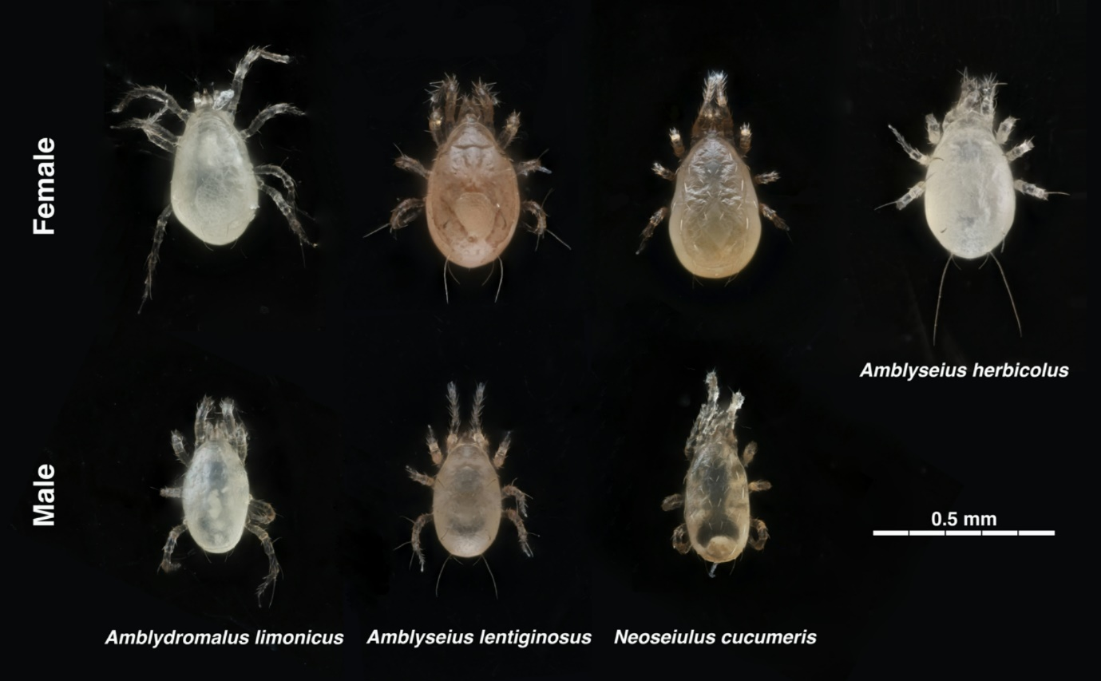
Supplementary Information 2. Images of mating pairs of Amblydromalus limonicus, Amblyseius lentiginosus, and Neoseiulus cucumeris, with females positioned ventral side up and males dorsal side up (venter-to-venter position). Images were captured using a camera with an adapted lens at 20× magnification. Specimens were euthanised by submersion in 75% ethanol prior to imaging. As a result, the positioning of the pairs may be slightly altered (males appear misaligned due to preservation) compared to in situ observations.
