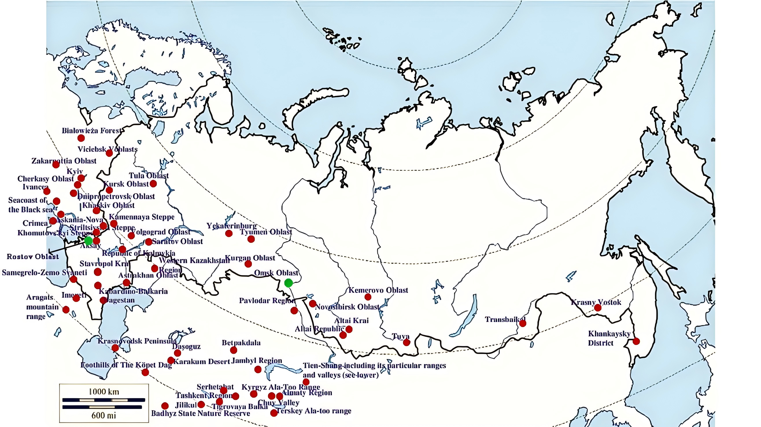

Fig 1 Map of Russia and neighboring countries showing the locations where Ixodes crenulatus was reported

Note: This image is an accompanying figure from the article by Fedorov D, Hornok S. Checklist of hosts, illustrated geographical range, and ecology of tick species from the genus Ixodes (Acari, Ixodidae) in Russia and other post-Soviet countries. Zookeys. 2024 May 14;1201:255-343. doi: 10.3897/zookeys.1201.115467. PMID: 38779584; PMCID: PMC11109513.
Hornok S is the author of this manuscript. The image is cited because it details the distribution of I. crenulatus in Russia and its neighboring countries. The two green dots correspond to sampling sites listed in Table 1 of this manuscript. The Rostov region is a newly added sampling site based on data from 2024.

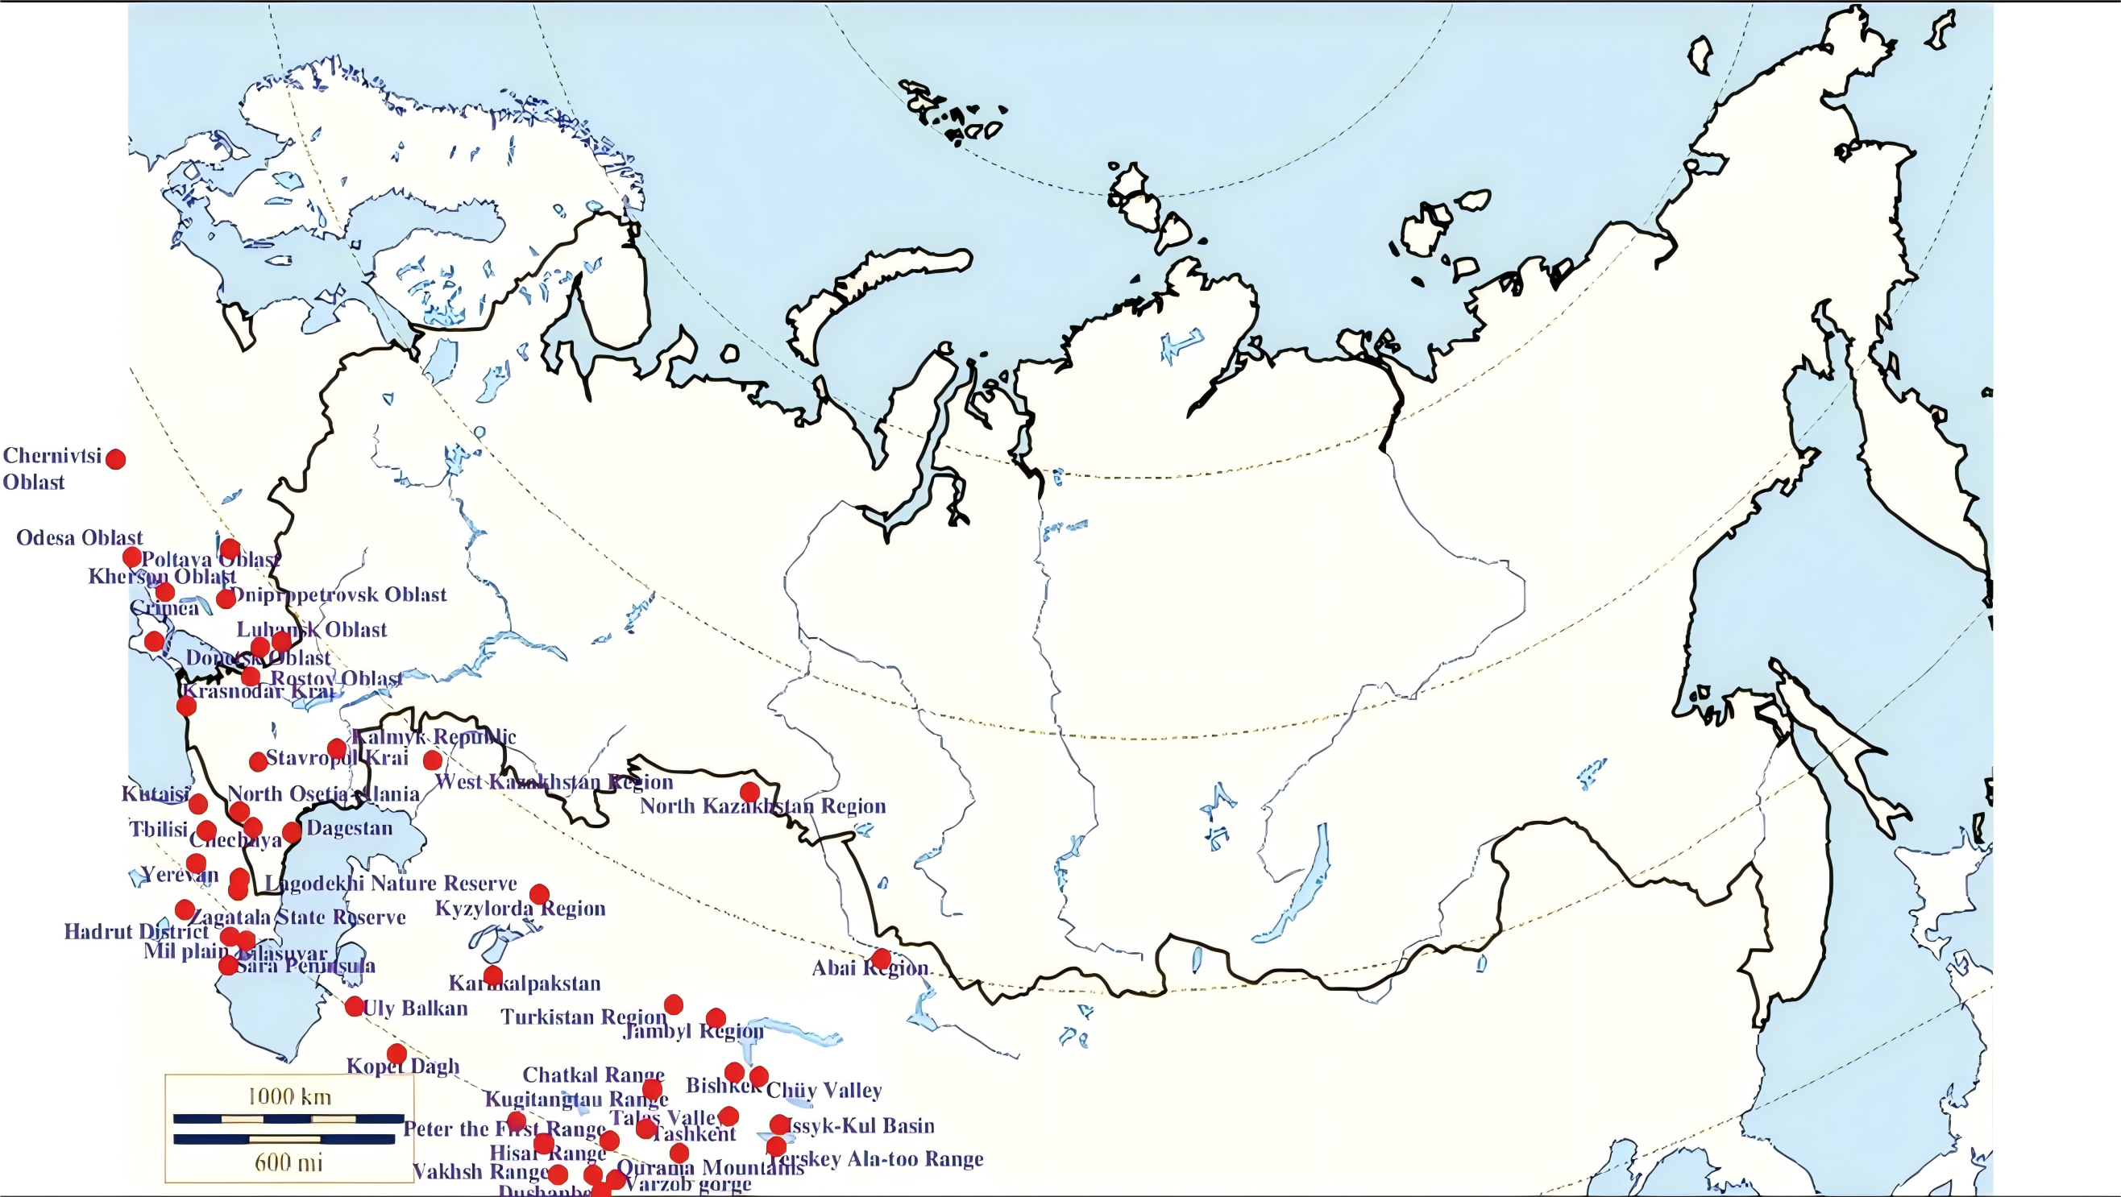
Fig 2 Map of Russia and neighboring countries showing the locations where Ixodes redikorzevi was reported
Note: This image is an accompanying figure from the article by Fedorov D, Hornok S. Checklist of hosts, illustrated geographical range, and ecology of tick species from the genus Ixodes (Acari, Ixodidae) in Russia and other post-Soviet countries. Zookeys. 2024 May 14;1201:255-343. doi: 10.3897/zookeys.1201.115467. PMID: 38779584; PMCID: PMC11109513.
Hornok S is the author of this manuscript. The image is cited because it details the distribution of I. redikorzev in Russia and its neighboring countries.

