Supplemental Material

Effects of microwaves on burning velocity, UV-VIS-spectra, and exhaust gas composition of premixed propane flames

Sven Eckart ^{1,}*, Sree Adinarayana Dasari ^{1,2}, Elizabeth Collins ^{1,3}, Ralph Behrend ¹, Julio Urbina ², Hartmut Krause ¹

¹ Institute of Thermal Engineering, Technische Universität Bergakademie Freiberg, Freiberg, Germany

² The Pennsylvania State University, University Park, PA, USA

³ Columbia University, Manhattan, NY, USA

*corresponding author: Sven Eckart, Sven.eckart@iwtt.tu-freiberg.de,

SM1 Comparison of input powers

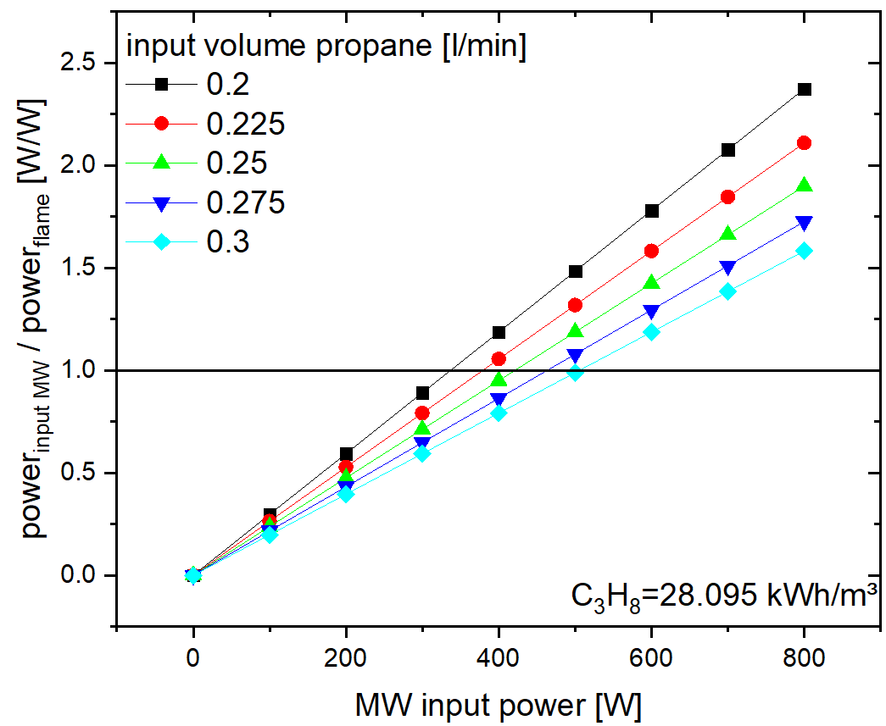
Figure S1 Comparison of the input power between the flame and the microwave cell

SM2 Results of the Open EMS simulations
The simulations were performed with the open source software OpenEMS [1], which can be used in Matlab®. The structure of a WR340 waveguide with a cylindrical cavity at one end was modelled, and the boundary conditions were programmed to have artificial layers that absorb electromagnetic waves. Another important property that had to be replicated was excitation. In the experiments, a 2.45 GHz microwave source was used, so in the simulation a sinusoidal excitation was generated at this frequency. The aim of these simulations was to gain a deeper understanding of the strength, propagation and stability of the microwaves at the point where the flame would be present. Seven current probe surfaces were used to visualize the propagation in the cavity. Three of these probes, which were aligned in the x, y and z planes, focused on the center where the burner was installed. The probes were placed so that propagation and reflection could be followed at the cavity walls. Three more probes were attached to the ends of the optical access tubes. These probes were placed there to track the
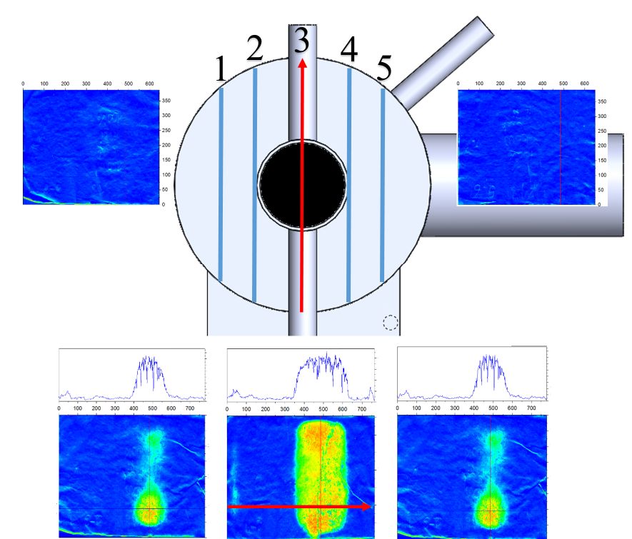  1  5  2  4  3  3  Figure S2 Investigation of the 3D-field distribution in the cavity (top-view) with thermal paper at a fixed three-stub-tuner position | 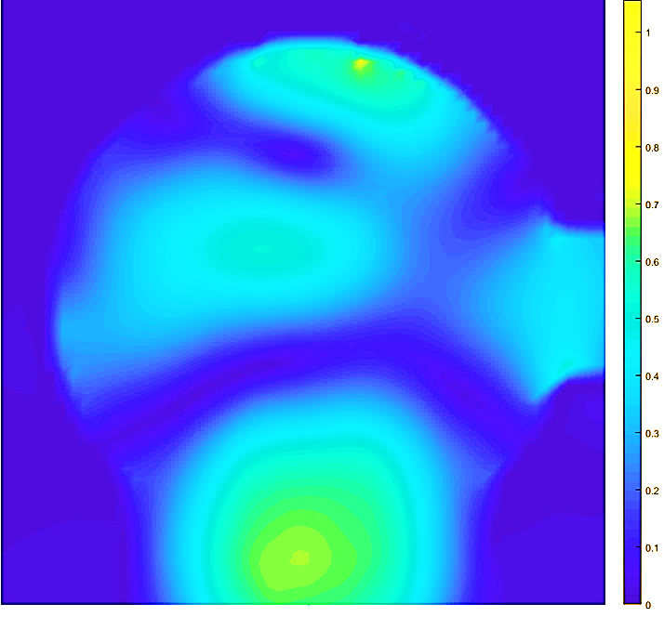  Figure S3 Results of an OpenEMS [1] simulation for a normalized microwave of 2.45 GHZ propagate in the cavity after sinusoidal excitation

microwaves leaving the waveguide, if any. The design has been optimized so that the microwaves are concentrated in the cavity and do not exit. This was confirmed by field strength measurements of the survey meter. In addition, moistened thermal paper was inserted into the waveguide to check the field distribution. The arrangement can be seen in Fig. S2. A reference measurement of 200 W and of 5 seconds of effective irradiation showed that a field distribution could be determined. This is shown in Fig. S3. It can be seen that in the middle of the cavity an interference zone is formed, and it decreases symmetrically towards the edge. Its diameter is about 25 mm and completely spans the burner nozzle. In the marginal areas of the interference field there seems to be an increased expression near the ground. The simulation also shows an interference field in the area of the burner nozzle. Therefore, the field was not totally symmetrical. This could be an effect of the sinusoidal excitation. It can be determined that an interference field is formed in the flame area, causing an interaction with the combustion radicals.

SM3 Experimental investigations on the position of the electric field

Nr. | 200W 5sec | 150W 5 sec
1 | 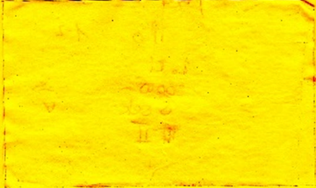 | 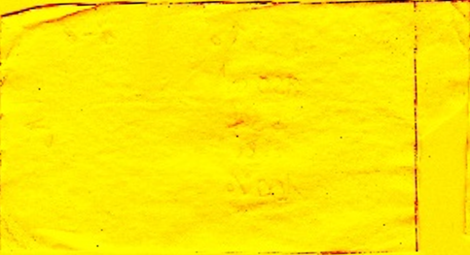
2 | 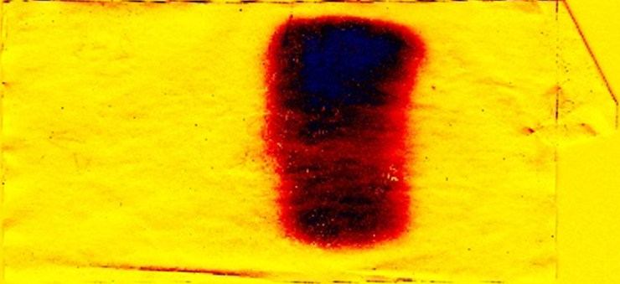 | 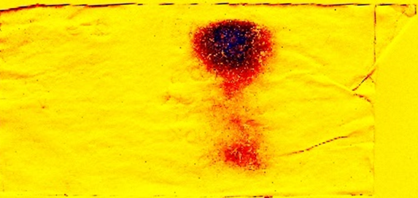
3 | 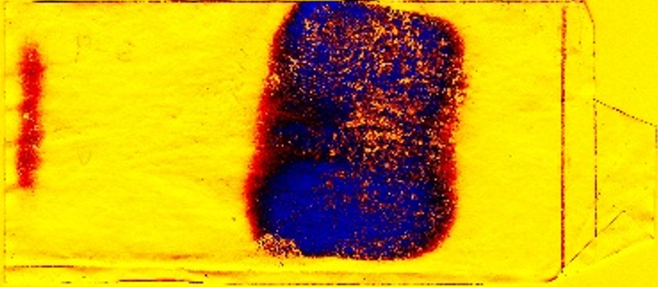 | 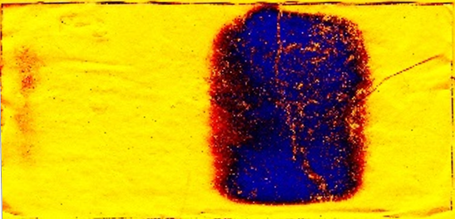
4 | 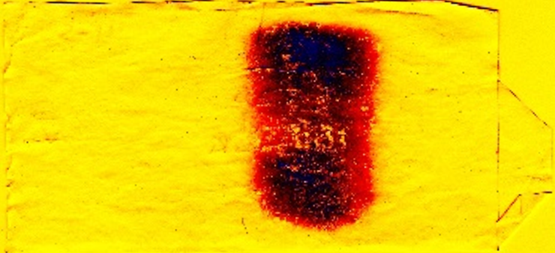 | 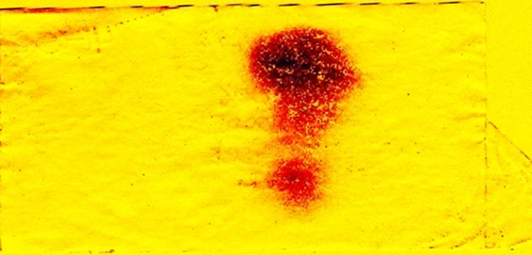
5 | 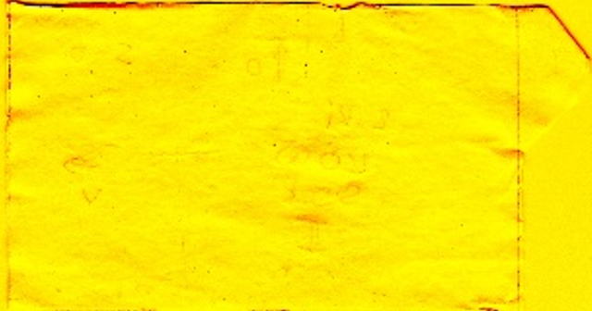 | 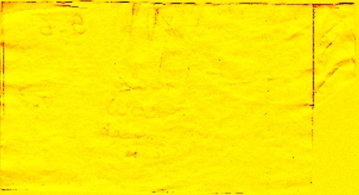
Figure S4 experimental investigations on the position of the electric field for 150/200 W and 5 s of effective irradiation

SM4 Calculated OH concentrations as a function of flame temperature and spectra smooting process

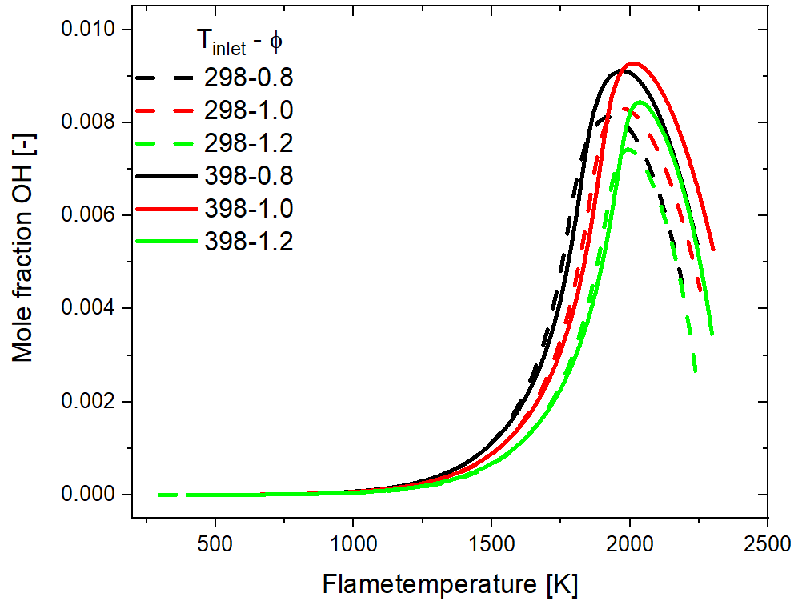
Figure S5 Calculated OH concentrations as a function of flame temperature, Simulations done with USC mechanism [2]
An increase in the inlet temperature of the unburned gas mixture leads to an increase in the simulated OH fraction during the course of the reaction. This can be observed for all three equivalence ratios investigated φ=0.8, 1.0 and 1.2. These naturally result in different adiabatic flame temperatures. This results in a shift of the maximum point of OH along the x-axis.

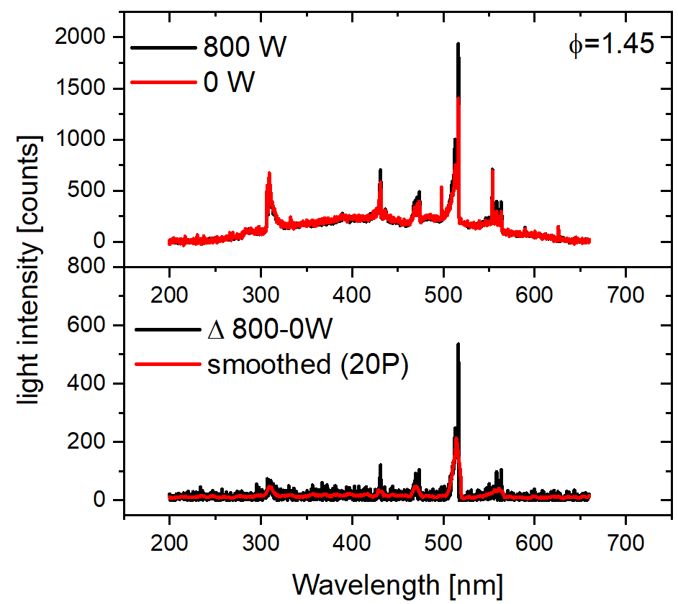
Figure S6 Example: process of data generation in relation to the change from 0 to 800 W microwave inlet power
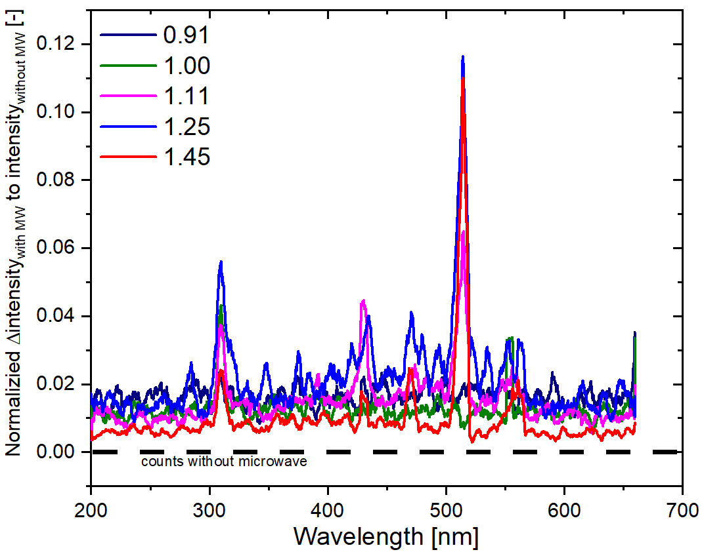
Figure S7 Normalized changes of the intensity Δ(Intensity800- Intensity0) / IntensityMax,0

SM5 Comparison of the laminar burning velocity

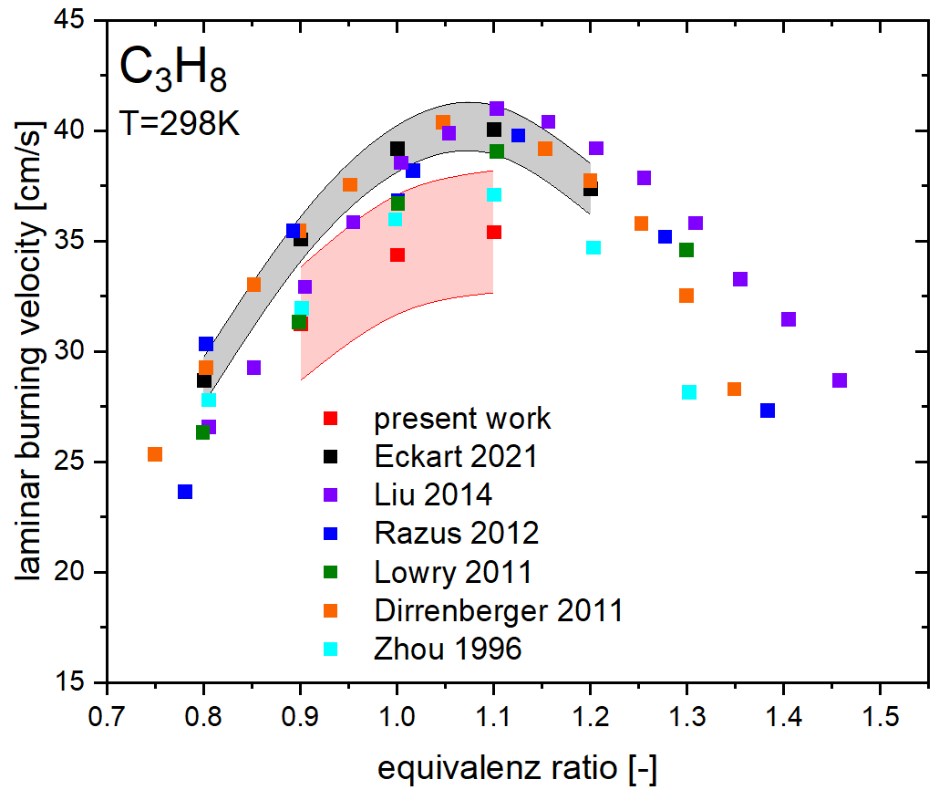
Figure S8 Comparison of the present measured LBV data with the literature [3–8]

SM6 Structure of the setup

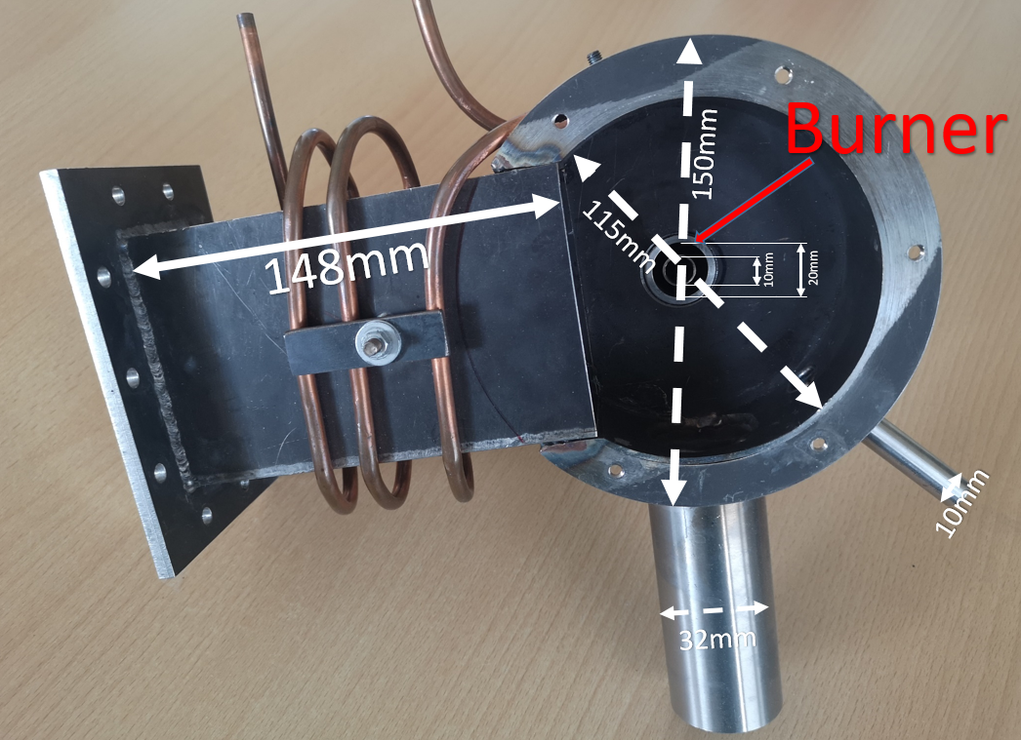
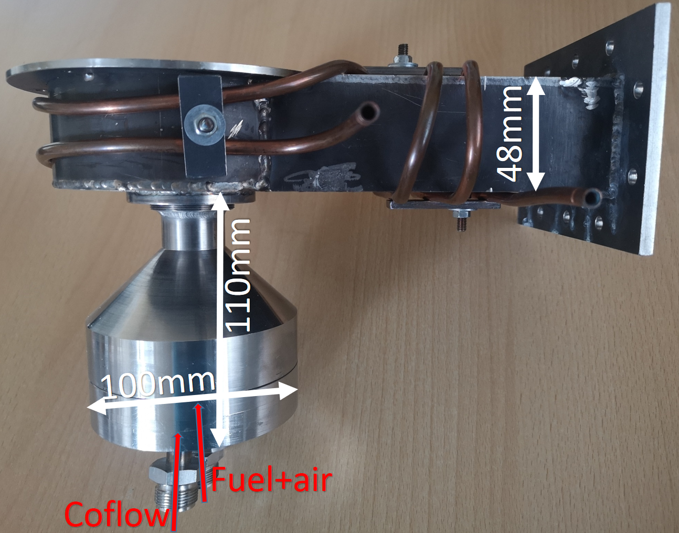
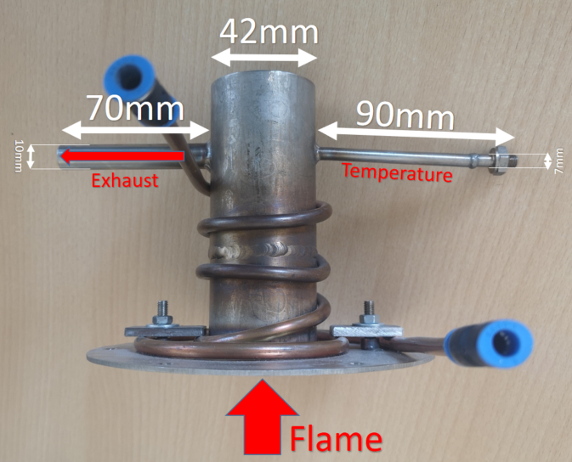
Figure S9 Chamber and burner dimensions, top: top view, middle: side view, bottom: exhaust part and cap

References
1. Liebig, T., Rennings, A., Held, S., Erni, D.: openEMS - a free and open source equivalent-circuit (EC) FDTD simulation platform supporting cylindrical coordinates suitable for the analysis of traveling wave MRI applications. Int. J. Numer. Model. 26, 680–696 (2013)
2. Wang, H., You, X., Joshi, V., Davis, G., Laskin, A., Egolfopoulos, F., Law, C.K.: USC Mech Version II. High-Temperature Combustion Reaction Model of H2/CO/C1-C4 Compounds. http://ignis.usc.edu/USC_Mech_II.htm (2007)
3. Dirrenberger, P., Le Gall, H., Bounaceur, R., Herbinet, O., Glaude, P.-A., Konnov, A., Battin-Leclerc, F.: Measurements of laminar flame velocity for components of natural gas. Energy Fuels (2011). https://doi.org/10.1021/ef200707h
4. Eckart, S., Fritsche, C., Krasselt, C., Krause, H.: Determining the laminar burning velocity of nitrogen diluted dimethoxymethane (OME1) using the heat-flux burner method: Numerical and experimental investigations. Int. J. Energy Res., 2824–2836 (2020)
5. Liu, Z., Kim, N.I.: An assembled annular stepwise diverging tube for the measurement of laminar burning velocity and quenching distance. Combust. Flame (2014). https://doi.org/10.1016/j.combustflame.2013.11.020
6. Lowry, W., Vries, J. de, Krejci, M., Petersen, E., Serinyel, Z., Metcalfe, W., Curran, H., Bourque, G.: Laminar Flame Speed Measurements and Modeling of Pure Alkanes and Alkane Blends at Elevated Pressures. J. Eng. Gas Turbine. Power (2011). https://doi.org/10.1115/1.4002809
7. Razus, D., Brinzea, V., Mitu, M., Movileanu, C., Oancea, D.: Burning Velocity of Propane–Air Mixtures from Pressure–Time Records during Explosions in a Closed Spherical Vessel. Energy Fuels (2012). https://doi.org/10.1021/ef201561r
8. Zhou, M., Garner, C.P.: Direct measurements of burning velocity of propane-air using particle image velocimetry. Combust. Flame (1996). https://doi.org/10.1016/0010-2180(96)00002-8

