Supplementary Material for Effect of Nanosecond Plasma Preconditioning on Detonation in High-Pressure H₂/O₂ Mixtures: A Multiscale Numerical Study
Giacomo Cinieri¹, Zubair Ali Shah¹, Ghazanfar Mehdi ², Maria Grazia De Giorgi^{1*}
¹ Department of Engineering for Innovation, University of Salento, Lecce, Italy
²Department of Energy and Mechanical Engineering, Aalto University, Espoo, Finland

*mariagrazia.degiorgi@unisalento.it

- Nomenclature
  - Abbreviations
CFD | Computational fluid dynamics
CJ | Chapman-Jouguet velocity
DBD | Dielectric barrier discharge
DDT | Deflagration-to-detonation transition
EEDF | Electron energy distribution function
Td | Townsend (10⁻²¹ V m²)
  - Symbols
Symbol | Definition | Units
E/N | Reduced electric field | Td
E_{p} | Pulse deposited energy density | J/cm³
F | Pulse repetition frequency | Hz
h_{c} | Height of the channel | mm
n_{i} | Number density of species | cm⁻³
p_{i} | Initial pressure | Pa
SL  t_{f} | Laminar flame speed  Final time | m/s  s
T_{f} | Final temperature | K
T_{i} | Initial temperature | K
$${ t}_{I}$$ | Induction time | s
x_{f} | Detonation front coordinate | mm
X_{i} | Mole fraction of species | -
Y_{i} | Mass fraction of species | -
δ | Induction length | mm
λ | Detonation cell width | mm
ϕ | Equivalence ratio | -

- Validation and limitations of the numerical model
The modelling framework was assessed through a hierarchical validation strategy, since no fully coupled experimental dataset is currently available for nanosecond plasma-assisted H₂/O₂ detonations. Direct validation of the plasma kinetics at the operating pressure considered in this work is presently not possible. To the authors' knowledge, the most comprehensive experimental datasets providing quantitative, time-resolved radical diagnostics in nanosecond-pulsed plasma environments are limited to sub-atmospheric pressures: Mao et al. [1] for H₂/O₂/He and Tsolas et al. [2] for H₂/O₂/Ar. No suitable species-resolved dataset is currently available above 1 atm for nanosecond-discharge-activated hydrogen mixtures, primarily because at elevated pressures the discharge transitions from a diffuse to a filamentary regime, severely compromising resolved optical diagnostics spatially [3]. The lower-pressure validation nonetheless remains useful for checking the consistency of the chemistry block. Matching the reduced electric field E/N from low-pressure conditions to high pressure mainly preserves the electron-impact kinetics, since E/N controls the electron energy distribution through the combined effects of pressure and temperature according to Zhong et al. [4] . Therefore, low-pressure validations can be regarded as a useful consistency check for the present methodology. The detonation-oriented components of the framework were validated separately against available non-plasma datasets. Accordingly, the present approach should be regarded as a partially validated multiscale framework, in which the plasma kinetics, detonation chemistry, and detonation scaling are each checked against the most relevant data presently available, but the fully coupled high-pressure plasma-assisted DDT problem is not yet directly validated. ​The IDT for ϕ = 1 (5.917 H₂ / 2.959 O₂ / 91.124 Ar) was simulated and compared with shock-tube experimental measurements reported by Hu et al.[5]. The comparison was conducted at pressures of 1.2, 4, 10 and 16 atm over a temperature range of 900–1700 K, as shown in Fig. SM1. The model correctly reproduces the monotonic decrease in IDT with increasing temperature as well as the overall pressure dependence. Overall, the selected mechanism captures the correct temperature and pressure trends, but its quantitative accuracy deteriorates at the fastest ignition conditions. Although the mechanism overpredicts the ignition delay time in the lower-temperature, longer-delay regime, its agreement with the experiments improves at higher temperatures. This aspect is particularly relevant for the present detonation-oriented application, since the reactive induction zone behind strong shocks is governed by high-temperature ignition chemistry rather than by low-temperature ignition pathways.
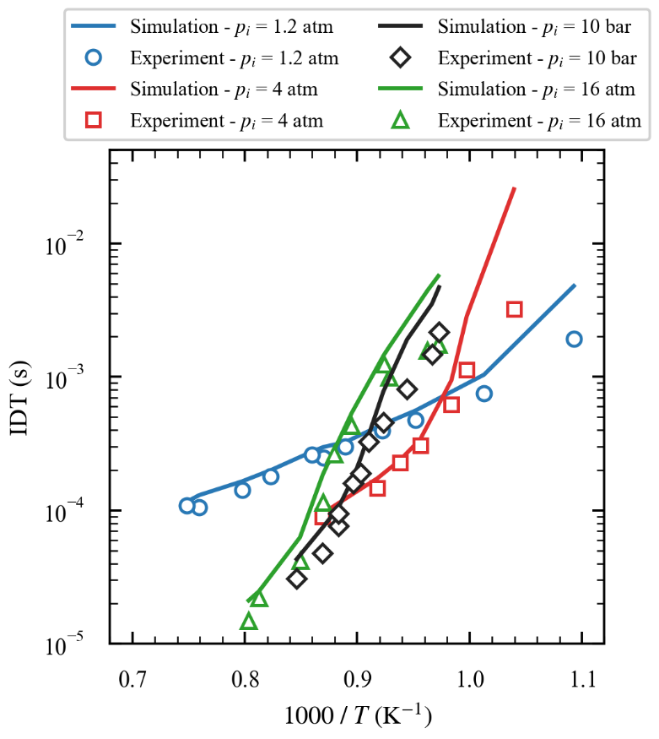
Fig. SM1 Comparison of simulated and experimental IDT for the stoichiometric mixture H₂/O₂/Ar (5.917/2.959/91.124) at pressures of 1.2, 4, 10, and 16 atm [5].

In deflagration, the laminar flame speed also plays a significant role. Since the simulations involve H₂O as a product of the plasma effect (X_{H2Omax} < 1%), an additional validation was carried out at the highest pressure available for laminar flame speed (S_{L}) for H₂/Air mixtures with varying H₂O dilution levels, using the data of Lyu et al. [6] in Fig. SM2. Results are in good agreement.
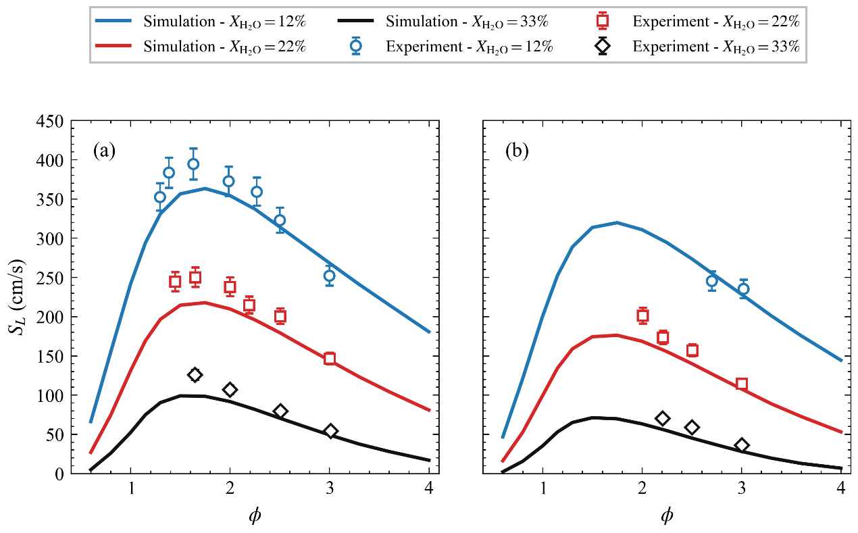
Fig. SM2 Comparison of simulated and experimental S_{L} for the stoichiometric mixture H₂/O₂/N₂/H₂O at different dilutions, T_{i} = 440 K a) p_{i}=3 atm, b) p_{i} =5 atm [6].

Fig. SM3 compares predicted detonation parameters for the H₂/O₂ mixture with experimental data in the 60–200 kPa pressure range. In this case, the model overpredicts the detonation cell width at lower pressure. This is reasonable because at reduced initial pressures, detonation waves exhibit stronger cellular instability, and the detonation structure becomes increasingly irregular [5].
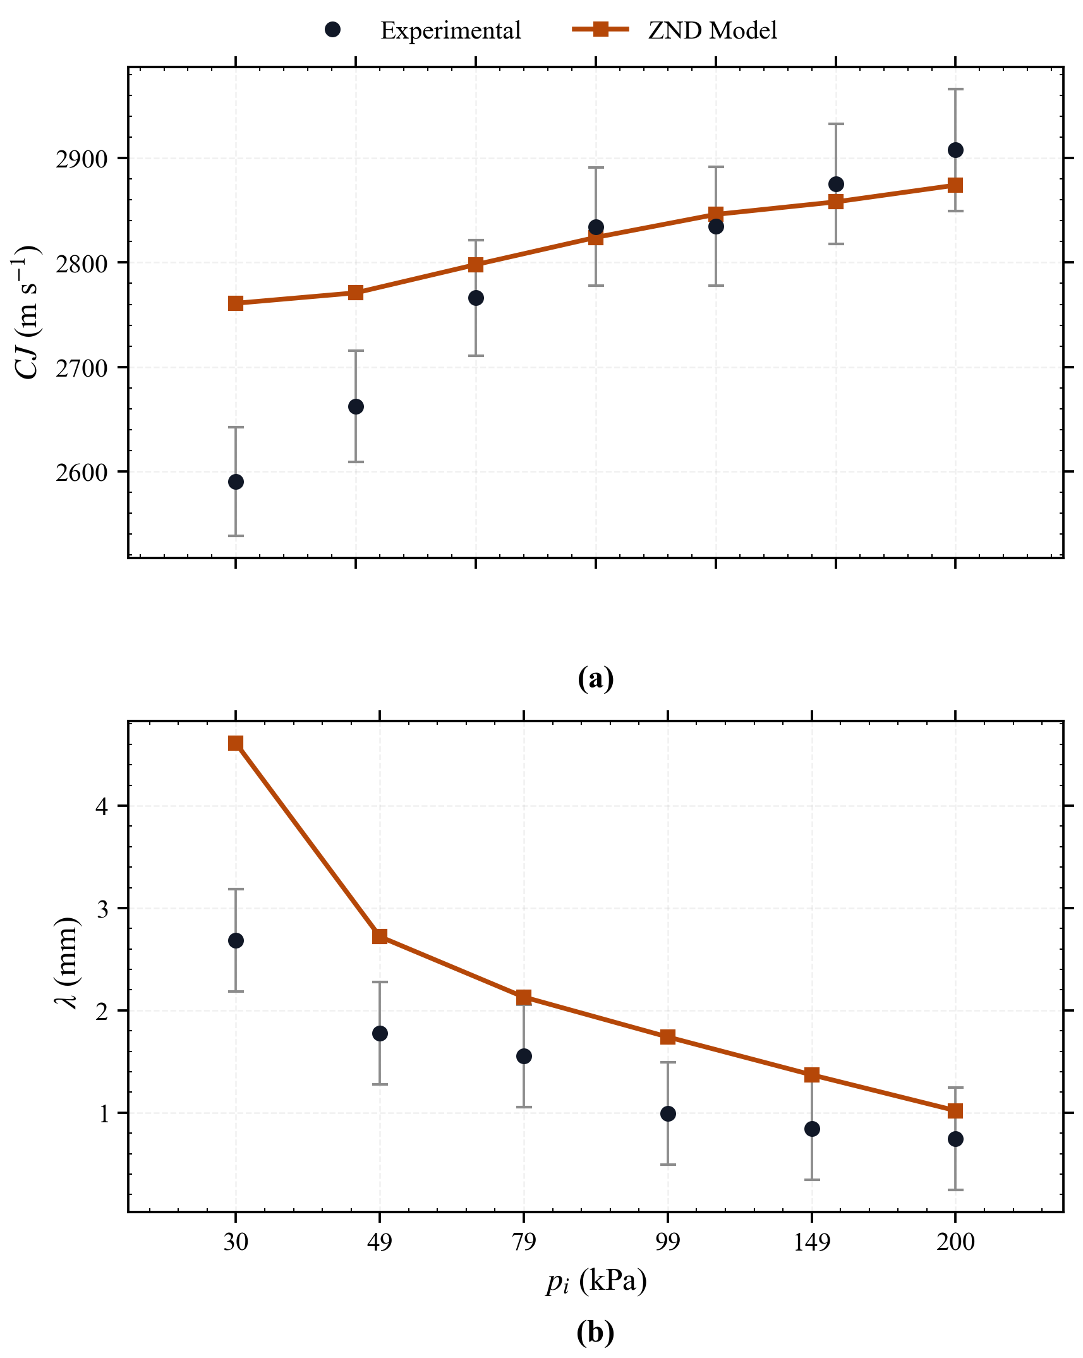
Fig. SM3 Comparison of simulated and experimental detonation parameters for H₂/O₂, ϕ = 1, T_{i} = 300 K, in the low-pressure range: a) CJ, b) λ [9].
A comparison with the available experimental literature at elevated pressure shows that the detonation velocities predicted in the present work (CJ) are in reasonable agreement with the reported values for stoichiometric H₂/O₂ mixtures. In particular, experimental values of CJ, 2820 m/s at 5 bar and 2905 m/s at 10 bar have been reported, whereas the present calculations provide 2926.6 m/s and 2963.8 m/s, respectively [10]. The numerical results, therefore, slightly overpredict the experimental values, with deviations of about 3.8% at 5 bar and 2.0% at 10 bar, while remaining within the expected high-pressure range for hydrogen-oxygen detonations. To validate λ at higher pressure for a stoichiometric mixture at Ti = 300 K, over the pressure range from 2 to 10 bar, the resulting values were then compared with the experimental measurements in Fig. SM4 reported by Manzhalei et al. [11]. The calculations correctly reproduce the expected monotonic decrease of cell size with increasing initial pressure. Although some discrepancy remains with the experimental data over the full pressure range, the model captures both the correct order of magnitude and the overall pressure dependence of the detonation cell size.
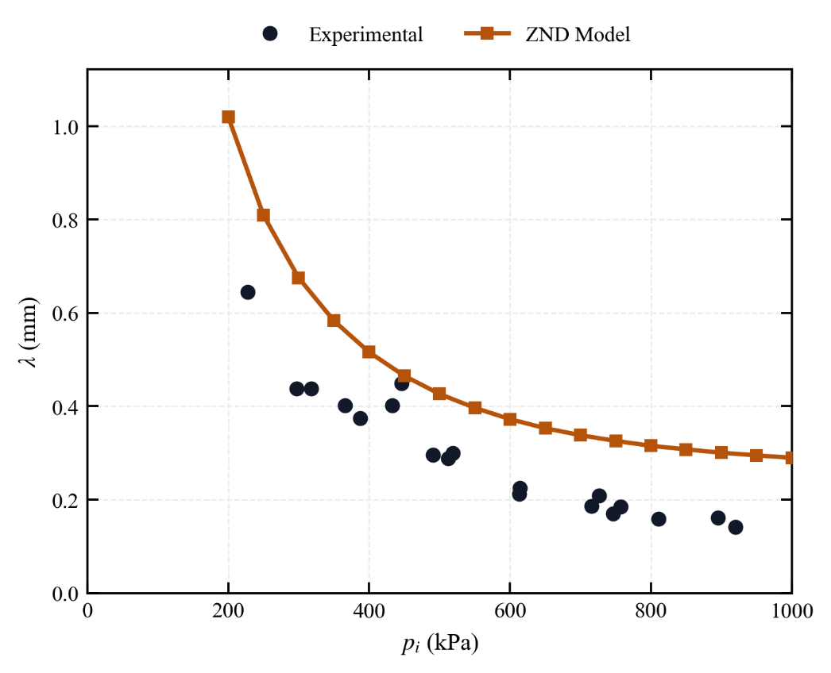
Fig. SM4 Comparison of simulated and experimental λ for H₂/O₂, ϕ = 1, T_{i} = 300 K, in the p_{i} range 20-1000 kPa [11].
Fig. SM5 compares the time-dependent predicted and experimental H₂O concentrations for a 0.1667 H₂ / 0.0833 O₂ / 0.75 He mixture at 60 Torr during 1500 pulses for f= 30 kHz in the burst-mode discharge following the experiment described by Mao et al. [1]. Results are in good agreement with experimental measurements. Water vapor is selected because it is a terminal stable product of both the combustion and plasma-assisted oxidation pathways.
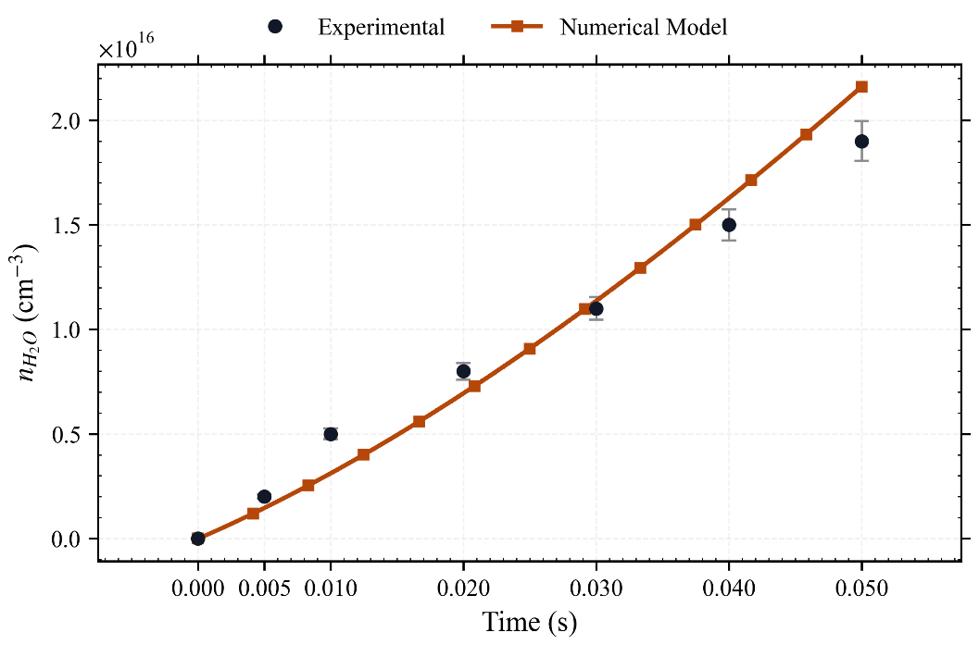
Fig. SM5 Comparison of simulated and experimental H₂O concentration for a 0.1667 H₂/0.0833 O₂/0.75 He mixture, f = 30 kHz, 1500 pulses, at p_{i} = 60 Torr [1].
The initial electron density N_{ei} for plasma simulations of this work was set to 1x10⁶ cm⁻³.To assess the influence of the assumed initial electron density on the plasma-kinetics results, two additional cases are shown in Fig. SM6 after 10 pulses (N_{p}) with p_{i} = 10 bar, T_{i} =503 K, ϕ = 1, E/N = 180 Td, at different N_{ei}. The values of 1x10⁵ cm⁻³ and 1x10⁷ cm⁻³ were intentionally chosen as lower and upper perturbations around this nominal condition to assess the sensitivity of the chemical kinetics to variations in electron density. Considering the final mole fraction of radical pool species, the deviations among the three cases at the final time step are < 1% (see Fig. SM6 b-d).
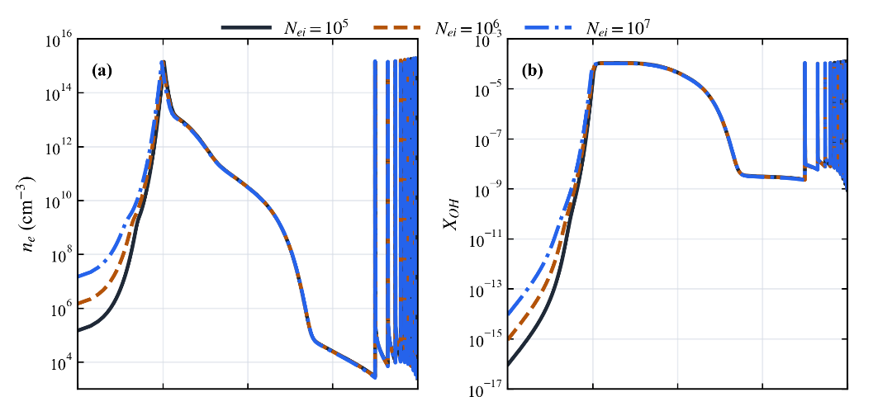
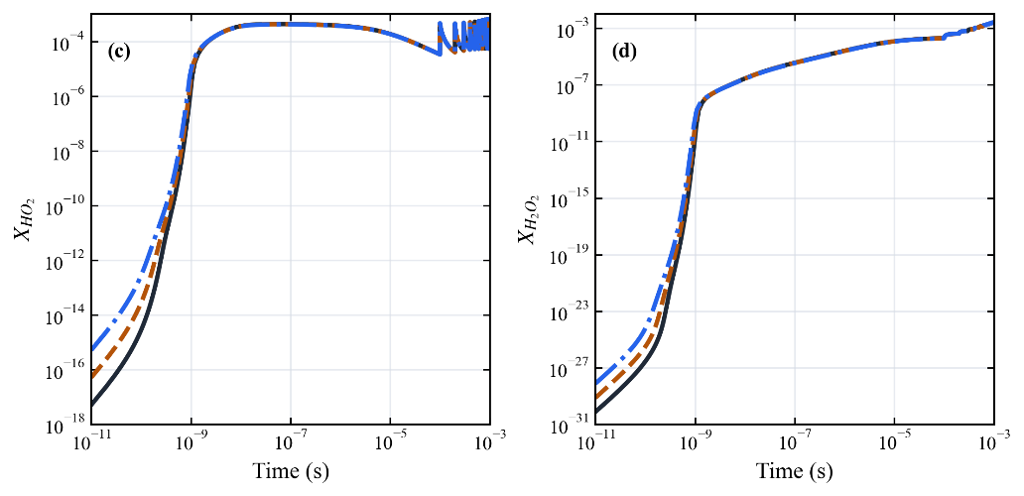
Fig. SM6 Species concentration for mixture H₂/O₂ after 10 pulses with p_{i} = 10 bar, E_{p} = 75 mJ·cm⁻³, T_{i} =503 K, ϕ = 1, E/N = 180 Td, f = 1x10⁴ Hz, N_{p}=10 at different N_{ei} a) electron number density, b) X_{OH}, c)X_{HO2}, d)X_{H2O2}.
Although the early-time electron density evolution differs among the three cases, the final post-discharge composition remains only weakly affected by the assumed initial electron density. To assess the uncertainties associated with the kinetic mechanism, a sensitivity analysis was performed by perturbing selected key plasma–chemical reaction rate coefficients by ±10% relative to the reference case (Case A), generating two additional configurations (A1: −10%, A2: +10%). For reactions 1–4, the reported values correspond to the perturbed pre-exponential factor A. For reactions 5–7, the values represent multiplicative scaling factors applied to the corresponding rate coefficients. All other reactions and initial conditions were kept unchanged to isolate the impact of the selected reactions in Table SM1. Reactions 1 and 2 were included because they represent the dominant chain-branching and radical-propagation steps in hydrogen oxidation, effective in the afterglow phase. Reactions 3 and 4 have the discharge effect mainly due to direct dissociation of stable fuel/oxidizer species, or due to rapid conversion of radical reservoirs into active chain carriers. Finally, the reactions 5, 6, and 7 involving vibrationally excited hydrogen, H₂(v1–v3) + HO₂ => H₂O₂ + H, were retained to quantify the contribution of vibrational nonequilibrium, which is a distinctive feature of nanosecond and non-thermal plasma discharges.
Table SM1. Selected reactions and perturbed pre-exponential factors used in sensitivity analysis.
 | Reactions | Case A1 (−10%) | Case A (reference) | Case A2 (+10%)
1 | H + O2 <=> O + OH | 3.18x10¹⁵ | 3.547x10¹⁵ | 3.9x10¹⁵
2 | O + H2 <=> H + OH | 4.57x10⁴ | 5.08 x10⁴ | 5.58 x10⁴
3 | E + HO2 => E + OH + O | 1.50x10⁻⁹ | 1.67x10⁻⁹ | 1.83x10⁻⁹
4 | E + H2O2 => E + 2 OH | 2.12x10⁻⁹ | 2.36x10⁻⁹ | 2.59x10⁻⁹
5 | H2(v1) + HO2 => H2O2 + H | 0.9 | 1 | 1.1
6 | H2(v2) + HO2 => H2O2 + H | 0.9 | 1 | 1.1
7 | H2(v3) + HO2 => H2O2 + H | 0.9 | 1 | 1.1

Conditions are at p = 10 bar, H₂/O₂, ϕ = 1, E/N = 180 Td, and T_{i} = 500 K, N_{p} = 10. Radical species exhibit the highest sensitivity, as expected: atomic oxygen shows the strongest response (about 10%), followed by H atoms (about 5%), whereas all other species remain below 1%. Overall, a ±10% uncertainty in the plasma-activated reaction rates results in variations of up to ±12% in O-atom concentration and about ±3-6% in OH and H concentrations, while the temperature is essentially unaffected. The imposed perturbations resulted in negligible variations in the gas temperature and total electron number density (≤ 0.07%) as reported in Table SM2.

Table SM2. Post-discharge temperature and species mole fractions delta between perturbed and original model for H₂/O₂, ϕ = 1, E_{p} = 75 mJ·cm⁻³, E/N = 180 Td, f = 1x10⁴ Hz, and T_{i} = 503 K, 10 pulses for cases A, A1 and A2.
Case | T_{f} (K) | X_{H} | X_{H2} | X_{O} | X_{O2} | X_{OH} | X_{H2O} | X_{HO2} | X_{H2O2}
ΔA₁(%) | 0.69 | 3.50 | -0.07 | 11.6 | -0.07 | 3.31 | 0.40 | 0.16 | -0.72
ΔA₂ (%) | 0.47 | -5.02 | -0.05 | -12.1 | -0.05 | -5.55 | 0.03 | -0.24 | 0.97

The detonation cell size (𝜆) in Table SM3 was evaluated using the final post-discharge composition obtained in conditions described in Table 2. Despite the imposed ±10% perturbations in the selected reactions, the resulting variation in 𝜆 remains below 3%.

Table SM3. λ for H₂/O₂, ϕ = 1, E_{p} = 75 mJ·cm⁻³, E/N = 180 Td, f = 1x10⁴ Hz, Ti = 503 K, N_{p}=10 for cases A, A1 and A2.
 | λ (x10⁻⁴ m)
A₁ | 1.163
A | 1.180
A₂ | 1.148
ΔA₁ | 1.44%
ΔA₂ | 2.71%
Since the ignition delay time governs the length of the induction zone behind the leading shock in a ZND structure, the impact of plasma on IDT of a stoichiometric H₂/O₂ mixture at 10 atm was simulated without and with plasma using as input into Cantera plasma output X_{i} and T_{f}, as shown in Fig. SM7 using E_{p} = 75 mJ·cm⁻³, E/N=180 Td, and a nanosecond pulse with a 10 kHz frequency. A shorter ignition delay time implies faster chemical activation behind the lead shock, which shortens the induction zone and leads to a more compact and generally more easily sustained detonation. Moreover, as reported in [12], [13] for H₂ mixtures, the longer the ignition delay time is, the bigger the cell size will be. The results demonstrate that plasma effect at the conditions E_{p} = 75 mJ·cm⁻³, E/N = 180 Td, t_{f} = 1x10-4 s, significantly reduces the ignition delay time (90 %), being an effective tool for detonation stabilization.
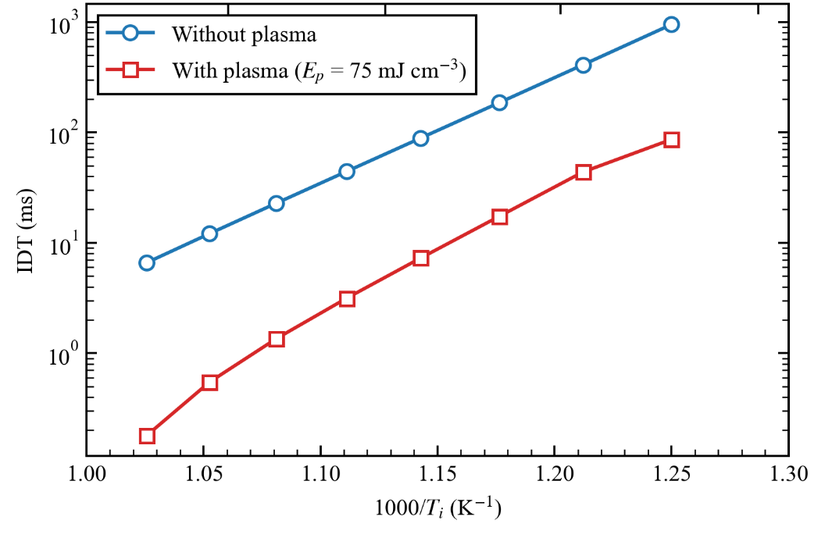
Fig. SM7 IDT versus T_{i} for ϕ = 1 and p = 10 bar, comparing clean and single pulse plasma-preconditioned cases at a E_{p} = 75 mJ·cm⁻³, E/N = 180 Td, T_{i} = 503 K, t_{f} = 1x10⁻⁴

Figure SM8-9-10 report the temporal evolution of plasma-specific species that are not included in the reduced combustion mechanism used for the ZND and CFD calculations at E_{p} = 25-75-150 mJ·cm⁻³, E/N = 180 Td, T_{i} = 503 K ϕ = 1 and p = 10 bar. The analysis shows that most charged species and short-lived electronically excited states decay rapidly during the afterglow. Among the non-combustion species in Li mechanism, only H₂(v1), O₂(A1), and O₃ mole fractions remain above approximately 10⁻⁵ at the end of the plasma simulations.
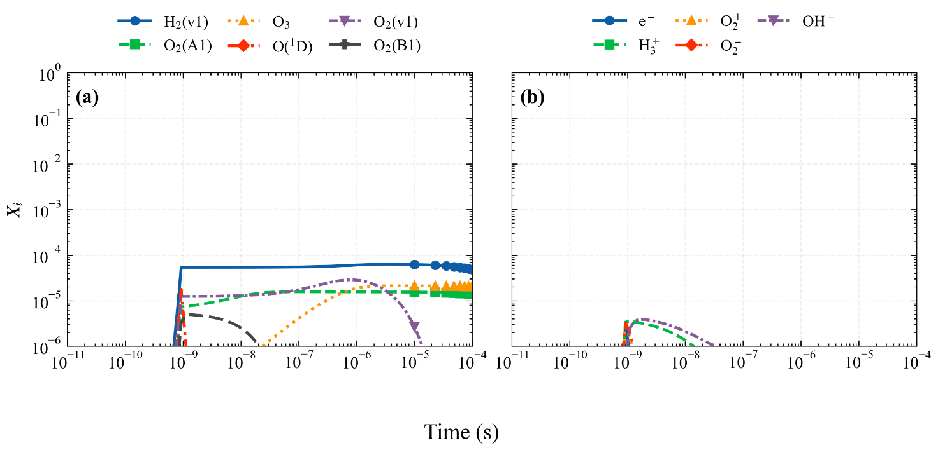
Fig. SM8 Main plasma model X_{i} species versus time for ϕ = 1 and p = 10 bar at a E_{p} = 25 mJ·cm⁻³, E/N = 180 Td, T_{i} = 503 K discharge a)excited species, b) ions and electrons.

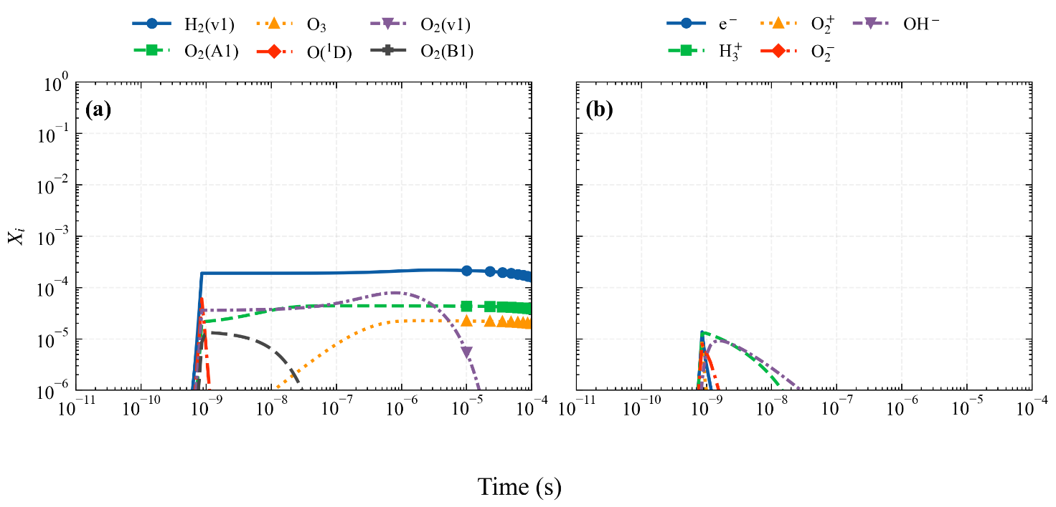
Fig. SM9 Main plasma model Xi species versus time for ϕ = 1 and p = 10 bar at a Ep = 75 mJ·cm⁻³, E/N = 180 Td, T_{i} = 503 K discharge a)excited species, b) ions and electrons.

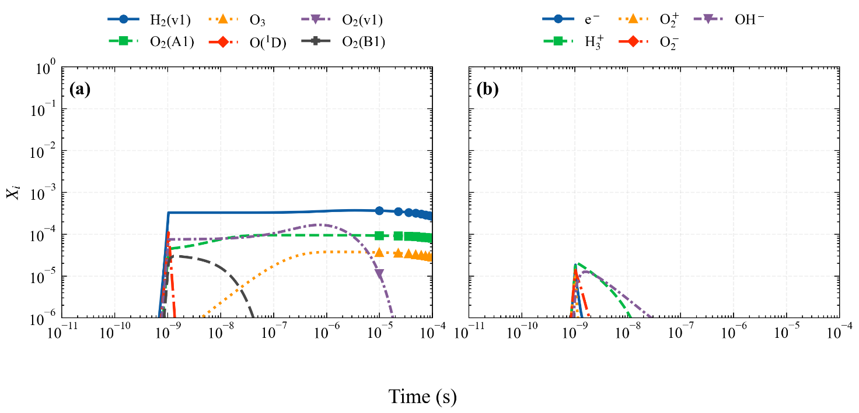
Fig. SM10 Main plasma model X_{i} species versus time for ϕ = 1 and p = 10 bar at a E_{p} = 150 mJ·cm⁻³, E/N = 180 Td, T_{i} = 503 K discharge a)excited species, b) ions and electrons.

A CFD mesh-independence study was carried out for the plasma-activated H₂/O₂ case at a volumetric energy density of 75 mJ/cm³. Three AMR refinement levels were considered. Because detailed AMR-based DDT high-pressure simulations are computationally very demanding when time steps of the order of 1x10⁻¹⁰ s are required, previous microchannel H₂/O₂ studies have generally adopted practical case flame length-dependent mesh strategies comparable to the intermediate refinement level considered rather than full grid-convergence campaigns as reported in previous studies [14], [15]. Table SM4 summarizes the resulting DDT onset times, defined as the instant at which the leading shock and the reaction front couple to form a self-sustained detonation wave. The difference in DDT onset time between the 16x and 32x refinement levels is approximately 4 μs, whereas the coarsest level (8x) predicts an onset time about three times smaller than that obtained on the 16x grid. These results indicate that full grid convergence has not yet been reached, but the second level of refinement is acceptable for the scope of the current study; however, further refinement beyond the 32x level would entail prohibitive computational costs, with runtimes approaching about 70000 CPU core/h.
Table SM4. AMR independence study for Test 3.
AMR  level | AMR Cell size (μm) | CPU core/h | DDT onset time (s)
2³ | 7 | 67 | 10
2⁴ | 3.5 | 1537 | 30
2⁵ | 1.75 | 8917 | 34

- Other informations

Table SM5. List of combustion model reactions nomenclature for sensitivity analysis (Li et al. [16]). R14-R15 and R20-R21 correspond to duplicate reaction entries in the Li mechanism and are therefore listed separately.
R1:  R2:  R3:  R4:  R5:  R6:  R7:  R8:  R9:  R10:  R11:  R12:  R13:  R14:  R15:  R16:  R17:  R18:  R19  R20:  R21: | H + O2 <=> O + OH  H2 + O <=> H + OH  H2 + OH <=> H + H2O  H2O + O <=> 2 OH  H2 + M <=> 2 H + M  2 O + M <=> O2 + M  H + O + M <=> OH + M  H + OH + M <=> H2O + M  H + O2 (+M) <=> HO2 (+M)  H + HO2 <=> H2 + O2  H + HO2 <=> 2 OH  HO2 + O <=> O2 + OH  HO2 + OH <=> H2O + O2  2 HO2 <=> H2O2 + O2  2 HO2 <=> H2O2 + O2  H2O2 (+M) <=> 2 OH (+M)  H + H2O2 <=> H2O + OH  H + H2O2 <=> H2 + HO2  H2O2 + O <=> HO2 + OH  H2O2 + OH <=> H2O + HO2  H2O2 + OH <=> H2O + HO2

Table SM6. Post-discharge thermochemical conditions for Ti=503 K, p_{i} = 10 bar, t_{f} = 1x10⁻⁴ s in H₂/O₂ mixtures at different single pulse plasma conditions.
E_{p} (mJ/cm³) | E/N (Td) | Φ | T_{f} (K) | X _{H2} | X _{O2} | X _{HO2} | X _{H2O2} | X _{H2O}
25 | 180 | 0.2 | 503 | 2.86x10⁻¹ | 7.14x10⁻¹ | 0 | 0 | 0
25 | 180 | 0.6 | 503 | 5.45x10⁻¹ | 4.55 x10⁻¹ | 0 | 0 | 0
25 | 180 | 0.8 | 509 | 6.15x10⁻¹ | 3.84 x10⁻¹ | 2.77 x10⁻⁵ | 6.81x10⁻⁵ | 9.31 x10⁻⁵
25 | 180 | 1 | 510 | 6.67 x10⁻¹ | 3.33 x10⁻¹ | 2.79 x10⁻⁵ | 7.70 x10⁻⁵ | 9.89 x10⁻⁵
25 | 180 | 1.2 | 509 | 6.87 x10⁻¹ | 3.12 x10⁻¹ | 2.74 x10⁻⁵ | 7.26 x10⁻⁵ | 8.90 x10⁻⁵
75 | 180 | 0.2 | 503 | 2.86 x10⁻¹ | 7.14 x10⁻¹ | 0 | 0 | 0
75 | 180 | 0.6 | 503 | 5.45 x10⁻¹ | 4.55 x10⁻¹ | 0 | 0 | 0
75 | 180 | 0.8 | 522 | 6.15 x10⁻¹ | 3.84 x10⁻¹ | 3.43 x10⁻⁵ | 1.75 x10⁻⁴ | 3.07 x10⁻⁴
75 | 180 | 1 | 522 | 6.66 x10⁻¹ | 3.33 x10⁻¹ | 3.29 x10⁻⁵ | 1.85 x10⁻⁴ | 2.92 x10⁻⁴
75 | 180 | 1.2 | 524 | 6.87 x10⁻¹ | 3.12 x10⁻¹ | 3.32 x10⁻⁵ | 2.09 x10⁻⁴ | 3.25 x10⁻⁴
150 | 180 | 0.2 | 503 | 2.86 x10⁻¹ | 7.14 x10⁻¹ | 0 | 0 | 0
150 | 180 | 0.6 | 503 | 5.45 x10⁻¹ | 4.55 x10⁻¹ | 0 | 0 | 0
150 | 180 | 0.8 | 541 | 6.15 x10⁻¹ | 3.84 x10⁻¹ | 4.20 x10⁻⁵ | 3.01 x10⁻⁴ | 6.65 x10⁻⁴
150 | 180 | 1 | 539 | 6.66 x10⁻¹ | 3.33 x10⁻¹ | 3.81 x10⁻⁵ | 3.11 x10⁻⁴ | 6.01 x10⁻⁴
150 | 180 | 1.2 | 542 | 6.87 x10⁻¹ | 3.12 x10⁻¹ | 3.76 x10⁻⁵ | 3.33 x10⁻⁴ | 6.24 x10⁻⁴
75 | 140 | 0.2 | 503 | 2.86 x10⁻¹ | 7.14 x10⁻¹ | 0 | 0 | 0
75 | 180 | 0.2 | 503 | 2.86 x10⁻¹ | 7.14 x10⁻¹ | 0 | 0 | 0
75 | 220 | 0.2 | 503 | 2.86 x10⁻¹ | 7.14 x10⁻¹ | 0 | 0 | 0
75 | 260 | 0.2 | 529 | 6.15 x10⁻¹ | 3.84 x10⁻¹ | 3.51 x10⁻⁵ | 2.34 x10⁻⁴ | 4.09 x10⁻⁴
75 | 140 | 0.6 | 503 | 5.45 x10⁻¹ | 4.55 x10⁻¹ | 0 | 0 | 0
75 | 180 | 0.6 | 503 | 5.45 x10⁻¹ | 4.55 x10⁻¹ | 0 | 0 | 0
75 | 220 | 0.6 | 527 | 5.45 x10⁻¹ | 4.54 x10⁻¹ | 3.83 x10⁻⁵ | 2.01 x10⁻⁴ | 4.07 x10⁻⁴
75 | 260 | 0.6 | 526 | 5.45 x10⁻¹ | 4.54 x10⁻¹ | 3.69 x10⁻⁵ | 2.01 x10⁻⁴ | 3.87 x10⁻⁴
75 | 140 | 1 | 503 | 6.67 x10⁻¹ | 3.33 x10⁻¹ | 0 | 0 | 0
75 | 180 | 1 | 522 | 6.66 x10⁻¹ | 3.33 x10⁻¹ | 3.29 x10⁻⁵ | 1.85 x10⁻⁴ | 2.92 x10⁻⁴
75 | 220 | 1 | 530 | 6.66 x10⁻¹ | 3.33 x10⁻¹ | 3.45 x10⁻⁵ | 2.52 x10⁻⁴ | 4.16 x10⁻⁴
75 | 260 | 1 | 531 | 6.66 x10⁻¹ | 3.33 x10⁻¹ | 3.42 x10⁻⁵ | 2.62 x10⁻⁴ | 4.20 x10⁻⁴

REFERENCES SM

[1] X. Mao, Q. Chen, A. C. Rousso, T. Y. Chen, and Y. Ju, ‘Effects of controlled non-equilibrium excitation on H2/O2/He ignition using a hybrid repetitive nanosecond and DC discharge’, Combustion and Flame, vol. 206, pp. 522–535, Aug. 2019, doi: 10.1016/j.combustflame.2019.05.027.
[2] K. Togai, N. Tsolas, and R. A. Yetter, ‘Kinetic modeling and sensitivity analysis of plasma-assisted oxidation in a H2/O2/Ar mixture’, Combustion and Flame, vol. 164, pp. 239–249, Feb. 2016, doi: 10.1016/j.combustflame.2015.11.020.
[3] S. A. Shcherbanev, N. A. Popov, and S. M. Starikovskaia, ‘Ignition of high pressure lean H2:air mixtures along the multiple channels of nanosecond surface discharge’, Combustion and Flame, vol. 176, pp. 272–284, Feb. 2017, doi: 10.1016/j.combustflame.2016.07.035.
[4] H. Zhong, X. Mao, N. Liu, Z. Wang, T. Ombrello, and Y. Ju, ‘Understanding non-equilibrium N 2 O / NO x chemistry in plasma-assisted low-temperature NH 3 oxidation’, Combustion and Flame, vol. 256, p. 112948, Oct. 2023, doi: 10.1016/j.combustflame.2023.112948.
[5] E. Hu, L. Pan, Z. Gao, X. Lu, X. Meng, and Z. Huang, ‘Shock tube study on ignition delay of hydrogen and evaluation of various kinetic models’, International Journal of Hydrogen Energy, vol. 41, no. 30, pp. 13261–13280, Aug. 2016, doi: 10.1016/j.ijhydene.2016.05.118.
[6] Y. Lyu, P. Qiu, L. Liu, C. Yang, and S. Sun, ‘Effects of steam dilution on laminar flame speeds of H2/air/H2O mixtures at atmospheric and elevated pressures’, International Journal of Hydrogen Energy, vol. 43, no. 15, pp. 7538–7549, Apr. 2018, doi: 10.1016/j.ijhydene.2018.02.065.
[7] Y. Ma, J. Guo, S. Liu, Y. Wang, J. Cai, and X. Cheng, ‘Effect of Low-Temperature Plasma-Modified Carbon Fibers on Impact Load Damage of Low-Density Oil-Well Cement’, ACS Omega, vol. 9, no. 7, pp. 7564–7574, Feb. 2024, doi: 10.1021/acsomega.3c06486.
[8] Z. Wang, X. Yu, B. Yin, B. Shi, and J. Chen, ‘Deflagration propagation characteristics of hydrogen-air premixed gas in a closed duct: Effects of ammonia addition and obstacle arrangement’, International Journal of Hydrogen Energy, vol. 100, pp. 816–831, Jan. 2025, doi: 10.1016/j.ijhydene.2024.12.145.
[9] Y. Hou, X. Liu, X. Lv, X. Yu, X. Yan, and J. Yu, ‘Detonation behaviors of stoichiometric H2-O2 mixture diluted with He, N2, CO2 at different initial pressures’, Fuel, vol. 330, p. 125555, Dec. 2022, doi: 10.1016/j.fuel.2022.125555.
[10] I. L. Drell and F. E. Belles, ‘Survey of Hydrogen Combustion Properties’. Jan. 01, 1958. Accessed: Mar. 24, 2026. [Online]. Available: https://ntrs.nasa.gov/citations/19930091021
[11] V. I. Manzhalei, V. V. Mitrofanov, and V. A. Subbotin, ‘Measurement of inhomogeneities of a detonation front in gas mixtures at elevated pressures’, Combust Explos Shock Waves, vol. 10, no. 1, pp. 89–95, Jan. 1974, doi: 10.1007/BF01463793.
[12] Y. Liu, W. Zhang, and Z. Jiang, ‘Relationship between ignition delay time and cell size of H2-Air detonation’, International Journal of Hydrogen Energy, vol. 41, no. 28, pp. 11900–11908, Jul. 2016, doi: 10.1016/j.ijhydene.2016.06.038.
[13] J. Crane, X. Shi, A. V. Singh, Y. Tao, and H. Wang, ‘Isolating the effect of induction length on detonation structure: Hydrogen–oxygen detonation promoted by ozone’, Combustion and Flame, vol. 200, pp. 44–52, Feb. 2019, doi: 10.1016/j.combustflame.2018.11.008.
[14] S. Ramachandran, N. Srinivasan, Z. Wang, A. Behkish, and S. Yang, ‘A numerical investigation of deflagration propagation and transition to detonation in a microchannel with detailed chemistry: Effects of thermal boundary conditions and vitiation’, Physics of Fluids, vol. 35, no. 7, p. 076104, Jul. 2023, doi: 10.1063/5.0155645.
[15] X. Shi, J. Pan, J. Li, C. Jiang, Y. Zhu, and E. K. Quaye, ‘Effect of obstacles behind the pre-detonator tube on the re-initiation of diffracted detonation wave’, International Journal of Hydrogen Energy, vol. 48, no. 12, pp. 4860–4874, Feb. 2023, doi: 10.1016/j.ijhydene.2022.11.012.
[16] J. Li, Z. Zhao, A. Kazakov, and F. L. Dryer, ‘An updated comprehensive kinetic model of hydrogen combustion’, Int J of Chemical Kinetics, vol. 36, no. 10, pp. 566–575, Oct. 2004, doi: 10.1002/kin.20026.

