Supplementary Fig. 1

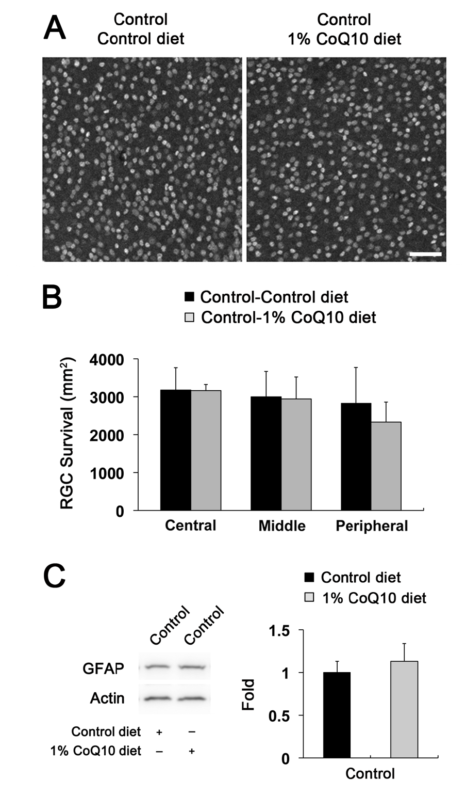

Supplementary Fig. 1 RGC survival and GFAP protein expression in control mice treated with control or CoQ₁₀ diet. Unsupplemented control or CoQ₁₀ (1%) diet were daily treated and continued for 2 weeks. (A) Retinal whole-mount immunohistochemistry for Brn3a at 2 weeks after transient retinal ischemia. High magnification showed representative images from the middle area of retinas. (B) There were no significant changes in RGC survival between control- and CoQ₁₀-treated control C57BL mice (n = 5 retinas/group). Scale bar 50 μm. (C) GFAP Western blot at 12 h after transient ischemia. There was no significant change in GFAP protein expression between control- and CoQ₁₀-treated control mice.

