Supplementary Figures
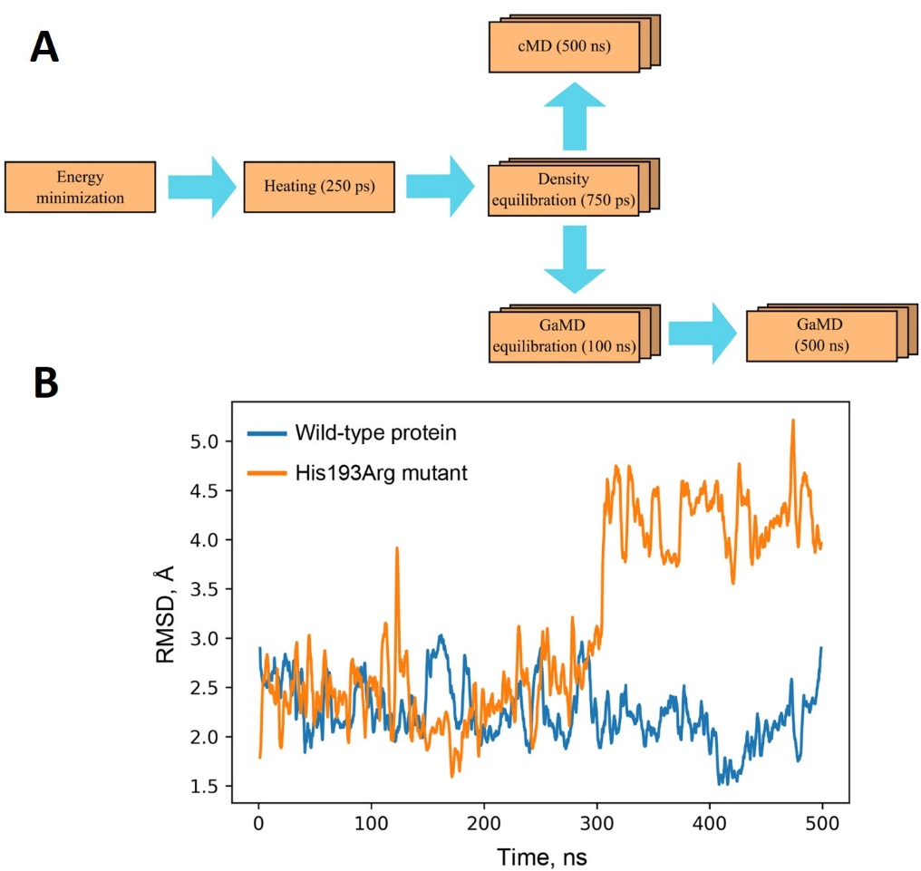
Figure S1. Schematic representation of p53 simulations (A) and root-mean-square deviation (RMSD) of the loop 182–194 from its initial position (obtained at the energy minimization stage) during GaMD simulations of p53 (B). Trajectory frames were superimposed onto the starting structure by fitting the backbone atoms of the protein, and then RMSD of the loop 182–194 backbone was calculated. A major conformational change in the His193Arg mutant structure was observed at t ≈ 300 ns.

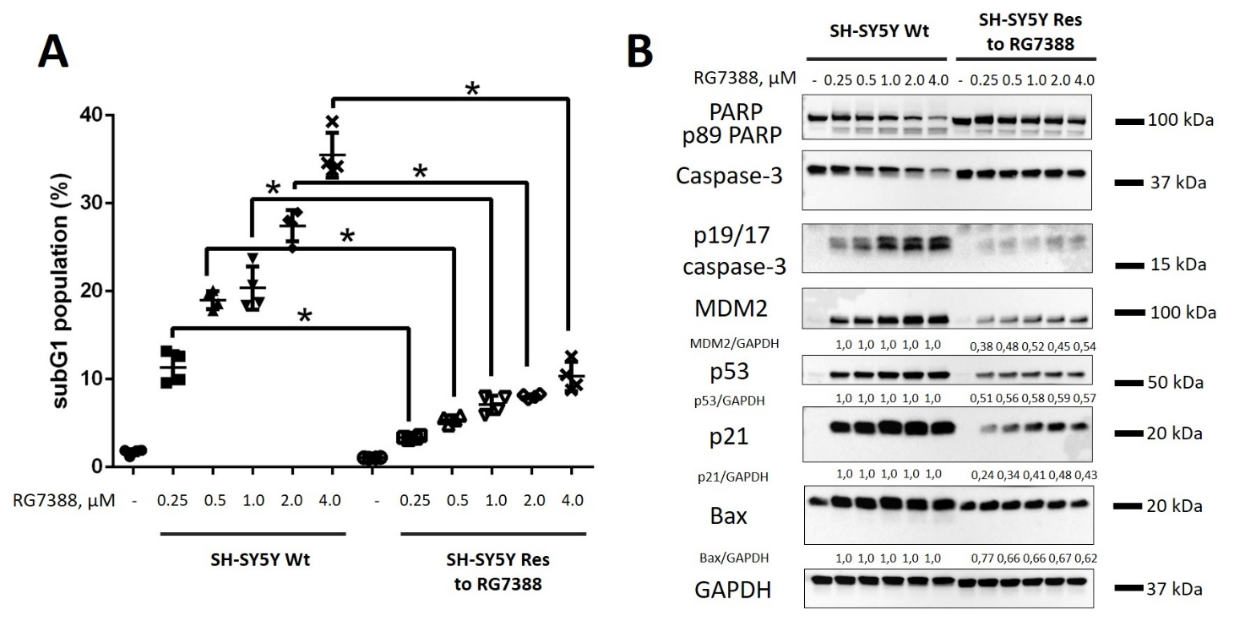
Figure S2. Analysis of the efficiency of RG7388 in wild-type and RG7388-resistant neuroblastoma cells (SH-SY5Y Wt and SH-SY5Y Res, respectively). SubG1 test (A) and WB analysis (B) of SH-SY5Y (parental and resistant cells) cells upon treatment with RG7388 at 0.25 – 4 µM. Densitometric analysis of p53, p21, Bax, and MDM2 levels normalized to GAPDH. Results are presented as mean ± standard deviation (SD), n = 4 (Mann-Whitney U-test), p < 0.05, n.s. — not significant. GAPDH was used as a loading control. Incubation time: 24 h.

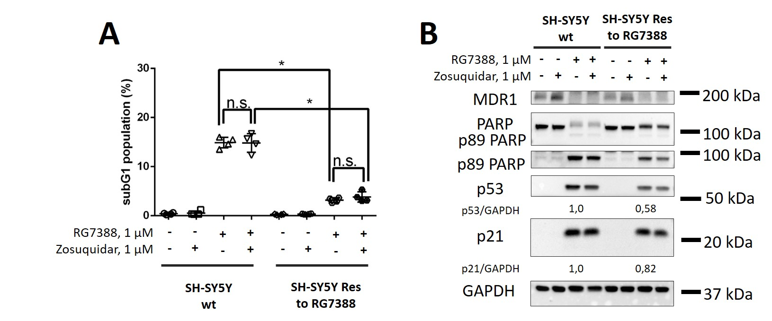
Figure S3. Analysis of the efficiency of the combination RG7388 and an MDR1 inhibitor, Zosuquidar, in wild-type and RG7388-resistant neuroblastoma cells (SH-SY5Y Wt and SH-SY5Y Res, respectively). SubG1 test (A) and WB analysis (B) of SH-SY5Y Wt and SH-SY5Y Res to RG7388 cells upon treatment with RG7388 and Zosuquidar (both – 1 µM, 24 h). Densitometric analysis of p53 and p21 levels normalized to GAPDH. Results are presented as mean ± standard deviation (SD), n = 4 (Mann-Whitney U-test), p < 0.05, n.s. — not significant. GAPDH was used as a loading control.

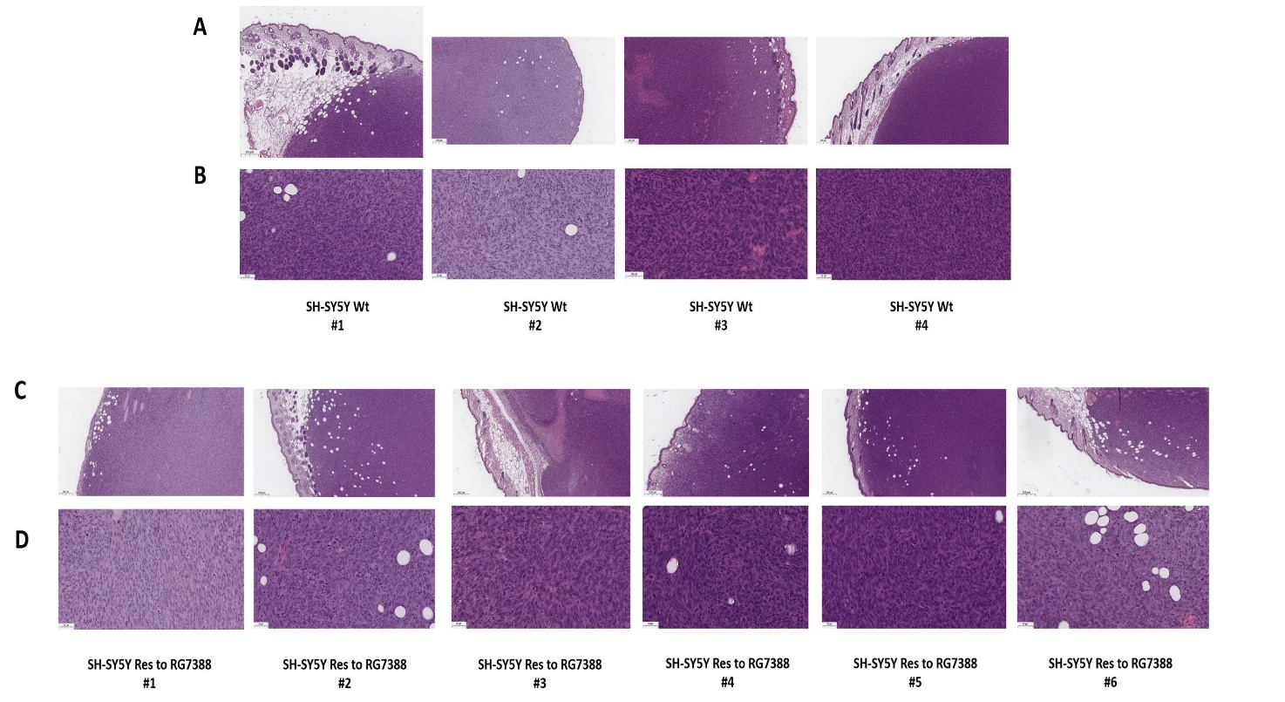
Figure S4. Histological analysis of tumors bearing wild-type (A, B) (n = 4) and resistant to RG7388 SH-SY5Y cells (C, D) (n = 6) obtained from mouse xenografts after hematoxylin and eosin staining. The representative images of tumor tissues.

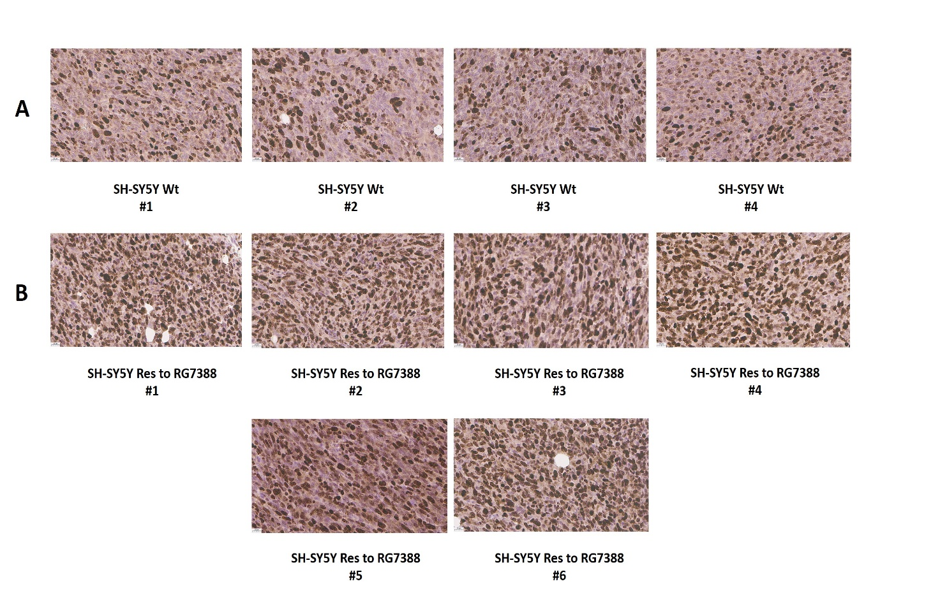
Figure S5. Ki67 immunohistochemical staining of tumors bearing Wt (A) (n = 4) and resistant to RG7388 SH-SY5Y cells (B) (n = 6) obtained from mouse xenografts. The representative images of tumor tissues.

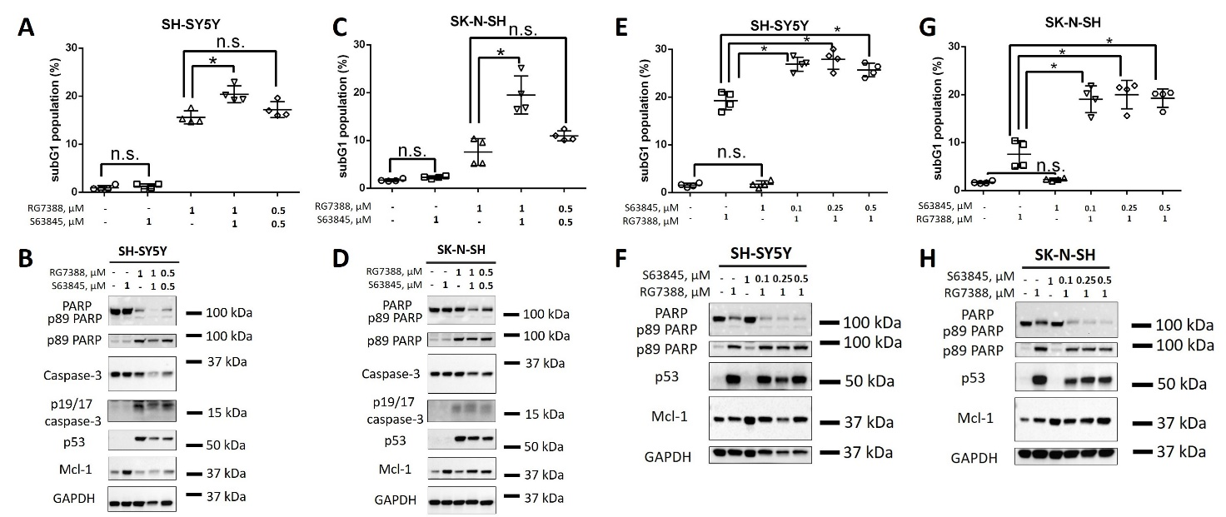
Figure S6. Analysis of the efficiency of simultaneous inhibition of Mcl-2 (S63845) and MDM2 (RG7388) in SH-SY5Y and SK-N-SH cells. subG1 test (A, C, E, G) and WB analysis (B, D, F, H) of SH-SY5Y (A, B) and SK-N-SH (C, D) cells upon treatment with S63845 and RG7388 at indicated concentrations. Results are presented as mean ± standard deviation (SD), n=4 (Mann-Whitney U-test), * p < 0.05, n.s. — not significant. GAPDH was used as a loading control. Time of incubation: 24 h.

Supplementary Tables
Table S1. List of primers used in RT-qPCR analysis.
Gene | Forward primer | Reverse primer
MDM2 | GCAGTGAATCTACAGGGACG | TCCTGATCCAACCAATCACCT
CDKN1A | TGGAGACTCTCAGGGTCGAAA | GGCGTTTGGAGTGGTAGAAATC
BAX | GTCGCCCTTTTCTACTTTGC | CGGAGGAAGTCCAATGTCC
BBC3 | CCTCAACGCACAGTACGAG | GCACCTAATTGGGCTCCATC
TBP | GAGAGTTCTGGGATTGTACC | GGATTATATTCGGCGTTTCG

Table S2. Control data used for p53 simulations in Amber.
Energy minimization, stage 1
&cntrl
imin=1, maxcyc=5000, ncyc=2500,
cut=10.0, ntb=1,
ntc=1, ntf=1,
ntpr=100,
ntr=1,
restraintmask=':1-197&!@H=',
restraint_wt=2.0
/
Energy minimization, stage 2
&cntrl
imin=1, maxcyc=10000, ncyc=5000,
cut=10.0, ntb=1,
ntc=1, ntf=1,
ntpr=100
/
Heating
&cntrl
irest=0, ntx=1,
nstlim=125000, dt=0.002,
ntpr=1000, ntwx=1000,
ntc=2, ntf=2,
cut=10.0, ntb=1,
ntt=3, gamma_ln=2.0,
tempi=0.0, temp0=300.0,
ntr=1, restraintmask=':1-197&!@H=',
restraint_wt=1.0,
nmropt=1
/
&wt TYPE='TEMP0',
istep1=0, istep2=125000,
value1=0.1, value2=300.0 /
&wt TYPE='END' /
Density equilibration
&cntrl
irest=1, ntx=5,
nstlim=375000, dt=0.002,
ntpr=1000, ntwx=1000,
ntc=2, ntf=2,
cut=10.0, ntb=2,
ntt=3, gamma_ln=2.0, temp0=300.0,
ntp=1, taup=2.0, barostat=1
/
cMD production
&cntrl
irest=1, ntx=5,
nstlim=250000000, dt=0.002,
ntpr=1000, ntwx=1000, ntwr=2500000,
ntc=2, ntf=2,
cut=10.0, ntb=2,
ntt=3, gamma_ln=2.0, temp0=300.0,
ntp=1, taup=2.0, barostat=2
/
GaMD equilibration*
&cntrl
irest=1, ntx=5,
nstlim=50000000, dt=0.002,
ntpr=1000, ntwx=1000, ntwr=2500000,
ntc=2, ntf=2,
cut=10.0, ntb=2,
ntt=3, gamma_ln=2.0, temp0=300.0,
ntp=1, taup=2.0, barostat=2,
igamd=3, iE=1, irest_gamd=0,
ntcmdprep=0, ntcmd=1000000,
ntebprep=4000000, nteb=45000000,
ntave=200000,
sigma0D=6.0, sigma0P=6.0
/
GaMD production
&cntrl
irest=1, ntx=5,
nstlim=250000000, dt=0.002,
ntpr=1000, ntwx=1000, ntwr=2500000,
ntc=2, ntf=2,
cut=10.0, ntb=2,
ntt=3, gamma_ln=2.0, temp0=300.0,
ntp=1, taup=2.0, barostat=2,
igamd=3, iE=1, irest_gamd=1,
ntcmdprep=0, ntcmd=0,
ntebprep=0, nteb=0,
ntave=200000,
sigma0D=6.0, sigma0P=6.0
/
* In GaMD simulations the dual potential boost (on both dihedral and total potential energy) was applied with default σ_{0P} and σ_{0D} values (6 kcal/mol), and threshold energy E was set to the lower bound. GaMD equilibration included ntcmd steps (2 ns) followed by ntebprep steps (8 ns) and nteb steps (90 ns); potential energy statistics were updated every 200,000 simulation steps.

Table S3. Values of minimum, average, maximum, and standard deviation of the potential energy (kcal/mol) were used to calculate the boost potentials when running GaMD production simulations of p53.
Wt protein
Potential energy statistics | V_{min} | V_{avg} | V_{max} | σ_{V}
Dihedral potential energy | 2386 | 2633 | 2696 | 12.09
Total potential energy | –113495 | –109811 | –109579 | 44.91
His193Arg mutant
Potential energy statistics | V_{min} | V_{avg} | V_{max} | σ_{V}
Dihedral potential energy | 2386 | 2631 | 2692 | 11.83
Total potential energy | –113770 | –110064 | –109835 | 45.22

Table S4. Histological analysis of tumors bearing wild-type (n = 4) and resistant SH-SY5Y cells (n = 6) obtained from mouse xenografts.
 | Tumor sample | Maximum size of tumor (mm) | Mitotic index (10 HPF ×400) | Apoptotic index (10 HPF ×400) | M/A ratio | Ki-67 (%)
SH-SY5Y Wt | 1 | 12 | 31 | 21 | 1,48 | 50
SH-SY5Y Wt | 2 | 12 | 30 | 18 | 1,67 | 40
SH-SY5Y Wt | 3 | 12 | 24 | 11 | 2,18 | 45
SH-SY5Y Wt | 4 | 8 | 20 | 9 | 2,22 | 50
SH-SY5Y Wt | Total (mean + SD) | 11 ± 2 | 26,25 ± 5,19 | 14,75 ± 5,68 | 1,89 ± 0,37 | 46,25 ± 4,79
SH-SY5Y Res to RG7388 | 1 | 11 | 38 | 9 | 4,22 | 70
SH-SY5Y Res to RG7388 | 2 | 9 | 21 | 12 | 1,75 | 75
SH-SY5Y Res to RG7388 | 3 | 10 | 38 | 11 | 3,45 | 85
SH-SY5Y Res to RG7388 | 4 | 8 | 40 | 13 | 3,08 | 85
SH-SY5Y Res to RG7388 | 5 | 9 | 36 | 15 | 2,40 | 70
SH-SY5Y Res to RG7388 | 6 | 14 | 39 | 10 | 3,90 | 90
SH-SY5Y Res to RG7388 | Total (mean + SD) | 10,17 ± 2,14 | 35,33 ± 7,15 | 11,67 ± 2,16 | 3,13 ± 0,93 | 79,17 ± 8,61
 | Mann-Whitney U-test | n.s. (p=0.5) | n.s. (p=0.057) | n.s. (p=0.58) | * (p=0.038) | * (p=0.0095)
Results are presented as mean ± standard deviation (SD), Mann-Whitney U-test, * p < 0.05, n.s. — not significant.

