Supplementary Figure Legends
Supplementary Figure 1. (A) SW480 and LoVo cells are treated with untreated control, CuCl₂ alone (Cu 50 μM), or Cu-elesclomol (ES) combination (Cu 50 μM + ES 50 nM) for 12 h, followed by annexin V-fluorescein isothiocyanate/propidium iodide double staining to analyze cell death. Representative flow cytometry results (left) and quantitative analysis (right) are shown. Data are presented as the mean ± standard deviation (n = 3). ns: not significant, *P < 0.05 and ***P < 0.001 vs. untreated. (B) SW480 and LoVo cells are treated with untreated control, Cu-ES combination at various concentrations (Cu 5 μM + ES 5 nM, Cu 10 μM + ES 10 nM, Cu 25 μM + ES 25 nM, and Cu 50 μM + ES 50 nM), or paclitaxel (10 nM) for 12 h. Apoptosis-related proteins (C-poly(ADP-ribose) polymerase 1, caspase 9, C-caspase 9, and C-caspase 3) are analyzed by western blotting (left panel). (C) Necroptosis (receptor-interacting protein kinase 1 and receptor-interacting protein kinase 3) and ferroptosis (solute carrier family 7 member 11, glutathione peroxidase 4, and heme oxygenase 1) related protein expression are examined (right panel). β-actin is used as a loading control. (D) SW480 and LoVo cells are treated with untreated control, Cu-ES combination (Cu 25 μM + ES 25 nM), or Cu-ES combination (Cu 50 μM + ES 50 nM) for 12 h. Ferroptosis-related proteins (glutathione peroxidase 4, solute carrier family 7 member 11, and heme oxygenase 1) are analyzed by immunofluorescence staining. Red fluorescence represents protein expression, blue (4',6-diamidino-2-phenylindole) represents nuclei, and merged images are shown. Scale bar = 20 μm. (E) SW480 and LoVo cells are treated with Cu-ES at various concentrations for 12 h. Ferredoxin 1 (FDX-1) protein expression is quantified by western blotting. (F) SW480 and LoVo cells are treated with Cu-ES at various concentrations for 12 h, and subcellular localization of ferredoxin 1 is analyzed by immunofluorescence staining. FDX-1 (red), 4',6-diamidino-2-phenylindole nuclear staining (blue), and merged images are shown. Scale bar = 20 μm. (G) Aggregated dihydrolipoamide S-acetyltransferase (DLAT) protein levels are quantified by western blotting in SW480 and LoVo cells treated with Cu-ES at various concentrations for 12 h. (H) DLAT puncta formation is analyzed by immunofluorescence staining in SW480 and LoVo cells treated with Cu-ES at various concentrations for 12 h. The number of DLAT puncta per cell is quantified. Data in (E, G and H) are normalized to untreated control and presented as the mean ± standard deviation (n = 3). ns, not significant, *P < 0.05, **P < 0.01, and ***P < 0.001 vs. untreated control.

Supplementary Figure 2. (A) SW480 and LoVo cells are treated with untreated control, CuCl₂ alone (Cu 50 μM), or Cu-ES combination (Cu 5, 10, 25, and 50 μM + ES 5, 10, 25, and 50 nM) for 12 h. Intracellular reactive oxygen species generation is analyzed. Mitochondrial reactive oxygen species are stained with MitoSOX (red), cytoplasmic reactive oxygen species with 2′,7′-Dichlorodihydrofluorescein diacetate (green), and nuclei with Hoechst 33342 (blue). Merged images represent the overlay of all fluorescent signals. Scale bar = 20 μm. (B) Intracellular ATP levels are measured by luminescence assay in SW480 and LoVo cells after 12 h of treatment with various concentrations of Cu-ES. Data are normalized to untreated control and presented as the mean ± standard deviation (n = 3). *P < 0.05, **P < 0.01, and ***P < 0.001 vs. untreated control.

Supplementary Figure 3. (A) Time-dependent alterations in the viability of SW480 and LoVo colorectal cancer cells treated with CuCl₂ (Cu; 5 or 10 μM) or Cu-elesclomol (Cu-ES; 5 μM Cu + 5 nM ES or 10 μM Cu + 10 nM ES) for 0 or 12 h. Cell viability is assessed using a 3-(4,5-dimethylthiazol-2-yl)-2,5-diphenyltetrazolium bromide (MTT) assay. Data are presented as the mean ± standard deviation (n = 3). ns: not significant vs. untreated. (B) SW480 and LoVo cells are treated with Cu alone (5, 10, 25, or 50 μM) or Cu-ES combination (Cu 5 μM + ES 5 nM, Cu 10 μM + ES 10 nM, Cu 25 μM + ES 25 nM, or Cu 50 μM + ES 50 nM) for 12 h. Epithelial-mesenchymal transition (EMT)-related proteins including E-cadherin, β-catenin, and vimentin are analyzed by western blotting and quantified. (C) SW480 and LoVo cells are treated with untreated control, Cu alone (25 μM), or Cu-ES combination (Cu 25 μM + ES 25 nM) for 12 h. EMT-related proteins (E-cadherin, vimentin, and β-catenin) are visualized by immunofluorescence staining and quantified. Nuclear translocation of β-catenin is assessed by measuring nuclear fluorescence intensity. Data in (B-C) are normalized to untreated control and presented as the mean ± standard deviation (n = 3). *P < 0.05, **P < 0.01, and ***P < 0.001 vs. untreated.

Supplementary Figure 4. (A) SW480 and LoVo cells are treated with Cu alone (5, 10, 25, or 50 μM) or Cu-elesclomol (Cu-ES) combination (Cu 5 μM + ES 5 nM, Cu 10 μM + ES 10 nM, Cu 25 μM + ES 25 nM, or Cu 50 μM + ES 50 nM) for 12 h. Forkhead box O3a (FOXO3a) and polo-like kinase 1 (PLK1) protein expression levels are analyzed by western blotting and quantified. (B) SW480 and LoVo cells are treated with untreated control, Cu alone (25 μM), or Cu-ES combination (Cu 25 μM + ES 25 nM) for 12 h, followed by nuclear and cytoplasmic fractionation. Nuclear FOXO3a protein expression is analyzed by western blotting and quantified. (C) Nuclear translocation of FOXO3a is assessed by immunofluorescence staining in SW480 and LoVo cells treated with untreated control, Cu alone (25 μM), or Cu-ES combination (Cu 25 μM + ES 25 nM) for 12 h. Nuclear fluorescence intensity is quantified. (D) SW480 and LoVo cells are treated with untreated control, Cu alone (25 μM), or Cu-ES combination (Cu 25 μM + ES 25 nM) for 12 h. Cyclin D1, cyclin D3, and c-MYC are analyzed by western blotting and quantified. All data are normalized to untreated control and presented as the mean ± standard deviation (n = 3). ns, not significant; *P < 0.05, **P < 0.01, and ***P < 0.001 vs. untreated control.

Supplementary Figure 5. (A) SW480 and LoVo cells are treated with various concentrations of BI-2536 (0, 10, 50, 100, 250, and 500 nM) for 24, 48, and 72 h. Cell viability is measured using 3-(4,5-dimethylthiazol-2-yl)-2,5-diphenyltetrazolium bromide (MTT) assay at 570/690 nm. IC50 values are calculated as 25.70 ± 13.786 nM for SW480 cells and 32.13 ± 5.11 nM for LoVo cells. Data are presented as the mean ± standard deviation (n = 3). (B) SW480 and LoVo cells are treated with untreated control or BI-2536 (10 nM) for 12 h. E-cadherin, vimentin, FOXO3a, cyclin B1, cyclin D1, and cyclin D3 protein expression levels are analyzed by western blotting and quantified. (C) SW480 and LoVo cells are treated with untreated control or BI-2536 (10 nM) for 12 h, followed by nuclear and cytoplasmic fractionation. Nuclear FOXO3a protein expression is analyzed by western blotting and quantified. (D) Nuclear translocation of FOXO3a is assessed by immunofluorescence staining in SW480 and LoVo cells treated with untreated control or BI-2536 (10 nM) for 12 h. Nuclear fluorescence intensity is quantified. Data in (B-D) are normalized to untreated control and presented as the mean ± standard deviation (n = 3). **P < 0.01 and ***P < 0.001 vs. untreated control.

Supplementary Figure 6. (A) Cell viability measurement by 3-(4,5-dimethylthiazol-2-yl)-2,5-diphenyltetrazolium bromide (MTT) assay in SW480 and LoVo cells treated with untreated control, BI-2536 10 nM alone for 12 h, Cu-ES 10 μM + 10 nM combination for 12 h, or BI-2536 10 nM pre-treatment followed by additional Cu-ES 10 μM + 10 nM treatment for 12 h. (B) Western blot analysis of intracellular distribution of FOXO3a and β-catenin in SW480 and LoVo cells under each treatment condition after cytoplasmic and nuclear fractionation. β-actin (cytoplasmic marker) and lamin B1 (nuclear marker) are used to confirm fractionation purity. (C) E-cadherin, vimentin, and FOXO3a protein expression levels are analyzed by western blotting and quantified in SW480 and LoVo cells treated with untreated control, Cu-ES (10 μM + 10 nM) for 12 h, or BI-2536 (10 nM) pre-treatment for 12 h followed by Cu-ES (10 μM + 10 nM) for 12 h. (D) Nuclear FOXO3a protein expression is analyzed by western blotting and quantified in SW480 and LoVo cells following nuclear and cytoplasmic fractionation after treatment with untreated control, Cu-ES (10 μM + 10 nM) for 12 h, or BI-2536 (10 nM) pre-treatment for 12 h followed by Cu-ES (10 μM + 10 nM) for 12 h. (E) Aggregated DLAT and FDX-1 protein expression levels are analyzed by western blotting and quantified in SW480 and LoVo cells treated with untreated control, Cu-ES (10 μM + 10 nM) for 12 h, or BI-2536 (10 nM) pre-treatment for 12 h followed by Cu-ES (10 μM + 10 nM) for 12 h. (F) DLAT puncta formation is analyzed by immunofluorescence staining in SW480 and LoVo cells treated with untreated control, Cu-ES (10 μM + 10 nM) for 12 h, or BI-2536 (10 nM) pre-treatment for 12 h followed by Cu-ES (10 μM + 10 nM) for 12 h. The number of DLAT puncta per cell is quantified. All data are normalized to untreated control and presented as the mean ± standard deviation (n = 3). ns, not significant; *P < 0.05, **P < 0.01, and ***P < 0.001 vs. untreated control.

Supplementary Figure 1
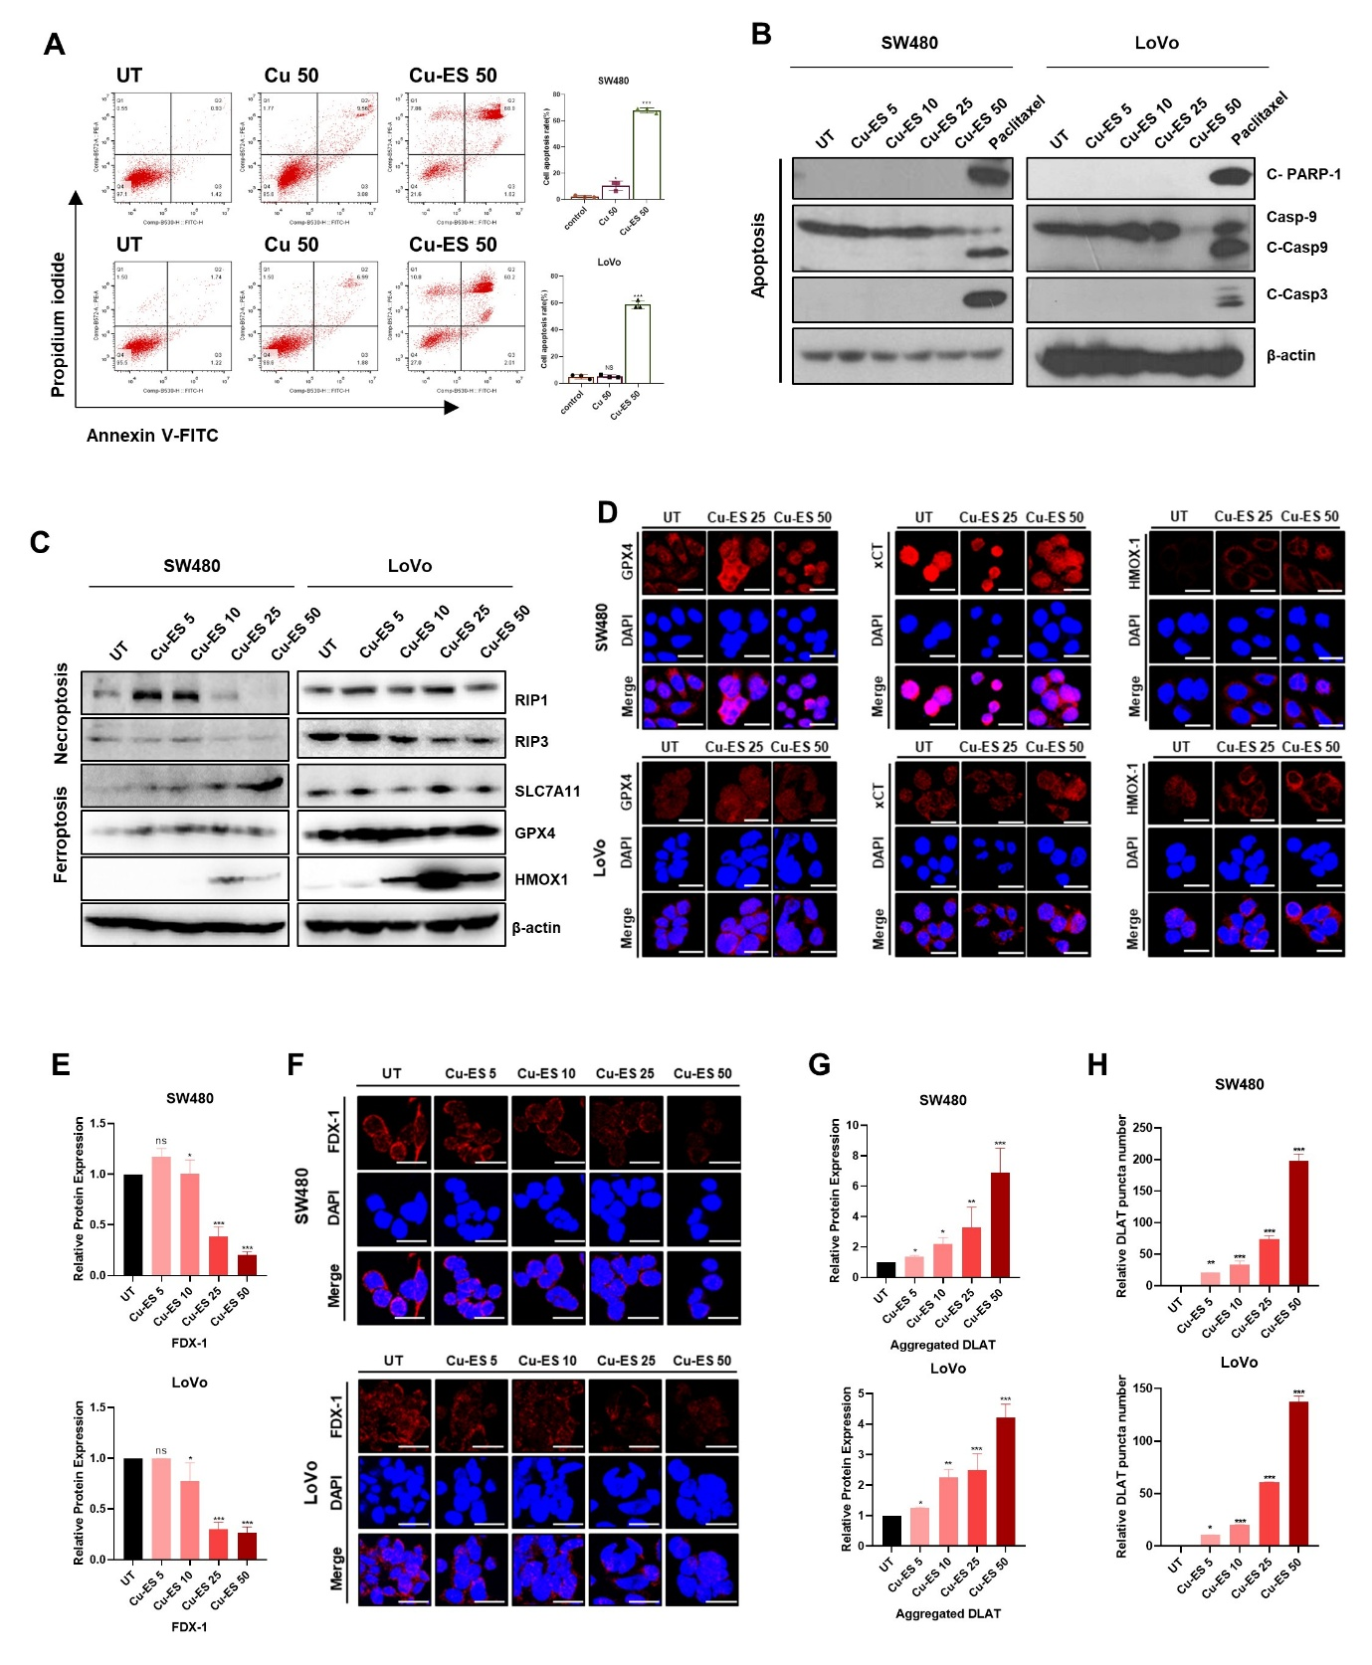

Supplementary Figure 2
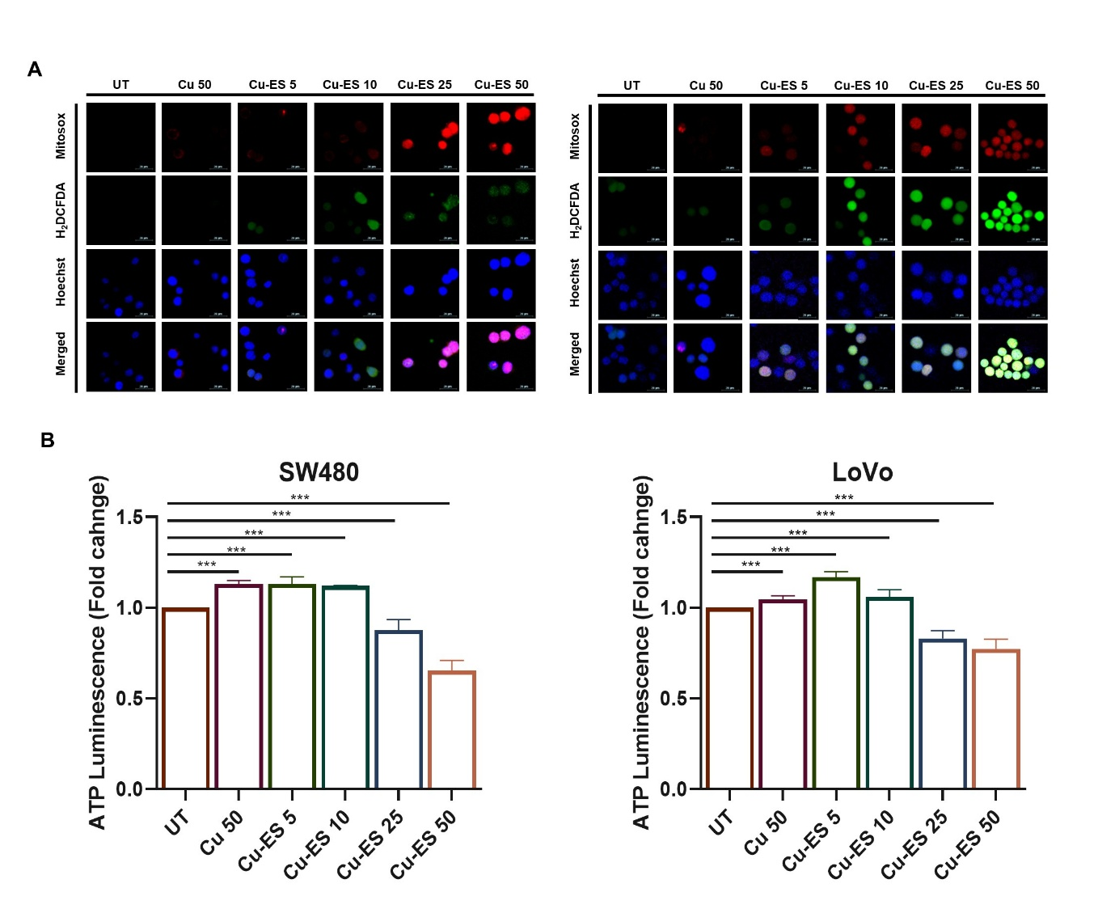

Supplementary Figure 3
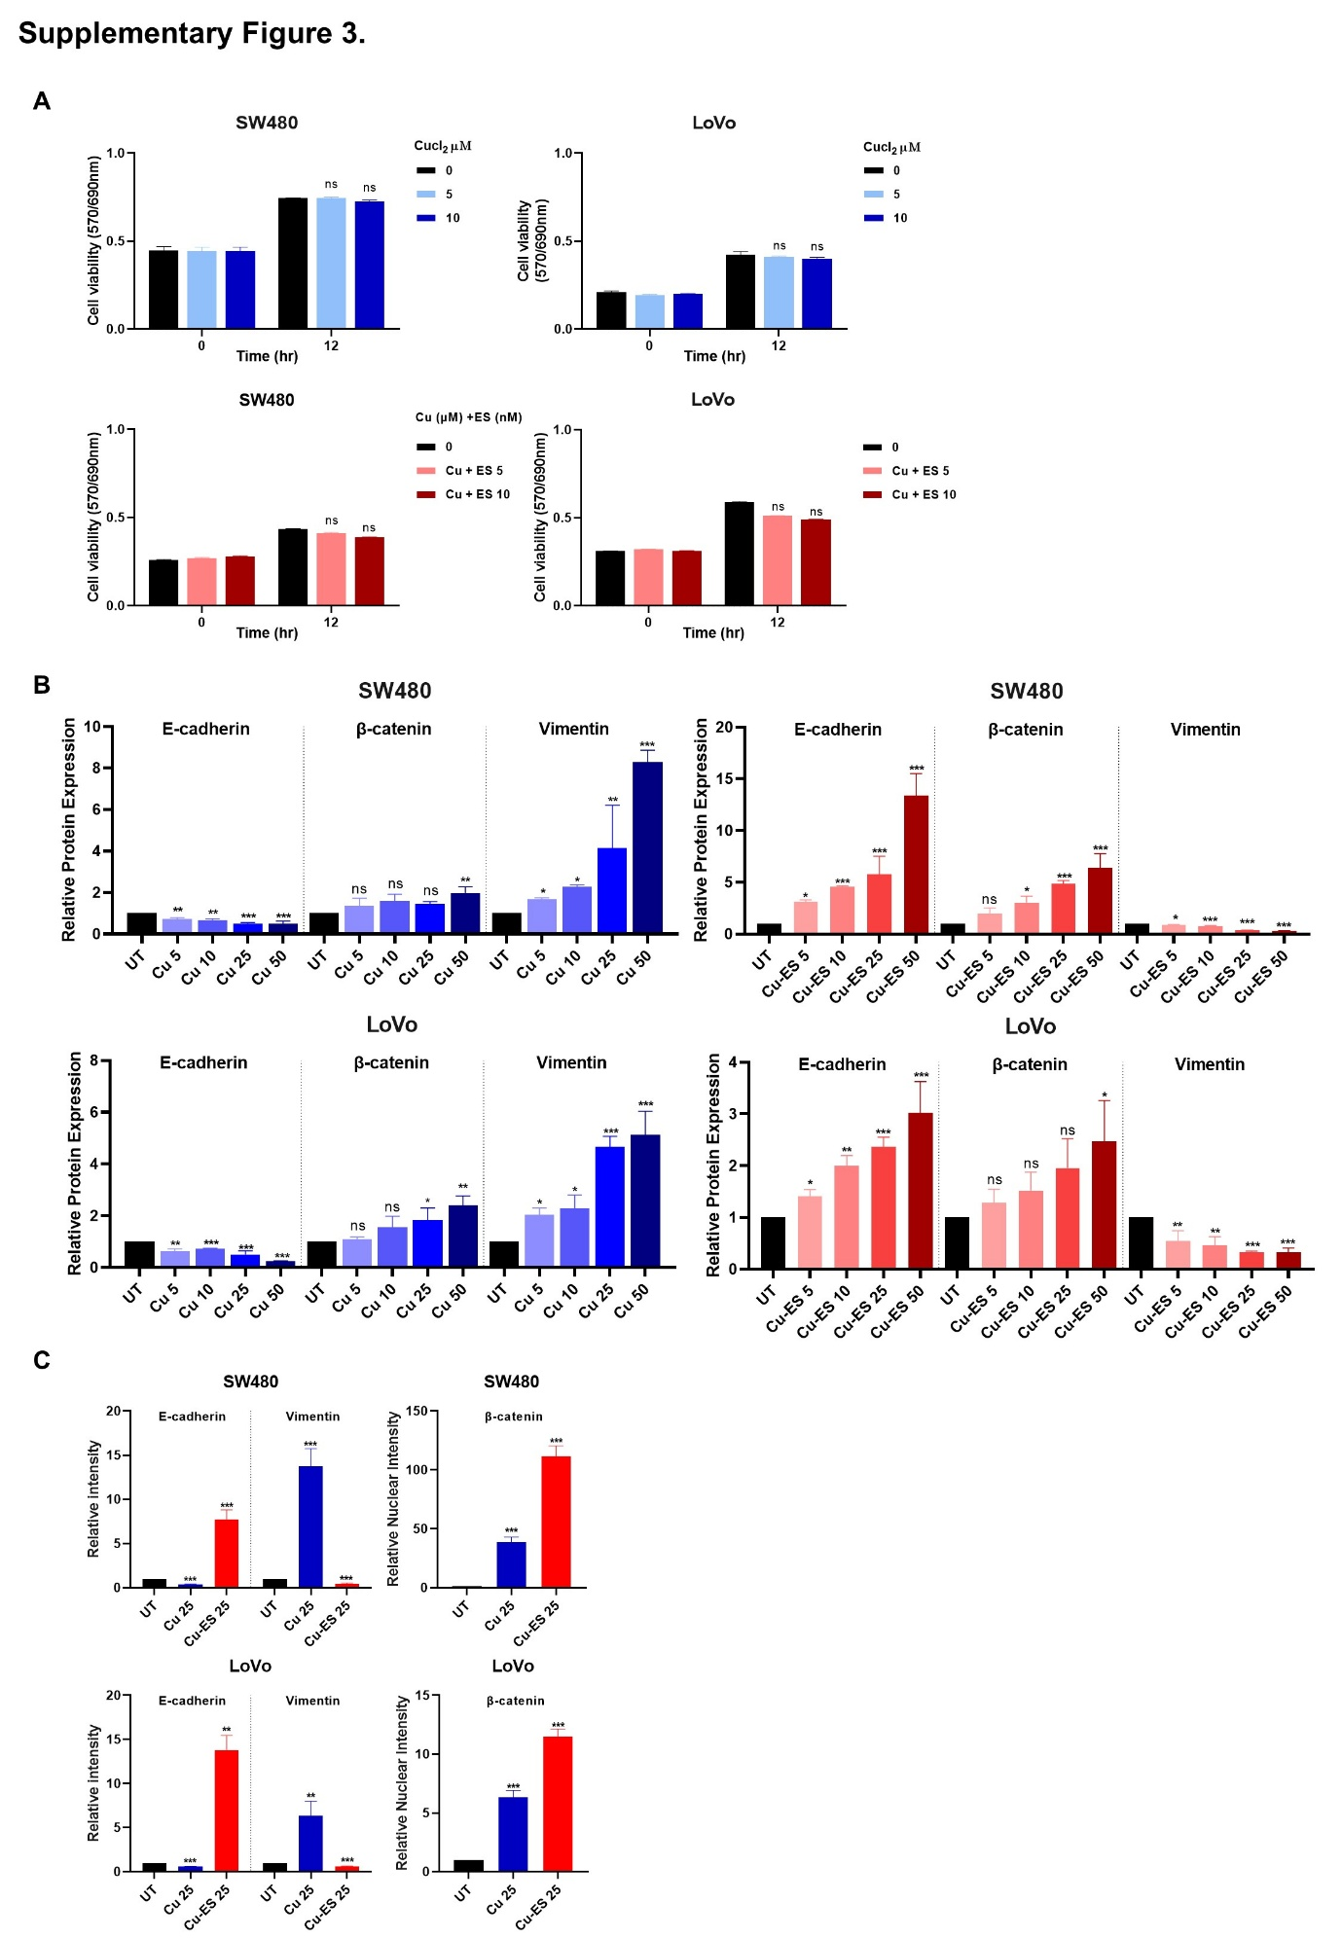
Supplementary Figure 4
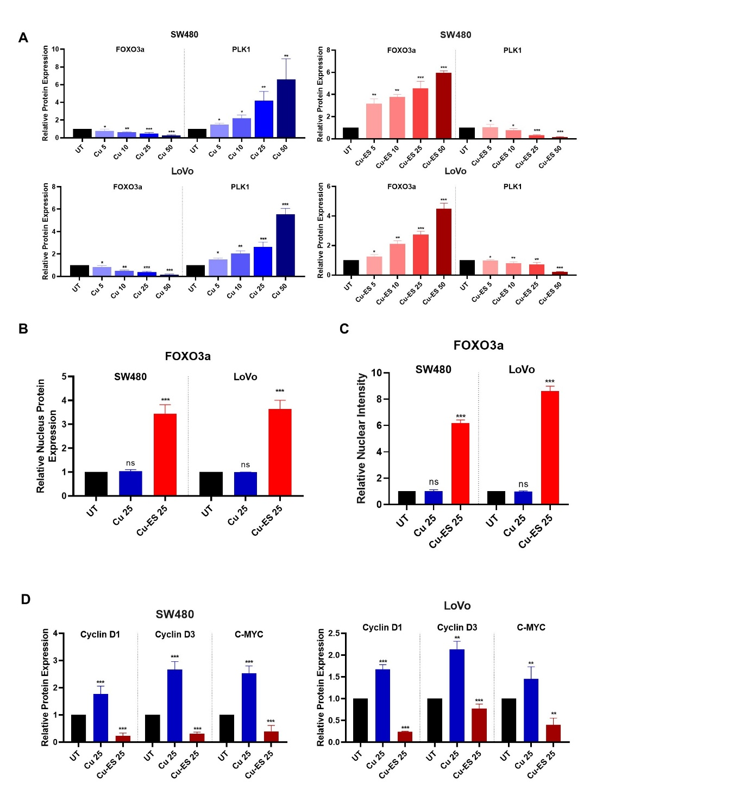

Supplementary Figure 5
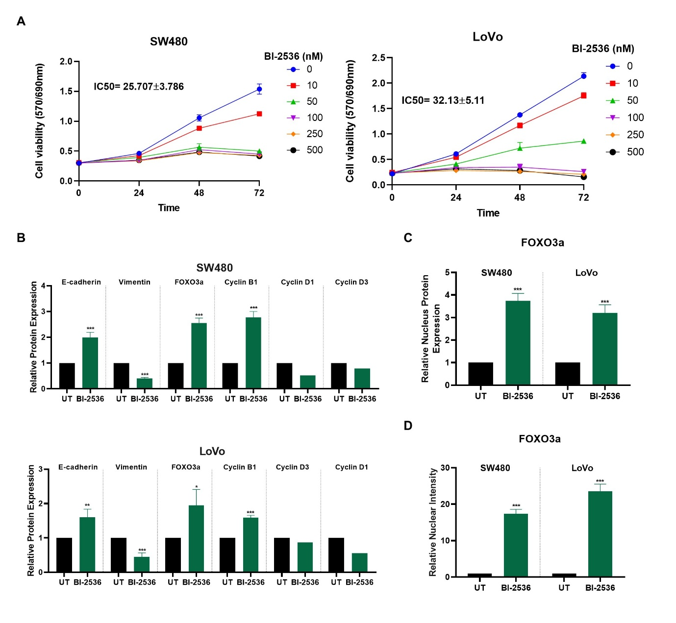

Supplementary Figure 6
