Supplementary Materials and Methods
Lentivirus construction and infection
For lentiviral packaging, 293T cells were co-transfected with control or target plasmid along with two helper plasmids (psPAX2 and pMD2.G). Collect the supernatant containing lentivirus, concentrate it by high-speed centrifugation, and purify it through filtration. Then, TCL cells (Hut-78 and H9) were infected with these lentiviruses. The lentiviral vector was pLKO.1 puro (MiaoLingPlasmid, China). The knockdown target sequences for c-Myc was GAATGTCAAGAGGCGAACACA.

Supplementary Figures
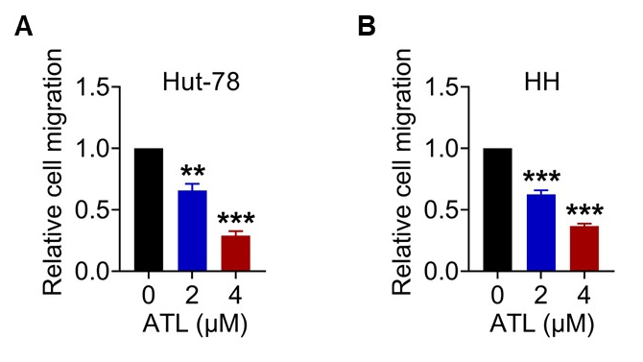
Supplementary Fig1. Alantolactone inhibits the migration of TCL cells. A-B. TCL cells were treated with alantolactone (ATL) for 24 h, and the migration capacity was determined by chamber migration assays. **p < 0.01, ***p < 0.001

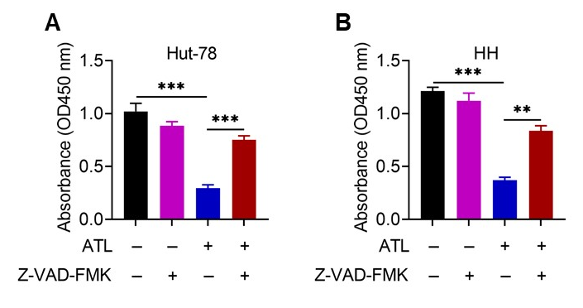
Supplementary Fig2. Alantolactone induces apoptosis in TCL cells. A-B. TCL cells were pre-incubated with or without Z-VAD-FMK (50 μM) for 1 h, and then treated with ATL (4 µM), cell viability was measured using the CCK-8 assay at 72 h. **p < 0.01, ***p < 0.001

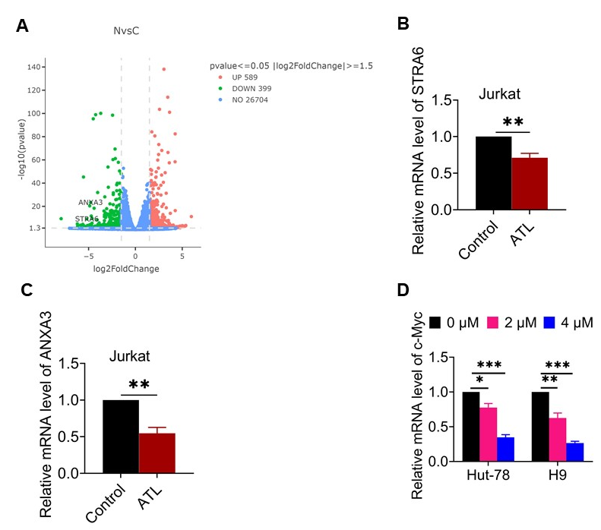
Supplementary Fig3. Differential gene analysis of TCL cells treated by control or Alantolactone. A. Volcano plot of differentially expressed genes in TCL cells. B-C. The mRNA levels of STRA6 (B) and ANXA3 (C) in Jurkat cells treated with or without 4 μM ATL for 48 h. D. The mRNA levels of c-Myc in Hut-78 and H9 cells treated with control or ATL for 48 h. *p < 0.05, **p < 0.01, ***p < 0.001

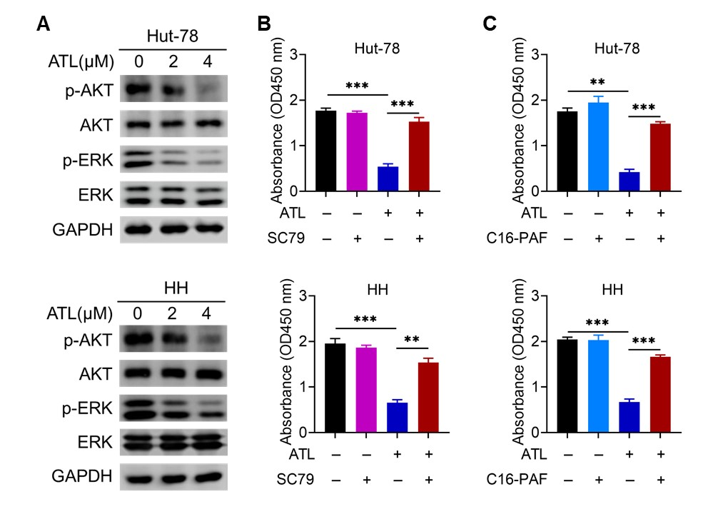
Supplementary Fig4. The PI3K/AKT and ERK signaling axis mediates the anti-TCL effect of Alantolactone. A. Western blot analysis of p-AKT, AKT, p-ERK, and ERK protein levels in TCL cells treated with ATL for 48 h. B. TCL cells were pretreated with 8 μM AKT activator (SC79) for 1 h prior to ATL (4 µM) treatment. Cell viability was determined by CCK-8 assay at 96 h. C. ERK activator C16-PAF (2 µM) significantly reversed the inhibitory effect of ATL (4 µM) on cell viability. **p < 0.01, ***p < 0.001
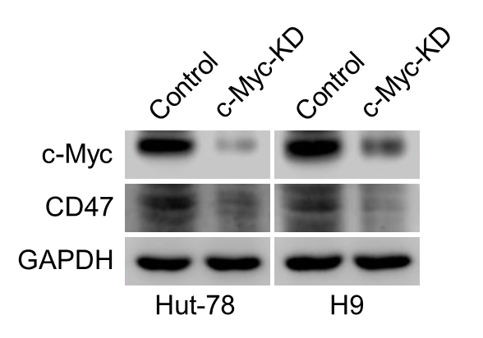
Supplementary Fig5. c-Myc regulates the expression of CD47 in TCL cells c-Myc knockdown (KD) reduces the expression of CD47 in TCL cells.

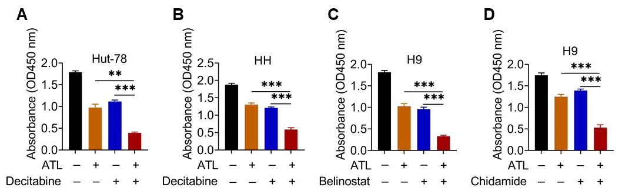
Supplementary Fig6. Alantolactone exerts synergistic effects combined with clinical chemotherapy drugs in TCL cells. A-B. TCL cells were treated with 2 μM ATL, 0.5 μM decitabine, or the combination of both, and cell viability was determined by CCK-8 assay at 96 h. C-D. The combination of 2 μM ATL and 0.2 µM belinostat (C) or 0.5 µM chidamide (D) also synergistically inhibits the proliferation of H9 cells at 96 h. **p < 0.01, ***p < 0.001

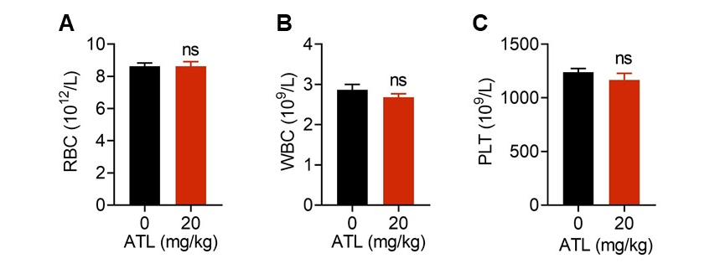
Supplementary Fig7. ATL exerts low toxicity in NSG mice. A-C. Hematological analysis demonstrating that ATL treatment did not significantly affect red blood cell (RBC) (A), white blood cell (WBC) (B), or platelet (PLT) (C) levels in tumor-bearing mice. ns, no significance.

Supplementary Table1. Primers used in this study
Primer | Forward | Reverse
STRA6 | 5′-AGACCAGGTCCCACACTGA-3′ | 5′-TTCATAATAGCCAAAGGCATAAAA-3′
ANXA3 | 5′-CCCATCAGTGGATGCTGAAG-3′ | 5′-TCACTAGGGCCACCATGAGA-3′
c-Myc | 5′-GGCTCCTGGCAAAAGGTCA-3′ | 5′-CTGCGTAGTTGTGCTGATGT-3′
GAPDH | 5′-CCACATCGCTCAGACACCAT-3′ | 5′-GCGCCCAATACGACCAAAT-3′

