Supplementary Material
to
Sex/Gender Attribution: When the Penis Makes the Difference

Adult Gender Attribution Test
The 120 stimuli in the Adult Gender Attribution Test are shown below on the following page. The red framed stimuli 1_F1 (female) and 64_M1 (male) are the original images bought from the website www.3d.sk with a perpetual, non-exclusive, non-transferable worldwide license to use the Content for the Permitted Uses. All copyright and other intellectual property rights relating to the Content, are retained by 3D.sk. The other 118 stimuli not framed in read have been created through the software Adobe Photoshop 14 (see also Supplementary material).

Table S1. The 120 stimuli of the Adult Gender Attribution Test.
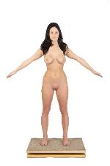 | 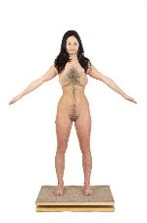 | 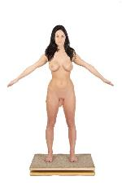 | 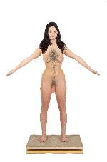 | 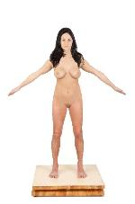
1_F1 | 2_F2 | 3_F3 | 4_F8 | 5_F4
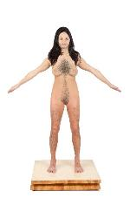 | 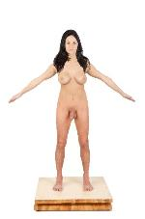 | 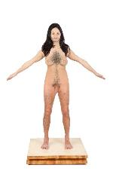 | 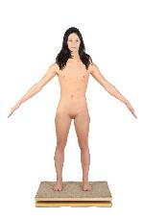 | 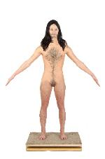
6_F9 | 7_F10 | 8_N1 | 9_F5 | 10_F11
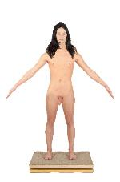 | 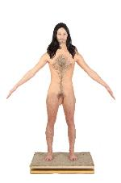 | 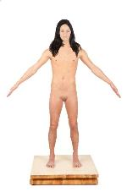 | 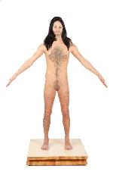 | 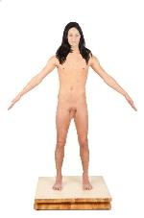
11_F12 | 12_N2 | 13_F13 | 14_N3 | 15_N4
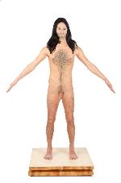 | 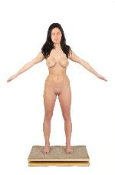 | 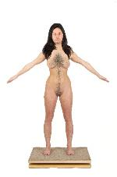 | 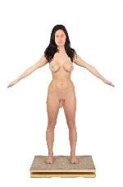 | 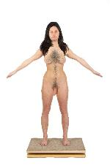
16_M8 | 17_F6 | 18_F14 | 19_F15 | 20_N5
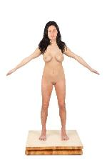 | 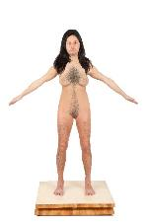 | 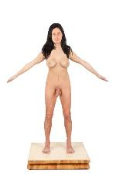 | 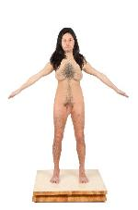 | 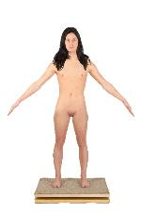
21_F16 | 22_N6 | 23_N7 | 24_M9 | 25_F17
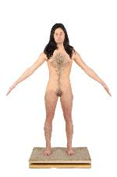 | 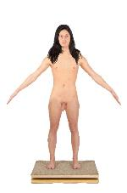 | 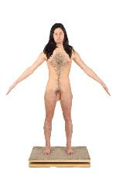 | 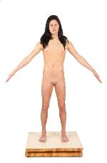 | 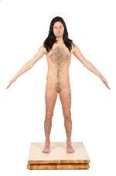
26_N8 | 27_N9 | 28_M10 | 29_N10 | 30_M11
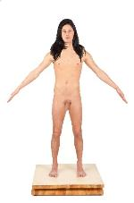 | 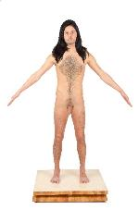 | 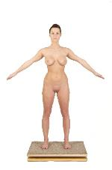 | 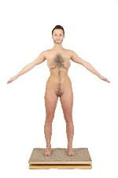 | 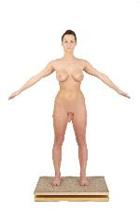
31_M12 | 32_M2 | 33_F7 | 34_F18 | 35_F19
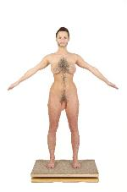 | 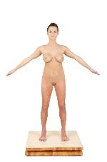 | 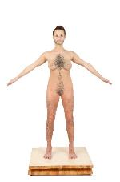 | 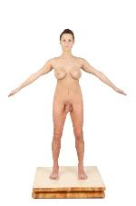 | 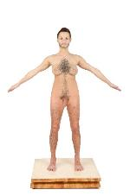
36_N11 | 37_F20 | 38_N12 | 39_N13 | 40_M13
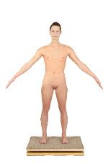 | 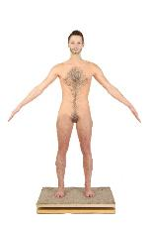 | 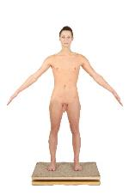 | 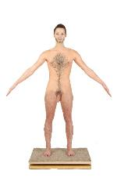 | 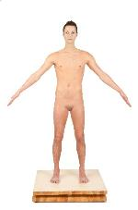
41_F21 | 42_N14 | 43_N15 | 44_M14 | 45_N16
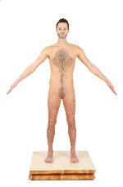 | 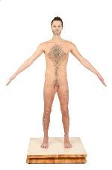 |  | 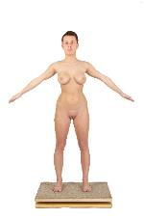 | 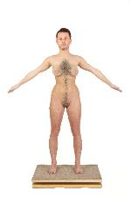
46_M15 | 47_M16 | 48_M3 | 49_F22 | 50_N17
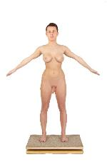 | 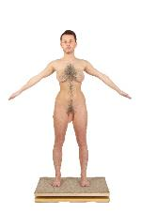 | 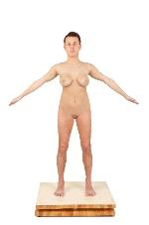 | 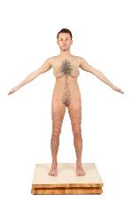 | 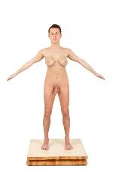
51_N18 | 52_M17 | 53_N19 | 54_M18 | 55_M19
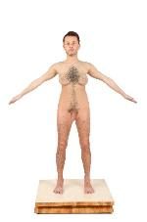 | 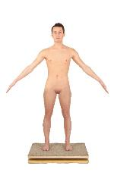 | 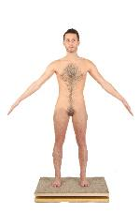 | 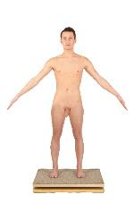 | 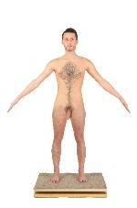
56_M4 | 57_N20 | 58_M20 | 59_M21 | 60_M5
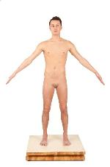 | 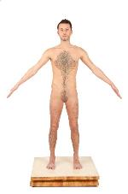 | 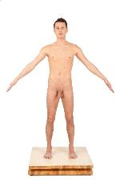 | 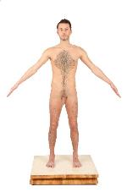 | 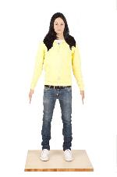
61_M22 | 62_M6 | 63_M7 | 64_M1 | 65_F69
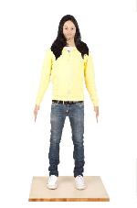 | 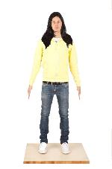 | 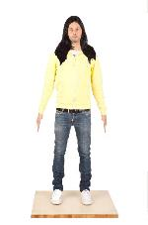 | 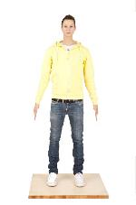 | 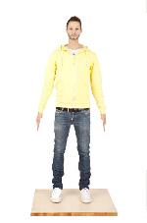
66_F70 | 67_F71 | 68_M66 | 69_F72 | 70_M67
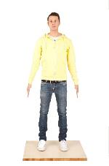 | 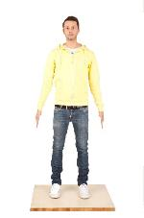 | 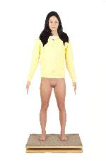 | 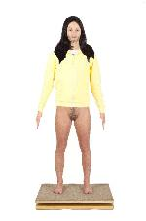 | 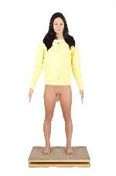
71_M68 | 72_M65 | 73_F89 | 74_F90 | 75_F91
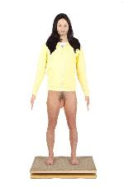 | 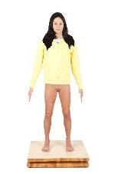 | 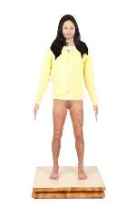 | 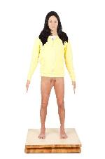 | 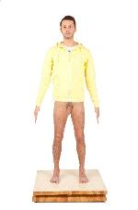
76_F95 | 77_F92 | 78_F96 | 79_F97 | 80_M73
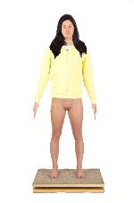 | 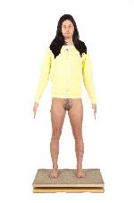 | 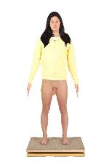 | 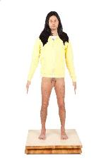 | 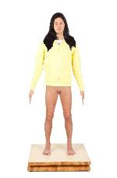
81_F93 | 82_F98 | 83_F99 | 84_M74 | 85_F100
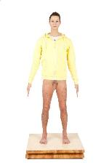 | 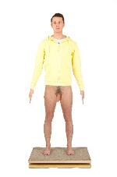 | 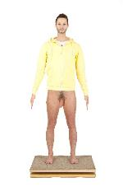 | 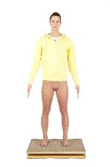 | 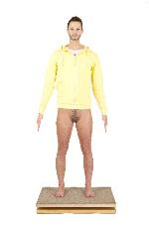
86_M75 | 87_M76 | 88_M83 | 89_F94 | 90_F101
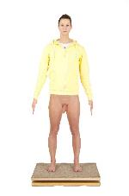 | 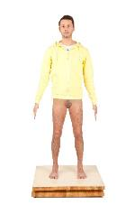 | 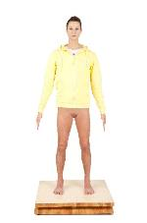 | 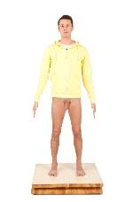 | 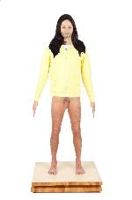
91_F102 | 92_M77 | 93_M103 | 94_M78 | 95_M79
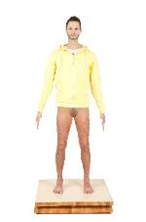 | 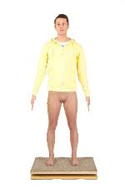 | 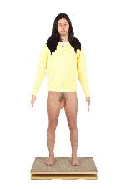 | 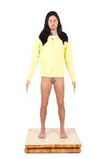 | 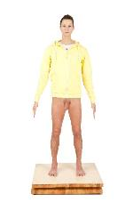
96_M84 | 97_F104 | 98_M80 | 99_M81 | 100_M85
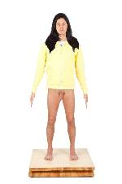 | 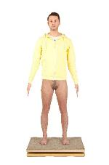 | 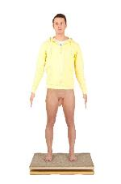 | 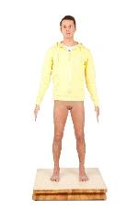 | 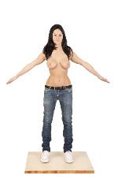
101_M82 | 102_M86 | 103_M87 | 104_M88 | 105_F116
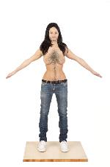 | 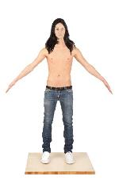 | 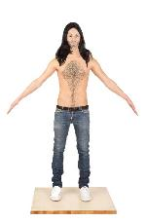 | 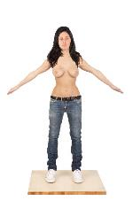 | 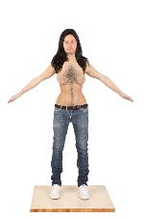
106_F117 | 107_F118 | 108_N105 | 109_F119 | 110_N106
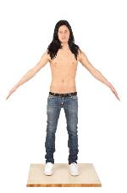 | 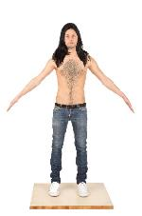 | 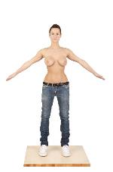 | 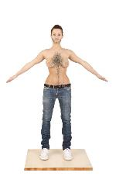 | 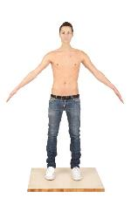
111_N107 | 112_M112 | 113_F120 | 114_N108 | 115_N109
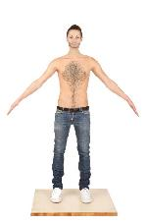 | 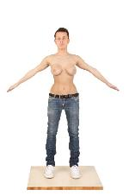 | 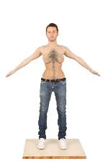 | 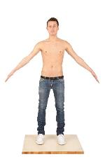 | 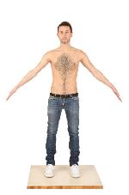
116_M113 | 117_N110 | 118_M114 | 119_M115 | 120_M111

Table S2. Combination of twelve human physical characteristics (short hair, male face, flat chest, narrow hips, penis, body hair, long hair, female face, breast, wide hips, vulva, no body hair) and two cloths (t-shirt unisex, jeans unisex) variables for each image. In the column “Partial”, the number is the sum of occurrences of male variables. When the number is < 3 the image is considered feminine, = 3 the image is considered as neutral, > 3 the image is considered as a masculine. In the column “Total”, F = feminine, N = neutral, M = masculine. In the column “Codex”, the alphanumeric code refers to the image code as shown in the Table S1.
Stimuli | Short hair | Male face | Flat chest | Narrow hips | Penis | Body hair | Partial | Long hair | Female face |  | Breast |  | Wide hips |  | Vulva |  | No body hair |  | T-shirt unisex |  | Jeans unisex |  | Total |  | Codex
1 | 0 | 0 | 0 | 0 | 0 | 0 | 0 | 1 | 1 |  | 1 |  | 1 |  | 1 |  | 1 |  | 0 |  | 0 |  | F |  | F1
2 | 0 | 0 | 0 | 0 | 0 | 1 | 1 | 1 | 1 |  | 1 |  | 1 |  | 1 |  | 0 |  | 0 |  | 0 |  | F |  | F2
3 | 0 | 0 | 0 | 0 | 1 | 0 | 1 | 1 | 1 |  | 1 |  | 1 |  | 0 |  | 1 |  | 0 |  | 0 |  | F |  | F3
4 | 0 | 0 | 0 | 0 | 1 | 1 | 2 | 1 | 1 |  | 1 |  | 1 |  | 0 |  | 0 |  | 0 |  | 0 |  | F |  | F8
5 | 0 | 0 | 0 | 1 | 0 | 0 | 1 | 1 | 1 |  | 1 |  | 0 |  | 1 |  | 1 |  | 0 |  | 0 |  | F |  | F4
6 | 0 | 0 | 0 | 1 | 0 | 1 | 2 | 1 | 1 |  | 1 |  | 0 |  | 1 |  | 0 |  | 0 |  | 0 |  | F |  | F9
7 | 0 | 0 | 0 | 1 | 1 | 0 | 2 | 1 | 1 |  | 1 |  | 0 |  | 0 |  | 1 |  | 0 |  | 0 |  | F |  | F10
8 | 0 | 0 | 0 | 1 | 1 | 1 | 3 | 1 | 1 |  | 1 |  | 0 |  | 0 |  | 0 |  | 0 |  | 0 |  | N |  | N1
9 | 0 | 0 | 1 | 0 | 0 | 0 | 1 | 1 | 1 |  | 0 |  | 1 |  | 1 |  | 1 |  | 0 |  | 0 |  | F |  | F5
10 | 0 | 0 | 1 | 0 | 0 | 1 | 2 | 1 | 1 |  | 0 |  | 1 |  | 1 |  | 0 |  | 0 |  | 0 |  | F |  | F11
11 | 0 | 0 | 1 | 0 | 1 | 0 | 2 | 1 | 1 |  | 0 |  | 1 |  | 0 |  | 1 |  | 0 |  | 0 |  | F |  | F12
12 | 0 | 0 | 1 | 0 | 1 | 1 | 3 | 1 | 1 |  | 0 |  | 1 |  | 0 |  | 0 |  | 0 |  | 0 |  | N |  | N2
13 | 0 | 0 | 1 | 1 | 0 | 0 | 2 | 1 | 1 |  | 0 |  | 0 |  | 1 |  | 1 |  | 0 |  | 0 |  | F |  | F13
14 | 0 | 0 | 1 | 1 | 0 | 1 | 3 | 1 | 1 |  | 0 |  | 0 |  | 1 |  | 0 |  | 0 |  | 0 |  | N |  | N3
15 | 0 | 0 | 1 | 1 | 1 | 0 | 3 | 1 | 1 |  | 0 |  | 0 |  | 0 |  | 1 |  | 0 |  | 0 |  | N |  | N4
16 | 0 | 0 | 1 | 1 | 1 | 1 | 4 | 1 | 1 |  | 0 |  | 0 |  | 0 |  | 0 |  | 0 |  | 0 |  | M |  | M8
17 | 0 | 1 | 0 | 0 | 0 | 0 | 1 | 1 | 0 |  | 1 |  | 1 |  | 1 |  | 1 |  | 0 |  | 0 |  | F |  | F6
18 | 0 | 1 | 0 | 0 | 0 | 1 | 2 | 1 | 0 |  | 1 |  | 1 |  | 1 |  | 0 |  | 0 |  | 0 |  | F |  | F14
19 | 0 | 1 | 0 | 0 | 1 | 0 | 2 | 1 | 0 |  | 1 |  | 1 |  | 0 |  | 1 |  | 0 |  | 0 |  | F |  | F15
20 | 0 | 1 | 0 | 0 | 1 | 1 | 3 | 1 | 0 |  | 1 |  | 1 |  | 0 |  | 0 |  | 0 |  | 0 |  | N |  | N5
21 | 0 | 1 | 0 | 1 | 0 | 0 | 2 | 1 | 0 |  | 1 |  | 0 |  | 1 |  | 1 |  | 0 |  | 0 |  | F |  | F16
22 | 0 | 1 | 0 | 1 | 0 | 1 | 3 | 1 | 0 |  | 1 |  | 0 |  | 1 |  | 0 |  | 0 |  | 0 |  | N |  | N6
23 | 0 | 1 | 0 | 1 | 1 | 0 | 3 | 1 | 0 |  | 1 |  | 0 |  | 0 |  | 1 |  | 0 |  | 0 |  | N |  | N7
24 | 0 | 1 | 0 | 1 | 1 | 1 | 4 | 1 | 0 |  | 1 |  | 0 |  | 0 |  | 0 |  | 0 |  | 0 |  | M |  | M9
25 | 0 | 1 | 1 | 0 | 0 | 0 | 2 | 1 | 0 |  | 0 |  | 1 |  | 1 |  | 1 |  | 0 |  | 0 |  | F |  | F17
26 | 0 | 1 | 1 | 0 | 0 | 1 | 3 | 1 | 0 |  | 0 |  | 1 |  | 1 |  | 0 |  | 0 |  | 0 |  | N |  | N8
27 | 0 | 1 | 1 | 0 | 1 | 0 | 3 | 1 | 0 |  | 0 |  | 1 |  | 0 |  | 1 |  | 0 |  | 0 |  | N |  | N9
28 | 0 | 1 | 1 | 0 | 1 | 1 | 4 | 1 | 0 |  | 0 |  | 1 |  | 0 |  | 0 |  | 0 |  | 0 |  | M |  | M10
29 | 0 | 1 | 1 | 1 | 0 | 0 | 3 | 1 | 0 |  | 0 |  | 0 |  | 1 |  | 1 |  | 0 |  | 0 |  | N |  | N10
30 | 0 | 1 | 1 | 1 | 0 | 1 | 4 | 1 | 0 |  | 0 |  | 0 |  | 1 |  | 0 |  | 0 |  | 0 |  | M |  | M11
31 | 0 | 1 | 1 | 1 | 1 | 0 | 4 | 1 | 0 |  | 0 |  | 0 |  | 0 |  | 1 |  | 0 |  | 0 |  | M |  | M12
32 | 0 | 1 | 1 | 1 | 1 | 1 | 5 | 1 | 0 |  | 0 |  | 0 |  | 0 |  | 0 |  | 0 |  | 0 |  | M |  | M2
33 | 1 | 0 | 0 | 0 | 0 | 0 | 1 | 0 | 1 |  | 1 |  | 1 |  | 1 |  | 1 |  | 0 |  | 0 |  | F |  | F7
34 | 1 | 0 | 0 | 0 | 0 | 1 | 2 | 0 | 1 |  | 1 |  | 1 |  | 1 |  | 0 |  | 0 |  | 0 |  | F |  | F18
35 | 1 | 0 | 0 | 0 | 1 | 0 | 2 | 0 | 1 |  | 1 |  | 1 |  | 0 |  | 1 |  | 0 |  | 0 |  | F |  | F19
36 | 1 | 0 | 0 | 0 | 1 | 1 | 3 | 0 | 1 |  | 1 |  | 1 |  | 0 |  | 0 |  | 0 |  | 0 |  | N |  | N11
37 | 1 | 0 | 0 | 1 | 0 | 0 | 2 | 0 | 1 |  | 1 |  | 0 |  | 1 |  | 1 |  | 0 |  | 0 |  | F |  | F20
38 | 1 | 0 | 0 | 1 | 0 | 1 | 3 | 0 | 1 |  | 1 |  | 0 |  | 1 |  | 0 |  | 0 |  | 0 |  | N |  | N12
39 | 1 | 0 | 0 | 1 | 1 | 0 | 3 | 0 | 1 |  | 1 |  | 0 |  | 0 |  | 1 |  | 0 |  | 0 |  | N |  | N13
40 | 1 | 0 | 0 | 1 | 1 | 1 | 4 | 0 | 1 |  | 1 |  | 0 |  | 0 |  | 0 |  | 0 |  | 0 |  | M |  | M13
41 | 1 | 0 | 1 | 0 | 0 | 0 | 2 | 0 | 1 |  | 0 |  | 1 |  | 1 |  | 1 |  | 0 |  | 0 |  | F |  | F21
42 | 1 | 0 | 1 | 0 | 0 | 1 | 3 | 0 | 1 |  | 0 |  | 1 |  | 1 |  | 0 |  | 0 |  | 0 |  | N |  | N14
43 | 1 | 0 | 1 | 0 | 1 | 0 | 3 | 0 | 1 |  | 0 |  | 1 |  | 0 |  | 1 |  | 0 |  | 0 |  | N |  | N15
44 | 1 | 0 | 1 | 0 | 1 | 1 | 4 | 0 | 1 |  | 0 |  | 1 |  | 0 |  | 0 |  | 0 |  | 0 |  | M |  | M14
45 | 1 | 0 | 1 | 1 | 0 | 0 | 3 | 0 | 1 |  | 0 |  | 0 |  | 1 |  | 1 |  | 0 |  | 0 |  | N |  | N16
46 | 1 | 0 | 1 | 1 | 0 | 1 | 4 | 0 | 1 |  | 0 |  | 0 |  | 1 |  | 0 |  | 0 |  | 0 |  | M |  | M15
47 | 1 | 0 | 1 | 1 | 1 | 0 | 4 | 0 | 1 |  | 0 |  | 0 |  | 0 |  | 1 |  | 0 |  | 0 |  | M |  | M16
48 | 1 | 0 | 1 | 1 | 1 | 1 | 5 | 0 | 1 |  | 0 |  | 0 |  | 0 |  | 0 |  | 0 |  | 0 |  | M |  | M3
49 | 1 | 1 | 0 | 0 | 0 | 0 | 2 | 0 | 0 |  | 1 |  | 1 |  | 1 |  | 1 |  | 0 |  | 0 |  | F |  | F22
50 | 1 | 1 | 0 | 0 | 0 | 1 | 3 | 0 | 0 |  | 1 |  | 1 |  | 1 |  | 0 |  | 0 |  | 0 |  | N |  | N17
51 | 1 | 1 | 0 | 0 | 1 | 0 | 3 | 0 | 0 |  | 1 |  | 1 |  | 0 |  | 1 |  | 0 |  | 0 |  | N |  | N18
52 | 1 | 1 | 0 | 0 | 1 | 1 | 4 | 0 | 0 |  | 1 |  | 1 |  | 0 |  | 0 |  | 0 |  | 0 |  | M |  | M17
53 | 1 | 1 | 0 | 1 | 0 | 0 | 3 | 0 | 0 |  | 1 |  | 0 |  | 1 |  | 1 |  | 0 |  | 0 |  | N |  | N19
54 | 1 | 1 | 0 | 1 | 0 | 1 | 4 | 0 | 0 |  | 1 |  | 0 |  | 1 |  | 0 |  | 0 |  | 0 |  | M |  | M18
55 | 1 | 1 | 0 | 1 | 1 | 0 | 4 | 0 | 0 |  | 1 |  | 0 |  | 0 |  | 1 |  | 0 |  | 0 |  | M |  | M19
56 | 1 | 1 | 0 | 1 | 1 | 1 | 5 | 0 | 0 |  | 1 |  | 0 |  | 0 |  | 0 |  | 0 |  | 0 |  | M |  | M4
57 | 1 | 1 | 1 | 0 | 0 | 0 | 3 | 0 | 0 |  | 0 |  | 1 |  | 1 |  | 1 |  | 0 |  | 0 |  | N |  | N20
58 | 1 | 1 | 1 | 0 | 0 | 1 | 4 | 0 | 0 |  | 0 |  | 1 |  | 1 |  | 0 |  | 0 |  | 0 |  | M |  | M20
59 | 1 | 1 | 1 | 0 | 1 | 0 | 4 | 0 | 0 |  | 0 |  | 1 |  | 0 |  | 1 |  | 0 |  | 0 |  | M |  | M21
60 | 1 | 1 | 1 | 0 | 1 | 1 | 5 | 0 | 0 |  | 0 |  | 1 |  | 0 |  | 0 |  | 0 |  | 0 |  | M |  | M5
61 | 1 | 1 | 1 | 1 | 0 | 0 | 4 | 0 | 0 |  | 0 |  | 0 |  | 1 |  | 1 |  | 0 |  | 0 |  | M |  | M22
62 | 1 | 1 | 1 | 1 | 0 | 1 | 5 | 0 | 0 |  | 0 |  | 0 |  | 1 |  | 0 |  | 0 |  | 0 |  | M |  | M6
63 | 1 | 1 | 1 | 1 | 1 | 0 | 5 | 0 | 0 |  | 0 |  | 0 |  | 0 |  | 1 |  | 0 |  | 0 |  | M |  | M7
64 | 1 | 1 | 1 | 1 | 1 | 1 | 6 | 0 | 0 |  | 0 |  | 0 |  | 0 |  | 0 |  | 0 |  | 0 |  | M |  | M1
65 | 0 | 0 | X | X | X | 0 | 0 | 1 |  | 1 |  | X |  | X |  | X |  | 1 |  | 1 |  | 1 |  | F |  | F69
66 | 0 | 0 | X | X | X | 1 | 1 | 1 |  | 1 |  | X |  | X |  | X |  | 0 |  | 1 |  | 1 |  | F |  | F70
67 | 0 | 1 | X | X | X | 0 | 1 | 1 |  | 0 |  | X |  | X |  | X |  | 1 |  | 1 |  | 1 |  | F |  | F71
68 | 0 | 1 | X | X | X | 1 | 2 | 1 |  | 0 |  | X |  | X |  | X |  | 0 |  | 1 |  | 1 |  | M |  | M66
69 | 1 | 0 | X | X | X | 0 | 1 | 0 |  | 1 |  | X |  | X |  | X |  | 1 |  | 1 |  | 1 |  | F |  | F72
70 | 1 | 0 | X | X | X | 1 | 2 | 0 |  | 1 |  | X |  | X |  | X |  | 0 |  | 1 |  | 1 |  | M |  | M67
71 | 1 | 1 | X | X | X | 0 | 2 | 0 |  | 0 |  | X |  | X |  | X |  | 1 |  | 1 |  | 1 |  | M |  | M68
72 | 1 | 1 | X | X | X | 1 | 3 | 0 |  | 0 |  | X |  | X |  | X |  | 0 |  | 1 |  | 1 |  | M |  | M65
73 | 0 | 0 | X | 0 | 0 | 0 | 0 | 1 |  | 1 |  | X |  | 1 |  | 1 |  | 1 |  | 1 |  | 0 |  | F |  | F89
74 | 0 | 0 | X | 0 | 0 | 1 | 1 | 1 |  | 1 |  | X |  | 1 |  | 1 |  | 0 |  | 1 |  | 0 |  | F |  | F90
75 | 0 | 0 | X | 0 | 1 | 0 | 1 | 1 |  | 1 |  | X |  | 1 |  | 0 |  | 1 |  | 1 |  | 0 |  | F |  | F91
76 | 0 | 0 | X | 0 | 1 | 1 | 2 | 1 |  | 1 |  | X |  | 1 |  | 0 |  | 0 |  | 1 |  | 0 |  | F |  | F95
77 | 0 | 0 | X | 1 | 0 | 0 | 1 | 1 |  | 1 |  | X |  | 0 |  | 1 |  | 1 |  | 1 |  | 0 |  | F |  | F92
78 | 0 | 0 | X | 1 | 0 | 1 | 2 | 1 |  | 1 |  | X |  | 0 |  | 1 |  | 0 |  | 1 |  | 0 |  | F |  | F96
79 | 0 | 0 | X | 1 | 1 | 0 | 2 | 1 |  | 1 |  | X |  | 0 |  | 0 |  | 1 |  | 1 |  | 0 |  | F |  | F97
80 | 1 | 1 | X | 1 | 1 | 1 | 5 | 0 |  | 0 |  | X |  | 0 |  | 0 |  | 0 |  | 1 |  | 0 |  | M |  | M73
81 | 0 | 1 | X | 0 | 0 | 0 | 1 | 1 |  | 0 |  | X |  | 1 |  | 1 |  | 1 |  | 1 |  | 0 |  | F |  | F93
82 | 0 | 1 | X | 0 | 0 | 1 | 2 | 1 |  | 0 |  | X |  | 1 |  | 1 |  | 0 |  | 1 |  | 0 |  | F |  | F98
83 | 0 | 1 | X | 0 | 1 | 0 | 2 | 1 |  | 0 |  | X |  | 1 |  | 0 |  | 1 |  | 1 |  | 0 |  | F |  | F99
84 | 0 | 1 | X | 1 | 1 | 1 | 4 | 1 |  | 0 |  | X |  | 0 |  | 0 |  | 0 |  | 1 |  | 0 |  | M |  | M74
85 | 0 | 1 | X | 1 | 0 | 0 | 2 | 1 |  | 0 |  | X |  | 0 |  | 1 |  | 1 |  | 1 |  | 0 |  | F |  | F100
86 | 1 | 0 | X | 1 | 1 | 1 | 4 | 0 |  | 1 |  | X |  | 0 |  | 0 |  | 0 |  | 1 |  | 0 |  | M |  | M75
87 | 1 | 1 | X | 0 | 1 | 1 | 4 | 0 |  | 0 |  | X |  | 1 |  | 0 |  | 0 |  | 1 |  | 0 |  | M |  | M76
88 | 1 | 0 | X | 0 | 1 | 1 | 3 | 0 |  | 1 |  | X |  | 1 |  | 0 |  | 0 |  | 1 |  | 0 |  | M |  | M83
89 | 1 | 0 | X | 0 | 0 | 0 | 1 | 0 |  | 1 |  | X |  | 1 |  | 1 |  | 1 |  | 1 |  | 0 |  | F |  | F94
90 | 1 | 0 | X | 0 | 0 | 1 | 2 | 0 |  | 1 |  | X |  | 1 |  | 1 |  | 0 |  | 1 |  | 0 |  | F |  | F101
91 | 1 | 0 | X | 0 | 1 | 0 | 2 | 0 |  | 1 |  | X |  | 1 |  | 0 |  | 1 |  | 1 |  | 0 |  | F |  | F102
92 | 1 | 1 | X | 1 | 0 | 1 | 4 | 0 |  | 0 |  | X |  | 0 |  | 1 |  | 0 |  | 1 |  | 0 |  | M |  | M77
93 | 1 | 0 | X | 1 | 0 | 0 | 2 | 0 |  | 1 |  | X |  | 0 |  | 1 |  | 1 |  | 1 |  | 0 |  | F |  | F103
94 | 1 | 1 | X | 1 | 1 | 0 | 4 | 0 |  | 0 |  | X |  | 0 |  | 0 |  | 1 |  | 1 |  | 0 |  | M |  | M78
95 | 0 | 0 | X | 1 | 1 | 1 | 3 | 1 |  | 1 |  | X |  | 0 |  | 0 |  | 0 |  | 1 |  | 0 |  | M |  | M79
96 | 1 | 0 | X | 1 | 0 | 1 | 3 | 0 |  | 1 |  | X |  | 0 |  | 1 |  | 0 |  | 1 |  | 0 |  | M |  | M84
97 | 1 | 1 | X | 0 | 0 | 0 | 2 | 0 |  | 0 |  | X |  | 1 |  | 1 |  | 1 |  | 1 |  | 0 |  | F |  | F104
98 | 0 | 1 | X | 0 | 1 | 1 | 3 | 1 |  | 0 |  | X |  | 1 |  | 0 |  | 0 |  | 1 |  | 0 |  | M |  | M80
99 | 0 | 1 | X | 1 | 0 | 1 | 3 | 1 |  | 0 |  | X |  | 0 |  | 1 |  | 0 |  | 1 |  | 0 |  | M |  | M81
100 | 1 | 0 | X | 1 | 1 | 0 | 3 | 0 |  | 1 |  | X |  | 0 |  | 0 |  | 1 |  | 1 |  | 0 |  | M |  | M85
101 | 0 | 1 | X | 1 | 1 | 0 | 3 | 1 |  | 0 |  | X |  | 0 |  | 0 |  | 1 |  | 1 |  | 0 |  | M |  | M82
102 | 1 | 1 | X | 0 | 0 | 1 | 3 | 0 |  | 0 |  | X |  | 1 |  | 1 |  | 0 |  | 1 |  | 0 |  | M |  | M86
103 | 1 | 1 | X | 0 | 1 | 0 | 3 | 0 |  | 0 |  | X |  | 1 |  | 0 |  | 1 |  | 1 |  | 0 |  | M |  | M87
104 | 1 | 1 | X | 1 | 0 | 0 | 3 | 0 |  | 0 |  | X |  | 0 |  | 1 |  | 1 |  | 1 |  | 0 |  | M |  | M88
105 | 0 | 0 | 0 | X | X | 0 | 0 | 1 |  | 1 |  | 1 |  | X |  | X |  | 1 |  | 0 |  | 1 |  | F |  | F116
106 | 0 | 0 | 0 | X | X | 1 | 1 | 1 |  | 1 |  | 1 |  | X |  | X |  | 0 |  | 0 |  | 1 |  | F |  | F117
107 | 0 | 0 | 1 | X | X | 0 | 1 | 1 |  | 1 |  | 0 |  | X |  | X |  | 1 |  | 0 |  | 1 |  | F |  | F118
108 | 0 | 0 | 1 | X | X | 1 | 2 | 1 |  | 1 |  | 0 |  | X |  | X |  | 0 |  | 0 |  | 1 |  | N |  | N105
109 | 0 | 1 | 0 | X | X | 0 | 1 | 1 |  | 0 |  | 1 |  | X |  | X |  | 1 |  | 0 |  | 1 |  | F |  | F119
110 | 0 | 1 | 0 | X | X | 1 | 2 | 1 |  | 0 |  | 1 |  | X |  | X |  | 0 |  | 0 |  | 1 |  | N |  | N106
111 | 0 | 1 | 1 | X | X | 0 | 2 | 1 |  | 0 |  | 0 |  | X |  | X |  | 1 |  | 0 |  | 1 |  | N |  | N107
112 | 0 | 1 | 1 | X | X | 1 | 3 | 1 |  | 0 |  | 0 |  | X |  | X |  | 0 |  | 0 |  | 1 |  | M |  | M112
113 | 1 | 0 | 0 | X | X | 0 | 1 | 0 |  | 1 |  | 1 |  | X |  | X |  | 1 |  | 0 |  | 1 |  | F |  | F120
114 | 1 | 0 | 0 | X | X | 1 | 2 | 0 |  | 1 |  | 1 |  | X |  | X |  | 0 |  | 0 |  | 1 |  | N |  | N108
115 | 1 | 0 | 1 | X | X | 0 | 2 | 0 |  | 1 |  | 0 |  | X |  | X |  | 1 |  | 0 |  | 1 |  | N |  | N109
116 | 1 | 0 | 1 | X | X | 1 | 3 | 0 |  | 1 |  | 0 |  | X |  | X |  | 0 |  | 0 |  | 1 |  | M |  | M113
117 | 1 | 1 | 0 | X | X | 0 | 2 | 0 |  | 0 |  | 1 |  | X |  | X |  | 1 |  | 0 |  | 1 |  | N |  | N110
118 | 1 | 1 | 0 | X | X | 1 | 3 | 0 |  | 0 |  | 1 |  | X |  | X |  | 0 |  | 0 |  | 1 |  | M |  | M114
119 | 1 | 1 | 1 | X | X | 0 | 3 | 0 |  | 0 |  | 0 |  | X |  | X |  | 1 |  | 0 |  | 1 |  | M |  | M115
120 | 1 | 1 | 1 | X | X | 1 | 4 | 0 |  | 0 |  | 0 |  | X |  | X |  | 0 |  | 0 |  | 1 |  | M |  | M111

Participants’ description
A t-test was run where the participant’s gender in a binary mode (man/woman) was the independent variable and the dependent were the means of the responses to the Adult Gender Attribution Test (Table S3).
Table S3. T-test on sexual orientation over biological sex.
 | Levene’test for quality of variance | t-test for Equality of Means
 | F | p. | t | gl | Sign. (2-tailes) | Mean Difference | Std. Error Difference | 95% Confidence  Interval of the Difference
 |  |  |  |  |  |  |  | Lower | Upper
Equal variances (presumed) | 7.406 | 0.007 | 1.241 | 590 | 0.215 | 0.123 | 0.099 | -0.072 | 0.317
Equal variances (not presumed) |  |  | 1.126 | 289.661 | 0.261 | 0.123 | 0.109 | -0.092 | 0.338

A one-way between-subjects ANOVAs were conducted to compare the effect of the independent variables—extracted through the Sociodemographic questionnaire and the Kinsey scale (sexual orientation)—on the means of the gender attribution (Tables: S4, S5, S6, S7, S8).
Table S4. One-way ANOVA: gender attribution (mean) over sexual identity (three categories: male, female, other).
 | Sum of squares | df | Mean (squared) | F | p.
Between groups | 0.008 | 2 | 0.004 | 0.497 | 0.609
Within groups | 4.546 | 589 | 0.008
Total | 4.554 | 591

Table S5. One-way ANOVA: gender attribution (mean) over sexual orientation (three categories: heterosexual, bisexual and homosexual).
 | Sum of squares | df | Mean (squared) | F | p.
Between groups | 0.003 | 2 | 0.001 | 0.180 | 0.836
Within groups | 4.551 | 589 | 0.008
Total | 4.554 | 591

Table S6. One-way ANOVA: gender attribution (mean) over religion (three categories: Catholic, no religion and other).
 | Sum of squares | df | Mean (squared) | F | p.
Between groups | 0.028 | 2 | 0.014 | 1.816 | 0.164
Within groups | 4.526 | 589 | 0.008
Total | 4.554 | 591

Table S7. One-way ANOVA: gender attribution (mean) over political orientation (five categories: Right-wing, Centre, Left-wing, none, Doesn’t know)
 | Sum of squares | df | Mean (squared) | F | p.
Between groups | 0.047 | 4 | 0.012 | 1.533 | 0.191
Within groups | 4.507 | 587 | 0.008
Total | 4.554 | 591

Table S8. One-way ANOVA: gender attribution (mean) over level of education (five categories: Secondary school diploma, Secondary school higher diploma, degree, master degree, post-graduate)
 | Sum of squares | df | Mean (squared) | F | p.
Between groups | 0.004 | 3 | 0.001 | 0.165 | 0.920
Within groups | 4.550 | 588 | 0.008
Total | 4.554 | 591

Table S9. Cronbach’s alpha: gender attribution for the 120 stimuli
Case Processing Summary
 |  | N | %
Cases | Valid | 581 | 98.1
Cases | Excludedª | 11 | 1.9
Cases | Total | 592 | 100.0
a. Listwise deletion based on all variables in the procedure.

Reliability Statistics
Cronbach’s Alpha | Cronbach’s Alpha Based on Standardized Items | N of Items
.855 | .826 | 120

Table S10. Cronbach’s alpha: confidence scale for the 120 stimuli
Case Processing Summary
 |  | N | %
Cases | Valid | 592 | 100.0
Cases | Excludedª | 0 | .0
Cases | Total | 592 | 100.0
a. Listwise deletion based on all variables in the procedure.

Reliability Statistics
Cronbach’s Alpha | Cronbach’s Alpha Based on Standardized Items | N of Items
.992 | .992 | 120

Table S11. Cronbach’s alpha: pleasantness scale for the 120 stimuli.
Case Processing Summary
 |  | N | %
Cases | Valid | 581 | 98.1
Cases | Excludedª | 11 | 1.9
Cases | Total | 592 | 100.0
a. Listwise deletion based on all variables in the procedure.

Reliability Statistics
Cronbach’s Alpha | Cronbach’s Alpha Based on Standardized Items | N of Items
.992 | .992 | 120

The male sexual characteristics effect on gender attribution (H1.a)
- See “H1a_mixedlogistic.spv” in “Data Sheet and SPSS Regression Outputs.zip” (Federici et al., 2020),

Primary sexual characteristics on gender attribution (H1.b)
- See “H1b e H1d_mixedlogistic.spv” in “Data Sheet and SPSS Regression Outputs.zip” (Federici et al., 2020),

Primary sexual characteristics (H1.c)
- See “H1c e H2_mixedlogistic.spv” in “Data Sheet and SPSS Regression Outputs.zip” (Federici et al., 2020),

The penis effect on gender attribution (H1.d)
- See “H1b e H1d_mixedlogistic.spv” in “Data Sheet and SPSS Regression Outputs.zip” (Federici et al., 2020),

Face effect on gender attribution (H2)
- See “H1c e H2_mixedlogistic.spv” in “Data Sheet and SPSS Regression Outputs.zip” (Federici et al., 2020).

Pre-experimental phase
In the following table are shown the twenty human models proposed for the choice of the two “original” images on which the 120 stimuli of the Adult Gender Attribution Test were depicted. The twenty photographs were bought from the website www.3d.sk; all had the same digital visual characteristics (light, exposure time, distance from the lens, resolution, etc.) across male and female models; all were shown in full nude in frontal position, aged between 21 and 30 years, white Caucasian, without visible marks on the body such as scars or tattoos.
Table S12. The 20 human images, male and female, administered in the pre-experimental phase. The two red framed images are the those that received the highest preference score as either more masculine or more feminine and adopt as “original” images for the Adult Gender Attribution Test (see above Table S1, stimuli 1_F1 and 64_M1).
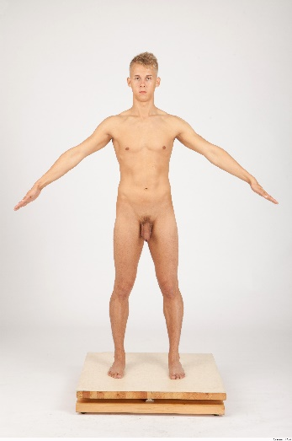 | 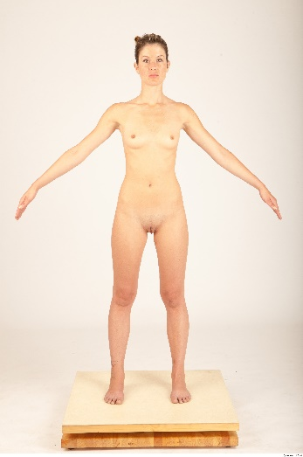
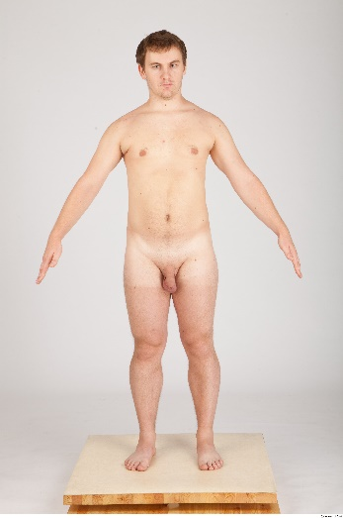 | 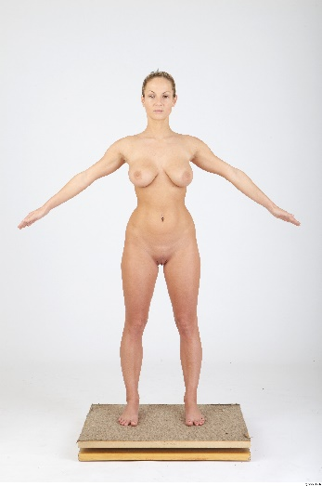
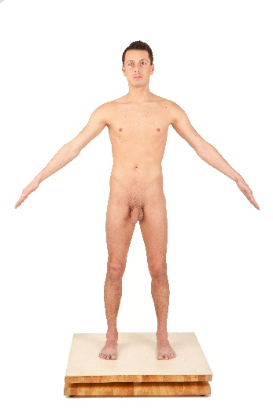 | 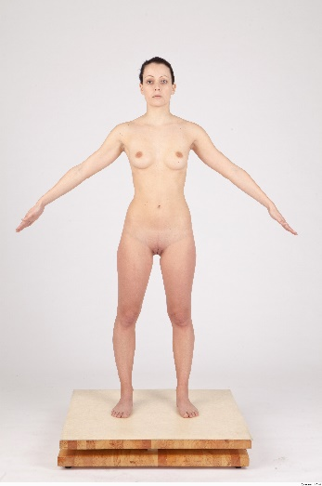
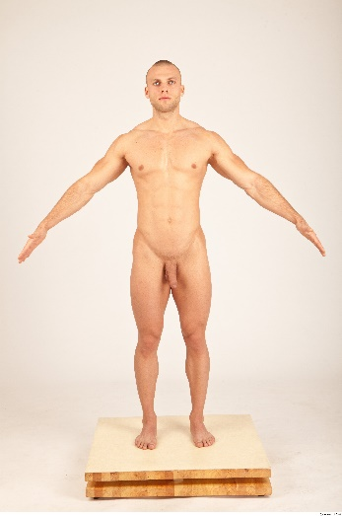 | 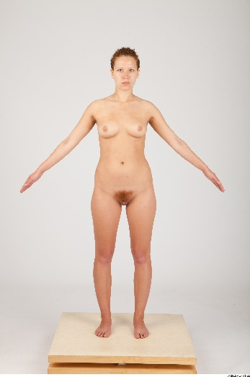
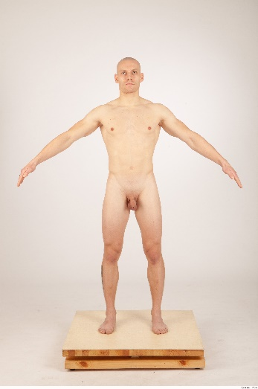 | 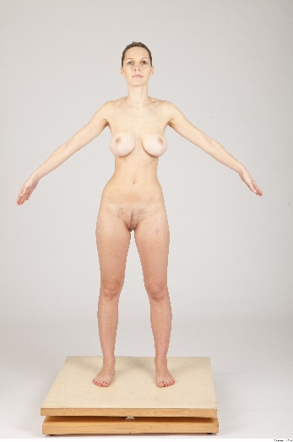
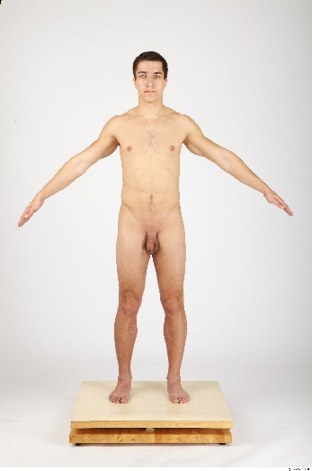 | 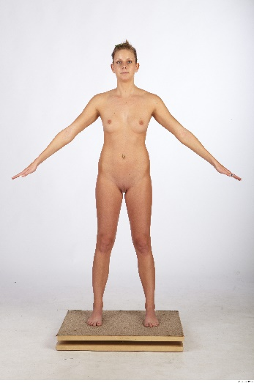
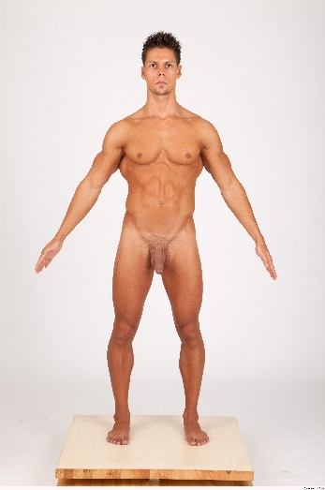 | 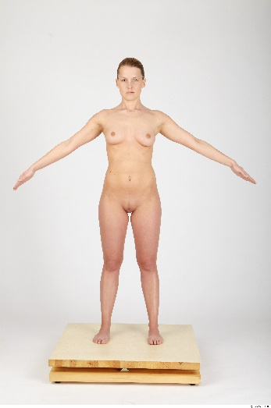
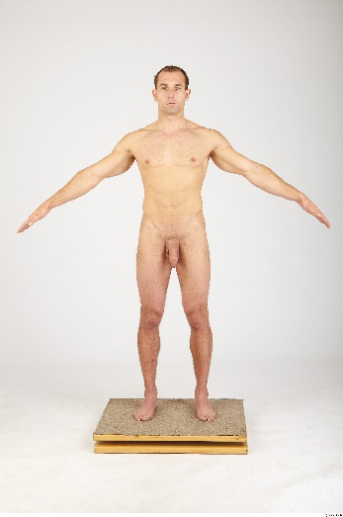 | 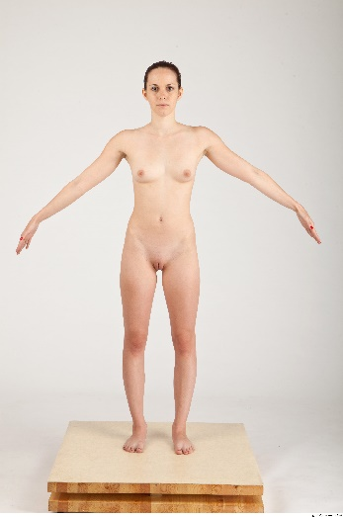
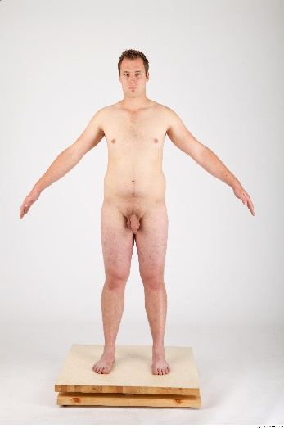 | 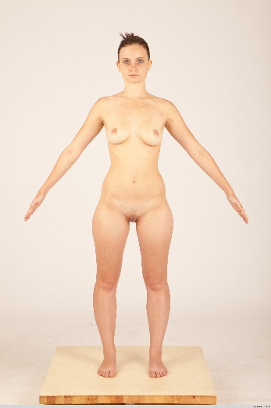
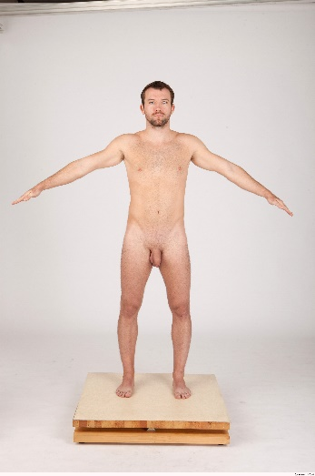 | 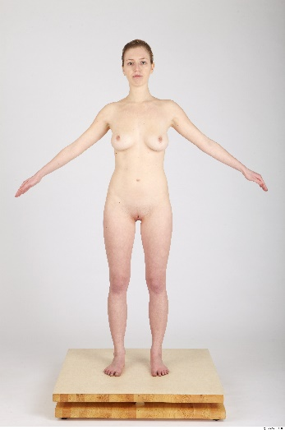
References
Federici, S., Lepri, A., & D’Urzo, E. (2020). Adult gender attribution test data: Raw data and spss regression outputs. ResearchGate. https://doi.org/10.13140/RG.2.2.30722.91840

