Table S1: Distribution of sexual orientation.
 | (n = 3558)
Variables | Missingness
Variables | n | %
Age | 0 | 0.00
Sex | 0 | 0.00
Same-sex attraction (number) | 53 | 1.50
Same-sex attraction (frequency) | 58 | 1.60
Same-sex behaviour (number) | 62 | 1.70
Same-sex behaviour (frequency) | 61 | 1.70
CGN – Item 1 | 25 | 0.70
CGN – Item 2 | 23 | 0.60
CGN – Item 3 | 33 | 0.90
CGN – Item 4 | 21 | 0.60
CGN – Item 5 | 35 | 1.00
CGN – Item 6 | 32 | 0.90
CGN – Item 7 | 28 | 0.80
CGN – Item 8 | 42 | 1.20
CGN – Item 9 | 22 | 0.60
CGN – Item 10 | 29 | 0.80
CGN – Item 11 | 43 | 1.20
CGN – Item 12 | 65 | 1.80
CGN – Item 13 | 53 | 1.50
ELA – Item 1 | 17 | 0.50
ELA – Item 2 | 20 | 0.60
ELA – Item 3 | 24 | 0.70
ELA – Item 4 | 18 | 0.50
ELA – Item 5 | 20 | 0.60
ELA – Item 6 | 24 | 0.70
ELA – Item 7 | 14 | 0.40
ELA – Item 8 | 17 | 0.50
ELA – Item 9 | 20 | 0.60
ELA – Item 10 | 21 | 0.60
ELA – Item 11 | 16 | 0.40
ELA – Item 12 | 19 | 0.50
ELA – Item 13 | 20 | 0.60
ELA – Item 14 | 19 | 0.50
ELA – Item 15 | 24 | 0.70
ELA – Item 16 | 16 | 0.40
ELA – Item 17 | 32 | 0.90
ELA – Item 18 | 23 | 0.60
ELA – Item 19 | 18 | 0.50
ELA – Item 20 | 28 | 0.80
ELA – Item 21 | 15 | 0.40
ELA – Item 22 | 15 | 0.40
ELA – Item 23 | 20 | 0.60
ELA – Item 24 | 17 | 0.50
ELA – Item 25 | 15 | 0.40

CGN – Childhood Gender Nonconformity, ELA – Early-Life Adversity
Table S2: Within-person and cross-twin correlations of study variables with 95% confidence intervals per sex and zygosity groups.

 | Male |  |  | Female
 | ELA (1) | CGN (2) | SO (3) | ELA (1) | CGN (2) | SO (3)
Within person
(1) | 1 |  |  | 1
(2) | 0.13  (0.07, 0.19) | 1 |  | 0.15  (0.11, 0.20) | 1
(3) | 0.11  (0.00, 0.22) | 0.43  (0.35, 0.51) | 1 | 0.27  (0.19, 0.34) | 0.21  (0.13, 0.29) | 1
Cross-twin
Monozygotic
(1) | 0.45  (0.27, 0.58) |  |  | 0.68  (0.62, 0.74)
(2) | 0.09  (-0.02, 0.21) | 0.44  (0.26, 0.57) |  | 0.11  (0.04, 0.17) | 0.51  (0.42, 0.59)
(3) | -0.01  (-0.26, 0.24) | 0.14  (-0.10, 0.36) | -0.16  (-0.85, 0.64) | 0.22  (0.09, 0.33) | 0.23  (0.10, 0.36) | 0.67  (0.36, 0.86)
Dizygotic
(1) | 0.28  (0.10, 0.43) |  |  | 0.47  (0.37, 0.55)
(2) | 0.10  (-0.04, 0.23) | 0.24  (0.00, 0.42) |  | 0.09  (0.01, 0.17) | 0.08  (-0.04, 0.20)
(3) | 0.31  (0.05, 0.54) | 0.29  (-0.03, 0.52) | 0.62  (-0.88, 0.92) | 0.03  (-0.12, 0.17) | -0.09  (-0.25, 0.07) | 0.12  (-0.28, 0.48)
Dizygotic opposite-sex
(1) | 0.17  (0.03, 0.30)
(2) | 0.01  (-0.09, 0.11) | -0.13  (-0.27, 0.01)
(3) | 0.15  (-0.03, 0.32) | 0.02  (-0.18, 0.21) | -0.07  (-0.59, 0.46)

ELA: Early-life adversities, CGN: Childhood gender nonconformity, SO: Sexual orientation.

Figure S1: Moderation of the phenotypic variance-covariance relationship between childhood gender nonconformity (CGN) and sexual orientation (SO) by CGN (a and b) and early-life adversity (ELA, c, d and e). Changes in unstandardized SO-CGN variances and covariance are plotted as functions of moderators (CGN and ELA).

Moderator | Variance of  childhood gender nonconformity | Covariance of sexual orientation  and childhood gender nonconformity | Variance of  sexual orientation
Childhood Gender Nonconformity |  | 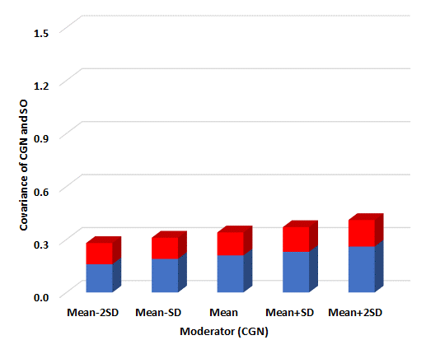 | 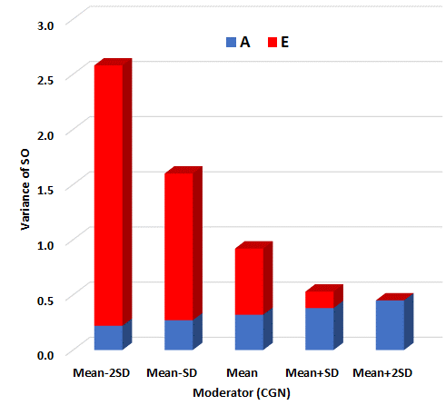
Early-Life Adversities | 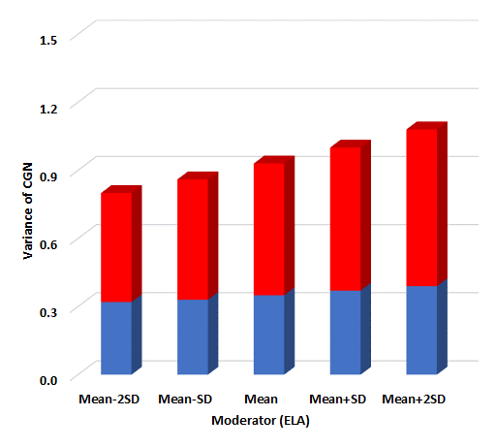 | 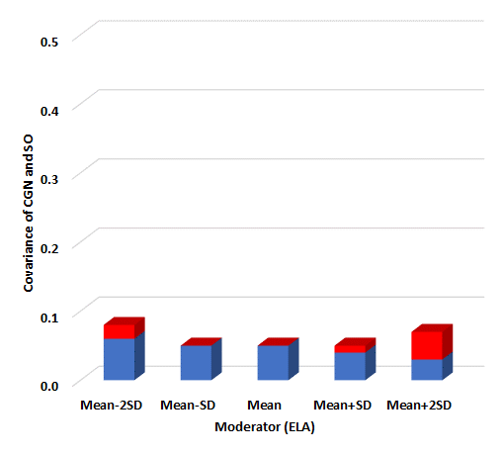 | 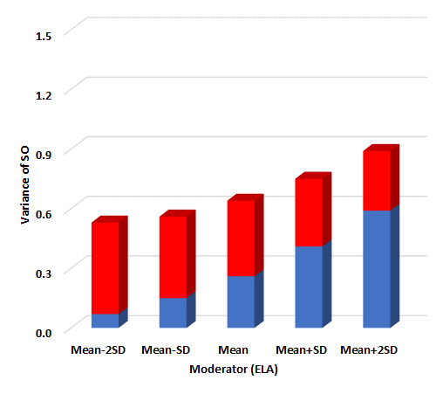

Figure S2: Moderation of covariance between childhood gender nonconformity (CGN) and sexual orientation (SO) and variance in SO by CGN (a and b respectively) and early-life adversity (ELA, c and d respectively). Changes in unstandardized SO-CGN covariance and SO variance are plotted as functions of moderators (CGN and ELA). A, and E: Additive genetic and Non-shared environmental components respectively.

