Appendix

Figure A1
Flowchart of responses through the study
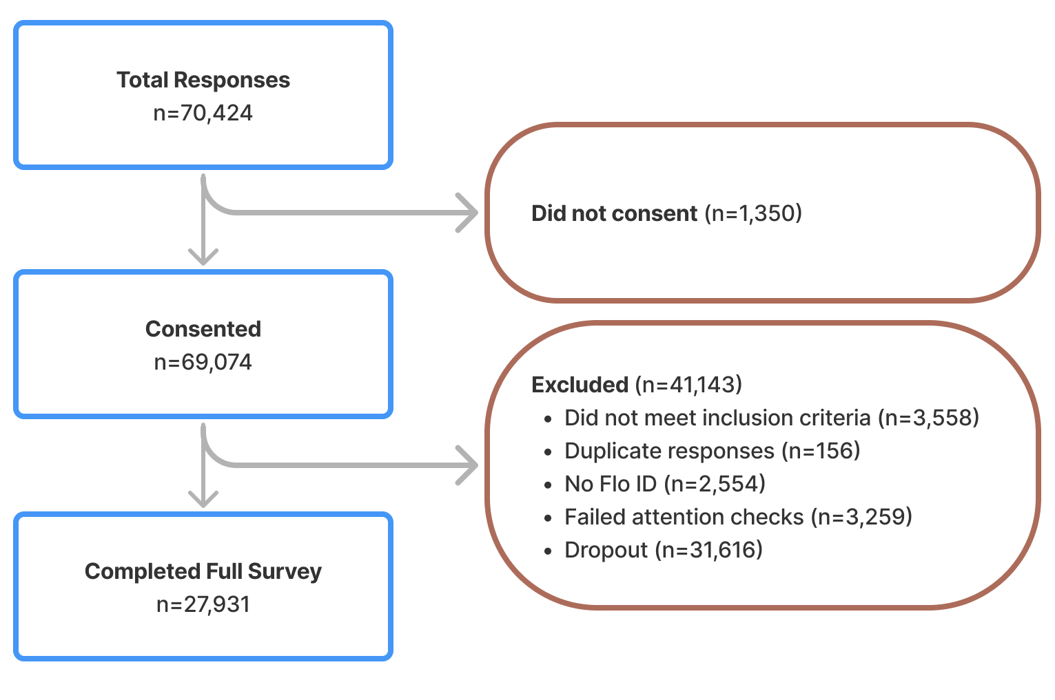

Table A1

Satisfaction and orgasm frequency scores from responses to the satisfaction with overall sex life and orgasm frequency questions

 | Overall (N=27931)
Satisfaction score
N-Miss | 1826
Mean (SD) | 3.597 (1.225)
Range | 1.000 - 5.000
Orgasm frequency score
N-Miss | 1553
Mean (SD) | 3.645 (1.445)
Range | 0.000 - 5.000

Note. SD = Standard Deviation.

Table A2

Pearson correlation matrix for supplementary material

 | Satisfaction | Overall Orgasm Frequency | Partnered score | Solo score | Partnered count | Solo count | Partnered orgasm frequency | Solo orgasm frequency
Satisfaction | 1
Overall Orgasm Frequency | 0.376*** | 1
Partnered score | 0.350*** | 0.498*** | 1
Solo score | 0.029*** | 0.052*** | 0.176*** | 1
Partnered count | 0.271*** | 0.260*** | 0.186*** | -0.011 | 1
Solo count | 0 | 0.068*** | -0.006 | -0.093*** | 0.344*** | 1
Partnered orgasm frequency | 0.252*** | 0.330*** | 0.264*** | -0.018** | 0.191*** | 0.077*** | 1
Solo orgasm frequency | -0.066*** | -0.071*** | -0.068*** | 0.105*** | -0.005 | 0.072*** | 0.452*** | 1
Note. *** p<.001; ** p<.01; * p<.05

