Table 1A. Seismic stations considered in this study with their station Vs30
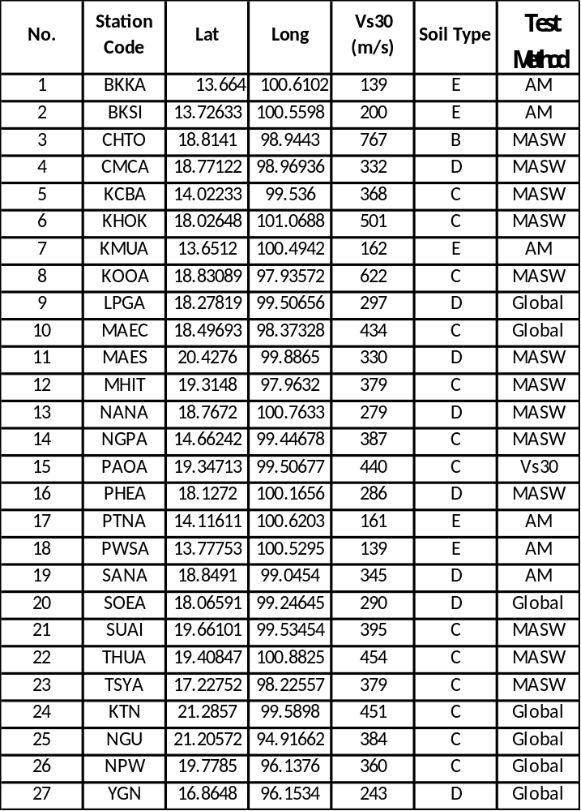
Remark: array microtremor (AM), Multichannel Analysis of Surface Waves (MASW), USGS Global Vs30 (Global)
BKKA EW
KMUA EW
PWSA EW
PTNA EW
Figure 1A Acceleration, Velocity of PWSA, BKKA, KMUA, PTNA stations in North, East directions

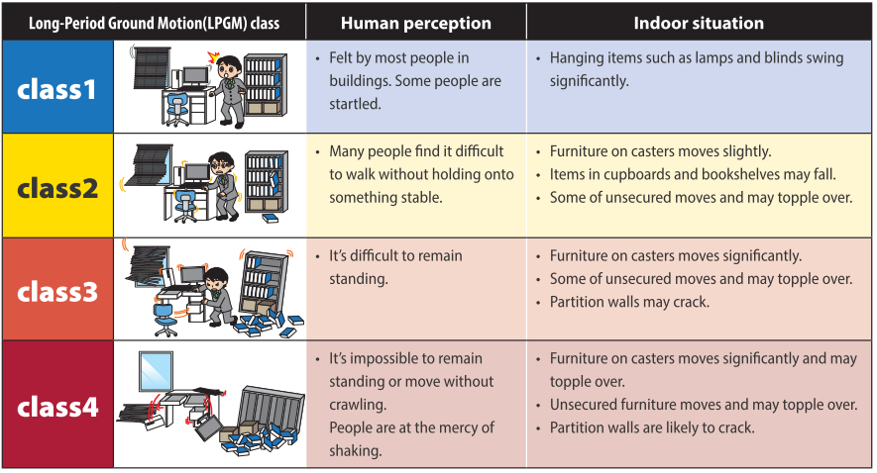

Figure 2A. Definition of the JMA Intensity Scale for Long-Period Ground Motion (JMA, 2025)

Figure 3A. Distribution of the JMA Intensity Scale for Long-Period Ground Motion after the 2011 Tohoku Earthquake (JMA, 2025)

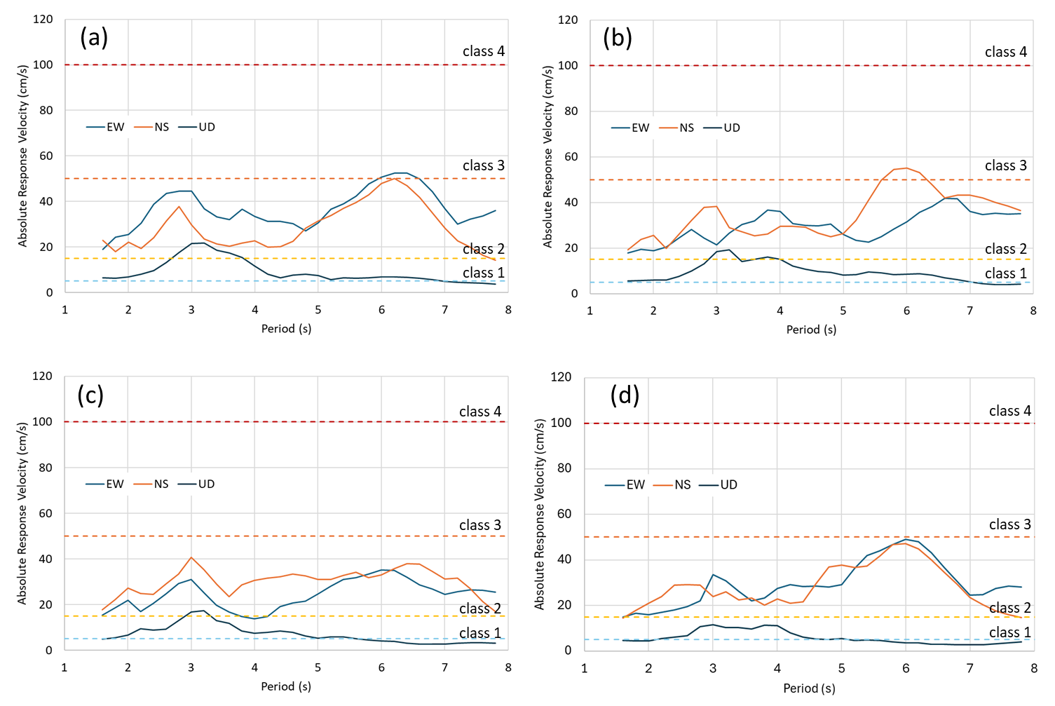
Figure 4A. Absolute velocity response spectra with 5% damping at (a) PWSA, (b) BKSI, (c) KMUA, and (d) BKKA, with threshold values for the JMA Intensity Scale for Long-Period Ground Motion

