Annex
Table A 1: SYNER-G taxonomy for masonry buildings.
Category |  |  | Classification
Force Resisting Mechanism | FRM | Bearing Walls (BW) | Out of plane (OP); In plane (IP) [Equivalent Frame (EF), Weak Spandrels Strong Piers (WSSP), Strong Spandrels Weak Piers (SSWP)]
Force Resisting Mechanism Material | FRMM | Unreinforced Masonry (URM) | Blocks: Adobe (A); Fired brick (FB); Soft Stone (SS); Hard Stone (HS) [Regular Cut (RC), Uncut (UC), Rubble (RU)]; Hollow clay tile (HC) [High % of voids (H%), Low % of voids (L%), Concrete Masonry Unit (CMU), Autoclaved Aerated Concrete (AAC)]. Mortar: Lime mortar (LM); Cement mortar (CM); Mud mortar (MM); Hydraulic mortar (HM). Strengthening: Strengthened masonry (Sm) Timber: Confined and braced masonry panels (TC); Horizontal timber tie (TT) Concrete and reinforcement: [Average Strength (20-50 MPa)(ASC), Low Strength (<20 MPa) (LSC)]; [Vertical Reinforcement Bars (RBV), Vertical and Horizontal Reinforcement Bars (RBVH)]
Force Resisting Mechanism Material | FRMM | Reinforced Masonry (RM)
Force Resisting Mechanism Material | FRMM | Confined Masonry (CM)
Force Resisting Mechanism Material | FRMM | Timber-framed Masonry (TM)
Force Resisting Mechanism Material | FRMM | Mixed Masonry-RC (MRC)
Plan | P | Regular (R) | Isolated (I), Aggregate (A)
Plan | P | Irregular (IR) | Isolated (I), Aggregate (A)
Elevation | E | Regular geometry (R)
Elevation | E | Irregular geometry (IR)
Cladding & Openings | CO | Regular openings (RO) | High % voids (H%), Low % voids (L%)
Cladding & Openings | CO | Irregular openings (IRO) | High % voids (H%), Low % voids (L%)
Details and Maintenance | DM | Details: High quality details (HQD), Low quality details (LQD) Maintenance: Good Maintenance (HM), Low Maintenance (LM) | Tie rods: Without tie rods (WoT); With tie rods (WT) Ring beams: Without ring beams (WoRB); With ring beams (WRB)
Floor System | FS | Rigid (R) | Reinforced concrete (RC); Steel (S); Timber (T); Vault (V)
Floor System | FS | Flexible (F) | Reinforced concrete (RC); Steel (S); Timber (T); Vault (V)
Roof System | RS | Peaked (P) | Material: Timber (Ti); Corrugated Metal Sheet (CMS); Reinforced Concrete (RC); Thatch (Th); Thrusting roof (Tr); Unthrusting roof (UTr)
Roof System | RS | Flat (F)
Roof System | RS | Gable End Walls
Height Level | HL | Low-rise (1–2) (L)
Height Level | HL | Mid-rise (3–5) (M)
Height Level | HL | High-rise (6–7) (H)
Height Level | HL | Tall (8+) (Ta)
Code Level | CL | Pre-Code (PC) | Pre-code Aseismic Construction: Low Level (LAC); Moderate Level (MAC); High Level (HAC)
Code Level | CL | None (NC)
Code Level | CL | Low (<0.1 g) (LC)
Code Level | CL | Moderate (0.1–0.3 g) (MC)
Code Level | CL | High (>0.3 g) (HC)

Table A 2: Characteristics of urban sectors of Sanremo Municipality, showing the Force Resisting Mechanism Material (FRMM) combination, the Height Level (HL), and the percentage distribution of Details and Maintenance (DM) and Floor System (FS) types, as recorded in the CARTIS sheets.
Urban sector | FRMM | DM |  | FS |  |  | HL
Urban sector | FRMM | LQD | HQD | F | R | V | HL
1 - Centro storico | URM-HS-RU | 70% | 30% | 40% |  | 60% | M (3)
2 - Espansione 1800 | URM-HS-UC | 20% | 80% | 70% |  | 30% | H (6)
3 - Bussana Nuova | URM-HS-RU | 20% | 80% | 20% | 80% | 0% | L (1) - M (3)
4 - Poggio | URM-HS-RU | 20% | 80% | 30% | 20% | 50% | L (2) - M (3)
5 - Coldirodi | URM-HS-RU | 20% | 80% | 25% | 25% | 50% | M (3, 4)
8 - San Romolo | URM-HS-RU | 90% | 10% | 70% |  | 30% | L (2)
11 - Case sparse | URM-HS-RU | 90% | 10% | 70% |  | 30% | L (2)
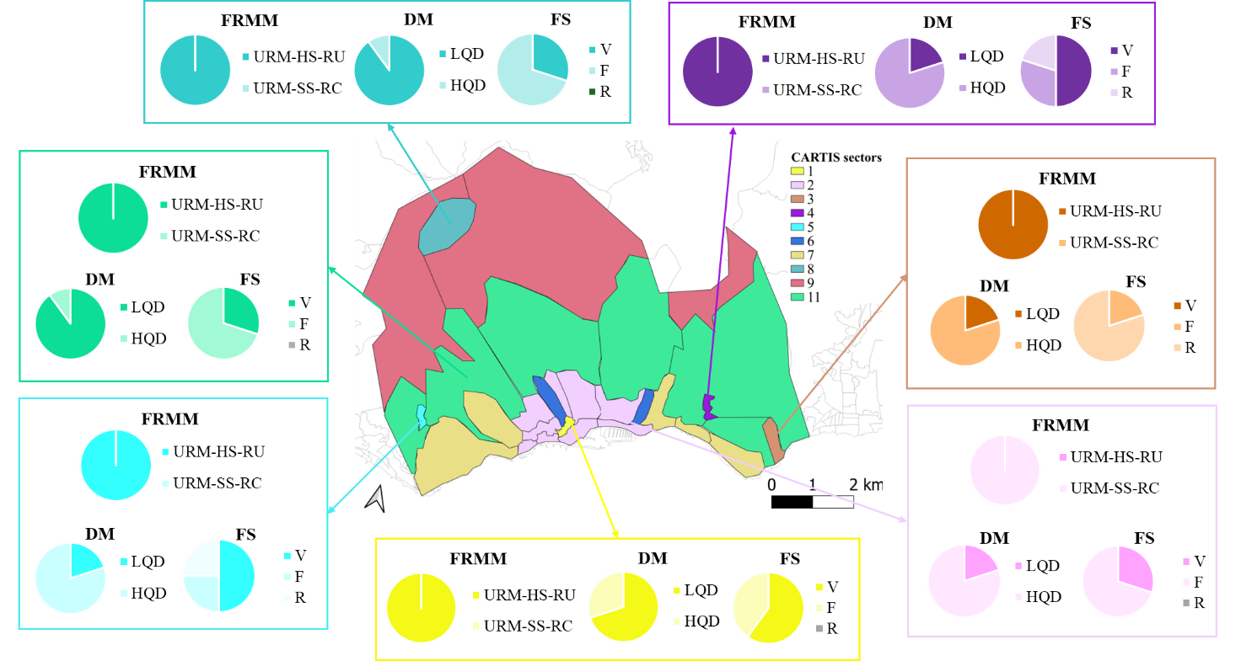
Figure A 1: Subdivision of the Municipality of Sanremo into urban sectors, with pie charts within masonry-containing sectors illustrating the distribution of FRMM, DM, and FS typologies.

Table A 3: Subtypologies of the analytical-mechanical model for the urban sector. The most common features characterizing the built environment of the Municipality of Sanremo are highlighted in orange.
FRMM |  | DM |  | FS |  | HL
1 | Split Stone | 1 | LQD | 1 | Vaults | 1 | 1 storey
2 | Regular Soft Stone | 2 | HQD-TR | 2 | Flexible | 2 | 2 storeys
3 | Blocks | 3 | HQD-RB | 3 | Semi-rigid | 3 | 3 storeys
4 | Bricks |  |  | 4 | Rigid | 4 | 4+ storeys
5 | Semi-solid Bricks
6 | Modern Masonry
7 | Fragile Blocks
8 | Rubble Stone
9 | Ashlar
10 | Irregular Soft Stone

Table A 4: Percentage distribution of the 48 prevalent FRMM-DM-FS combinations in Sanremo across specific sectors.
FRMM | DM | FS | HL | Sector 1 | Sector 2 | Sector 3 | Sector 4 | Sector 5 | Sector 8,11
Stone | LQD | V | 1
Stone | LQD | F | 1 |  |  | 1%
Stone | LQD | SR | 1 |  |  | 4%
Ashlar | LQD | V | 1
Ashlar | LQD | F | 1 |  |  | 1%
Ashlar | LQD | SR | 1 |  |  | 4%
Stone | HQD-TR | V | 1
Stone | HQD-TR | F | 1 |  |  | 4%
Stone | HQD-TR | SR | 1 |  |  | 16%
Ashlar | HQD-TR | V | 1
Ashlar | HQD-TR | F | 1 |  |  | 4%
Ashlar | HQD-TR | SR | 1 |  |  | 16%
Stone | LQD | V | 2 |  |  |  | 2.50% |  | 13.50%
Stone | LQD | F | 2 |  |  |  | 1.50% |  | 31.50%
Stone | LQD | SR | 2 |  |  |  | 1%
Ashlar | LQD | V | 2 |  |  |  | 2.50% |  | 13.50%
Ashlar | LQD | F | 2 |  |  |  | 1.50% |  | 31.50%
Ashlar | LQD | SR | 2 |  |  |  | 1%
Stone | HQD-TR | V | 2 |  |  |  | 10% |  | 1.50%
Stone | HQD-TR | F | 2 |  |  |  | 6% |  | 3.50%
Stone | HQD-TR | SR | 2 |  |  |  | 4%
Ashlar | HQD-TR | V | 2 |  |  |  | 10% |  | 1.50%
Ashlar | HQD-TR | F | 2 |  |  |  | 6% |  | 3.50%
Ashlar | HQD-TR | SR | 2 |  |  |  | 4%
Stone | LQD | V | 3 | 21% |  |  | 2.50% | 2.50%
Stone | LQD | F | 3 | 14% |  | 1% | 1.50% | 1.25%
Stone | LQD | SR | 3 |  |  | 4% | 1% | 1.25%
Ashlar | LQD | V | 3 | 21% |  |  | 2.50% | 2.50%
Ashlar | LQD | F | 3 | 14% |  | 1% | 1.50% | 1.25%
Ashlar | LQD | SR | 3 |  |  | 4% | 1% | 1.25%
Stone | HQD-TR | V | 3 | 9% |  |  | 10% | 10%
Stone | HQD-TR | F | 3 | 6% |  | 4% | 6% | 5%
Stone | HQD-TR | SR | 3 |  |  | 16% | 4% | 5%
Ashlar | HQD-TR | V | 3 | 9% |  |  | 10% | 10%
Ashlar | HQD-TR | F | 3 | 6% |  | 4% | 6% | 5%
Ashlar | HQD-TR | SR | 3 |  |  | 16% | 4% | 5%
Stone | LQD | V | 4+ |  |  |  |  | 2.50%
Stone | LQD | F | 4+ |  |  |  |  | 1.25%
Stone | LQD | SR | 4+ |  |  |  |  | 1.25%
Ashlar | LQD | V | 4+ |  | 6% |  |  | 2.50%
Ashlar | LQD | F | 4+ |  | 14% |  |  | 1.25%
Ashlar | LQD | SR | 4+ |  |  |  |  | 1.25%
Stone | HQD-TR | V | 4+ |  |  |  |  | 10%
Stone | HQD-TR | F | 4+ |  |  |  |  | 5%
Stone | HQD-TR | SR | 4+ |  |  |  |  | 5%
Ashlar | HQD-TR | V | 4+ |  | 24% |  |  | 10%
Ashlar | HQD-TR | F | 4+ |  | 56% |  |  | 5%
Ashlar | HQD-TR | SR | 4+ |  |  |  |  | 5%

