Supplementary Material
Supplementary material for the paper “Modelling building exposure in Java, Indonesia for use in Seismic Risk Assessment” by Rikki Weber, Phil Cummins, Vitor Silva and Mark Edwards.
Table S1 Mapping sub-categories of enterprises in the Economic Census to a taxonomy for large-scale enterprises. Taxonomies listed use the GEM taxonomy (see Silva et al., 2022). Some sub-categoreis map to different building types depending on whether the enterprise in located in a kota (city) or in a kabupaten (regency). This is indicated in brackets where relevant.
Sector | Building Class | Size sub-classification | Taxonomy*
Mining, waste management and water management | Factory | Small | S/LFM-DUL/H:1
Mining, waste management and water management | Factory | Medium | C/LFM-DUL/H:1
Mining, waste management and water management | Factory | Large | CR/PC/LFM-DUL/H:1  CR/PC/LFM-DUL/H:2
Processing and manufacturing | Factory | Small | S/LFM-DUL/H:1
Processing and manufacturing | Factory | Medium | CR/PC/LFM-DUL/H:1
Processing and manufacturing | Factory | Large | CR/PC/LFM-DUL/H:2
Construction | Warehouse | Small | S/LFM-DUL/H:1
Construction | Warehouse | Medium | S/LFM-DUL/H:1
Construction | Warehouse | Large | CR/LDUAL/DUM/HBET:6-12  CR/LDUAL/DUM/HBET:13+
Transportation | Warehouse | Small | S/LFM-DUM/H:1
Transportation | Warehouse | Medium | S/LFM-DUM/H:1
Transportation | Warehouse | Large | S/LFM-DUM/H:1
Scientific and technical services | Low-rise office building | Small | MCF/LWAL-DUM/H:2
Scientific and technical services | Low-rise office building | Medium | CR/LFINF-DUM/HBET:3-5
Scientific and technical services | Low-rise office building | Large | CR/LFINF-DUM/HBET:3-5
Hospitality | Hotels and restaurants | Restaurant | CR+PC/LFM/H:1 (kota)  MCF/LWAL-DUM/H:1 (kabu)
Hospitality | Hotels and restaurants | Small hotel | CR/LDUAL-DUH/HBET:6-12 (kota)  CR/LFINF-DUM/HBET:3-5 (kabu)
Hospitality | Hotels and restaurants | Large hotel | CR/LDUAL-DUH/HBET:13+ (kota)  CR/LFINF/DUM/HBET:3-5 (kabu)
Retail, ICTIS, insurance, finance, real estate | Office/retail building | Small (shop or office in a shared building) | CR/LDUAL-DUH/HBET:6-12 (kota)
Retail, ICTIS, insurance, finance, real estate | Office/retail building | Small (individual shop or office) | MCF/LWAL-DUL/H:1 (kabu)
Retail, ICTIS, insurance, finance, real estate | Office/retail building | Medium (shop or office in a shared building) | CR/LDUAL/DUM/H:6-12 (kota)
Retail, ICTIS, insurance, finance, real estate | Office/retail building | Medium (individual shop or office) | CR/LFINF-DUM/HBET:3-5 (kabu)
Retail, ICTIS, insurance, finance, real estate | Office/retail building | Large (one enterprise in building) | CR/LDUAL/DUM/HBET:13+ (kota)  CR/DUAL/DUM/H:6-12 (kabu)
*S=steel, CR=reinforced concrete, MCF= confined masonry, PC=precast concrete, LFM=moment frame, LWAL=wall, LDUAL= dual frame wall system, DUL= low ductility, DUM = moderate ductility, DUH=high ductility, H: = height, HBET: = height range.
Table S2 Mapping sub-categories of enterprises in the Economic Census to a taxonomy for small-scale enterprises. Taxonomies listed use the GEM taxonomy (see Silva et al., 2022).
Sector | Building Class | Location | Taxonomy*
Mining, waste management and water management | Warehouse | Kota | S/LFM-DUL/H:1
Mining, waste management and water management | Warehouse | Urban | S/LFM-DUL/H:1
Mining, waste management and water management | Warehouse | Rural | MUR/LWAL/CL99-DNO/H:1
Processing and manufacturing | warehouse | Kota | S/LFM-DUL-H:1
Processing and manufacturing | warehouse | Urban | S/LFM-DUL/H:1
Processing and manufacturing | warehouse | Rural | MUR/LWAL/CL99-DNO/H:1
Construction | warehouse | Kota | S/LFM-DUL/H:1
Construction | warehouse | Urban | S/LFM-DUL/H:1
Construction | warehouse | Rural | MUR/LWAL/CL99-DNO/H:1
Transportation | warehouse | Kota | S/LFM-DUL/H:1
Transportation | warehouse | Urban | S/LFM-DUL/H:1
Transportation | warehouse | Rural | MUR/LWAL-DNO/H:1
Scientific and technical services | office | Kota | CR/LFINF-DUM/HBET:3-5
Scientific and technical services | office | Urban | MCF/LWAL-DUM/H:1
Scientific and technical services | office | Rural | MUR/LWAL/CL99-DNO/H:1
Hospitality | Accommodation or restaurant | Kota | CR/LFINF-DUM/HBET:3-5
Hospitality | Accommodation or restaurant | Urban | MCF/LWAL-DUM/H:2
Hospitality | Accommodation or restaurant | Rural | W/LFM-DUM/H:1
Retail | Shop | Kota | CR/PC/LFM-DUM/H:2
Retail | Shop | Urban | MCF/LWAL-DUM/H:1
Retail | Shop | Rural | MCF/LWAL-DUL/H:1
ICTIS, Insurance & Financial Servies, Real estate | Office | Kota | CR/LFINF-DUM/HBET:3-5
ICTIS, Insurance & Financial Servies, Real estate | Office | Urban | MCF/LWAL-DUM/H:1
ICTIS, Insurance & Financial Servies, Real estate | Office | Rural | MCF/LWAL-DUL/H:1
*S=steel, CR=reinforced concrete, MCF= confined masonry, MUR=unreinforced masonry, PC=precast concrete, CL99=clay fired brick, LFM=moment frame, LWAL=wall, LDUAL= dual frame wall system, DUL= low ductility, DUM = moderate ductility, DUH=high ductility, DNO=non-ductile, H: = height, HBET: = height range.

Table S3 Mapping scheme for school buildings in Java, based on the height and the poverty rate (percentage of population living below the poverty line). The taxonomy used is the GEM taxonomy (see Silva et al., 2022).
Height | Poverty Rate | Taxonomy* | Comments
One story | All | MUR/LWAL/CL99-DNO/H:1 | These are located across Java in rural settings
One story | <10% | MCF/LWAL-DUH/H:1 | These are located across Java in urban settings.
 | 10-25% | MCF/LWAL-DUM/H:1 | These are located across Java in urban settings.
 | >25% | MCF/LWAL-DUL/H:1 | These are located across Java in urban settings.
Two story | <20% | MCF/LWAL-DUM/H:2 | These are located across Java in both rural and urban settings.
Two story | >20% | MCF/LWAL-DUL/H:2
Three story | <10% | CR/LFINF-DUH/H:3 | These are located across Java, typically in more urban settings.
Three story | 10-25% | CR/LFINF-DUM/H:3
Three story | >25% | CR/LFINF-DUL/H:3
Three to eight story | <10% | CR/LFINF-DUH/HBET:3-8 | These are located in cities, predominantly in DKI Jakarta.
Three to eight story | 10-25% | CR/LFINF-DUM/HBET:3-8 | These are located in cities, predominantly in DKI Jakarta.
Three to eight story | >10% | CR/LFINF-DUL/HBET:3-8 | These are located in cities, predominantly in DKI Jakarta.
* MUR= unreinforced masonry, MCF= confined masonry, CR= reinforced concrete, LWAL = wall, LFINF= infilled wall, LDUAL=dual system wall, DNO=non ductile, DUL = low ductility, DUM = moderate ductility, DUH = high ductility, H: = height, HBET: = height range.

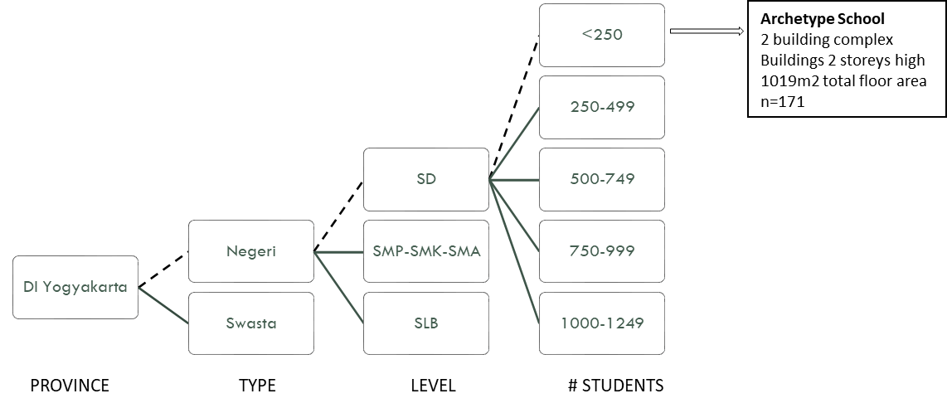
Fig S1 An example of the definition of archtype schools which are used to define the floor area, the number of buildings that comprise a school, and the height of the buildings (before harmonisation with the GHSL building height model).
Table S4 Mapping scheme for hospital buildings in Java, based on the height and the poverty rate (percentage of population living below the poverty line). The taxonomy used is the GEM taxonomy (see Silva et al., 2022).
Hospital Class | Setting | Height | Taxonomy*
BD | All | 1-2 | MCF/LWAL/DUM
A | All | <10 | CR/LFM-DUH
A | All | >10 | CR/LDUAL-DUH
B | kota | <10 | CR/LFM/DUH
B | kabupaten | <10 | CR/LFM/DUM
B | All | >10 | CR/LDUAL-DUH
C | DKI Jakarta, Kota Semarang, Kota Surabaya, Kota Bandung | <10 | CR/LFM-DUH
C | Everywhere else | <10 | CR/LFM-DUM
 | All | >10 | CR/LDUAL-DUH
D | DKI Jakarta, Kota Semarang, Kota Surabaya, Kota Bandung | <10 | CR/LFM-DUM
D | Everywhere else | <10 | CR/LFM-DUL
* MCF=confined masonry, CR=reinforced concrete, LFM=moment frame, LDUAL=dual system wall, DUL = low ductility, DUM=moderate ductility, DUH=high ductility.

