APPENDIX
Table S1: Estimated fractional exceedance areas (%) for Greece based on three intensity measures (IMs) computed using the greater-of-two-horizontal components, as typically reported in USGS ShakeMaps, for two return periods (RP) according to the ESHM20 hazard maps. Results are shown for earthquakes with minimum potency magnitude Mp ≥ 4.5 occurring during the period 1973–2022. For each intensity measure and aggregation level of the ESHM20 hazard model (mean, 16th, 50th, and 84th percentiles), the estimated fractional exceedance area is reported together with upper (+1σ) and lower (−1σ) bounds derived from ShakeMap uncertainty propagation. These bounds reflect the effect of ShakeMap uncertainty on exceedance mapping when using the greater-of-two-horizontals component definition and are provided for comparison with the RotD50-based results presented in the main text.
 |  |  | Fractional Exceedance Area (%)
RP = 475 yrs  Expected Fractional Area 10% | Intensity Measure | Aggregation Level | Estimated  (%) | Upper bound (+1σ) (%) | Lower bound  (–1σ) (%)
RP = 475 yrs  Expected Fractional Area 10% | PGA | Mean | 6.06 | 16.50 | 1.93
RP = 475 yrs  Expected Fractional Area 10% | PGA | 16th | 16.84 | 43.17 | 6.89
RP = 475 yrs  Expected Fractional Area 10% | PGA | 50th | 7.85 | 22.19 | 2.77
RP = 475 yrs  Expected Fractional Area 10% | PGA | 84th | 3.43 | 10.01 | 0.90
RP = 475 yrs  Expected Fractional Area 10% | Sa (0.3 s) | Mean | 5.38 | 19.38 | 1.27
RP = 475 yrs  Expected Fractional Area 10% | Sa (0.3 s) | 16th | 13.36 | 37.78 | 4.17
RP = 475 yrs  Expected Fractional Area 10% | Sa (0.3 s) | 50th | 6.78 | 22.73 | 1.62
RP = 475 yrs  Expected Fractional Area 10% | Sa (0.3 s) | 84th | 2.95 | 12.04 | 0.55
RP = 475 yrs  Expected Fractional Area 10% | Sa (1.0 s) | Mean | 7.79 | 28.07 | 2.09
RP = 475 yrs  Expected Fractional Area 10% | Sa (1.0 s) | 16th | 16.38 | 47.56 | 4.81
RP = 475 yrs  Expected Fractional Area 10% | Sa (1.0 s) | 50th | 9.30 | 31.63 | 2.46
RP = 475 yrs  Expected Fractional Area 10% | Sa (1.0 s) | 84th | 4.77 | 18.86 | 1.04
RP = 50 yrs  Expected Fractional Area 63.2% | Intensity Measure | Aggregation Level | Estimated  (%) | Upper bound (+1σ) (%) | Lower bound  (–1σ) (%)
RP = 50 yrs  Expected Fractional Area 63.2% | PGA | Mean | 56.27 | 94.74 | 23.31
RP = 50 yrs  Expected Fractional Area 63.2% | PGA | 16th | 89.25 | 99.84 | 51.81
RP = 50 yrs  Expected Fractional Area 63.2% | PGA | 50th | 65.08 | 97.13 | 28.25
RP = 50 yrs  Expected Fractional Area 63.2% | PGA | 84th | 35.64 | 79.41 | 13.94
RP = 50 yrs  Expected Fractional Area 63.2% | Sa (0.3 s) | Mean | 54.08 | 92.30 | 21.36
RP = 50 yrs  Expected Fractional Area 63.2% | Sa (0.3 s) | 16th | 78.36 | 98.23 | 38.09
RP = 50 yrs  Expected Fractional Area 63.2% | Sa (0.3 s) | 50th | 58.89 | 94.06 | 24.35
RP = 50 yrs  Expected Fractional Area 63.2% | Sa (0.3 s) | 84th | 39.05 | 81.08 | 13.77
RP = 50 yrs  Expected Fractional Area 63.2% | Sa (1.0 s) | Mean | 68.10 | 94.45 | 27.87
RP = 50 yrs  Expected Fractional Area 63.2% | Sa (1.0 s) | 16th | 83.58 | 98.16 | 46.48
RP = 50 yrs  Expected Fractional Area 63.2% | Sa (1.0 s) | 50th | 71.43 | 95.42 | 30.98
RP = 50 yrs  Expected Fractional Area 63.2% | Sa (1.0 s) | 84th | 52.94 | 88.22 | 18.45
Appendix Figures:

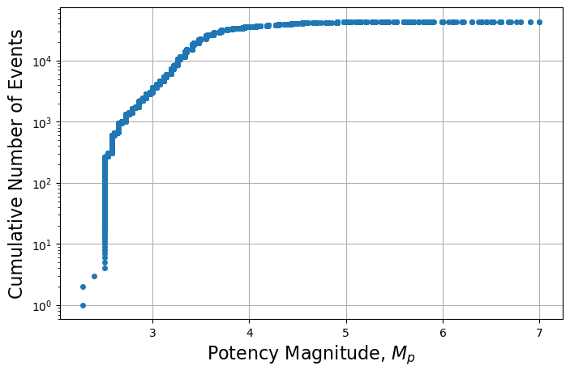
Figure S1. Cumulative frequency–magnitude distribution of the USGS ComCat catalogue used in this study for earthquakes occurring between January 1973 and December 2022 (43,196 events). A threshold potency magnitude of Mp ≥ 4.5 is adopted for the analyses, corresponding to the minimum magnitude above which ShakeMaps are generated, and exceedance statistics are evaluated.

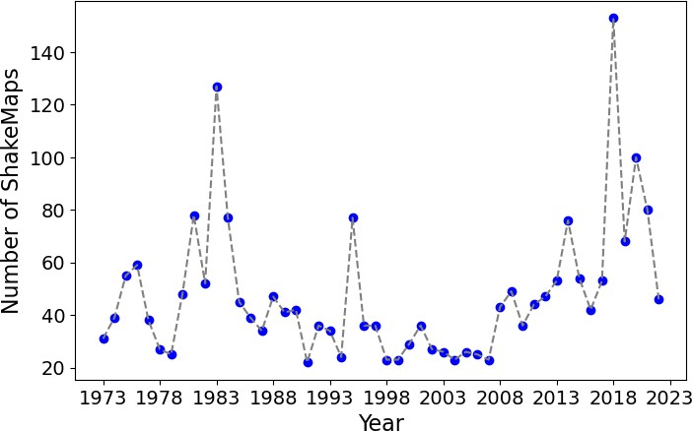
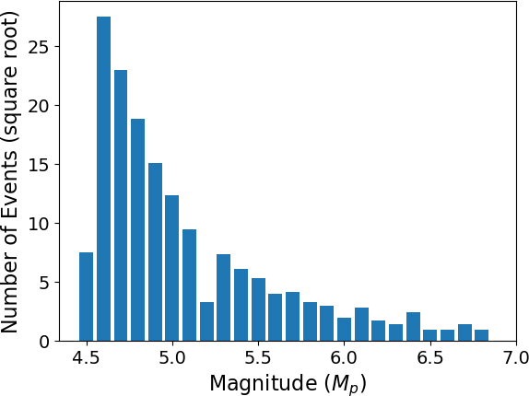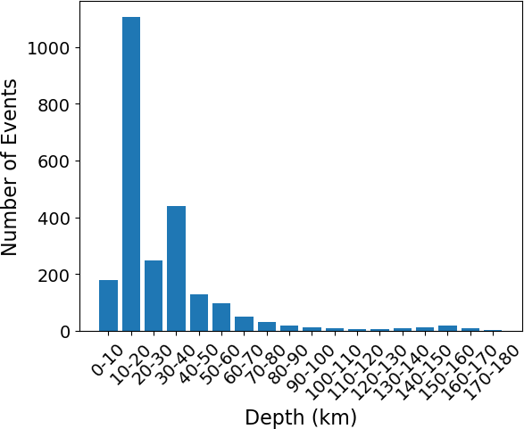
Figure S2. Distributions of the 2,617 ShakeMap footprints analysed in this study for the period January 1973 to December 2022: (a) potency magnitude (Mp), (b) focal depth, and (c) annual number of ShakeMaps. The magnitude distribution reflects the decreasing frequency of larger events, while the depth distribution is dominated by shallow earthquakes, with fewer intermediate-depth events. The annual counts illustrate temporal variability in ShakeMap availability over the study period.

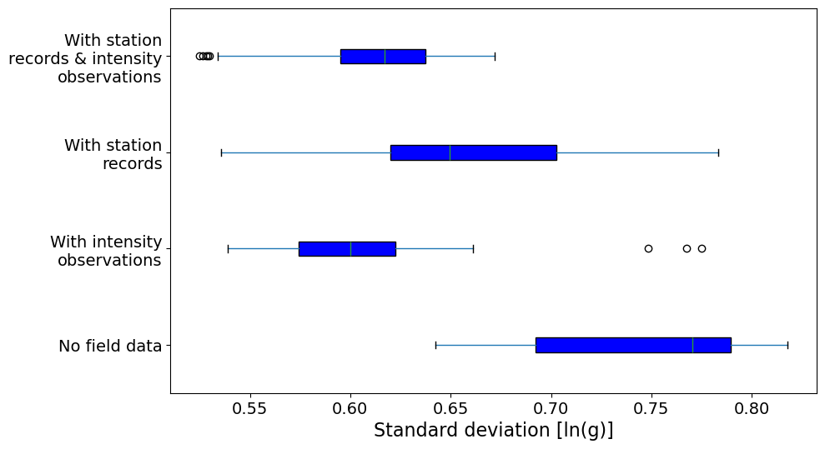
Figure S3. Boxplot representation of the distribution of the mean standard deviation of ShakeMap-derived peak ground acceleration (PGA), expressed in ln(g), across the 2,617 ShakeMap footprints analysed in this study. For each ShakeMap, the standard deviation is averaged over the spatial grid. Boxes indicate the interquartile range (25th–75th percentiles), the central line denotes the median, whiskers extend to 1.5 times the interquartile range, and circles represent outliers. Distributions are shown separately for ShakeMaps incorporating strong-motion station recordings and/or macroseismic intensity observations and for ShakeMaps without field data.

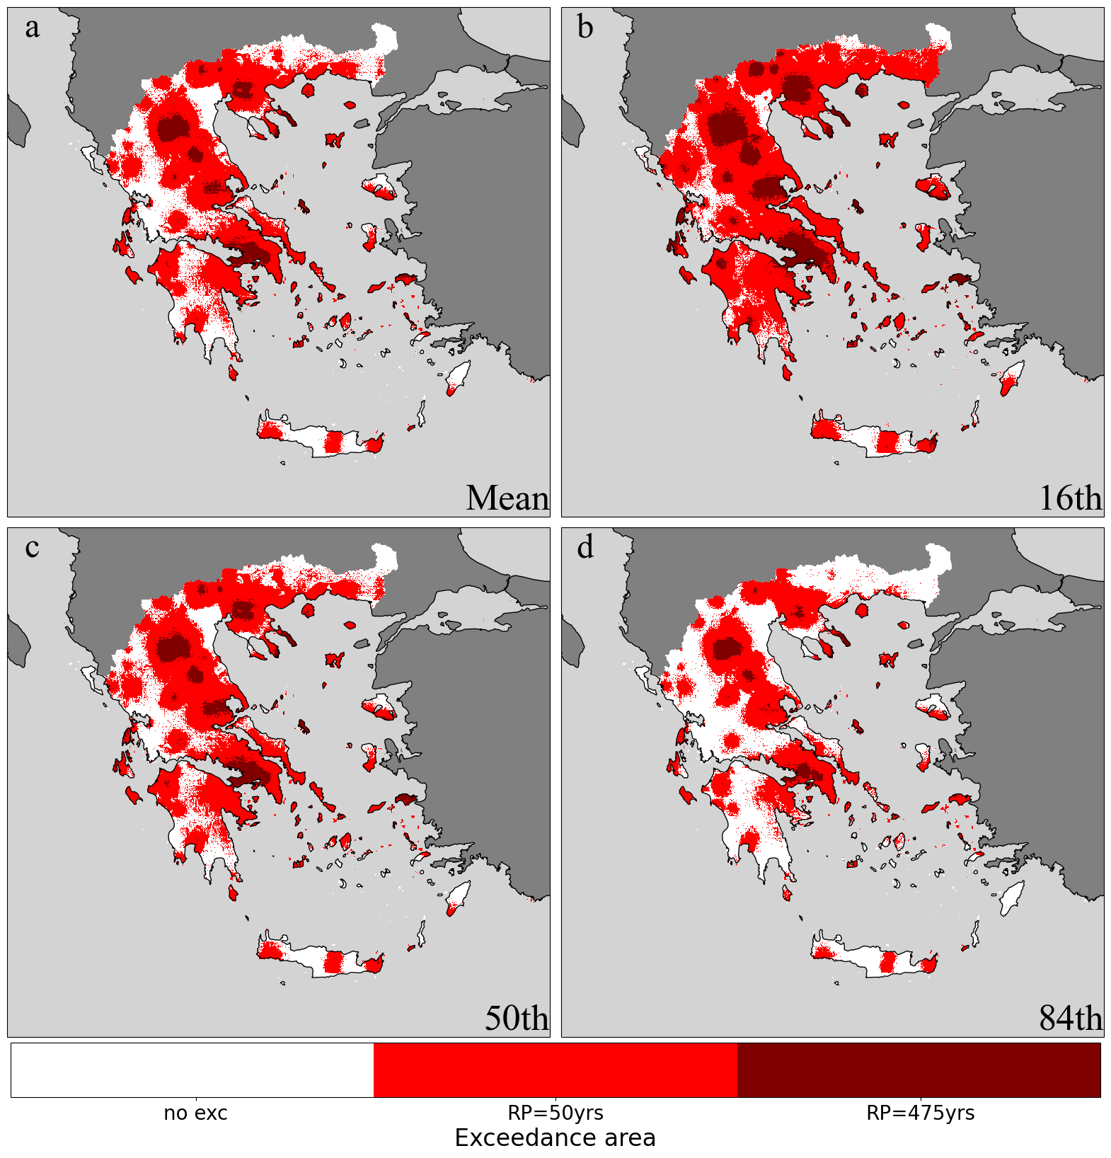
Figure S4. Fractional exceedance areas where at least one ShakeMap-derived RotD50 spectral acceleration at T = 0.3 s (Sa[0.3 s]) exceeded the corresponding ESHM20 hazard thresholds. The Sa(0.3 s) intensity measure is relevant for mid-rise building typologies commonly found in Greece, with fundamental periods on the order of 0.3–0.4 s. Colour shading, consistent with Figure 5, indicates the presence of exceedances for the 50-year and 475-year return-period hazard levels. Spatial variability reflects the combined effects of ground-motion model variability within the ShakeMap logic tree and site-response adjustments, rather than systematic bias in the ESHM20 hazard model.
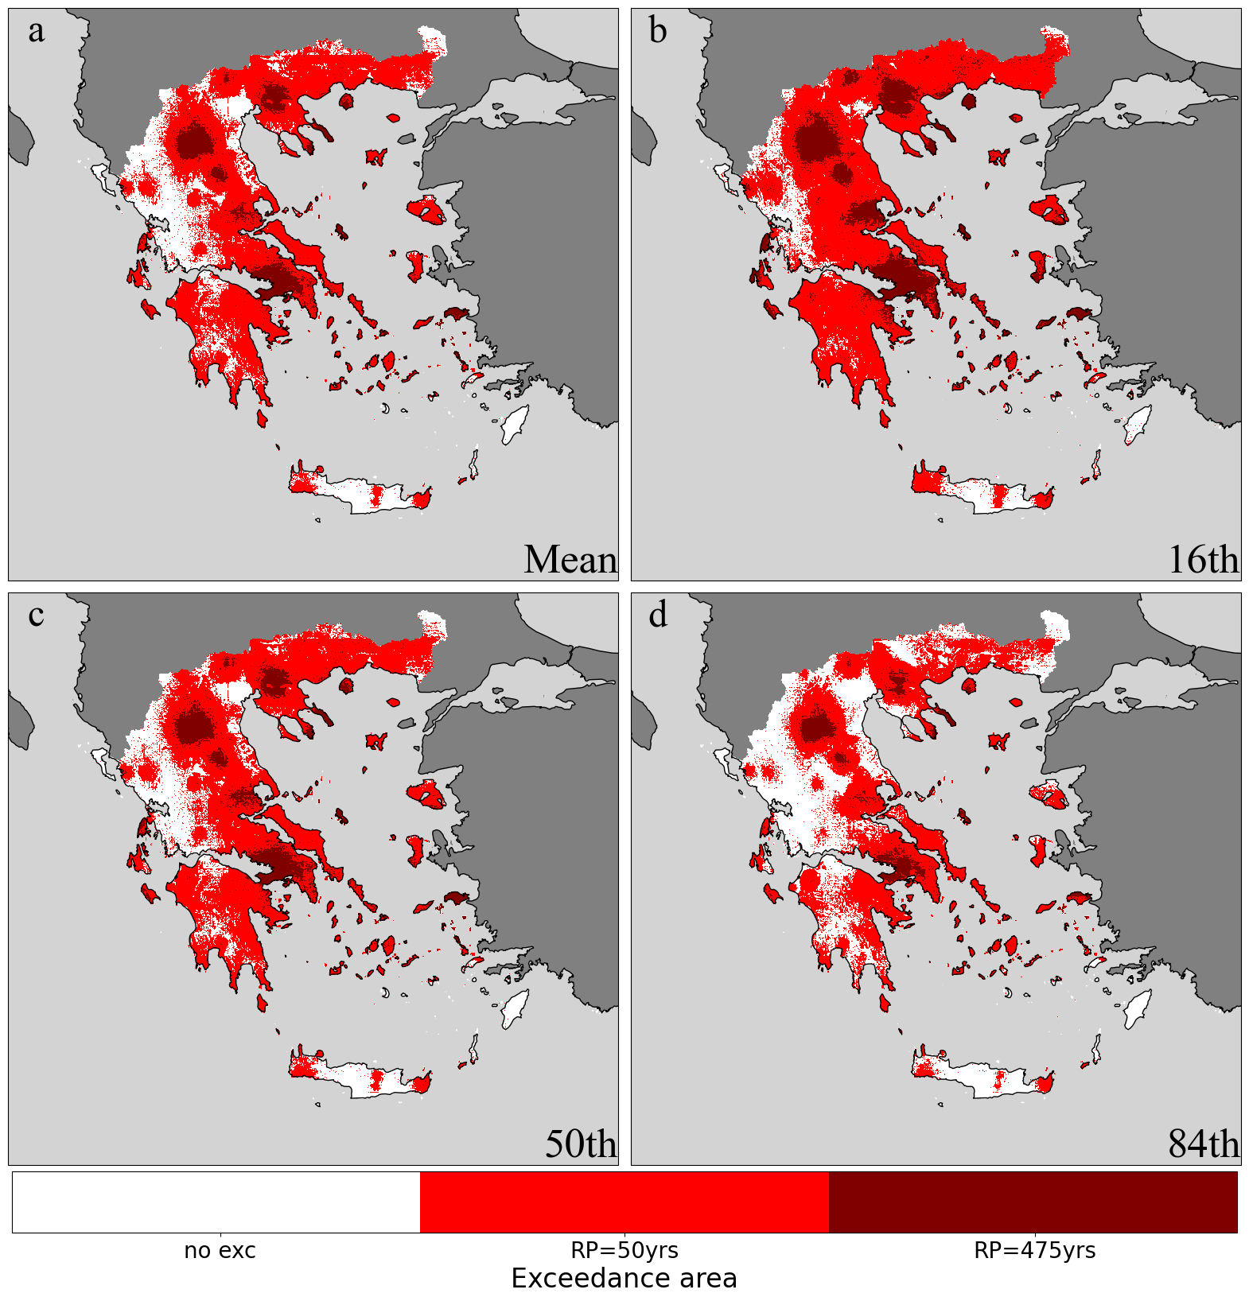
Figure S5. As in Fig. S4 for spectral acceleration at T=1.0 second (Sa[1.0s]).
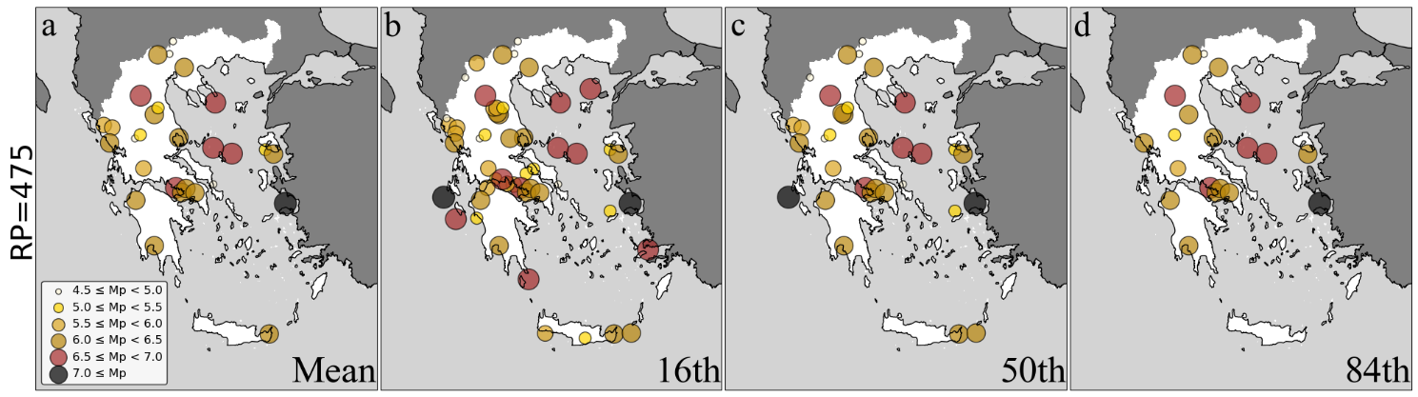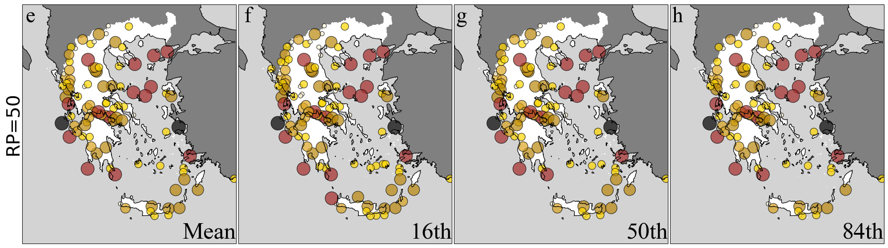
Figure S6. Spatial distribution of earthquake epicentres (circles, coloured by potency magnitude, Mp) associated with at least one exceedance of the ESHM20 RotD50 spectral acceleration hazard thresholds at T = 0.3 s (Sa[0.3 s]) in the ShakeMap-derived ground-motion fields. Panels (a–d) correspond to exceedances relative to the 475-year return-period hazard levels, and panels (e–h) to the 50-year return-period hazard levels. Columns show different aggregation levels of the ESHM20 hazard model: mean, 16th percentile, 50th percentile (median), and 84th percentile.

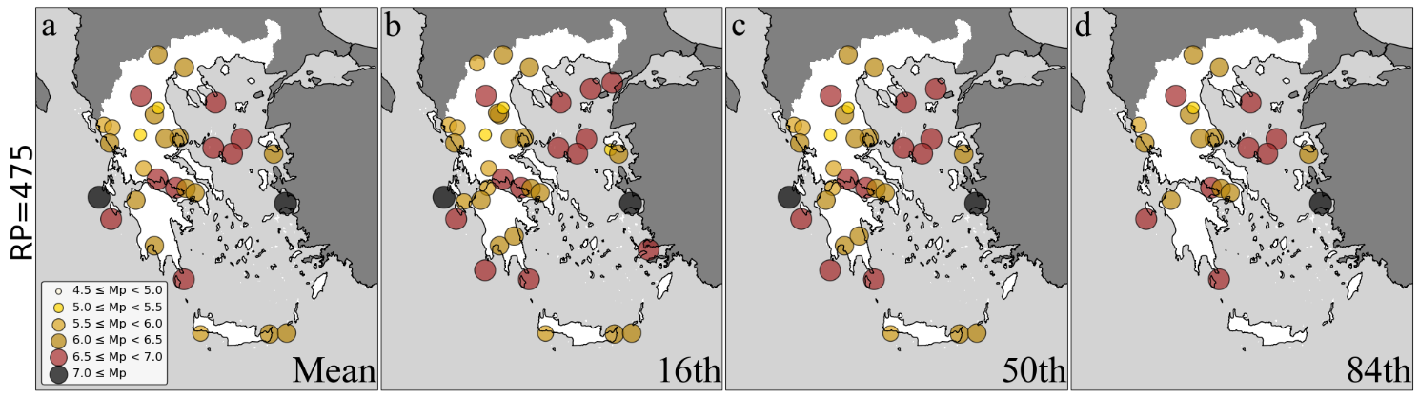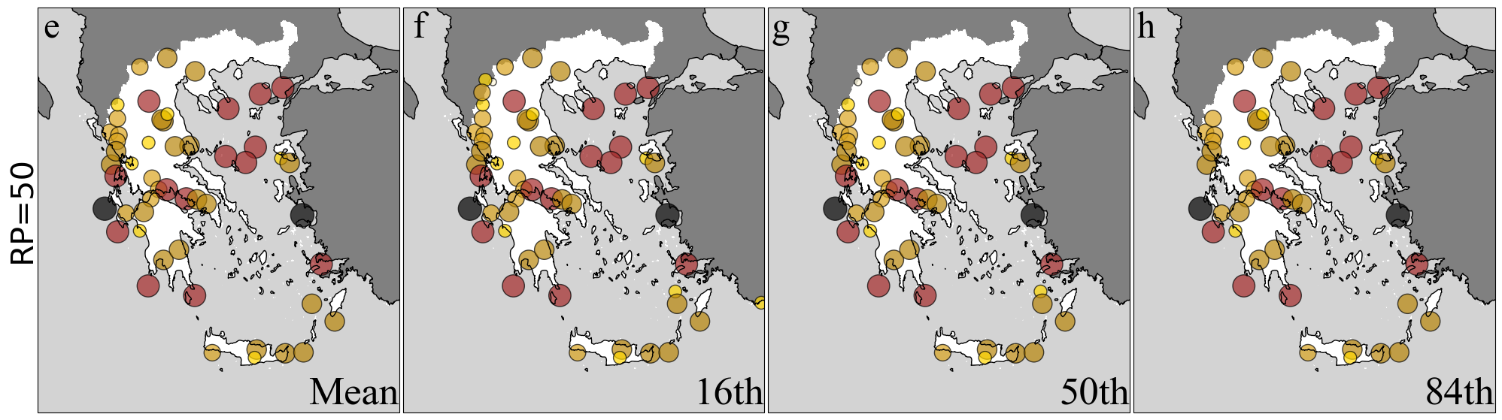
Figure S7. As in Figure S6, but for RotD50 spectral acceleration at T = 1.0 s (Sa[1.0 s]). Spatial distribution of earthquake epicentres (circles, coloured by potency magnitude, Mp) associated with at least one exceedance of the ESHM20 hazard thresholds in the ShakeMap-derived ground-motion fields, shown for return periods of 475 years (a–d) and 50 years (e–h), and for different aggregation levels of the ESHM20 hazard model (mean, 16th, 50th, and 84th percentiles).

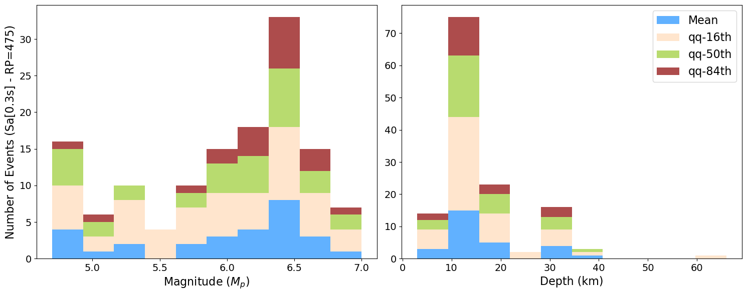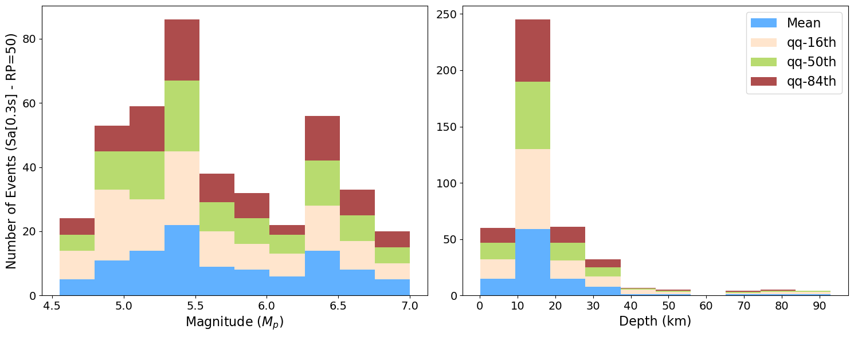
Figure S8. Number of earthquake events associated with at least one exceedance of the ESHM20 RotD50 spectral acceleration hazard thresholds at T = 0.3 s (Sa[0.3 s]) in the ShakeMap-derived ground-motion fields, shown as a function of potency magnitude and focal depth. The top row corresponds to exceedances relative to the 475-year return-period hazard levels, and the bottom row to the 50-year return-period hazard levels. Coloured bars indicate exceedance counts for different aggregation levels of the ESHM20 hazard model (mean, 16th percentile, 50th percentile, and 84th percentile).

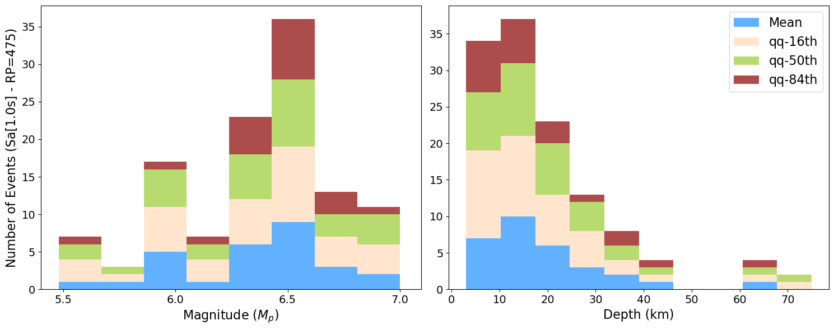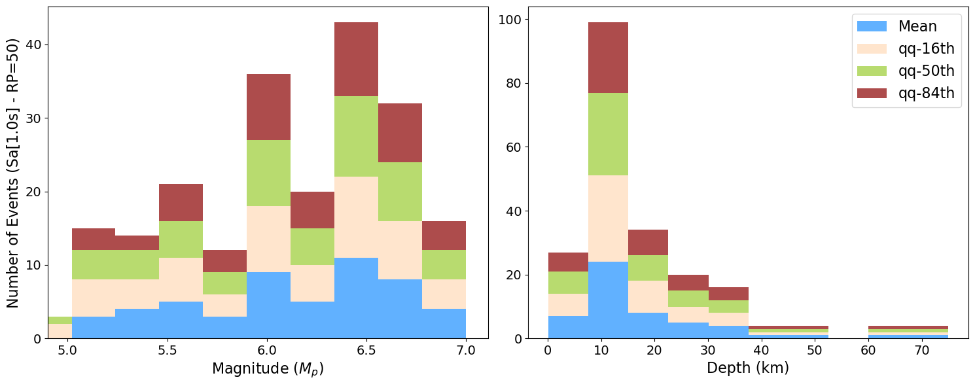
Figure S9. As in Fig. S8, but for RotD50 spectral acceleration at T = 1.0 s (Sa[1.0 s]).
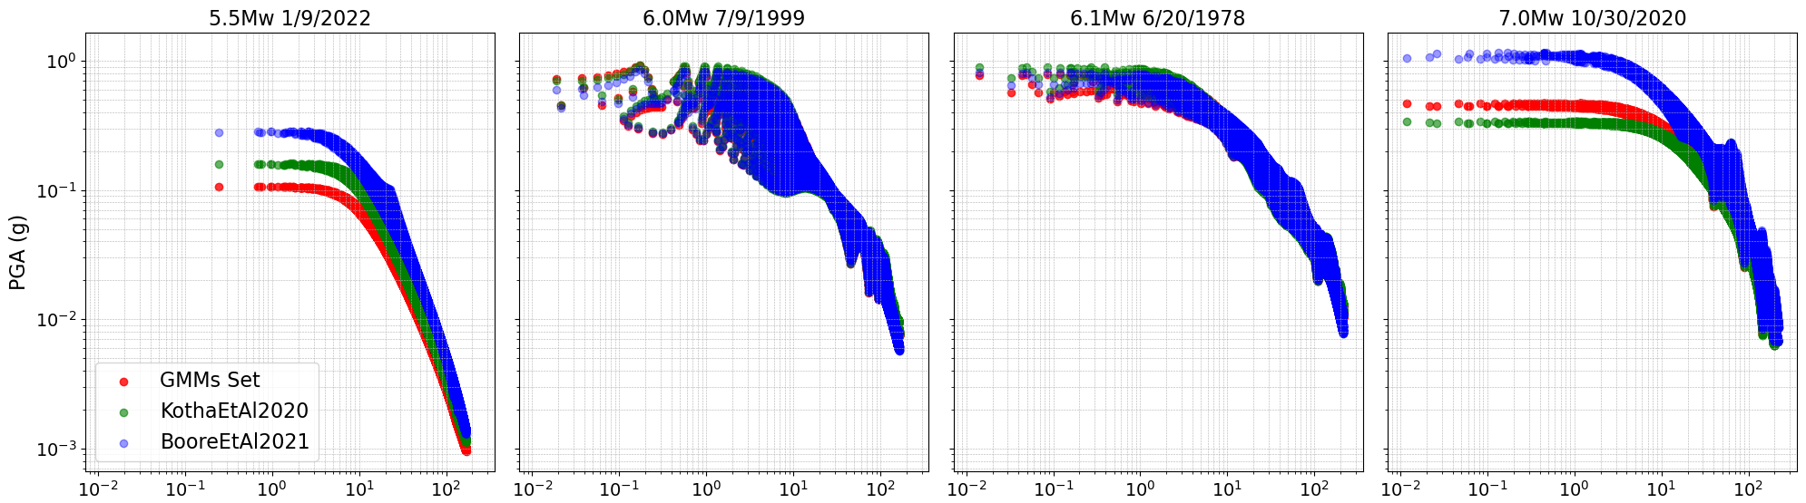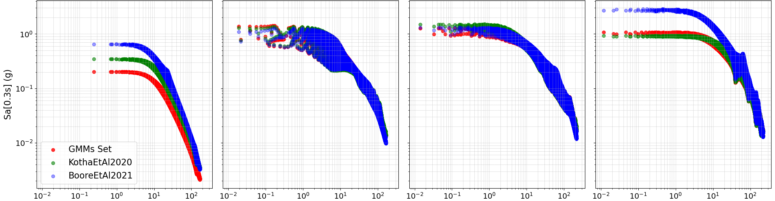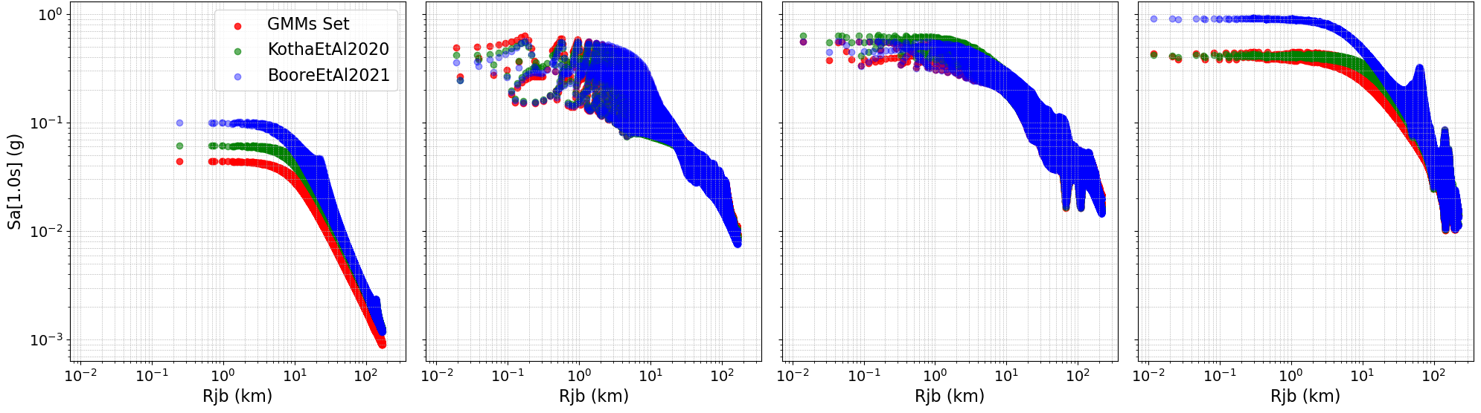
Figure S10. Distance–attenuation behaviour of ShakeMap-derived intensity measures (IMs) as a function of Joyner–Boore distance (Rjb) for four representative earthquakes in Greece: (a) Mw 5.5, 1 September 2022; (b) Mw 6.0, 7 September 1999 (Athens); (c) Mw 6.5, 20 June 1978 (Thessaloniki); and (d) Mw 7.0, 30 October 2020 (Samos). Rows correspond to different intensity measures: peak ground acceleration (PGA, top row), spectral acceleration at T = 0.3 s (Sa[0.3 s], middle row), and spectral acceleration at T = 1.0 s (Sa[1.0 s], bottom row). For each event and intensity measure, ShakeMaps were generated using three alternative ground-motion modelling configurations: a composite model combining four active-crustal GMMs used in the ShakeMap logic tree (red; see Table 1), the Kotha et al. (2020) GMM (green), and the Boore et al. (2021) GMM (blue). The figure illustrates the range of model-dependent attenuation behaviour that contributes to epistemic variability in ShakeMap ground-motion fields.
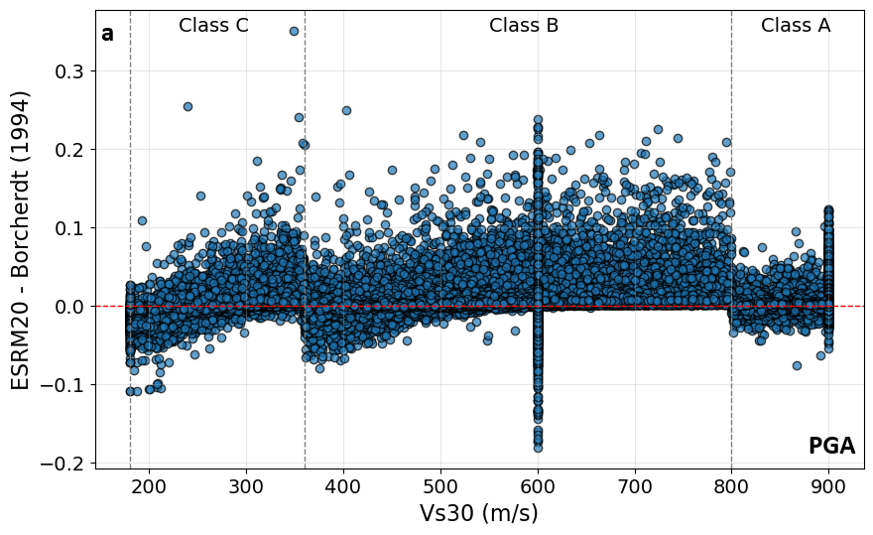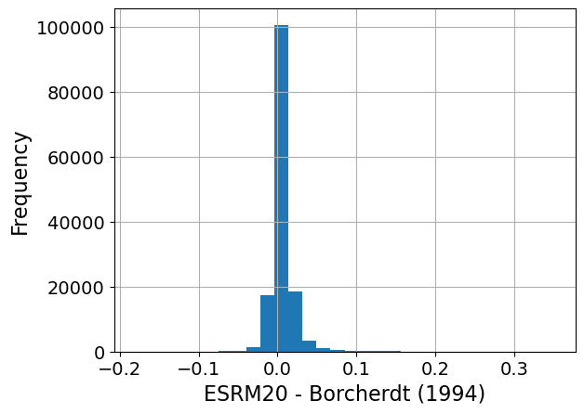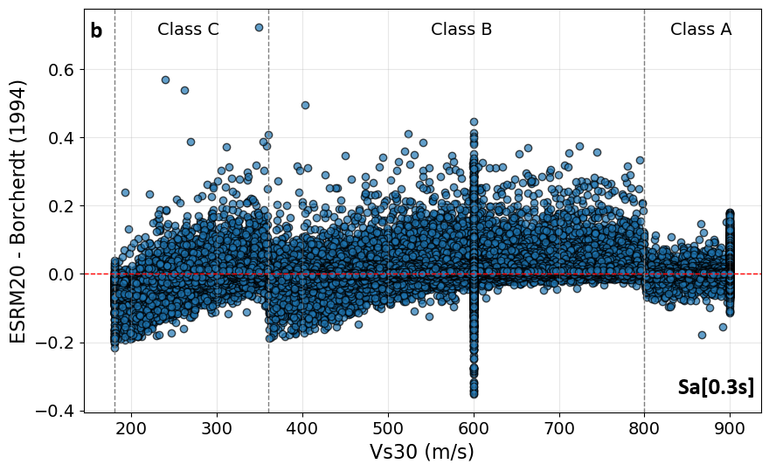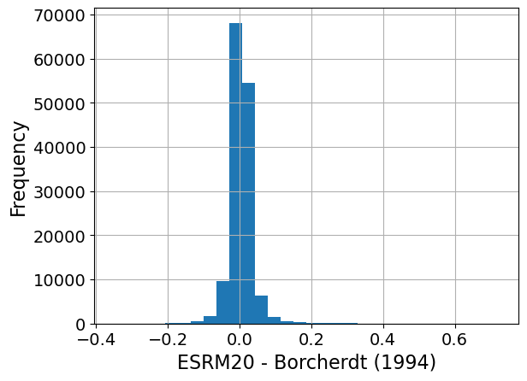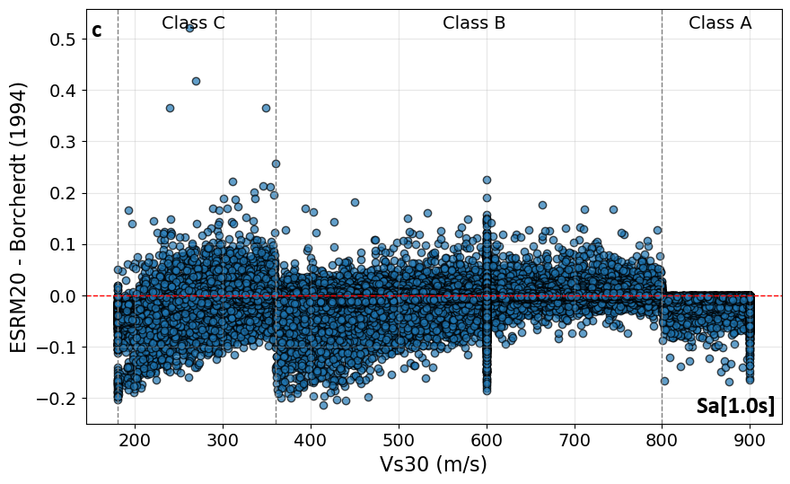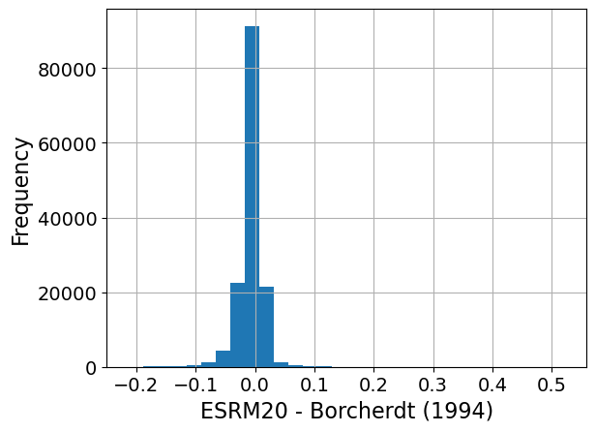
Figure S11. Differences in intensity measures (IMs) obtained using rock-site amplification factors from the European Site Response Model (ESRM20; Weatherill et al., 2021) relative to those derived from the Borcherdt (1994) formulation, shown as a function of Vs30. Positive values indicate larger IM values after adjustment with ESRM20 compared to Borcherdt (1994). Vertical dashed lines denote Eurocode 8 site-class boundaries (Classes C, B, and A). Right-hand panels show the corresponding frequency distributions of the IM differences. Panels correspond to (a) peak ground acceleration (PGA), (b) spectral acceleration at T = 0.3 s (Sa[0.3 s]), and (c) spectral acceleration at T = 1.0 s (Sa[1.0 s]). The scatter highlights increased variability near site-class boundaries, illustrating how differences in site-response parameterisation can contribute to residual variability in ShakeMap-derived ground-motion fields.

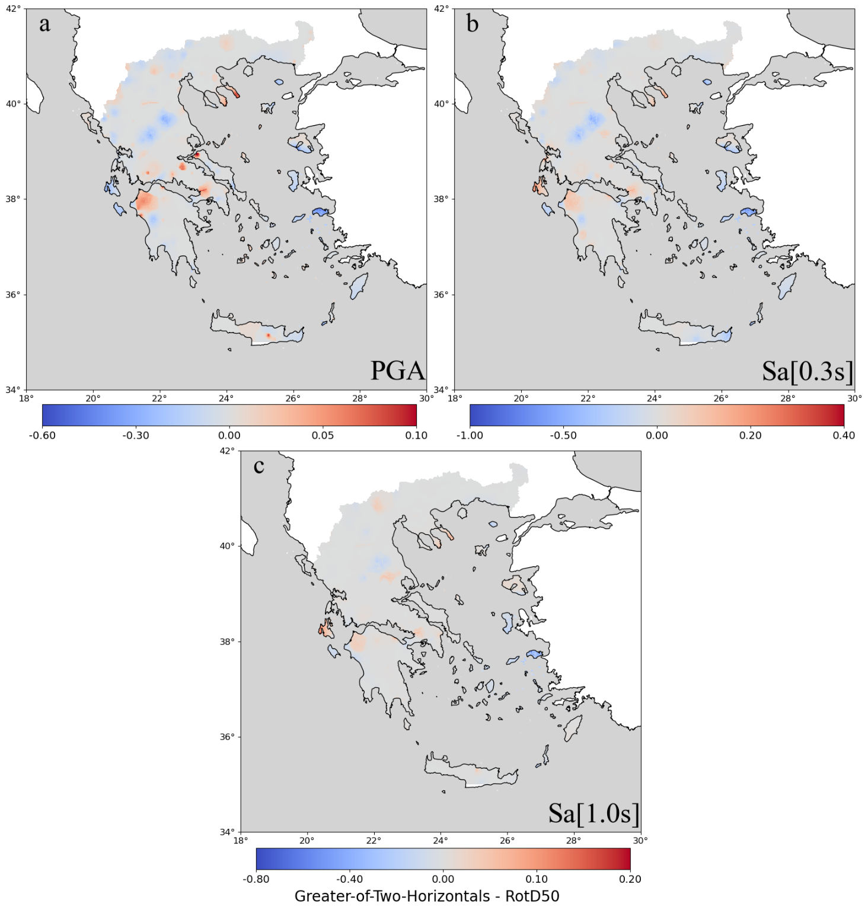
Figure S12. Spatial distribution of the difference between intensity measures (IMs) computed using the greater-of-two-horizontal components and the rotation-independent RotD50 definition. Positive values (red) indicate locations where the greater-of-two-horizontals approach yields larger IM values than RotD50 (Boore, 2010). Panels show results for (a) peak ground acceleration (PGA), (b) spectral acceleration at T = 0.3 s (Sa[0.3 s]), and (c) spectral acceleration at T = 1.0 s (Sa[1.0 s]). Differences reflect component-definition effects rather than physical changes in ground shaking and illustrate the magnitude and spatial variability of IM conversion effects relevant for comparison with ESHM20 hazard maps.

