Genetic and environmental influences on singing self-evaluation and its relationship with singing ability: An Australian twin study

Supplementary Information

Daniel Yeom ¹ *, Kendall S. Stead ¹ *, Yi Ting Tan ², Gary E. McPherson ², Miriam A. Mosing ¹ ³ ⁴, Sarah J. Wilson ¹ ⁵

ORCID IDs:
Daniel Yeom: https://orcid.org/0000-0002-1281-6299
Kendall Stead: https://orcid.org/0000-0001-9645-2439
Gary E. McPherson: https://orcid.org/0000-0002-2543-6762
Miriam A. Mosing: https://orcid.org/0000-0003-2049-125X
Sarah J. Wilson: https://orcid.org/0000-0002-2678-1576

Figure S1. Variance decomposition of the correlated factors model between the Singing Phenotypic Index, the singing self-evaluation factor (SSE-Factor) and the single self-evaluation item (SSE-Single).
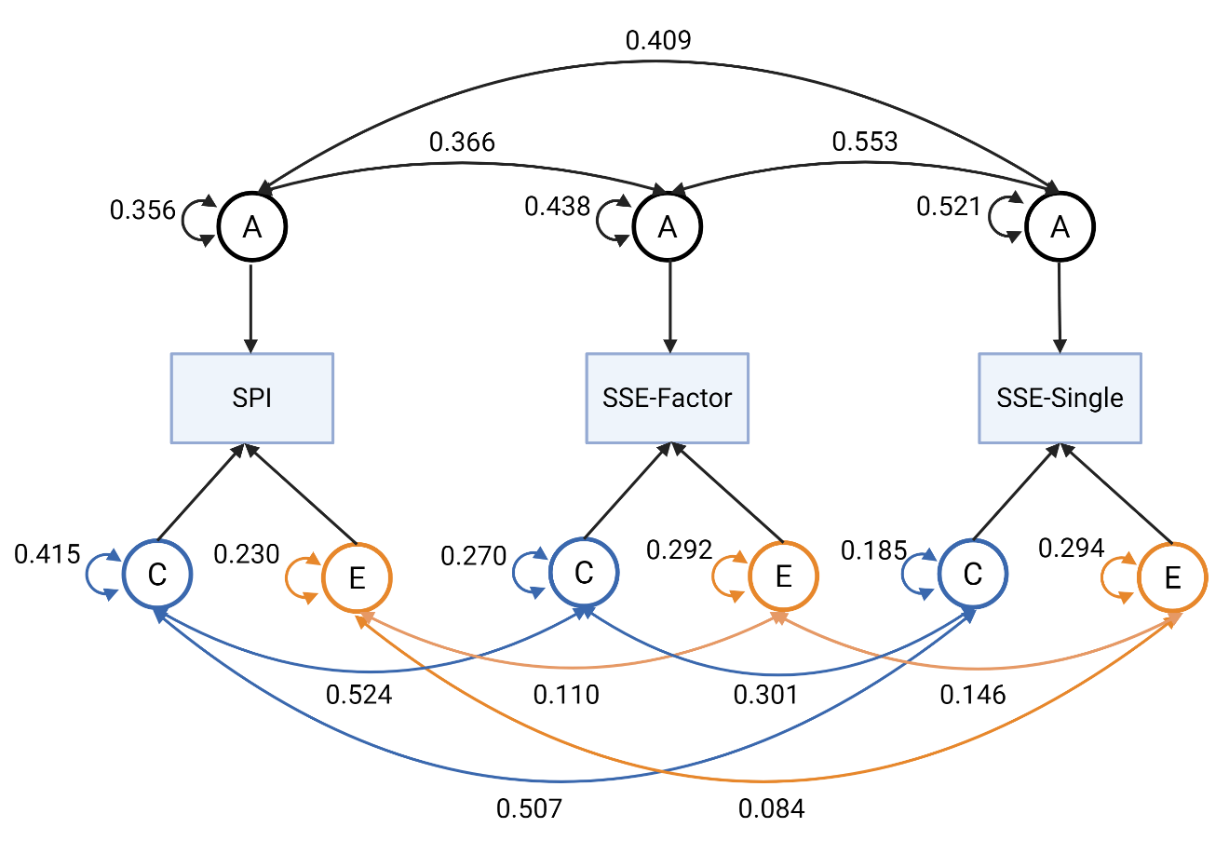
Note. Standardised variances are displayed. For visualisation purposes, the C components have been coloured blue and the E components have been coloured orange. SPI = Singing Phenotypic Index; SSE-Factor = Singing Self-Evaluation Factor; SSE-Single = Singing Self-Evaluation Single item.

Table S1. Assumption Testing Statistics for Genetic Analyses (n_{pair} = 453)
Variable | Base | Comparison | ep | -2LL | df | AIC | Δ -2LL | Δ df | p
SPI | Saturated |  | 27 | 2164.83 | 879 | 2218.83
 | Saturated | Equal Means Twin Order | 23 | 2167.44 | 883 | 2213.44 | 2.61 | 4 | 0.625
 | Equal Means Twin Order | Equal Means SS Zygosity | 21 | 2168.96 | 885 | 2210.96 | 1.51 | 2 | 0.470
 | Equal Means SS Zygosity | Equal Means All Zygosity | 19 | 2176.45 | 887 | 2214.45 | 7.50 | 2 | 0.024
 | Equal Means All Zygosity | Equal Means | 18 | 2176.45 | 888 | 2212.45 | -0.00 | 1 | 1
 | Equal Means | Equal Variance Twin | 14 | 2176.98 | 892 | 2204.98 | 0.53 | 4 | 0.970
 | Equal Variance Twin | Equal Variance SS Zygosity | 12 | 2177.15 | 894 | 2201.15 | 0.17 | 2 | 0.918
 | Equal Variance SS Zygosity | Equal Variance All Zygosity | 10 | 2177.18 | 896 | 2197.18 | 0.02 | 2 | 0.988
 | Equal Variance All Zygosity | Equal Variance | 9 | 2178.65 | 897 | 2196.65 | 1.47 | 1 | 0.225
 | Equal Variance | Equal Covariance MZ | 8 | 2178.67 | 898 | 2194.67 | 0.02 | 1 | 0.886
 | Equal Covariance MZ | Equal Covariance DZ | 7 | 2178.67 | 899 | 2192.67 | 0.01 | 1 | 0.936
 | Equal Covariance DZ | Equal Covariance MZ DZ All | 6 | 2178.68 | 900 | 2190.68 | 0.00 | 1 | 0.976
Self-Evaluation | Saturated |  | 27 | 2288.76 | 879 | 2342.76
 | Saturated | Equal Means Twin Order | 23 | 2290.47 | 883 | 2336.47 | 1.70 | 4 | 0.790
 | Equal Means Twin Order | Equal Means SS Zygosity | 21 | 2290.65 | 885 | 2332.65 | 0.18 | 2 | 0.914
 | Equal Means SS Zygosity | Equal Means All Zygosity | 19 | 2295.57 | 887 | 2333.57 | 4.93 | 2 | 0.085
 | Equal Means All Zygosity | Equal Means | 18 | 2295.57 | 888 | 2331.57 | -0.00 | 1 | 1
 | Equal Means | Equal Variance Twin Order | 14 | 2296.02 | 892 | 2324.02 | 0.45 | 4 | 0.978
 | Equal Variance Twin Order | Equal Variance SS Zygosity | 12 | 2297.07 | 894 | 2321.07 | 1.05 | 2 | 0.593
 | Equal Variance SS Zygosity | Equal Variance All Zygosity | 10 | 2297.09 | 896 | 2317.09 | 0.02 | 2 | 0.992
 | Equal Variance All Zygosity | Equal Variance | 9 | 2297.49 | 897 | 2315.49 | 0.40 | 1 | 0.527
 | Equal Variance | Equal Covariance MZ | 8 | 2302.73 | 898 | 2318.73 | 5.25 | 1 | 0.022
 | Equal Covariance MZ | Equal Covariance DZ | 7 | 2302.81 | 899 | 2316.81 | 0.07 | 1 | 0.786
 | Equal Covariance DZ | Equal Covariance MZ DZ All | 6 | 2303.20 | 900 | 2315.20 | 0.39 | 1 | 0.532
Single Item | Saturated |  | 27 | 2292.73 | 879 | 2346.73
 | Saturated | Equal Means Twin Order | 23 | 2297.49 | 883 | 2343.49 | 4.75 | 4 | 0.313
 | Equal Means Twin Order | Equal Means SS Zygosity | 21 | 2297.60 | 885 | 2339.60 | 0.11 | 2 | 0.946
 | Equal Means SS Zygosity | Equal Means All Zygosity | 19 | 2298.09 | 887 | 2336.09 | 0.49 | 2 | 0.781
 | Equal Means All Zygosity | Equal Means | 18 | 2298.09 | 888 | 2334.09 | 0.00 | 1 | 1
 | Equal Means | Equal Variance Twin Order | 14 | 2299.68 | 892 | 2327.68 | 1.59 | 4 | 0.810
 | Equal Variance Twin Order | Equal Variance SS Zygosity | 12 | 2299.77 | 894 | 2323.77 | 0.08 | 2 | 0.960
 | Equal Variance SS Zygosity | Equal Variance All Zygosity | 10 | 2300.32 | 896 | 2320.32 | 0.55 | 2 | 0.760
 | Equal Variance All Zygosity | Equal Variance | 9 | 2300.32 | 897 | 2318.32 | 0.00 | 1 | 0.964
 | Equal Variance | Equal Covariance MZ | 8 | 2300.33 | 898 | 2316.33 | 0.01 | 1 | 0.924
 | Equal Covariance MZ | Equal Covariance DZ | 7 | 2301.47 | 899 | 2315.47 | 1.14 | 1 | 0.286
 | Equal Covariance DZ | Equal Covariance MZ DZ All | 6 | 2301.77 | 900 | 2313.77 | 0.31 | 1 | 0.580

Note. n_{pair} reflects the total pair of twins (MZ and DZ) with complete data. Level of significance for each comparison is p < .01. SPI = singing phenotypic index. Base = baseline model, ep = estimated parameters, -2LL = minus two times the log-likelihood, df = degrees of freedom, AIC = Akaike Information Criterion, Δ = change between baseline and comparison model.

Table S2. Model Fitting Statistics for Univariate Genetic Analyses (n_{pair} = 453).
Variable | Base | Comparison | ep | -2LL | df | AIC | Δ -2LL | Δ df | p
SPI | ACE |  | 6 | 2178.68 | 900 | 2190.68
 | ACE | AE | 5 | 2188.83 | 901 | 2198.83 | 10.16 | 1 | <.001***
 | ACE | CE | 5 | 2194.73 | 901 | 2204.73 | 16.05 | 1 | <.001***
 | ACE | E | 4 | 2531.44 | 902 | 2539.44 | 352.77 | 2 | <.001***
Self-Evaluation Factor | ACE |  | 6 | 2303.20 | 900 | 2315.20
 | ACE | AE | 5 | 2307.49 | 901 | 2317.49 | 4.29 | 1 | .038*
 | ACE | CE | 5 | 2317.95 | 901 | 2327.95 | 14.75 | 1 | <.001***
 | ACE | E | 4 | 2564.79 | 902 | 2572.79 | 261.59 | 2 | <.001***
Single Item | ACE |  | 6 | 2301.77 | 900 | 2313.77
 | ACE | AE | 5 | 2303.11 | 901 | 2313.11 | 1.34 | 1 | .247
 | ACE | CE | 5 | 2322.99 | 901 | 2332.99 | 21.22 | 1 | <.001***
 | ACE | E | 4 | 2561.12 | 902 | 2569.12 | 259.34 | 2 | <.001***

Note. n_{pair} reflects the total pair of twins (MZ and DZ) with complete data. SPI = singing phenotypic index. Base = baseline model, ep = estimated parameters, -2LL = minus two times the log-likelihood, df = degrees of freedom, AIC = Akaike Information Criterion, Δ = change between baseline and comparison model.
*p < .05, **p < .01, ***p < .001

Table S3. ACE Estimates Between Objective and Self-Evaluated Singing Ability, Controlling for Years of Music Training (n_{pair} = 450).
 |  |  | % of r_{p} |  |  |  | Genetic and Environmental Correlations  [95% CI] |  |  |  | CTCT Correlations  [95% CI]
 | r_{p} | A (%) |  | C (%) | E (%) |  | r_{g} | r_{c} | r_{e} |  | MZ | DZ
SSE-Factor and SPI | .63  [.58, .67] | 38.49 |  | 48.25 | 13.26 |  | .62  [.21, .98] | 1 | .28  [.28, .37] |  | .54  [.48, .60] | .41  [.31, .51]
SSE-Single and SPI | .62  [.57, .67] | 44.17 |  | 44.98 | 10.86 |  | .62  [.25, .93] | 1ª | .22  [.11, .32] |  | .55  [.49, .60] | .41  [.30, .51]

Note. All estimates are derived from the multivariate correlated factors model. Years of training was winsorised to a maximum of 20 years to account for implausible values. n_{pair} reflects the total pair of twins (MZ and DZ) with complete data. SPI = singing phenotypic index, SSE-Factor = singing self-evaluation factor, SSE-Factor = singing self-evaluation single item, CI = confidence interval, CTCT = cross-twin cross-trait [correlations], r_{p} = total phenotypic correlation, r_{g} = genetic correlation, r_{c} = shared environmental correlation, r_{e} = unshared environmental correlation.
ª The value here exceeds 1, which can occur in direct symmetric parameterisations of twin models. For reporting purposes we report these as 1.

Bivariate analyses of individual items in the SSE-Factor. The SSE-Factor is made up of four self-report items related to singing. We fit bivariate Cholesky models to examine the genetic and environmental correlations/relationships between each item and the Singing Phenotypic Index. These are presented in Tables S4 and S5 below.

Table S4. Bivariate ACE estimates Between Individual Singing Self-Evaluation Factor Items with Objective Singing Ability (n_{pair} = 453)
 |  | % of r_{p} |  |  |  |  | Genetic and environmental correlations [95% CI]
Variable | r_{p} | A (%) | C (%) | E (%) |  |  | r_{g} | r_{c} | r_{e}
I can tell when people sing out of tune. | .57 | 57.01* | 33.61 | 9.38* |  |  | .74*  [.74, 1] | .91  [-1, 1] | .18*  [.08, .28]
I find it easy to sing, hum or whistle a familiar tune from memory. | .51 | 52.08* | 39.65* | 8.28* |  |  | .78*  [.34, 1] | .60*  [.60, 1] | .14*  [.03, .24]
After hearing a new song two or three times, I can usually sing/hum/whistle it by myself. | .48 | 24.61 | 62.33* | 13.06* |  |  | .40  [-1, .69] | 1*  [.78, 1] | .18*  [.07, .28]
When I sing/hum/whistle, I have no idea whether I’m in tune or not. ª | .54 | 51.42* | 34.76* | 13.82* |  |  | .74*  [.74, 1] | 1*  [.95, 1] | .21*  [.11, .31]

Note. n_{pair} reflects the total pair of twins (MZ and DZ) with complete data. SPI = singing phenotypic index, A = additive genetic effects, C = shared environmental effects, E = unshared environmental effects, CI = confidence interval, r_{p} = total phenotypic correlation, r_{g} = genetic correlation, r_{c} = shared environmental correlation, r_{e} = unshared environmental correlation.
ª This item was reverse-scored.
* p <.05

Table S5. Model Fit Statistics for Bivariate Analyses of Individual SSE-Factor Items (n_{pair} = 453).
Variable | Comparison | EP | -2LL | df | AIC | Δ -2LL | Δ df | p
I can tell when people sing out of tune. | Full model | 17 | 4493.26 | 1963 | 4527.26
I can tell when people sing out of tune. | r_{g} = 0 | 16 | 4509.34 | 1964 | 4541.34 | 16.08 | 1 | < .001***
I can tell when people sing out of tune. | r_{c} = 0 | 16 | 4496.75 | 1964 | 4528.75 | 3.48 | 1 | .06
I can tell when people sing out of tune. | r_{e} = 0 | 16 | 4504.74 | 1964 | 4536.74 | 11.47 | 1 | < .001***
I find it easy to sing, hum or whistle a familiar tune from memory. | Full model | 17 | 4820.75 | 1963 | 4854.75
 | r_{g} = 0 | 16 | 4829.77 | 1964 | 4861.77 | 9.02 | 1 | < .001***
 | r_{c} = 0 | 16 | 4824.72 | 1964 | 4856.72 | 3.97 | 1 | .05
 | r_{e} = 0 | 16 | 4827.66 | 1964 | 4859.66 | 6.91 | 1 | .01**
After hearing a new song two or three times, I can usually sing/hum/whistle it by myself. | Full model | 17 | 4861.94 | 1963 | 4895.94
 | r_{g} = 0 | 16 | 4864.11 | 1964 | 4896.11 | 2.16 | 1 | .14
 | r_{c} = 0 | 16 | 4871.97 | 1964 | 4903.97 | 10.03 | 1 | < .001***
 | r_{e} = 0 | 16 | 4873.34 | 1964 | 4905.34 | 11.40 | 1 | < .001***
When I sing/hum/whistle, I have no idea whether I’m in tune or not. ª | Full model | 17 | 5237.71 | 1963 | 5271.71
 | r_{g} = 0 | 16 | 5248.50 | 1964 | 5280.50 | 10.79 | 1 | < .001***
 | r_{c} = 0 | 16 | 5242.31 | 1964 | 5274.31 | 4.60 | 1 | .03*
 | r_{e} = 0 | 16 | 5254.27 | 1964 | 5286.27 | 16.56 | 1 | < .001***
Personal Engagement Factor | Full model | 17 | 4403.81 | 1795 | 4437.81
Personal Engagement Factor | r_{g} = 0 | 16 | 4405.19 | 1796 | 4437.19 | 1.38 | 1 | .24
Personal Engagement Factor | r_{c} = 0 | 16 | 4407.13 | 1796 | 4439.13 | 3.32 | 1 | .07
Personal Engagement Factor | r_{e} = 0 | 16 | 4408.16 | 1796 | 4440.16 | 4.35 | 1 | .04*
Social Engagement Factor | Full model | 17 | 4359.05 | 1795 | 4393.05
Social Engagement Factor | r_{g} = 0 | 16 | 4361.08 | 1796 | 4393.08 | 2.03 | 1 | .15
Social Engagement Factor | r_{c} = 0 | 16 | 4366.47 | 1796 | 4398.47 | 7.42 | 1 | .01**
Social Engagement Factor | r_{e} = 0 | 16 | 4368.43 | 1796 | 4400.43 | 9.39 | 1 | < .001***

Note. Each submodel is compared to the full model. n_{pair} reflects the total pair of twins (MZ and DZ) with complete data. EP = estimated parameters, -2LL = minus two times the log-likelihood, df = degrees of freedom, AIC = Akaike Information Criterion, Δ = change between baseline and comparison model. Best fitting models are reflected in bold.
ª This item was reverse-scored.
* p < .05, **p < .01, ***p < .001

