SUPPLEMENTARY INFORMATION

Fig. S1. The Gini concentration index and the Lorenz curve
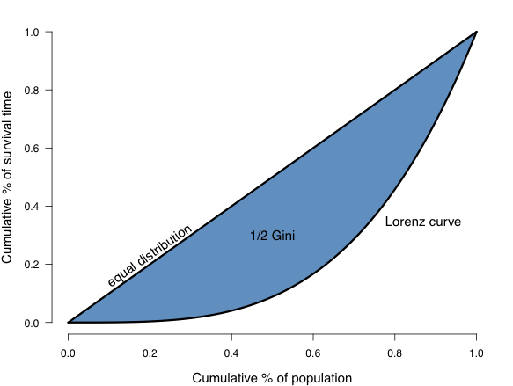
Text S1. R code for calculating the shape of aging
# -------- Compute rescaled shape measure from Gini coefficient -------------- #
# Notes:
# - the Gini coefficient is computed from the “ineq” package
# - different group data could be collected in columns or rows (here columns).
# All is needed to do is to choose the value of 1 (for row) or 2 (for
# columns) in the apply function (see comments in the code).

## ----------------------------------------------- ##
## -- Compute Gini and shape measures
## ----------------------------------------------- ##

## load required library
library(ineq)

## read data
mydata <- read.csv("Data.csv", header=TRUE, sep="," , na.strings = ".")

## compute the Gini coefficient (2 if columns, 1 if rows)
gini <- apply(mydata, 2, Gini, na.rm = TRUE) # here we have groups in columns
# gini <- apply(mydata, 1, Gini, na.rm = TRUE) # here we have groups in rows

## compute shape measure and its rescaled version
shape <- 1 - 2*gini
shape.rescaled <- (1-gini)/gini

