Supplementary Tables
Supp Table 1: Prelamin A
 | Nuclei exhibiting scoring pattern (%± SEM, n=3)
Drug(s) | Negative | Speckles | Weak rim + Speckles | Strong rim + Speckles
2DD Control | 100.0 ± 0.0 | 0.0 ± 0.0 | 0.0 ± 0.0 | 0.0 ± 0.0
AG01972 Control | 23.4 ± 3.6 | 54.6 ± 9.2 | 20.2 ± 7.6 | 1.8 ± 1.4
FTI-277 | 2.7 ± 1.8 | 3.5 ± 3.3 | 11.5 ± 3.2 | 82.3 ± 5.3
Pravastatin | 22.6 ± 15.4 | 15.8 ± 6.0 | 57.8 ± 12.4 | 3.8 ± 3.8
Zoledronic acid | 8.9 ± 3.6 | 15.2 ± 2.1 | 53.8 ± 8.6 | 22.1 ± 14.2
Rapamycin | 70.9 ± 14.3 | 25.2 ± 10.5 | 3.8 ± 3.8 | 0.1 ± 0.1
IGF-1 | 55.0 ± 19.4 | 23.6 ± 13.4 | 19.2 ± 8.6 | 2.3 ± 1.1
N-acetyl-L-Cysteine | 54.9 ± 22.2 | 29.7 ± 15.5 | 14.6 ± 6.6 | 0.8 ± 0.6
FG | 10.6 ± 5.0 | 1.4 ± 0.6 | 19.1 ± 8.3 | 68.9 ± 6.8
PZ | 23.3 ± 12.4 | 16.6 ± 6.2 | 59.3 ± 11.6 | 0.8 ± 0.4
FPZ | 2.9 ± 2.0 | 0.1 ± 0.1 | 12.2 ± 1.9 | 84.8 ± 3.5

Supp Table 2 - Lamin A
 | Nuclei exhibiting scoring pattern (%± SEM, n=3)
Drug(s) | Rim | Rim and Speckles | Negative
2DD Control | 81.4 ± 1.0 | 18.6 ± 1.0 | 0.0 ± 0.0
AG01972 Control | 0.2 ± 0.2 | 0.0 ± 0.0 | 99.8 ± 0.2
FTI-277 | 36.3 ± 10.7 | 58.6 ± 5.7 | 5.0 ± 5.0
Pravastatin | 49.8 ± 2.2 | 43.8 ± 5.4 | 6.4 ± 4.5
Zoledronic acid | 14.5 ± 14.5 | 16.3 ± 16.3 | 69.3 ± 30.7
Rapamycin | 0.0 ± 0.0 | 0.0 ± 0.0 | 100.0 ± 0.0
IGF-1 | 0.0 ± 0.0 | 0.0 ± 0.0 | 100.0 ± 0.0
N-acetyl-L-Cysteine | 15.7 ± 7.4 | 0.0 ± 0.0 | 84.3 ± 7.4
FG | 13.3 ± 3.9 | 81.9 ± 8.7 | 4.8 ± 4.8
PZ | 6.8 ± 3.9 | 8.4 ± 8.4 | 84.8 ± 9.4
FPZ | 11.2 ± 8.0 | 0.0 ± 0.0 | 88.8 ± 8.0

Supp Table 3 - Lamin A/C
 | Nuclei exhibiting scoring pattern (%± SEM, n=3)
Drug(s) | Rim | Rim and Speckles | Speckles | Negative
2DD Control | 87.4 ± 2.9 | 12.6 ± 2.9 | 0.0 ± 0.0 | 0.0 ± 0.0
AG01972 Control | 9.2 ± 1.7 | 84.6 ± 2.8 | 6.3 ± 3.6 | 0.0 ± 0.0
FTI-277 | 47.0 ± 10.3 | 52.8 ± 10.2 | 0.2 ± 0.1 | 0.0 ± 0.0
Pravastatin | 60.9 ± 9.0 | 38.5 ± 8.7 | 0.5 ± 0.4 | 0.0 ± 0.0
Zoledronic acid | 38.0 ± 6.2 | 62.0 ± 6.2 | 0.0 ± 0.0 | 0.0 ± 0.0
Rapamycin | 45.0 ± 4.9 | 55.0 ± 4.9 | 0.0 ± 0.0 | 0.0 ± 0.0
IGF-1 | 76.9 ± 1.2 | 23.1 ± 1.2 | 0.0 ± 0.0 | 0.0 ± 0.0
N-acetyl-L-Cysteine | 78.7 ± 6.9 | 21.3 ± 6.9 | 0.0 ± 0.0 | 0.0 ± 0.0
FG | 83.3 ± 7.2 | 16.5 ± 7.3 | 0.2 ± 0.2 | 0.0 ± 0.0
PZ | 60.6 ± 7.2 | 39.4 ± 7.2 | 0.0 ± 0.0 | 0.0 ± 0.0
FPZ | 67.6 ± 2.6 | 32.4 ± 2.6 | 0.0 ± 0.0 | 0.0 ± 0.0

Supp Table 4 - Progerin
 | Nuclei exhibiting scoring pattern (%± SEM, n=3)
Drug(s) | Rim | Rim and Speckles | Speckles | Negative
2DD Control | 0.0 ± 0.0 | 0.0 ± 0.0 | 1.0 ± 1.0 | 99.0 ± 1.0
AG01972 Control | 0.0 ± 0.0 | 34.3 ± 3.6 | 53.7 ± 0.8 | 12.0 ± 3.1
FTI-277 | 0.0 ± 0.0 | 9.4 ± 2.6 | 47.9 ± 7.7 | 42.7 ± 5.4
Pravastatin | 0.0 ± 0.0 | 11.2 ± 2.3 | 58.0 ± 2.9 | 30.8 ± 1.4
Zoledronic acid | 0.0 ± 0.0 | 39.0 ± 2.0 | 12.0 ± 2.3 | 48.9 ± 0.4
Rapamycin | 0.0 ± 0.0 | 8.6 ± 2.9 | 44.3 ± 2.0 | 47.1 ± 4.9
IGF-1 | 1.3 ± 1.3 | 33.9 ± 2.8 | 50.4 ± 4.2 | 14.5 ± 2.9
N-acetyl-L-Cysteine | 0.0 ± 0.0 | 51.0 ± 10.6 | 16.2 ± 3.6 | 32.8 ± 10.8
FG | 0.0 ± 0.0 | 54.2 ± 7.6 | 19.5 ± 8.5 | 26.3 ± 12.2
PZ | 0.0 ± 0.0 | 16.2 ± 2.8 | 46.7 ± 6.9 | 37.1 ± 9.7
FPZ | 0.0 ± 0.0 | 33.6 ± 7.2 | 58.4 ± 4.0 | 8.0 ± 3.3

Supp Table 5 - Lamin B2
 | Nuclei exhibiting scoring pattern (%± SEM, n=3)
Drug(s) | Rim | Rim and Speckles | Speckles | Negative
2DD Control | 10.3 ± 5.1 | 88.9 ± 4.4 | 0.8 ± 0.8 | 0.0 ± 0.0
AG01972 Control | 12.4 ± 3.0 | 38.5 ± 10.7 | 31.3 ± 7.7 | 17.8 ± 5.9
FTI-277 | 9.1 ± 4.3 | 74.2 ± 7.2 | 7.5 ± 3.7 | 9.2 ± 6.1
Pravastatin | 9.3 ± 3.7 | 80.7 ± 7.5 | 4.7 ± 2.7 | 5.3 ± 3.6
Zoledronic acid | 7.5 ± 4.5 | 79.0 ± 4.6 | 5.6 ± 2.5 | 7.9 ± 4.0
Rapamycin | 10.3 ± 4.5 | 64.2 ± 1.0 | 11.0 ± 5.8 | 14.5 ± 2.1
IGF-1 | 5.5 ± 3.1 | 86.1 ± 4.0 | 5.2 ± 2.1 | 3.2 ± 2.5
N-acetyl-L-Cysteine | 8.5 ± 1.9 | 84.6 ± 3.9 | 5.8 ± 3.0 | 1.2 ± 1.0
FG | 2.2 ± 1.1 | 82.4 ± 4.7 | 9.4 ± 2.3 | 6.0 ± 3.2
PZ | 9.5 ± 2.5 | 80.9 ± 5.7 | 4.8 ± 2.6 | 4.8 ± 3.7
FPZ | 6.0 ± 2.7 | 76.5 ± 1.5 | 6.9 ± 1.5 | 10.6 ± 0.7

Supplementary Figure 1
Western blot with anti-Progerin Antibody.
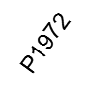
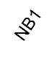
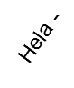
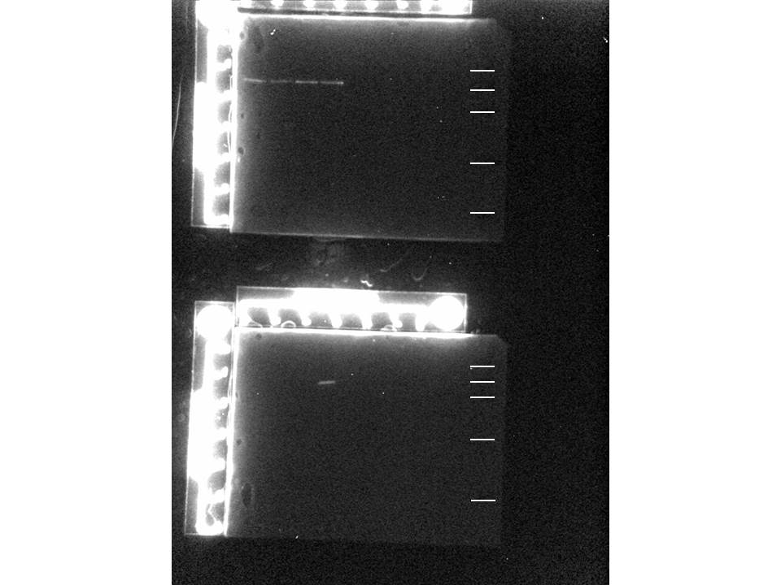

Anti-Progerin Western Blot
Hela cells, control fibroblasts (NB1) and AG01972 HGPS fibroblasts (2x105 cells per lane) were loaded onto a 10% SDS-PAGE gel. A western blot was performed with anti-Progerin mAb 13A4 (Enzo Life Sciences) diluted 1:1000 in PBS/1% dried milk. The secondary antibody was anti-mouse IgG, HRP-linked, diluted in 1:20.000. The signal was detected through Enhanced Chemiluminescence (ECL-ChemiDoc MP system - BioRad©). Markers were 100 kDa, 60kDa, 45kDa, 20kDa and 8kDa.

