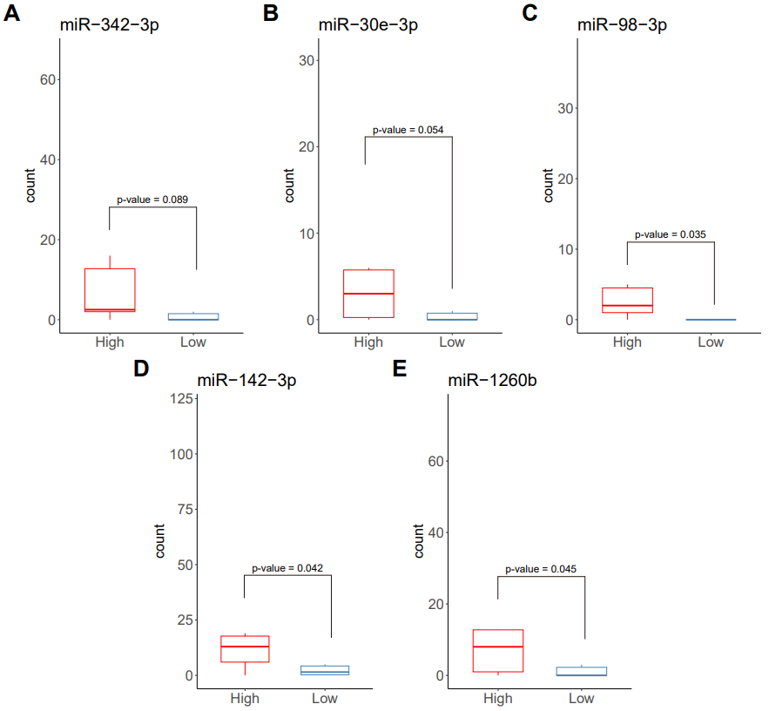
Supplementary Figure S1. Boxplots of significantly differentially expressed miRNAs between high and low RHI group.

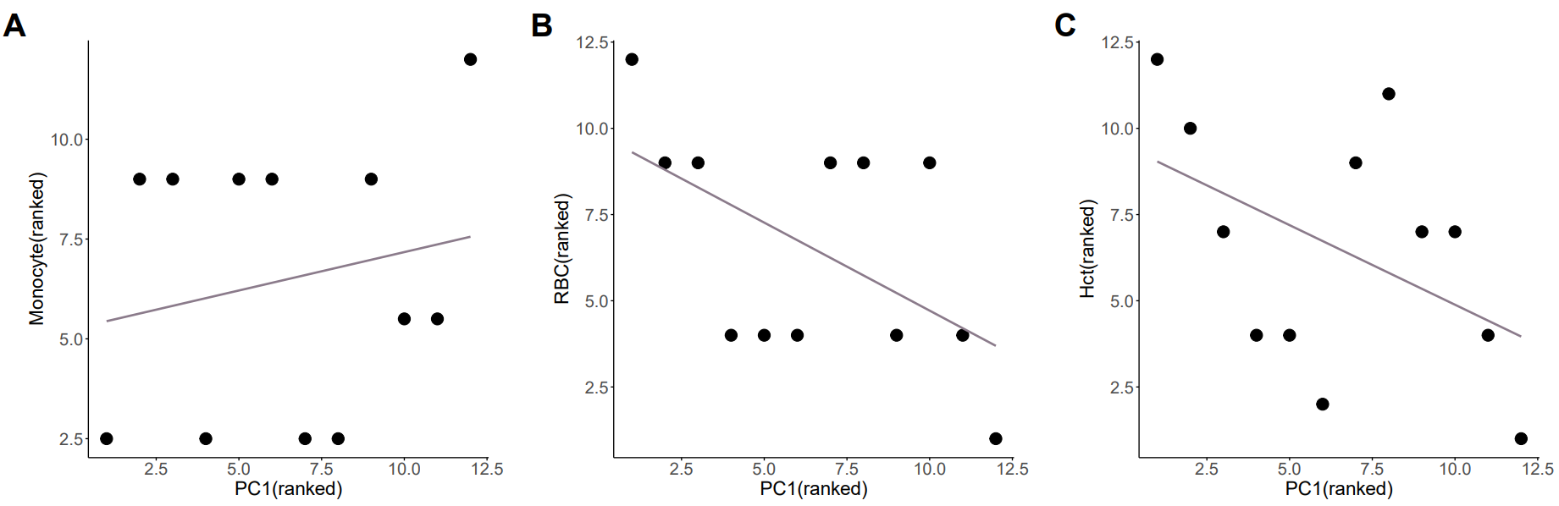
Supplementary Fig 2. Scatter Plots of correlation between significant clinical information and expression values ​​of all analyzed samples

