Table S1 Factor loadings of two principal components based on principal component analysis
Variables | PC1 | PC2
TAC | 0.828 | 0.478
Vitamin A | 0.386 | -0.308
Vitamin C | 0.807 | 0.490
Vitamin E | 0.479 | -0.014
Alpha-carotene | 0.476 | -0.591
Beta-carotene | 0.656 | -0.649
Beta-cryptoxanthin | 0.514 | 0.374
Lycopene | 0.289 | 0.157
Lutein + zeaxanthin | 0.474 | -0.416
Percent of variance explained | 32.72% | 18.59%

Fig. S1 Scree plot, single and cumulative explained variance ratios of principal components
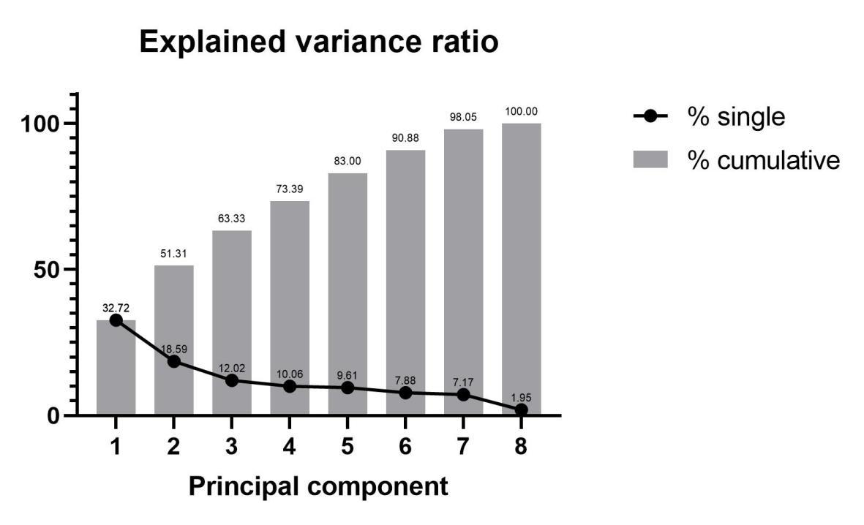

Fig. S2 PCA plot, PhenoAge acceleration (red) and deceleration (blue)
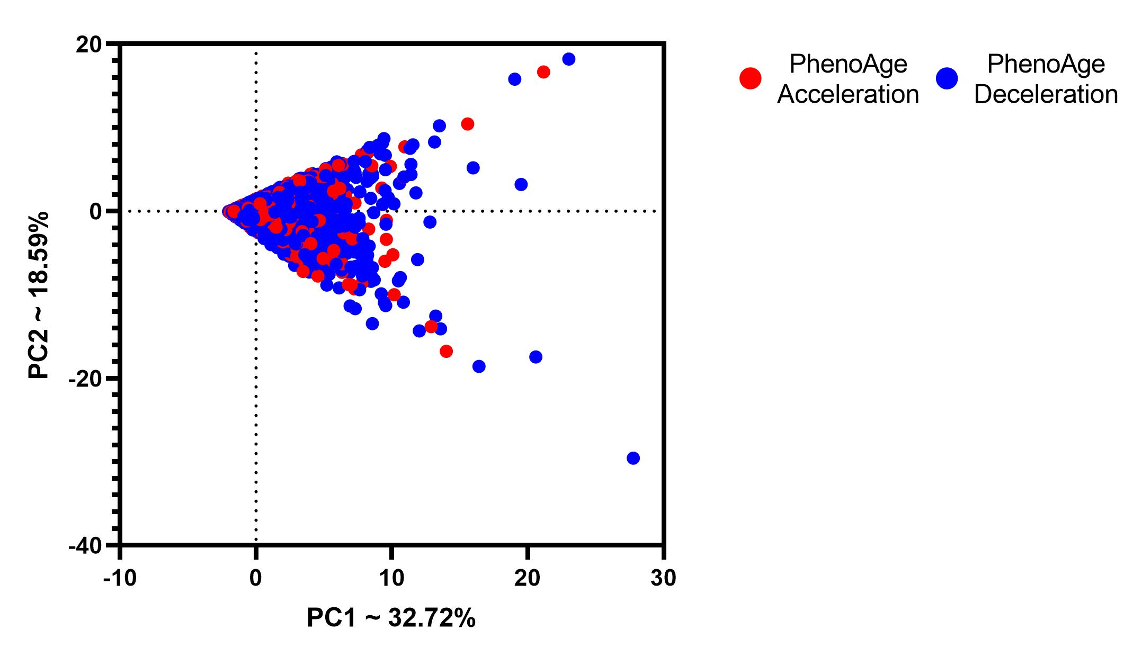

Title: The L-shaped Link Between Total Antioxidant Capacity and Phenotypic Age Acceleration: Evidence from NHANES 2003–2010 (Previous title: Association of Total Antioxidant Capacity with Phenotypic Age Acceleration: Insight from NHANES 2003–2010)

Submission ID: c61870fb-6813-428c-850d-e3e5214a7d9c

Journal: Biogerontology

Author: Yukun Wu 1, Mengxiang Xiang 1, Yangcheng Zhao 1, Yu Zhang 1, Wenxiang Cheng 1 and Jiangbei Deng 1, *

*Corresponding author: Jiangbei Deng
Department of peripheral vascular intervention, The Affiliated Changsha Central Hospital, Hengyang Medical School, University of South China
No.161,Shaoshan road, Changsha, Hunan, China
Email: dengjiangbei1988@hotmail.com
Tel.: +86-13507432551

