Supplementary data
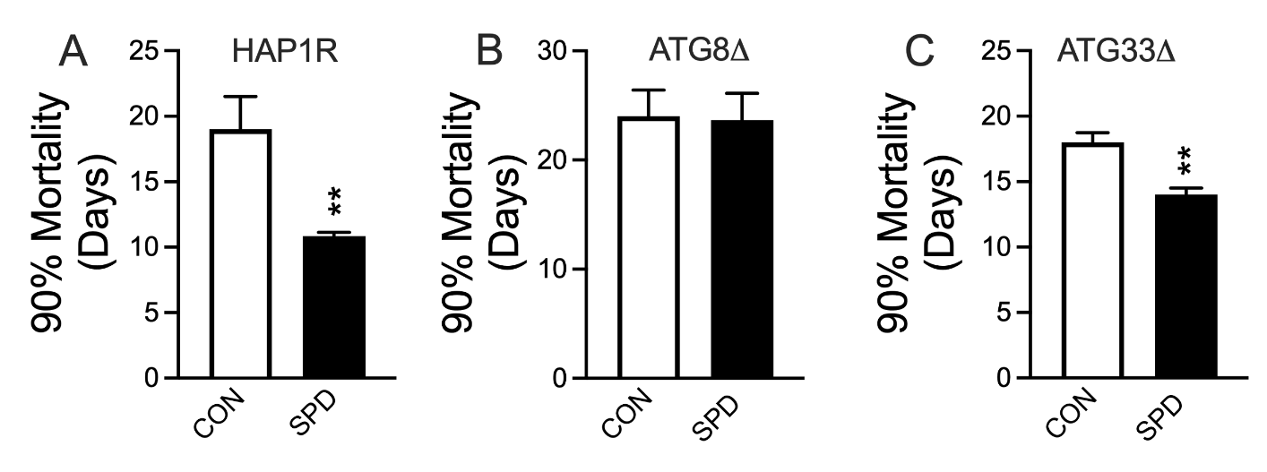

Fig. S1. The effect of SPD on the 90% mortality lifespan of A HAP1R cells, B ATG8 KO cells, and C ATG33 KO cells. **P<0.005, P=0.92 for ATG8Δ, unpaired t test. n=6 for each group.

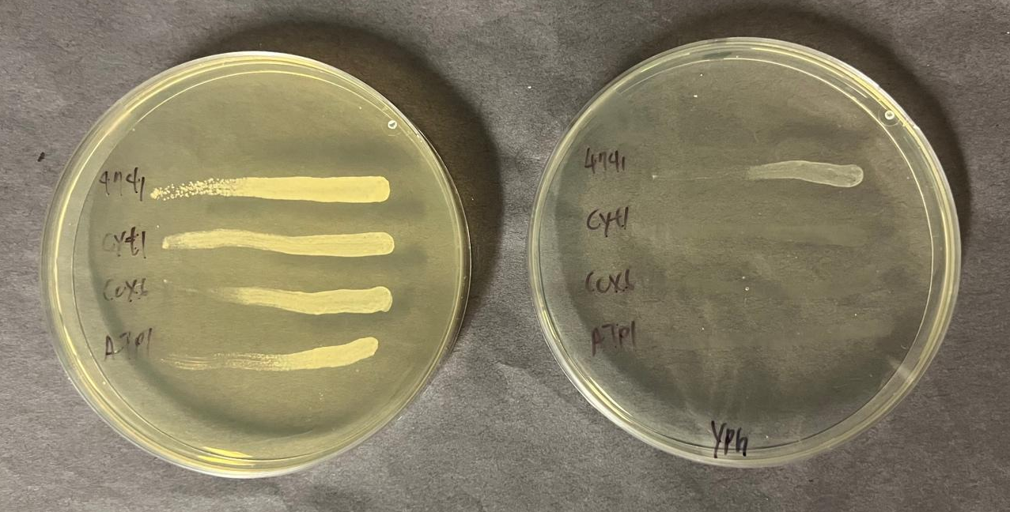

Fig. S2. Growth of BY4741 control cells and CYT1, COX6, and ATP1 deficient cells on glucose (left plate) and glycerol (right plate).

Table S1. Yeast strains used in this study
Strain | genotype | source
S288C | MATα SUC2 gal2 mal2 mel flo1 flo8-1 hap1 ho bio1 bio6 | ATCC:204508
W303-1B | MATα leu2-3,112 trp1-1 can1-100 ura3-1 ade2-1 his3-11,15 | ATCC:201238
BY4741 | MATa his3Δ1 leu2Δ0 met15Δ0 ura3Δ0 | Horizon discovery
D273-10B | MATα mal GAL | ATCC:24657
BY4741 HAP1 repaired | MATa his3Δ1 leu2Δ0 met15Δ0 ura3Δ0 hap1Δ::HAP1 | This work
nde1Δ,BY4741 | MATa his3Δ1 leu2Δ0 met15Δ0 nde1::KanMX | Horizon discovery
nde1Δ,nde2Δ  BY4741 | MATa his3Δ1 leu2Δ0 met15Δ0 nde1Δ::KanMX,nde2Δ::URA3 | This work
ndi1Δ BY4741 | MATa his3Δ1 leu2Δ0 met15Δ0 ura3Δ0 nde1Δ::KanMX | Horizon discovery
sdh2Δ BY4741 | MATa his3Δ1 leu2Δ0 met15Δ0 ura3Δ0 sdh2Δ::KanMX | Horizon discovery
cyt1Δ BY4741 | MATa his3Δ1 leu2Δ0 met15Δ0 ura3Δ0 cyt1Δ::KanMX | Horizon discovery
cox6Δ BY4741 | MATa his3Δ1 leu2Δ0 met15Δ0 ura3Δ0 cox6Δ::KanMX | Horizon discovery
atp1Δ BY4741 | MATa his3Δ1 leu2Δ0 met15Δ0 ura3Δ0 atp1Δ::KanMX | Horizon discovery
atg8Δ BY4741 | MATa his3Δ1 leu2Δ0 met15Δ0 ura3Δ0 atg8Δ::KanMX | Horizon discovery
atg33Δ BY4741 | MATa his3Δ1 leu2Δ0 met15Δ0 ura3Δ0 atg33Δ::KanMX | Horizon discovery

Table S2. Primers and oligos used in this study
Primer/oligo | Sequence (5’ to 3’)
ACTF | TCGTTCCAATTTACGCTGGTT
ACTR | CGGCCAAATCGATTCTCAA
ATG7F | TTGCAATACGATGTTCCTGACTTGA
ATG7R | TGCTAGCTTACCTTGCACATTCCTT
ATG8F | TCGGAGAGGATTGCTGACAG
ATG8R | CTACGGTAAGGTCAGCAGGA
GAL1F | TGCTTTGTCAAATGGATCATATGG
GAL1R | CCTGGAACCAAGTGAACAGTACAA
COX1F | CACCACTAATTGAAAACCTFTCTG
COX1R | GATTTATCGTATGCTCATTTCCAA
MIP1F | GCATACCCAGACGAAGAGC
MIP1R | CAGTGCAGCAGGATCATCAC
CYT1F | TTACATCCCTGGCCCATACC
CYT1R | ACCACCGTGTCTAGCTTTCA
HAP1F | 5’-CAACGGCAGTGCTTTATCGA-3’
HAP1R | GCGTTTCAGCTTCCACTAATT
HAP1 gRNAF | GATCATCAATTTCAACATTATCAAGTTTTAGAGCTAG
HAP1 gRNAR | CTAGCTCTAAAACTTGATAATGTTGAAATTGAT
NDE2F | TAAGTCAGCCCCTCCCTTTG
NDE2R | CGCGAATCTTCCATGACCAA3’
NDE2 gRNAF | GATCGGTCATCTTGAAACGGTGTAGTTTTAGAGCTAG
NDE2 gRNAR | CTAGCTCTAAAACTACACCGTTTCAAGATGACC
HAP1  Repair template | CCTAATAACCTTGGAAGAAATGACGCGGTTGATTTTCTACC  AGTTGATAATGTTGAAATTGATGGACTAGTAGATTTTTATAGA  GCAGATTTTCCAATATGGGAGTGATGTTGGAATAAAAATCAACT  ATCATCTACTAACTAGTATT

