Supplementary Material
Supplementary Table 1
NFE2L2
NLRP3
ATP7B
ATP7A
SLC31A1
FDX1
LIAS
LIPT1
LIPT2
DLD
DLAT
PDHA1
PDHB
MTF1
GLS
CDKN2A
DBT
GCSH
DLST
19 cuproptosis-related genes (CRGs) were acquired from TCGA and previous publications.
Covariates | Type | Total | Test | Train | Pvalue
Age | <=65 | 306(56.56%) | 156(57.56%) | 150(55.56%) | 0.7005
 | >65 | 235(43.44%) | 115(42.44%) | 120(44.44%)
Stage | I | 339(62.43%) | 166(61.25%) | 173(63.6%) | 0.6062
 | II | 52(9.58%) | 26(9.59%) | 26(9.56%)
 | III | 123(22.65%) | 61(22.51%) | 62(22.79%)
 | IV | 29(5.34%) | 18(6.64%) | 11(4.04%)
Grade | G1 | 99(18.23%) | 51(18.82%) | 48(17.65%) | 0.5723
 | G2 | 121(22.28%) | 66(24.35%) | 55(20.22%)
 | G3 | 312(57.46%) | 148(54.61%) | 164(60.29%)
 | G4 | 11(2.03%) | 6(2.21%) | 5(1.84%)

Supplementary Table 2
Clinicopathologic characteristics in entire, testing, and training groups.
Primers name | Sequences of primers (5'→3')
H-GAPDH-F | GGAGCGAGATCCCTCCAAAAT
H-GAPDH-R | GGCTGTTGTCATACTTCTCATGG
H-AC026202.2-F | GCAGTTCCTCCTTCCCACTC
H-AC026202.2-R | GTGTTAGCCAGGGTGGTCTC
H-NRAV-F | GGAGTTGATGCCTCCGAACA
H-NRAV-R | ATGACCGGAGCTGAAAGGTG
H-LINC01545-F | TGGGATTACAAGCATGAGC
H-LINC01545-R | CAGAAGGATGGGAGGGTGG
H-AL450384.1-F | CCACAATCTCCTCCACCTC
H-AL450384.1-R | CCTGTAATGCCAGCACTTT
H-AC079466.2-F | CCTGTCAGTGGCAGAAGTT
H-AC079466.2-R | CTTAGGGAAACCAAAGCAG
H-AC090617.5-F | CGAGCCATTAGACTTTAGC
H-AC090617.5-R | GTGCCACTTACAGAAACAA
Supplementary Table3
The sequences of primers used in our study were as follows.
Supplementary Table Q3
Table Q3. Main characteristics of the previous related studies.
FIG.S3 Train,test and all cohort clinical characteristics and risk score ROC curves.
Fig.S8-A Results of immune cell infiltration under the TIMER algorithm.（a）Boxplot of the differential results of six immune cell infiltrates in the high and low risk groups.(b) Heatmap of correlation between six immune cells and CRLs and their risk scores.(c-d)Correlation analysis of the degree immune infiltration and the risk score(T cell CD8 + _TIMER , Macrophage _ TIMER ).
Fig.S8-B The relationship between immune cell infiltration analysis using the CIBERSORT algorithm and CRLs score.

Fig.S12 CCLE database validation.(A) Heat maps of the expression levels of the three cell lines(KLE, HEC-1A, IshikawaHER) ,the numbers represent the degree of expression rather than the expression level after clustering.(B) Heat map of six lncRNAs expression in 28 endometrial cancer cell lines, obtained from the CCLE database.
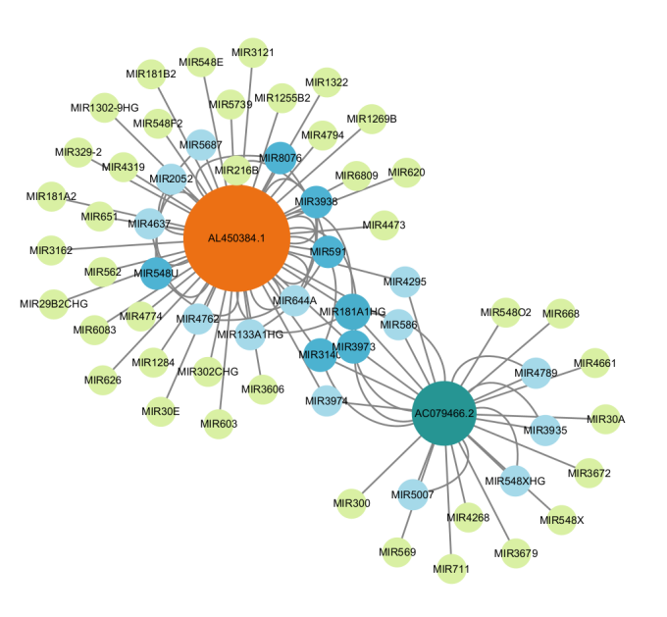
Fig.S13 Network interaction regulation of CRLs and miRNA composition.

