Result of Western-blot
- MPAECs hypoxic intervention for 48h
Lane1-3: normoxic group, Lane4-6: hypoxic group
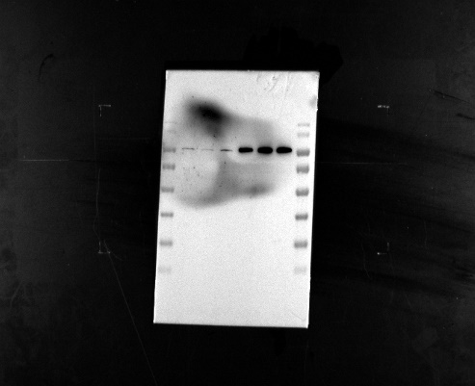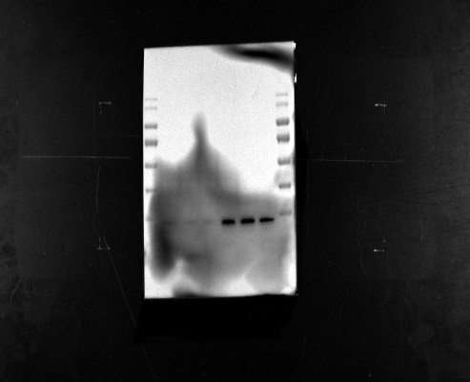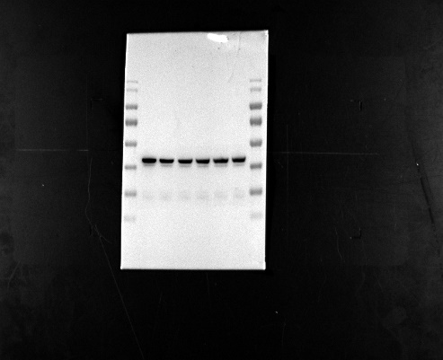
β-actin
VEGF
HIF-1α

2. Knockdown of lncRNA H19 in MPAECs under hypoxic conditions for 48h.
Lane1-3: shNC group, Lane4-6: shRNA-LncRNA H19 group
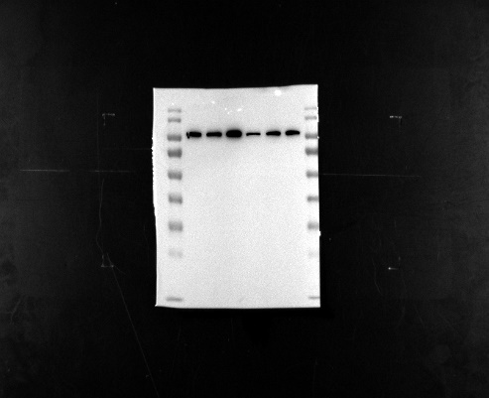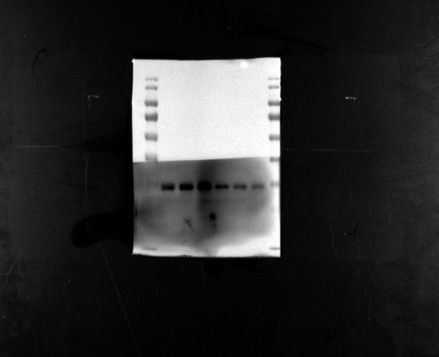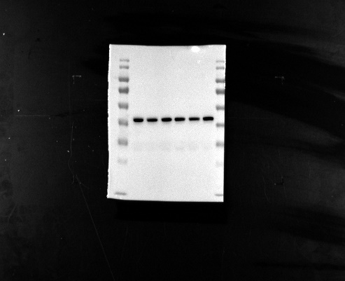
β-actin
VEGF
HIF-1α
- Overexpression of lnRNA H19 in MPAECs under hypoxic conditions for 48h.
Lane1-3: OE-NC group, Lane4-6: OE-LncRNA H19 group
β-actin
VEGF
HIF-1α
4. Knockdown of miR-20a-5p on MPAECs under hypoxic conditions for 48h.
Lane1-3: NC group, Lane4-6: siRNA-miR-20a-5p group
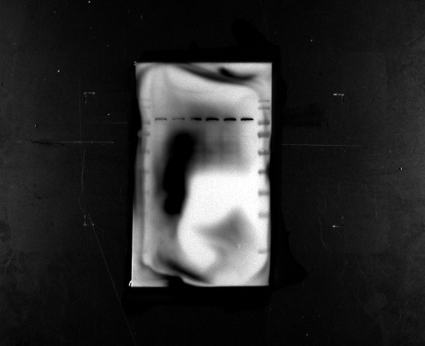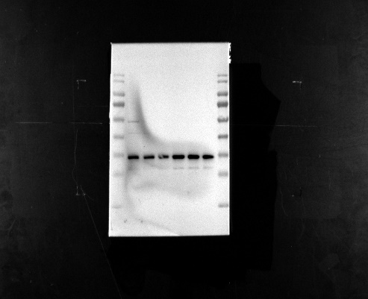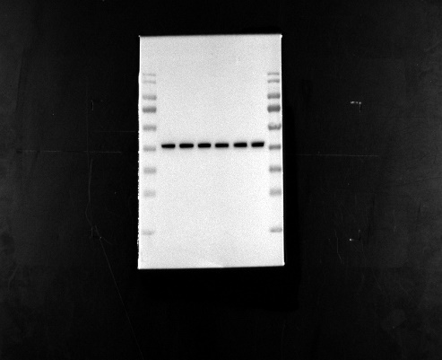
β-actin
VEGF
HIF-1α

