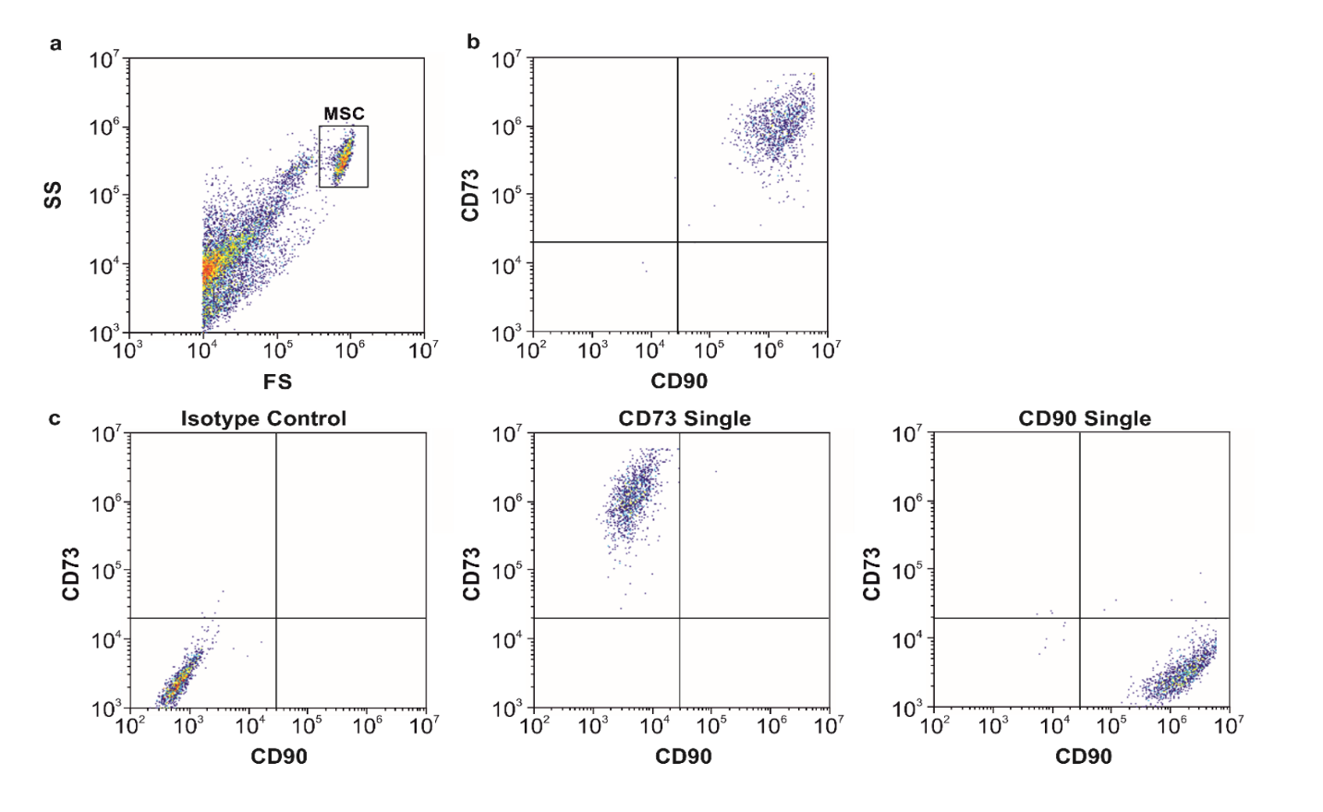 Supplementary Figure 1: Surface marker analysis of MSCs

