a
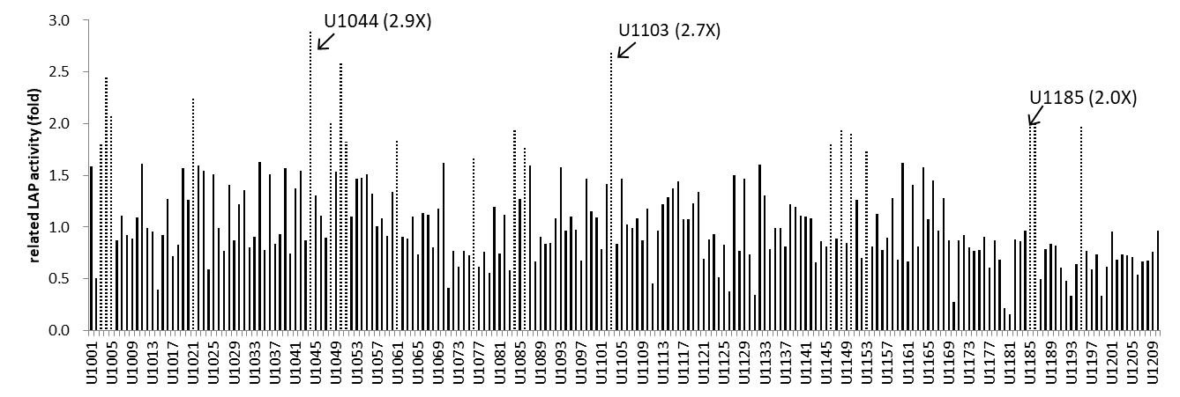
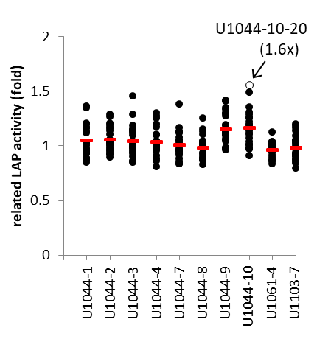
b c
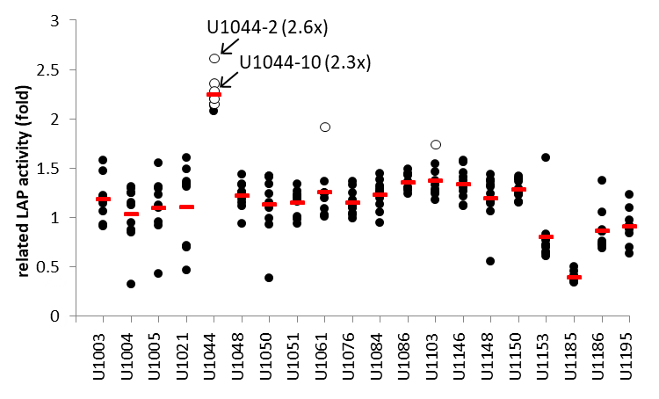
Fig. S1 Related LAP activity of A. oryzae LL1 mutant strains after UV exposure.
a A total of 210 mutant strains from A. oryzae LL1 irradiated with 15 J/m² of UV-C exposures. The top 20 mutant strains with the highest LAP activity were selected for further study and represented by dotted lines. b A total of 200 subclones (10 from each of 20 mutant strains) were analyzed for LAP activity. The top 10 subclones with higher LAP activity were selected for further study and represented by open circles. c 10 subclones were sub-cultured again, and 240 subclones were analyzed for LAP activity. The clone U1044-10-20 with the highest LAP activity were selected for further study and represented by open circle. The related LAP activity of the mutant strains was compared with that of A. oryzae LL1. The horizontal line represents the average.
a
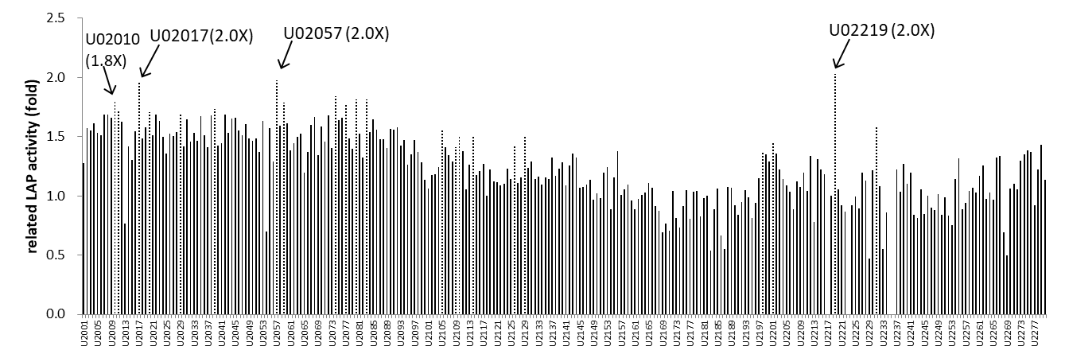
b c
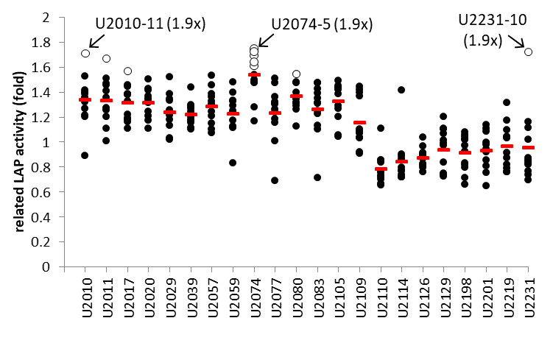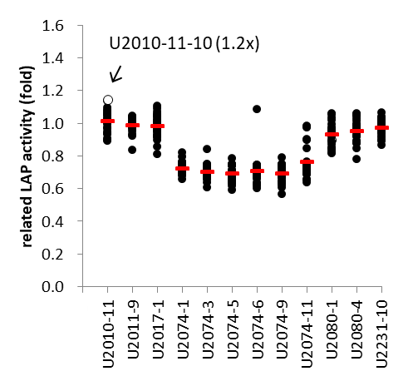
Fig. S2 Related LAP activity of mutant strains after second-round of UV exposure.
a A total of 280 mutant strains from A. oryzae U1044 irradiated with 15 J/m² of UV-C exposures. The top 22 mutant strains with the highest LAP activity were selected for further study and represented by dotted lines. b A total of 264 subclones (10 from each of 22 mutant strains) were analyzed for LAP activity. The top 12 subclones with higher LAP activity were selected for further study and represented by open circles. c 12 subclones were sub-cultured again, and 288 subclones were analyzed for LAP activity. The clone U2010-11-10 with the highest LAP activity were selected for further study and represented by open circle. The related LAP activity of the mutant strains was compared with that of A. oryzae U1044. The horizontal line represents the average.
a
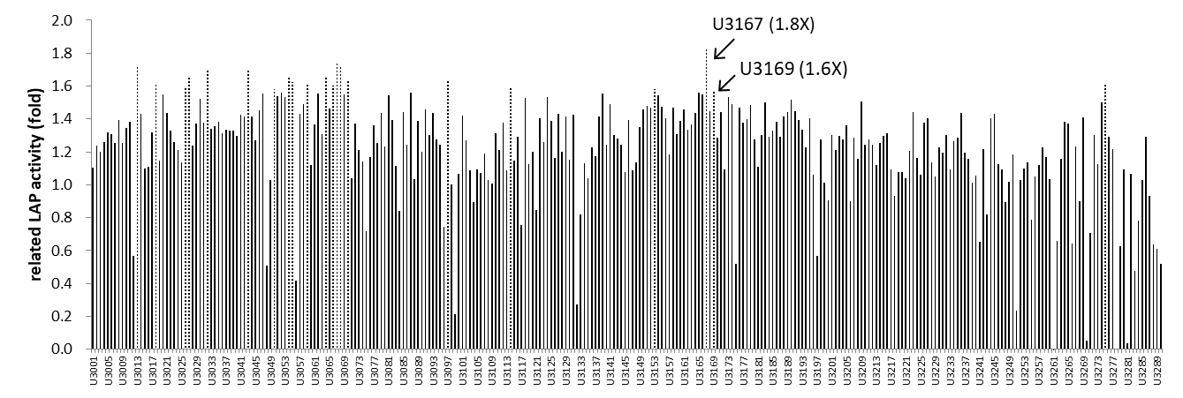
b c
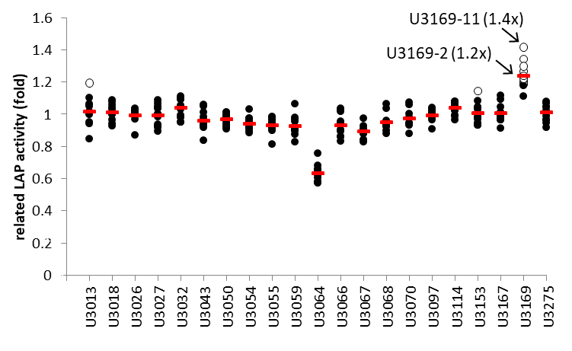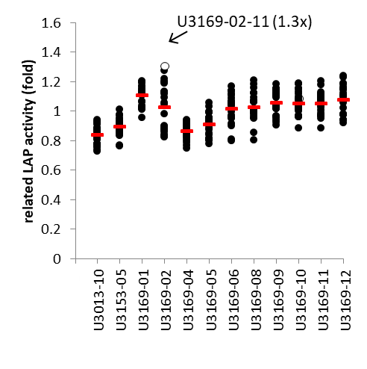
Fig. S3 Related LAP activity of mutant strains after third-round of UV exposure.
a A total of 290 mutant strains from A. oryzae U2010 irradiated with 20 J/m² of UV-C exposures. The top 21 mutant strains with the highest LAP activity were selected for further study and represented by dotted lines. b A total of 252 subclones (10 from each of 21 mutant strains) were analyzed for LAP activity. The top 12 subclones with higher LAP activity were selected for further study and represented by open circles. c 12 subclones were sub-cultured again, and 288 subclones were analyzed for LAP activity. The clone U31169-2-11 with the highest LAP activity were selected for further study and represented by open circle. The related LAP activity of the mutant strains was compared with that of A. oryzae U2010. The horizontal line represents the average.

