Supplementary materials
Impact of invasions on native ant communities
Method: We defined invaded areas as those where L. humile were present at any point during the surveying, and areas where they were absent as non-invaded. Ant community composition (species mean relative abundance) was determined using a series of pitfall traps. At each site, two 100 m transects were established and pitfall traps placed at 5 m intervals. Each trap consisted of 50 ml of propylene glycol in 150 ml beakers, which were buried into the ground, flush with the surface of the soil. The traps were left out for 72 hours; after which time they were collected and all trapped ants were identified to species level, where possible.

In addition, baiting was used to assess temporal shifts in ant community composition (e.g. species presence/absence at baits) during the day. Ten baits were placed at 10 m intervals along each 100 m transect. Each bait consisted of 5 g of ant bait (5:1 mix of tuna and honey) placed on a 10 cm² white laminated card. Baits were set out at 7:00, 11:00, 15:00 and 19:00 hours; ants were collected from each bait after 1 hour and identified to species level, where possible.

Results: Two distinct ant communities were identified. A total of 16,406 individual ants were collected in pitfall traps, belonging to 31 species from 17 genera (Table S1). NMDS showed clear pitfall trap clustering according to the presence/absence of the invasive ant L. humile (Fig. S1). Furthermore, baiting experiments revealed that there was no clear temporal (daytime) partitioning of ant species activity, neither within invaded nor non-invaded (Fig. S2) localities. This suggests that the same ant species were seen attending baits, irrespective of the time of day.
Invaded localities were found to be ant species poor. Localities invaded by L. humile (n = 4 transects) were found to have the lowest mean species richness (2.0 ± SD 0.00) and abundance scores (0.06 ± SD 0.01), suggesting that the invasive ants are displacing all native species at these sites, except for Plagiolepis pygmaea (Table 2). By contrast, non-invaded localities (n = 4 transects) had the highest species richness (17.5 ± SD 1.73) and abundance scores (1.48 ± SD 0.51). Pheidole pallidula was the most abundant (63% of all individuals collected in pitfall traps) native ant species out of the 19 species identified at baits (Table S1); it monopolised most of the baits in non-invaded localities, irrespective of time of day sampled (Fig. S2).

Table S1: Ant species collected from pitfall traps (n = 160) in L. humile invaded and non-invaded sites. *Site coded by location (UG = University of Girona Montilivi Campus; CdA = Castell d’Aro; SdA = Santuari dels Angels) and transect number.
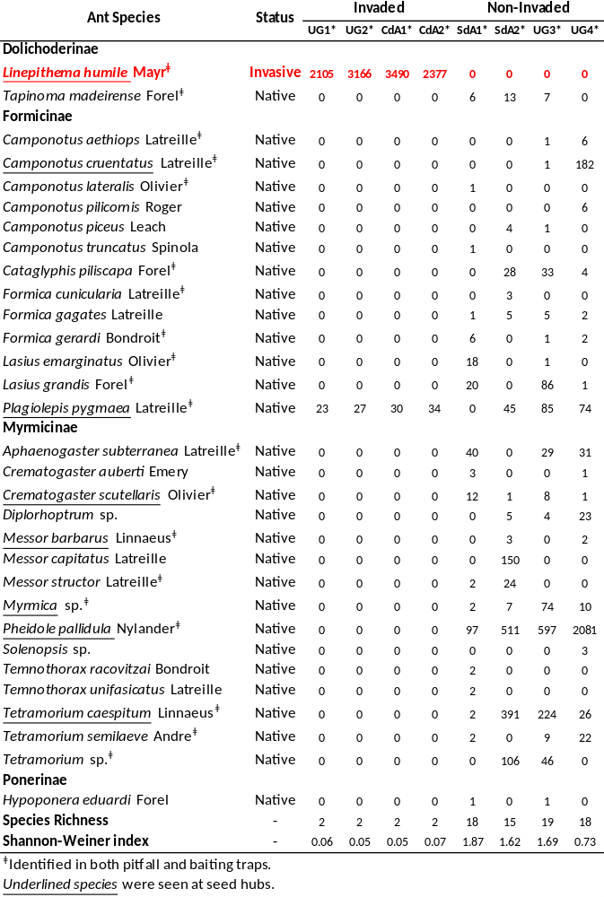

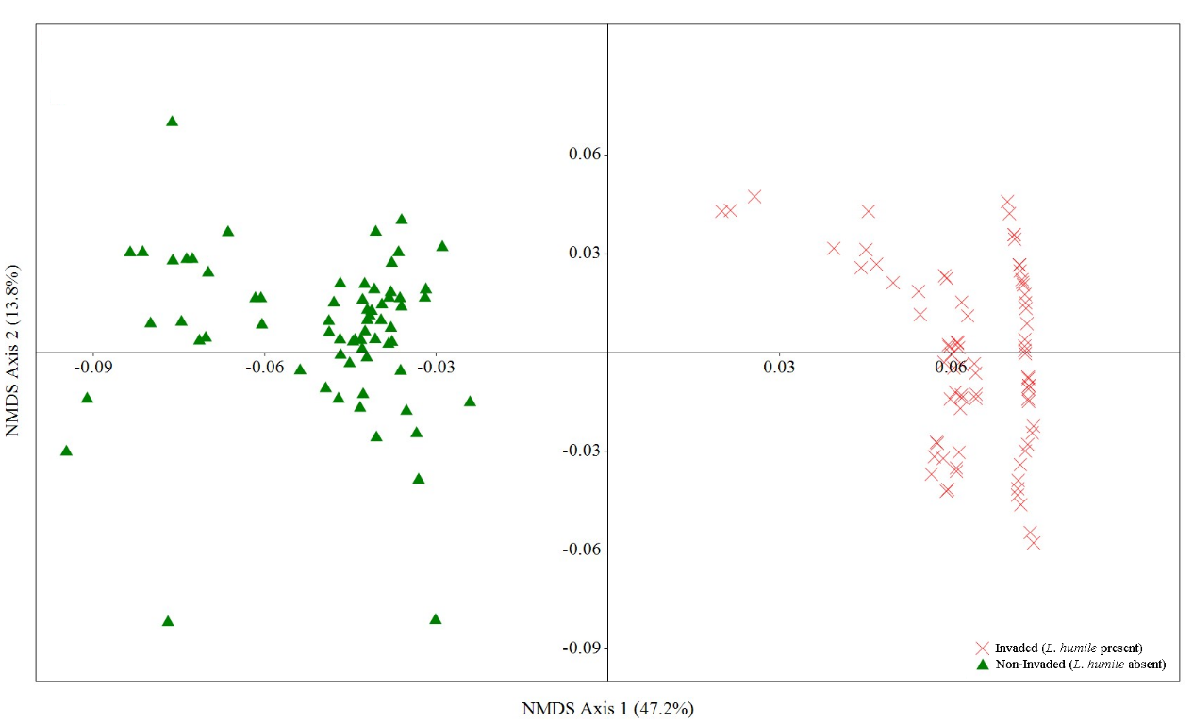
Figure S1. Ant communities’ structure differed between invaded (L. humile present) and non-invaded (L. humile absent) regions. Non-Metric Multidimensional Scaling (NMDS) ordination (based on Bray-Curtis Similarity Index) of ant community assemblages (3D stress value = 0.248) determined from pitfall trap sampling (n = 160). Points represent pitfall traps placed in L. humile invaded (red cross) and non-invaded (green triangle) regions. The amount of variation represented by each axis is indicated in parentheses.

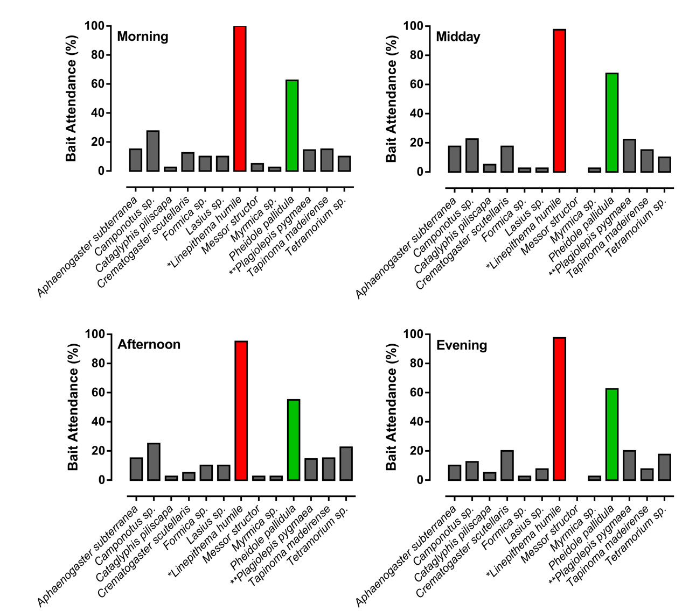

Figure S2. Ant activity of both the dominant native P. pallidula (green) and invasive L. humile (red) was consistent throughout the day. Recorded ant attendance (% of baits attended) at tuna and honey (5:1 mix) baits (n = 320) placed across four time periods (Morning = 7-8am; Midday = 11-12pm; Afternoon = 3-4pm; Evening = 7-8pm) in both invaded and non-invaded regions. *Present only in invaded regions; **Present in both invaded and non-invaded regions.

