Supplementary material 1: Supplementary Tables 3 – 5, and Supplementary Figures 4 -5.
Supplementary material to the paper:
Liedtke R, Barros A, Essl F, Lembrechts JJ, Wedegärtner REM, Pauchard A, Dullinger S. Hiking trails as conduits of non-native species spread into mountain areas. Biological Invasions
Corresponding author:
S Dullinger
Department of Botany and Biodiversity Research
University of Vienna
1010 Vienna, Austria
stefan.dullinger@univie.ac.at

Table 3: Protection status, year of foundation of the five protected areas, with their visitor numbers in 2017 and the number of trails sampled in the respective area.
Protected area | Protection status | Foundation year | Visitor number | Number of trails
Malalcahuello | National Reserve | 1931 | 112,000 | 3
Tolhuaca | National Park | 1935 | 8, 000 | 2
Conguillio | National Park | 1950 | 92,000 | 3
Huerquehue | National Park | 1967 | 47,000 | 2
Villarrica | National Park | 1940 | 61,000 | 7

Table 4: Overview on the trails sampled. El. = elevation, No.= number, Sp. = species.
Park | trail | El. trail head (m) | El. highest point  (m) | El.  Treeline  (m) | Trail length(km) | No.  transects | Human disturbance | Native sp. | Non-native sp.
Malalcahuello | Piedra Santa | 964 | 1670 | 1645 | 7.9 | 15 | occasional cows | 61 | 26
Malalcahuello | Coloradito | 1156 | 1654 | 1430 | 5 | 11 | recreational horse riding | 64 | 12
Malalcahuello | Sierra Colorada | 1362 | 1748 | 1720 | 2.9 | 9 |  | 58 | 11
Conguillio | Sierra Nevada | 1150 | 1688 | 1655 | 5.6 | 12 |  | 57 | 1
Conguillio | Los Carpinteros | 1160 | 1360 |  | 3.2 | 5 |  | 32 | 0
Conguillio | Sendero de Chile | 1258 | 1559 | 1480 | 3.3 | 7 |  | 32 | 1
Tolhuaca | Mesacura-Lagunillas | 907 | 1607 |  | 8.6 | 15 | fire 2015 | 74 | 17
Tolhuaca | Laguna Verde | 1122 | 1375 |  | 2.7 | 6 |  | 41 | 0
Huerquehue | Los Lagos | 788 | 1288 |  | 6.3 | 11 | cows in lowest parts | 59 | 12
Huerquehue | San Sebastian | 785 | 1910 | 1820 | 6.7 | 24 | fire around 1950 | 109 | 15
Villarrica | Lagos Andinos | 1117 | 1614 | 1530 | 6 | 11 | occasional cows in lower parts | 53 | 12
Villarrica | Momolluco | 1053 | 1756 | 1580 | 12.1 | 18 | occasional horse riding, cows in lower parts | 68 | 14
Villarrica | Laguna los Patos | 1010 | 1459 |  | 8.7 | 10 | occasional horse riding, cows in lower parts | 49 | 18
Villarrica | Volcan Quinquilil | 1054 | 1806 | 1570 | 8 | 16 | occasional horse riding, cows in lower parts | 61 | 8
Villarrica | Laguna Azul | 984 | 1760 | 1630 | 5.6 | 17 | occasional cows | 73 | 14
Villarrica | Glaciar Pichillancahue | 1295 | 1696 | 1390 | 3.8 | 9 | occasional cows | 31 | 2
Villarrica | Los Crateres | 1167 | 1417 | 1380 | 3.4 | 6 |  | 30 | 3

Table 5: List of the non-native species sampled, the number and percentage of plots along the trails in which they occurred, and the mean coverage in these plots. No. = Number.
Species | No. of plots | Percentage of plots | Mean coverage (%)
Achillea millefolium | 18 | 2.86 | 16.82
Agrostis capillaris | 58 | 9.21 | 11.00
Anthoxanthum odoratum | 6 | 0.95 | 5.43
Arrhenatherum elatius | 7 | 1.11 | 13.96
Centaurea nigra | 2 | 0.32 | 1.73
Cerastium arvense | 44 | 6.98 | 2.77
Cirsium vulgare | 6 | 0.95 | 1.50
Crepis capillaris | 11 | 1.75 | 5.67
Dactylis glomerata | 29 | 4.60 | 4.18
Echium vulgare | 8 | 1.27 | 3.90
Elymus repens | 29 | 4.60 | 3.54
Holcus lanatus | 33 | 5.24 | 2.96
Hypericum humifusum | 1 | 0.16 | 3.47
Hypericum perforatum | 8 | 1.27 | 2.60
Hypochaeris radicata | 89 | 14.13 | 3.92
Lapsana communis | 8 | 1.27 | 0.87
Leucanthemum vulgare | 12 | 1.90 | 15.07
Lotus corniculatus | 19 | 3.02 | 5.36
Lupinus arboreus | 3 | 0.48 | 72.07
Malus domestica | 4 | 0.63 | 3.29
Phleum pratense | 1 | 0.16 | 3.47
Pinus contorta | 1 | 0.16 | 0.69
Plantago lanceolata | 35 | 5.56 | 3.58
Poa compressa | 3 | 0.48 | 5.78
Poa pratensis | 38 | 6.03 | 3.85
Prunella vulgaris | 35 | 5.56 | 4.85
Prunus sp. | 1 | 0.16 | 3.47
Pseudotsuga menziesii | 7 | 1.11 | 95.34
Ranunculus repens | 3 | 0.48 | 3.23
Rosa rubiginosa | 19 | 3.02 | 4.81
Rubus ulmifolius | 12 | 1.90 | 5.49
Rumex acetosella | 93 | 14.76 | 4.87
Stellaria media | 1 | 0.16 | 3.47
Taraxacum officinale | 70 | 11.11 | 3.19
Trifolium arvense | 1 | 0.16 | 3.47
Trifolium pratense | 11 | 1.75 | 3.97
Trifolium repens | 34 | 5.40 | 5.93
Verbascum thapsus | 2 | 0.32 | 3.12
Veronica arvensis | 5 | 0.79 | 1.11
Veronica serpyllifolia | 2 | 0.32 | 3.12

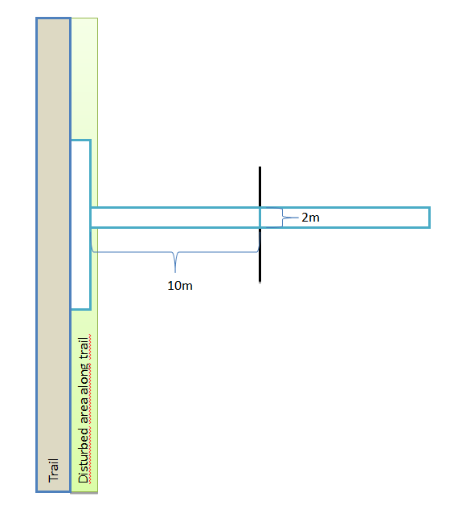

Figure 3: Design of the sampling transects. Each transect included three plots of 2 x 10 m, indicated by the light blue rectangles. The first plot was aligned in parallel to the trail to capture the disturbed area immediately adjacent to the trail (symbolized by the green-shaded rectangle), the other two were oriented perpendicular to the trail into the undisturbed vegetation.

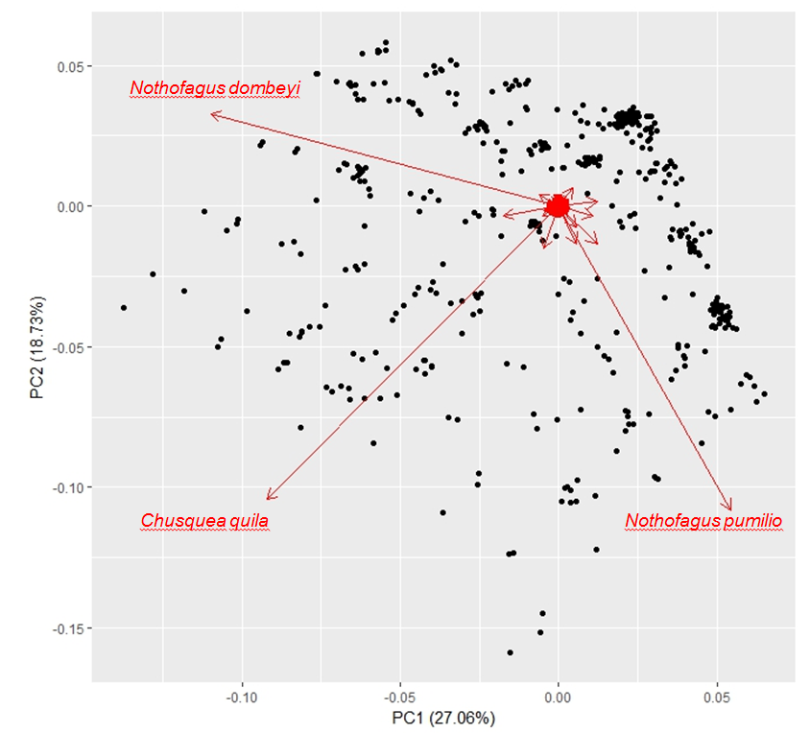
Figure 4: The first two axes of a PCA of the native species abundance in 735 vegetation plots sampled in valley bottoms and along hiking trails in five protected areas of southern central Chile. The names of the three species that contribute most to the variation in species composition among plots are highlighted in red.

