Electronic Supplementary Material

Journal: Biological Invasions
Title: Exploring the desiccation tolerance of the invasive bivalve Corbicula fluminea (Müller 1774) at different temperatures
Simone Guareschi¹, Paul J Wood¹
¹ Geography and Environment, Loughborough University, Loughborough, Leicestershire, LE11 3TU, England

Corresponding author: S. Guareschi S.Guareschi@lboro.ac.uk

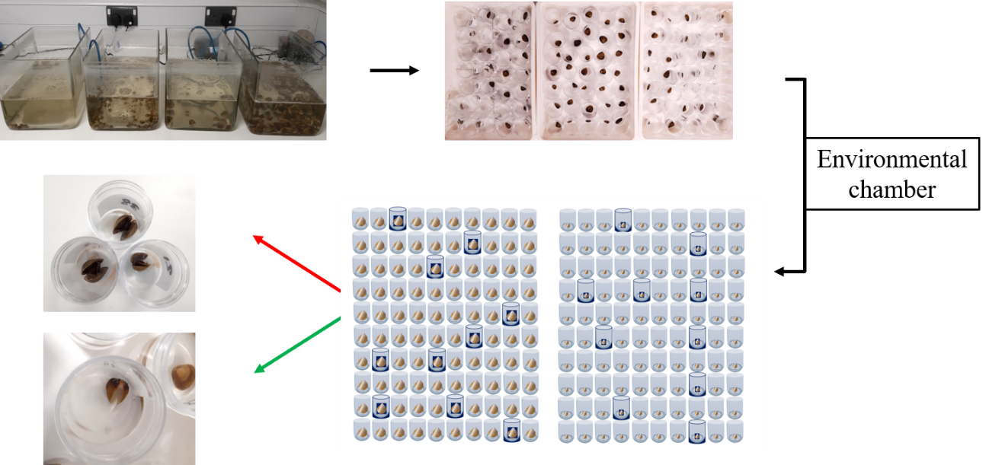
SM_1. Summary of the experimental design from acclimation (starting point) through to the final randomised checks (10 different specimens, here in blue, out of 100, every 24 h for both sizes and temperature scenarios). Red arrow indicated example of dead clams while green arrow indicates live individual with foot visible (Photos: S.G.).

