Online resources

Online resource 1. Detailed Literature Search Methodology.

To assess the fire related traits of a species, google scholar (scholar.google.com), google (google.com), and CORE (core.ac.uk) were used as search engines. We attempted to use the Web of Science (webofknowledge.com) to search for species flammability data, but had much greater success using the other 3 search engines previously listed as they allow a search of the full text of an article. Web of Science only indexes the abstracts of articles and much, if not most of the data found during our literature review was found as brief notes in discussion sections or figures and tables. Only in the minority of cases were the papers actually focused on one species of interest and its flammability traits. Biodiversity heritage library (BHL; biodiversitylibrary.org) was also briefly used as a search engine but with limited success. BHL has a wealth of gray literature and very old literature dating back to the 1700’s, but as fire ecology is somewhat of a more contemporary field, limited information was found. It may be more useful if the majority of species being assessed are of North American origin as there seems to be a geographical bias in their dataset where less information is available for tropical and southern hemisphere species.

Peer reviewed papers were mainly used to identify fire related info for each species, but dissertations, theses, technical reports, and gray literature reports were also used. If the species was reviewed in the Fire Effects Information System (FIES; www.feis-crs.org/feis/; Gucker et al. 2012), the data from the FIES species review was used extensively and the literature was not searched if all required data could be found within the FIES review.

To assess how a species responds to fire the search “species binomial” OR “synonym binomial” fire OR burn was used in google and google scholar. An identical search but with modified syntax (“species binomial” OR “synonym binomial”) AND (fire OR burn) was used in CORE. If a search brought up mostly irrelevant results, filters were added to remove papers which don’t focus on fire ecology. For example -medicinal was added to the search when many results were about medicinal properties of a plant. Typically about 40 articles (top 4 pages) were reviewed on google scholar. However, once all questions were answered for a species, I did not continue reading if I had not yet reached the 4th page. CORE was not searched if all questions could be answered from google scholar.

When reading an individual paper, the search utility (pressing ctrl + f on windows) was used to search through the paper quickly and dramatically decreased the amount of time required to extract information about a species from each source. Depending on the scope and the conventions used of the paper (whether the authors mostly referred to the species with the full binomial, or as "G. species”, or simply referred to it by the genus name) I searched for either the genus name, the species epithet, or the word “fire” or “burn” to quickly find the relevant parts of the paper.

Plant traits:

Reported flammable: Categorical. High, Low, or No Data. Whether the plant is flammable. When the searches above could not answer this question sometimes another search which replaced “fire OR burn” with “flammable OR fuel” was used. If the species is described as a “fire risk”, “flammable”, “fire promoting” or similar language this question was answered with High. If no data was available regarding how this species burns, it was answered with No Data, low was used when a reference explicitly stated the species is not flammable, is reluctant to burn, or does not carry fire. Many species did not have explicit information characterizing their flammability, and the majority of species were scored as No Data.

Data were often encountered regarding lab burn tests, if these protocols used oven dried material to characterize flammability, calorimetry, or any other method which did not involve burning a large quantity of plant material while maintaining its natural structure, the study was not considered for this analysis. Oven dried material does not accurately represent fire risk of plants in their habitat as the conditions of those tests are not typically encountered in natural systems.

Fire Promoting Invader Elsewhere: Categorical. Yes or No. Whether a plant adds significant fuels to a landscape in its introduced range. This question is highly correlated with reported flammable as almost every species which is fire promoting is also flammable. We assumed that if a species is fire promoting it will have already been recorded somewhere in the literature or on the internet. This assumption allowed us to remove the No Data category since the lack of data implies that this species does not modify fire regimes. and the question was answered No. If a paper described an ecosystem where the species of interest was listed as a majority member of a flammable community, or had its fuel characteristics described as flammable or highly flammable, this question was answered as Yes. This question was also answered for species which produce a highly flammable litter bed, but the main body of the plant does not typically burn in (e.g. Pinus spp.).

Not all species assessed have an introduced range outside of Hawaiʻi, these species were scored as No. If a species was not described as particularly flammable, but somehow alters the fuel characteristics of the community to make it more flammable, this was answered as Yes. An example would be a species invading an area with a naturally discontinuous fuel bed and connecting these fuels to increase the flammability of an ecosystem.

Relative is flammable: Categorical. Yes or No. Whether another plant in the same genus which meets the criteria described by the Fire Promoting Native, Fire Fromoting Invader, or Reported Flammable category. This was searched as described above but only the genus name was used in the search.

The following plant traits below were not used in the final model.

Fire Promoting Native: Categorical. Yes or No. Same as Fire Promoting Invader Elsewhere, but within the plant's native range.

Native Habitat Fire Proneness. Categorical: Yes, No, or No Data. Whether the plant grows in a fire prone habitat naturally. Many species can grow in areas which experience fire in one part of their range but in other parts of their range they may never experience fire, in this case, this question was answered as Yes. If a plant was described in a habitat such as fynbos or Cerrado, this question was answered Yes. Many papers would describe a recent or historical fire on their study site and then list species in an appendix or figure, this was one of the main ways this question was answered. If the species was described as growing mostly in perennially wet areas such as rainforests, the question was answered No. If a species was described as part of a community which does not naturally experience fire, it was answered No. If no data could be found for a species, it was answered with No Data.

Regenerates after fire: Categorical. Yes, No, No Data. Whether the population can survive fire though either sprouting, suckering, surviving entirely, or growing back from seeds. If a percentage mortality was given in a paper, a threshold of about 80% mortality was used as the maximum for this to be answered with No. We recognize this is an arbitrary threshold, however, most papers did not describe an exact number and would simply state what plants survived a fire and which did not so the threshold was not used extensively. If no data existed regarding the species response to fire, it was scored as No Data

Promoted by fire: Categorical. Yes, No, No Data. Whether fire can cause an increase in population in the fire affected area. This is highly correlated with regenerates after fire, as a plant cannot be promoted after fire if it is killed by fire. To answer this as Yes, a paper had to demonstrate an increase in population or density after a fire burns through an area. If no data existed regarding the species response to fire, it was scored as No Data

Flammable compounds: Categorical. Yes or No. Whether the plant has a large quantity of highly flammable chemicals such as terpenes or resins which may help to lower the ignition temperature of the plant.

The following questions were answered primarily through photos from starrenvironmental.com (Forest Starr & Kim Starr) and using research grade iNaturalist inaturalist.org observations.

Fine Standing Debris: Categorical. Yes, No, or No Data. Is there a substantial quantity of dry dead material on the plant? Assessed entirely via photos. Leaves, fine stems, flower parts were all counted. A minimum threshold of about 10% debris by apparent volume was required for this to be answered yes. For grasses fine standing debris was counted as dead leaves / culms which are retained upright whereas Leaf Litter is material matted down on the ground.

Stand density: Categorical. Dense, Sparse, No Data. How dense does this plant get? A google search of “Species binomial” AROUND(6) dense (this query ensures that the word dense occurs adjacent to the species name within 6 words) was used, searches of photos were also used. If a species fors dense or thick stands, including monocultures, where plants are spaced together about as closely as possible, they were scored as Dense. Sparse was used when individuals are well spaced (about ~3m apart for woody plants, ~1m apart of herbaceous plants) The most extreme stand density found was reported.

Monocultures: Categorical. Yes or No. The same search was used but instead of “dense”, “monoculture” was used. When assessing from a photo, this was answered yes when it’s clear that the plant forms large, landscape level single species stands.

Vegetative Horizontal continuity: Categorical. High, Low, No Data. Does a plant spread vegetatively by rooting, stolons, runners or in another asexual manor in such a way that a single clone is capable of spreading fire across a landscape. This was mostly assessed from floras and weed factsheets which describe the species mode of reproduction.

Leaf Litter: Categorical. High, Low, No Data. High leaf litter consisted of either a written description stating the plant form large quantities of litter, or a photo showing a continuous layer of litter all coming from the same species. Low litter was used when litter accumulation was not continuous or a litter layer was entirely absent. This was mainly assessed from photos

For identifying plant biological attributes including leaf or leaflet length, leaf or leaflet width, growth form, height, and leaf thickness, data were primary obtained from published floras such as Manual of the Flowering Plants of Hawaiʻi (Wagner et al. 1999), Flora of North America (Flora of North America Editorial Committee 1993), Flora of China (Wu & Raven 1994), Grassbase (Clayton et al. 2021), the Jepson Flora Project (Jepson Flora Project 2021), and other miscellaneous floras digitized on World Flora Online (WFO 2021) or Plants of the World Online (POWO 2021). If data could not be found in these sources, the primary literature and the internet was searched. Leaf thickness was assessed from photographs when the leaf thickness was not explicitly mentioned in floristic treatments.

For all continuous plant measurements except SLA, both a minimum and maximum value were recorded if available. The median between these was used as a predictor for the model. If only a single value was available, it was used in place of the median. If multiple measurements were available for one continuous trait from different sources, the more extreme value was used. However, identifying variation in traits was not the purpose of this work so typically the first value found for each trait was used in our analysis.

Rather than using leaf area, the size of the minimum leaf division, leaf or leaflet area, was chosen as small leaves will have a larger edge to surface area which can increase flammability (Schwilk 2015) and affect leaf litter packing. Leaf or leaflet area was calculated as the median leaf or leaflet width multiplied by the median leaf or leaflet length. We recognize that this calculation is naive as no leaves are perfect rectangles but hope that it does provide somewhat of an order of magnitude level indication of leaf area.

Specific leaf area (SLA) data were obtained from both the primary literature by searching google scholar. Both SLA and LMA (leaf mass area) were used as search keywords, data were then subsequently converted to SLA. Only dry SLA values were used in this analysis. SLA data were also acquired from the TRY project (Kattge et al. 2020). These data consisted of multiple SLA values per species, so they were averaged together along with being averaged with the literature SLA values if both existed for the same species. Extreme SLA values from the TRY dataset (characterized by an ErrorRisk > 4) were discarded.

Online Resource 2. All species assessed as low risk from the 142 species which have naturalized in Oʻahu over the past 10 years and their fire risk scores

Score | Species
0.31 | Cyperus aggregatus
0.31 | Cyperus fulvus
0.30 | Ficus pumila
0.30 | Jasminum multiflorum
0.30 | Melaleuca armillaris
0.25 | Alopecurus pratensis
0.25 | Leptochloa panicea
0.25 | Rhynchospora inexpansa
0.25 | Annona cherimola
0.25 | Arctotheca calendula
0.25 | Cananga odorata
0.25 | Cornus kousa
0.25 | Cotoneaster pannosus
0.25 | Crassula multicava
0.25 | Euphorbia ingens
0.25 | Galium parisiense
0.25 | Guzmania monostachia
0.25 | Hedypnois rhagadioloides
0.25 | Linaria purpurea
0.25 | Liriodendron tulipifera
0.25 | Matricaria discoidea
0.25 | Nerium oleander
0.25 | Peniocereus hirschtianus
0.25 | Pereskia aculeata
0.25 | Phytolacca dioica
0.25 | Swietenia mahagoni
0.25 | Yucca aloifolia
0.22 | Acacia aulacocarpa
0.22 | Acacia robusta subsp. clavigera
0.22 | Albizia procera
0.22 | Cupressus lusitanica
0.22 | Cynanchum gerrardii
0.22 | Ficus religiosa
0.22 | Grewia truncata
0.22 | Melicope elleryana
0.22 | Neolitsea cassia
0.22 | Pittosporum senacia
0.22 | Salvia procurrens
0.16 | Acokanthera schimperi
0.16 | Adiantum macrophyllum
0.16 | Adiantum trapeziforme
0.16 | Aechmea cephaloides
0.16 | Aechmea fulgens
0.16 | Aglaomorpha rigidula
0.16 | Ailanthus altissima
0.16 | Albizia adianthifolia
0.16 | Amaranthus polygonoides
0.16 | Anthurium schlechtendalii
0.16 | Anthurium urbanii
0.16 | Ardisia kusukusensis
0.16 | Ardisia solanacea
0.16 | Beaumontia multiflora
0.16 | Begonia serratipetala
0.16 | Buddleja paniculata
0.16 | Calathea zebrina
0.16 | Calendula arvensis
0.16 | Callicarpa macrophylla
0.16 | Carthamus tinctorius
0.16 | Castilla elastica
0.16 | Cordia sebestena
0.16 | Costus malortieanus
0.16 | Cyclophyllum barbatum
0.16 | Dendrobium cv. Jaquelyn Thomas
0.16 | Dendrobium discolor
0.16 | Dendrobium lineale
0.16 | Dendrobium rhombeum
0.16 | Dischidia ovata
0.16 | Elaeocarpus angustifolius
0.16 | Enterolobium cyclocarpum
0.16 | Erythrina speciosa
0.16 | Euphorbia antiquorum
0.16 | Euphorbia leucocephala
0.16 | Flacourtia zippelii
0.16 | Flemingia macrophylla
0.16 | Gliricidia sepium
0.16 | Guaiacum sanctum
0.16 | Heteranthera reniformis
0.16 | Homalanthus populneus
0.16 | Homalocladium platycladum
0.16 | Inga feuillei
0.16 | Ipomoea corymbosa
0.16 | Justicia gendarussa
0.16 | Justicia secunda
0.16 | Kalanchoe laxiflora
0.16 | Kalanchoe rotundifolia
0.16 | Kalanchoe x houghtonii
0.16 | Laportea aestuans
0.16 | Lappula occidentalis
0.16 | Lespedeza cuneata
0.16 | Leucanthemum x superbum
0.16 | Licuala spinosa
0.16 | Ludwigia hyssopifolia
0.16 | Maclura tinctoria
0.16 | Markhamia lutea
0.16 | Mimusops elengi
0.16 | Moringa stenopetala
0.16 | Myrciaria floribunda
0.16 | Norantea guianensis
0.16 | Nymphoides aquatica
0.16 | Oenothera curtiflora
0.16 | Parkia timoriana
0.16 | Pelargonium x domesticum
0.16 | Phyllanthus reticulatus
0.16 | Pilea hyalina
0.16 | Pilea spruceana
0.16 | Pimenta racemosa
0.16 | Piper auritum
0.16 | Piper divaricatum
0.16 | Polyscias filicifolia
0.16 | Porophyllum ruderale
0.16 | Pseudognaphalium attenuatum
0.16 | Pterocarpus indicus
0.16 | Pyrrosia longifolia
0.16 | Quisqualis indica
0.16 | Sagittaria platyphylla
0.16 | Schefflera insularum
0.16 | Schefflera roxburghii
0.16 | Scleranthus annuus
0.16 | Sesbania grandiflora
0.16 | Silene armeria
0.16 | Solanum mammosum
0.16 | Sophora tomentosa
0.16 | Spermacoce alata
0.16 | Spermacoce ocymifolia
0.16 | Synadenium grantii
0.16 | Tephrosia pumila
0.16 | Thunbergia vogeliana
0.16 | Tithonia rotundifolia
0.16 | Trimezia steyermarkii
0.16 | Verbesina turbacensis
0.16 | Viola hederacea
0.16 | Werauhia gladioliflora
0.16 | Ziziphus mauritiana

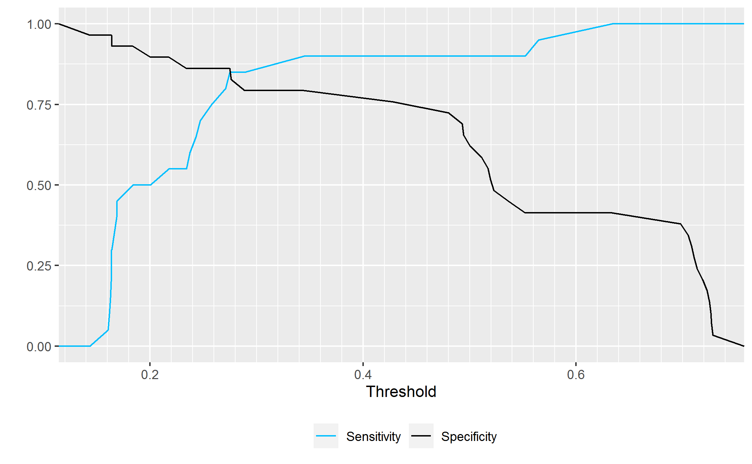Online Resource 3. Sensitivity and specificity at each possible model threshold. At each threshold, species predicted to have scores greater than the threshold would be classified as higher risk, and those less than the threshold as a low fire risk.

