ESM 5. Details of the methods to calculate a rough estimation of the costs of research on invasive ants.

In order to estimate the global economic costs incurred by research on invasive non-native ants, we sent an inquiry to researchers working with invasive ants in order they provided the number of papers and the amount of funding from their research projects. First, we searched the ISI Web of Science platform, for terms related to invasive species and ants, and using the names of the 19 invasive ants reported by the IUCN (http://www.issg.org/database). We used the following search string:

(biological invasion or non-native or exotic or alien invasive species or invas*) and ant not (non-invasive or non invasive) or (“Acromyrmex octospinosus” or “Anoplolepis gracilipes” or “Brachyponera chinensis” or “Lasius neglectus” or “Linepithema humile” or “Monomorium floricola” or “Monomorium pharaonis” or “Myrmica rubra” or “Nylanderia pubens” or “Paratrechina longicornis” or “Pheidole megacephala” or “Solenopsis geminata” or “Solenopsis invicta” or “Solenopsis papuana” or “Solenopsis richteri” or “Tapinoma melanocephalum” or “Technomyrmex albipes” or “Trichomyrmex destructor” or “Wasmannia auropunctata”)

We obtained a total of 4,742 scientific articles, since 1917 (Fig. ESM5 a). Second, from each article, we obtained the corresponding author address and we sent an inquiry to the corresponding authors of the 4,742 articles retained in the search. We requested researchers to estimate (i) the number of papers the researcher produce on average per funded project and (ii) the average amount of money of each project. We obtained 45 responses in different currencies and for different diverse and/or unspecified periods of time. We standardized the mean costs for each researcher data to 2017 US$. Cost per article ranged between US$ 0 to US$ 116,612, and the mean value was US$ 27,160, which is the estimated average of the cost per invasive ant article (Fig. ESM5 b).

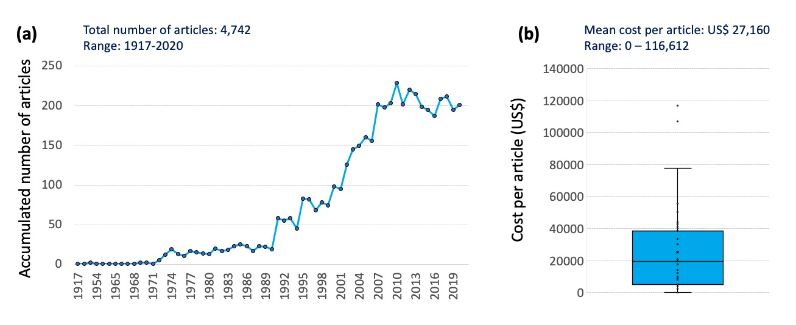

Fig. ESM5. (a) Number of articles about invasive ants along time and (b) cost per article (US$) based in 45 responses.

